­­

ADM Technical Enablement

**ALM Octane – DevOps**

**Hands-on Exercise Guide – v43**

Designed with NimbusServer-2021.R3 and NimbusClient-2022-R5

For container versions, see the Appendix.



MICRO FOCUS and the Micro Focus logo, among others, are trademarks or registered trademarks of Micro Focus (IP) Limited or its subsidiaries in the United Kingdom, United States and other countries. All other marks are the property of their respective owners.

# Contents

Contents 2

Welcome! 6

Roles 6

Activities 6

Exercise 1: Overview of ALM Octane 7

ALM Octane and Quality Management 7

ALM Octane Modules 8

The Requirements Module 10

The Backlog Module 11

The Team Backlog Module 12

The Quality Module 13

The Pipelines Module 14

The Release Management Module 15

The My Work Module 16

The Dashboard Module 17

The Issues Module 18

Exercise 2: Configuring Octane’s Workspace 19

Setting up Releases 19

Setting up Teams 20

Setting up Programs 21

Exercise 3: Navigating Octane’s Advanced UI 22

Navigating Module Functions 22

Manipulating Octane’s Controls 25

Exercise 4: Building an Agile Backlog 31

Backlog Structure/Hierarchy: 31

Navigating through the Modules 32

Creating an Epic 33

Creating a Feature 33

Creating a User Story and Tasks 34

Planning a Release 38

Defining Processes and Process Flows 42

Exercise 5: Defining Test Coverage and My Work 47

Viewing Test Coverage in the Dashboard 47

Creating Test Coverage in the Backlog 48

Executing a Standard Manual Test 51

Reviewing Relations, Test Runs, and Automation Status 54

Managing the Team Backlog 55

Reviewing My Work 58

Exercise 6: Managing Quality 60

Reviewing Failure Analysis in a Pipeline 60

Examining a Build Failure 62

Understanding the Quality Module 63

Navigating the Quality Module 64

Exercise 7: Analyzing Data 66

Reviewing the Dashboard 66

Dashboard Activities 66

Exercise 8: Administration and Settings 72

Settings Overview 72

Adding User-Defined Fields (UDFs) 75

Creating API Keys 76

Creating Workflow Transitions 78

Exercise 9: Configuring DevOps Connections 80

Starting the DevOps, Octane and SSC Containers 80

Configuring the Jenkins-Octane Connection 81

Configuring the Jenkins-Software Security Center (SSC) Connection 83

Exercise 10: Jenkins and DevOps Integrations 85

The Nimbus DevOps Architecture 85

Getting Started with Jenkins 86

The Jenkins Interface 87

Managing Jenkins 88

Managing Plugins 89

The Octane - Jenkins Integration 90

Running a Jenkins Pipeline 92

Exercise 11: Tracking Code Changes in Octane 96

Examining the DevOps File System 98

Modifying the AOS Source Code 100

Running the Pipeline from Octane 104

Viewing Code Changes in Octane 105

Exercise 12: Workin’ with Gherkin 107

Creating a Gherkin Test in ALM Octane 107

Automating a Gherkin Feature File 110

Exercise 13: Creating Testing Jobs in Jenkins 117

Running a UFT One test from a file 117

Running a UFT One test from ALM QC 122

Bonus Question #1 127

Bonus Question #2 127

Challenge Exercise #1 127

Exercise 14: Integrating UFT One tests in Octane 128

Configuring Jenkins for UFT execution 128

Configuring a Git repository for UFT tests 129

Configuring the Octane integration with UFT One 133

Exercise 15: Creating UFT One Tests on SAP 139

Configuring UFT One and the SAP VPN 139

Understanding the VA01 Transaction on SAP Gui 140

Recording the VA01 Transaction with UFT One 142

Adding the VA02 Transaction to UFT One 149

Understanding the VA01 Transaction on Fiori 152

Recording the VA01 Transaction with UFT AI 154

Exercise 16: Integrating Security Testing 159

Running a Fortify Security Scan 159

Using the Fortify Audit Workbench 160

Using the Fortify Software Security Center 164

Integrating Fortify results in Octane and the Jenkins CI 166

Running WebInspect Dynamic Scans 170

Challenge Exercise #2 171

Exercise 17: Synchronizing with MF Connect 172

Configuring the Jira Cloud instance 172

Configuring MF Connect to communicate with Jira 177

Connecting the Octane API 180

Synchronizing Jira and Octane 184

Verifying data in Octane and Jira 190

Challenge Exercise #3 192

Challenge Exercise #4 192

Synchronizing Jira and ALM QC 193

Challenge Exercise #5 196

Challenge Exercise #6 196

Synchronizing ALM QC and Octane 197

Exercise 18: Integrating SonarQube Code Coverage 200

Starting SonarQube 200

Modifying the Pipeline Code 201

Configuring Jenkins to work with SonarQube 203

Exercise 19: Building the Account Service Module 206

Cloning the Root Module Jobs in Jenkins 206

Updating the Pipeline Script 208

Building the Account Services Module 209

Exercise 20: Using the Octane Interactive API Client 210

Setting up the API Access 210

Using the Interactive API Client 212

Challenge Exercise #3 213

Challenge Exercise #4 213

Exercise 21: Using OData for Extended Reporting 214

Connecting to Octane from Excel and OData 214

Querying the Octane Database through OData 216

Using Microsoft Power BI for Reports 219

Challenge Exercise #5 220

Exercise 22: ALM QC Test Run Injection 221

Configuring Octane for Test Injection 221

Configuring the ALM Container 223

Configuring ALM QC for Test Injection 224

Testing the Test Injection Integration 228

Exercise 23: ALM / QC External Test Automation 230

Importing External Test Results 230

Verify the Jenkins Plug-in 231

Understanding External Tests in ALM 231

Importing a JUnit test result to ALM QC from a file 231

Create a Jenkins job to run a JUnit-UFTDev-Selenium test 235

Importing a JUnit test result via Jenkins to ALM QC 235

Challenge Exercise 237

Exercise 24: Implementing the Definition of Done 239

Mark Features Done if Stories are Completed 239

Creating a Sample Hierarchy in Octane 240

Creating a Business Rule in Octane 241

Testing our Business Rule 244

Extending the Definition of Done 246

Exercise 25: Introduction to PulseUno 247

Configuring PulseUno 247

Creating and Running Chains 252

Executing UFT One tests from PulseUno 256

Configuring PulseUno with Octane / ValueEdge 263

Creating a Chain on the AOS-source Repository 268

Connecting the Pipeline to Octane / ValueEdge 273

Running the AOS-Web-Root-Module-Pipeline Chain 274

Changing the AOS-source code and Rebuilding 277

Examining PulseUno’s Code Tracking 282

Running Release Process Auto-Actions using PulseUno 285

Exercise 26: Configuring ValueEdge with Data 287

Configuring ValueEdge to Track Waste 287

Populating Waste Data in ValueEdge 289

Configuring Waste Widgets 290

Exercise 27: Exporting and Importing Workspaces 291

Exporting an Octane Space 291

Importing an Octane Space 294

Exercise 28: Utilizing Model Based Testing (MBT) 296

Configuring the SaaS instance of MBT 296

Cloning the Flight-MBT git repository 296

Configuring Jenkins and DevOps 297

Configuring Octane 298

Creating and Running an MBT Model 301

Creating and Running an AI Codeless Model 306

Caveats for MBT 306

Resetting the MBT Environment 306

Appendix 307

Welcome!

These exercises will guide you through some advanced ALM Octane integrations for the ADM portfolio as used in the Nimbus Demo environment. This information and the associated exercises are for beginner to intermediate individuals who are learning Octane but who also want to know more about DevOps and Octane’s various integrations.

Octane is an advanced software planning and tracking tool that integrates with other DevOps tools to provide insight into the complete DevOps lifecycle. You may think that Octane is just an agile management tool but when combined with CI and DevOps tools it provides unparalleled visibility and drilldown capabilities into a wealth of application development details.

Roles

The exercises contained in this guide are specifically built to manage and automate packaging, compiling, deploying and testing software. These tools and techniques are primarily used by integration or automation engineers. The following list shows some other roles that might be involved:

* Integration Engineer
* Automation Engineer
* Developer
* Tester
* QA Lead
* Project Manager

Activities

The list below shows some of the overall progression of learning activities for this guide:

• Overview and Introduction of ALM Octane

• Building an Agile Backlog

* Jenkins and DevOps Integrations
* Tracking Code Changes in Octane
* Working with Gherkin
* Running the AOS Web Pipeline
* Integrating UFT One Tests in Octane
* Integrating Security Testing
* Synchronizing MF Connect with Jira, Octane and ALM
* Integrating SonarQube Code Coverage
* Building the Account Service Module
* Using the Octane Interactive API Client
* Using OData for Extended Reporting

***Let’s get started!***

Exercise 1: Overview of ALM Octane

ALM Octane and Quality Management

ALM Octane covers different aspects of quality management, including managing backlog items, creating and executing tests, as well as tracking release, build and overall product quality.



**Track build quality**

**At any time, analyze quality using reactive dashboards**

**Manage the backlog and track release quality**

**Incorporate test and build results into product quality**

**Track product quality**

Use the **Pipelines Module** to track builds and run automated tests from Jenkins steps

Use the **Backlog Module** to manage work items and dashboards to track release quality

Use the **Application Module tree** and dashboards to track product quality

Assign **Application Modules** to features and builds to incorporate results into overall product quality

For each release, ALM Octane organizes **Epics**, **Features, User Stories** and **Tasks** into a structure called the  
**Backlog Tree**. Upon completion, QA engineers can design tests in context of the work they are doing.  
They can create manual tests or BDD Gherkin tests to cover and track quality for a release, including functional, sanity, and acceptance tests. Created tests can then be executed, and if they fail, a Defect can be created, assigned, worked on, and fixed.

In addition, tests can be assigned to specific releases for tracking Release Quality as well as to **Application Modules** for tracking overall Product Quality**.** Quality reports for a product can be monitored by using the provided Dashboard feature. ALM Octane can be integrated with a CI server like Jenkins to future enhance Product and Release Quality reporting and manage a DevOps team.

ALM Octane Modules

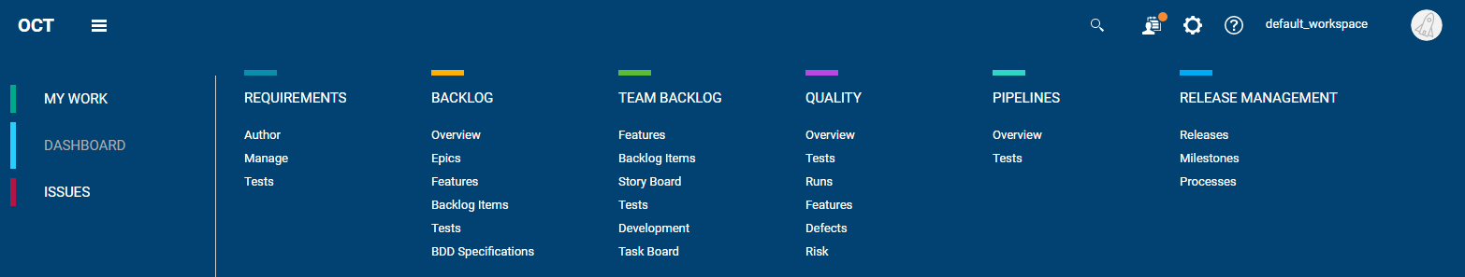

|  |  |
| --- | --- |
|   **Requirements** | The Requirements module provides you with a free-form method of describing what you want to deliver, in terms of ideas and general specifications.  Create requirements documents describing what you want to deliver at a high level. You can also link requirements to tests. |
|   **Backlog** | The backlog is a list of the items you are handling during product development. For each release you define a backlog, which includes epics, features, user stories, quality stories, defects, and their tests. |
|   **Team Backlog** | Manage the team backlog by assigning items to teams, designating specific team members to perform the work, and track progress of the team.  After setting up the overall release plan, work with your team's backlog items to start carrying out your development plan. |
|   **Quality** | Analyze and track the quality of the product with end-to-end testing, cross-feature functionality testing, and regression tests. |
|   **Pipelines** | Track the status of builds and test runs included in pipeline runs, and analyze build failures. |
|   **Release Management** | Allows you to manage Releases, Timelines and Processes without having to enter the Settings section. |
|   **My Work** | Quickly view the work assigned or related to you. |
|   **Dashboard** | Use the ALM Octane charts and graphs to analyze quality in context. |
| **Issues** | Report and fix defects when running manual tests or analyzing automated test failures. You can also view and manage security vulnerabilities. |

The Requirements Module

|  |
| --- |
| In order to start using Octane and view these modules run the following command on NimbusServer:  $ nimbusapp octane:16.0.400.79 start (Username: sa@nga Password: Password1)  Then navigate to the Requirements module and start looking around. |

Requirements can be high-level descriptions or formal documentation depending on your methodology.

You can link requirements to tests, providing you with coverage on each requirement. If your team works with both requirements and backlogs, the two can be linked to one another, showing which backlog item implements which requirement.

For example, you might have a requirement to send astronauts to Mars and bring them back to Earth, and your backlog will be comprised of a huge number of detailed features, user stories, and tasks.

You can also use requirements to document business-oriented information rather than simply defining deliverables. For example, within requirements you might enter business objectives, executive briefs, risk factors, or market opportunities.

**How are requirements related to backlog items?**

From a use-case perspective, the Backlog module is project-management oriented. Backlog items are defined in a hierarchy of epics, features, and stories, and different backlog items are created for different teams (for example back-end vs. client).

Requirements contain the overall story of what you want to deliver, rather than a hierarchy of tasks. For example, you might define a requirement as "Multi-language support," and this could be mapped to ten different items in the backlog.

This is also reflected in the personas using these modules; backlog items may be written by project owners or PMOs, while requirements may be written by business analysts or PMs.

From the perspective of test coverage, you could work with both backlog and requirements in parallel. Alternatively, you could choose one of these modules to reflect quality implementation, and link your tests  
to that module.

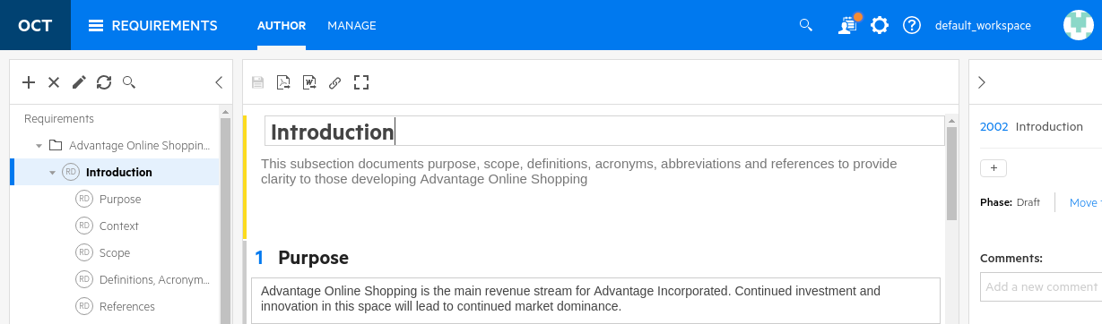

The Backlog Module

The backlog is simply a list of work items identified during product development. Backlog items can also include defects and quality stories (aka spikes). Defects can also be viewed in the **Issues** module as well as in the **Quality** module. The Backlog module contains all the product's epics, features, user stories, quality stories, defects, and their tests and is where most users spend their time.

The Backlog module contains:

* The Backlog tree containing the hierarchy of epics and features, regardless of release
* A grid containing separate tabs for epics, features, backlog items (user stories, quality stories, and defects), and tests. The items displayed in the grid are dependent on the item selected in the tree, and selected releases and sprints, or any additional filters

The Backlog module enables you to:

* Create epics and features, user stories, defects or quality stories
* Open defects for problems encountered during development, testing, or deployment
* Rank items and plan development cycles
* Add tests to epics, features, user and quality stories, or defects
* Track release and sprint development progress

**Navigate** to the BACKLOG module in Octane to browse these views.

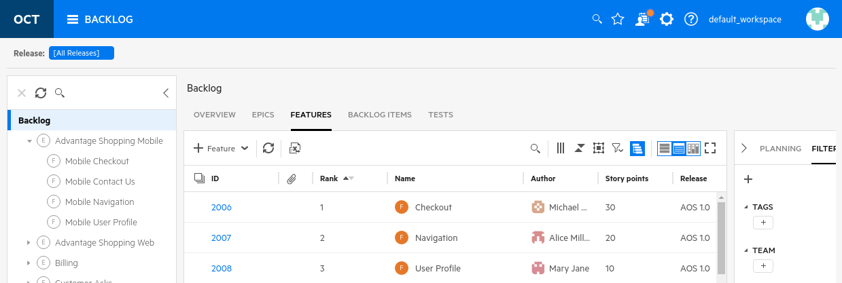

The Team Backlog Module

Teams and cross functional collaboration are an integral part of agile development. After setting up the overall release plan, you work with your team's assigned items to start carrying out your development plan. Do this from the Team Backlog module. You can edit your team’s capacity per sprint, assign items to team members, track team progress, create user stories and tasks, and create and execute tests.

The Team Backlog lets you manage your team’s work by focusing on your team’s sprint activities and provides views tailored to make it easy to track your team’s status. You can even view code commits related to a specific release.

You can also easily filter your team’s backlog items and plan your team’s capacity.

**Navigate** to the TEAM BACKLOG module in Octane to browse this view.

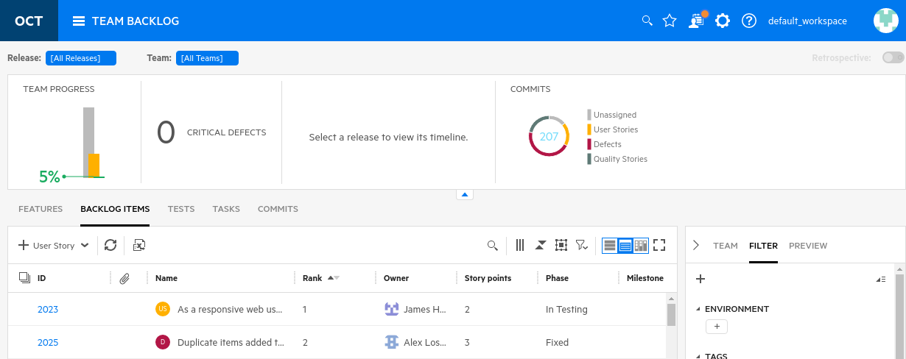

The Quality Module

In ALM Octane, you have the ability not only to monitor the progress of your work but also to track product quality across all areas of your application and project. This is unique to ALM Octane since it measures quality in a number of different ways, including test results, defects, or feature quality status. You can view this quality in the Quality module and also through the various dashboards.

Application modules are unique to ALM Octane and represent a functional breakdown of the product.  
These application modules are linked to features, defects and tests. It’s through these tests that the overall application quality is determined.

Using application modules is important, as in many cases it is seen that many of the reported defects and testing problems that occur are limited to a small number of areas within an application. By setting up application modules, and associating tests, defects, and features, it helps you see the problematic areas of the application and concentrate testing efforts and development effort toward these areas.

Application modules are release-agnostic, which means that the details you view about the application module are global across all releases and reflect the overall health of the product.

In the Quality module, application modules are displayed in a tree. This tree is a visual representation of your application, organized hierarchically.

**Navigate** to the QUALITY module in Octane to browse this view.

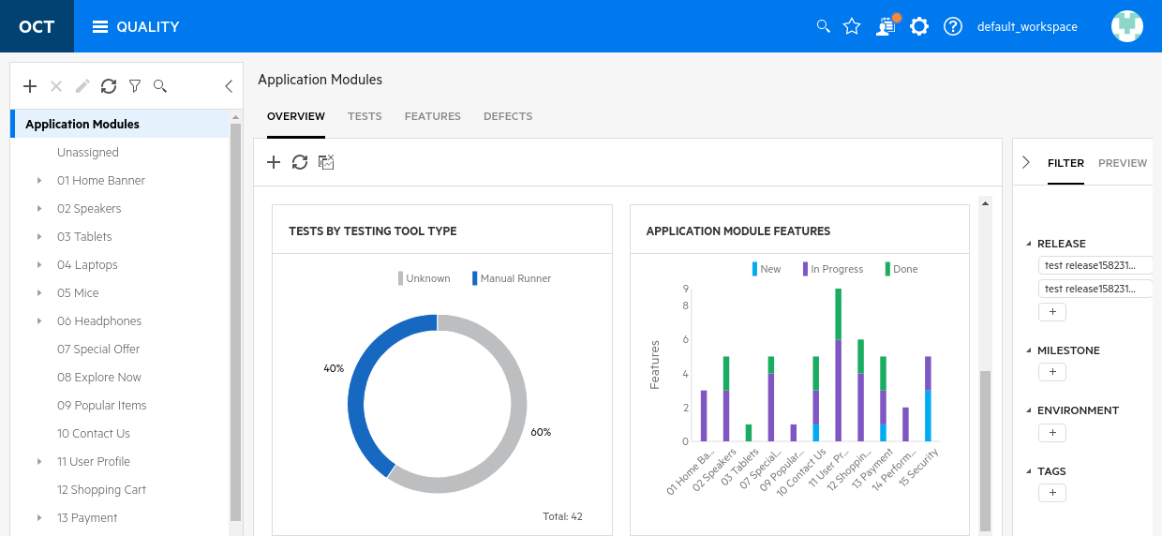

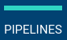The Pipelines Module

Pipelines in ALM Octane represent the jobs or steps that run on your CI server. ALM Octane incorporates data from your pipelines into your application delivery process, helping you analyze quality, progress, change impact, and more.

After you set up ALM Octane to integrate with your continuous integration (CI) server, you can create pipelines in ALM Octane.

Pipelines represent the flow of your CI server jobs. If you are working with Jenkins or Bamboo, the graphical representation of the pipeline also shows the hierarchy of the jobs in the flow.

When you run a pipeline after adding it to ALM Octane, ALM Octane collects build, test run, and commit information from the pipeline run.

**Navigate** to the PIPELINES module in Octane to browse this view.

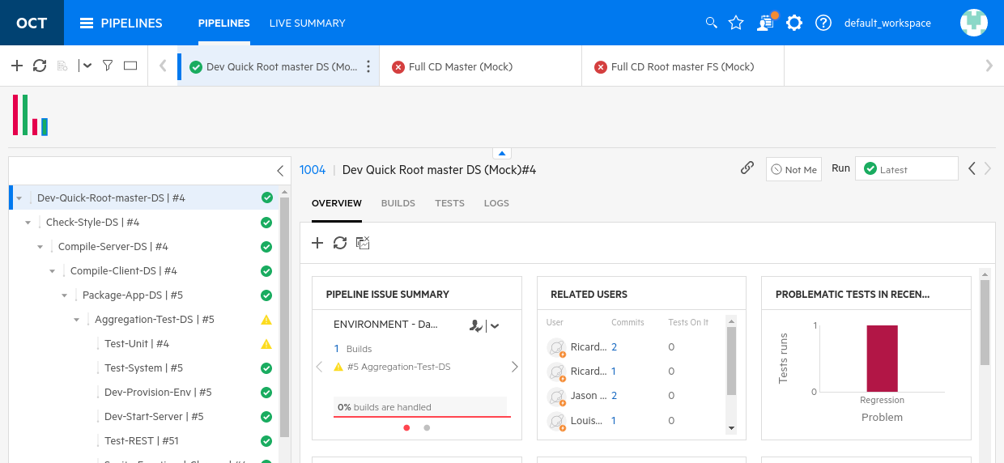

The Release Management Module

The Management module currently serves to edit the releases, milestones and processes.

**Releases** can be created and edited in this section and can be changed between Scrum and Kanban along with the start and end dates along with the number of sprints. Releases can also be managed through the **Settings** section.

**Milestones** can be added and edited along with their attachments and history. Milestones can be set to be cross-release or release-specific.

**Processes** can be defined and edited, and process flows can be executed. Parallel or sequential execution can be defined along with quality gates. Automated process functionality may come into this module down the road.

**Navigate** to the RELEASE MANAGEMENT module in Octane to browse this view.

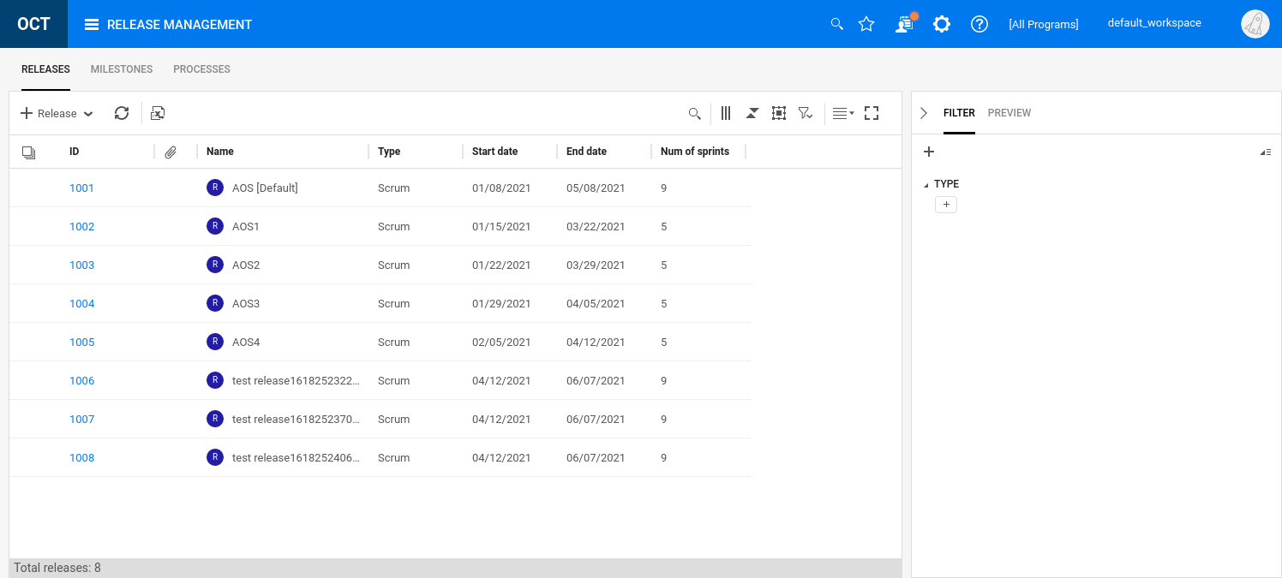

The My Work Module

Track your work with a personalized to-do list of work items. This enables you to quickly view and complete the work assigned or related to you.

By default, items are displayed in the My Work page of the owner of the item. It is also possible to display an item in the My Work module of other users. To do this, your workspace admin creates a rule to assign the item to these users.

The following items are listed on the My Work page:

* Assigned items (Requirements, Backlog Items, Tests), assigned either via a business rule or added manually by another user
* Test runs
* Mentions in comments
* Notifications on followed items

**Navigate** to the MY WORK module in Octane to browse this view.

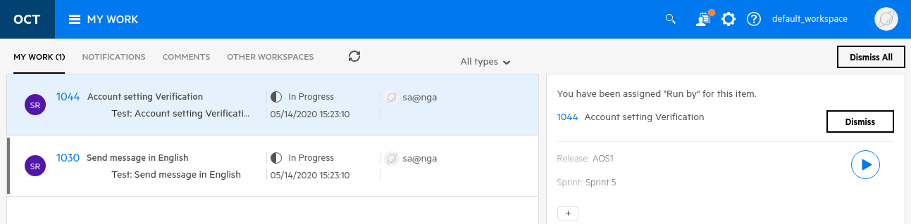

The Dashboard Module

The ALM Octane Dashboard is the control center for analysis of your application's development and quality. It gives a visual, customizable display of how the application's development is progressing and the level of quality.

The dashboard is a collection of widgets (graphs and charts) designed to share data about your product development and progress. Out-of-the-box widgets include widgets to measure product quality within and across releases, progress within a release, test results, and other analytics. If the out-of-the-box widgets are not sufficient for your analysis needs, you can create a custom widget to display your data.

NOTE: Charts and graphs are available in the Backlog, Team Backlog and Quality modules (called Overview) as well as in the Dashboard. The difference is that those should be designed to cater to their specific module while the Dashboard module is an overall collections of metrics and health.

For the dashboard widgets, it is possible to customize the information shown in the dashboard such as the type of data reported, the scope and time frame, and how the data is grouped and displayed.

The dashboard also enables you to configure how you want to view widgets and save different widgets as favorites to use on repeated visits to the dashboard.

**Navigate** to the DASHBOARD module in Octane to browse this view.

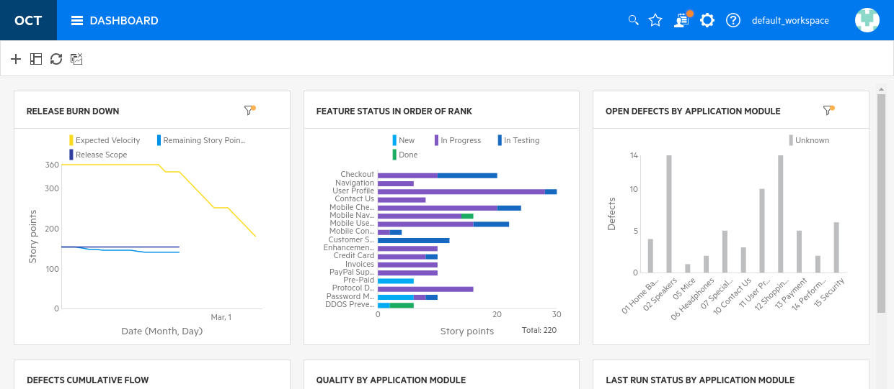

The Issues Module

The Issues module enables access to both defects and vulnerabilities. Defects are entities that need attention or fixing while vulnerabilities are code issue that exhibit security issues. Vulnerabilities cannot be created manually in Octane but are discovered with security inspection tools like Fortify and SonarQube.

While defects can be viewed in other modules like the Backlog or Quality modules, they are consolidated here as well which allows specific teams to have access to this module without visibility to other modules in ALM Octane.

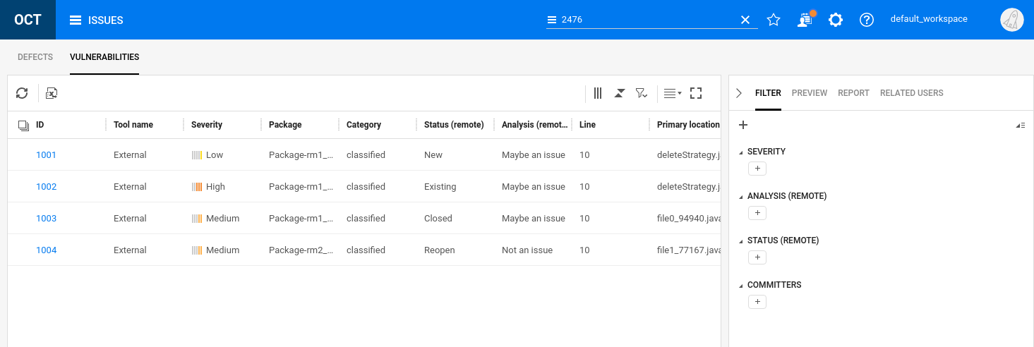

Exercise 2: Configuring Octane’s Workspace

In order for Octane’s data to be connected, relevant and current we need to configure a couple of items first.

## Setting up Releases

1. If Octane isn’t running, start it from the **terminal** on **NimbusServer** by typing:

**$ nimbusapp octane:16.0.400.79**  **start**

1. Open your browser and **Login to ALM Octane**: <http://nimbusserver.aos.com:8085/ui>
   * Username: [**sa@nga**](mailto:userx@octane.com)
   * Password: **Password1**

NOTE: Releases can be defined in either the **Management** module or in the **Settings** section. If you want to configure multiple workspace releases at one time then that can only be done in the Settings section.

In this example we’ll manage releases in the **Settings** section. 

1. Click the **Settings Icon** and select **Spaces** to get to the Octane administration module.
2. Select the **default_workspace** under **A Default Shared Workspace** on the left and then the **Releases** tab and set the **END DATE** for the **AOS1 (Default)** andthe **AOS** releases to be at least one month from today’s date. If it is already that far in advance then no need to change anything. That properly adjusts the current sprints.

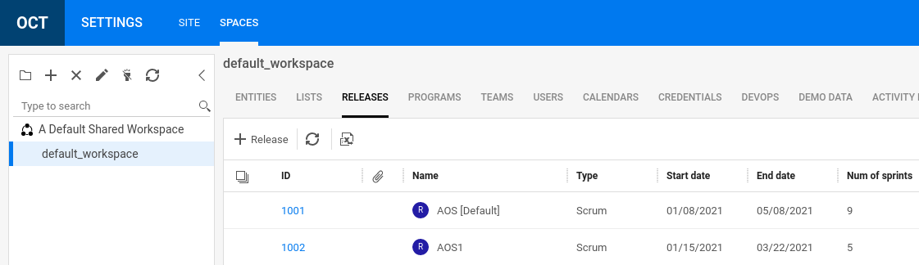

## Setting up Teams

We also need to set up some teams to accurately portray our users of Octane.

1. Select the **TEAMS** tab verify that the **AOS_UI, AOS_API** and **AOS_Infra** teams exist.
2. Under the Team lead column select to add sa@nga to each of these three teams as the team lead.  
   Do this for all **three** of the teams (AOS_UI, AOS_API, AOS_Infra).

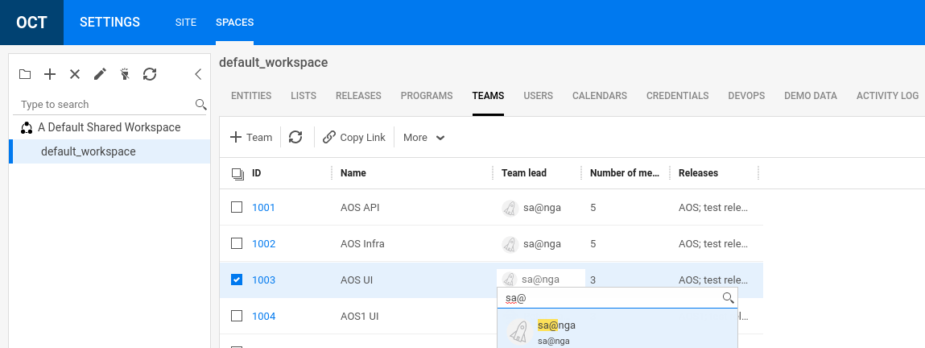

NOTE: You can also do this by clicking the numeric link and selecting the **DETAILS** tab.

1. Click on the numeric link for **AOS Infra** (1002) and select the **MEMBERS** tab.
2. Add a team member by clicking on **Assign Members** pull-down.
   1. Add **Alice Miller** to this team by clicking on **Assign members** and typing in her name.

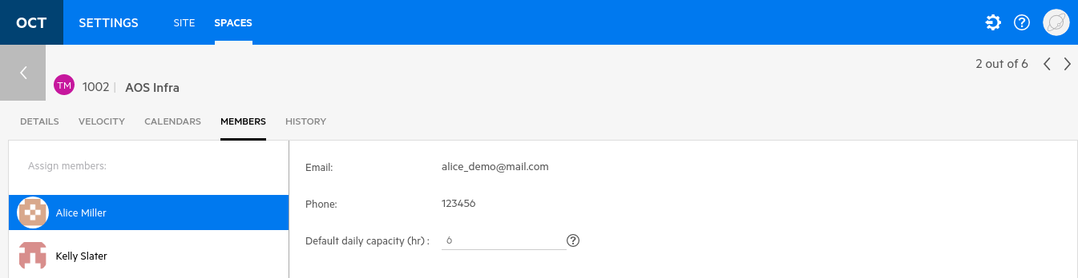

## Setting up Programs

A program represents an "important, ongoing system development mission" as part of the SAFe initiative.  
For more details, check out this link from the SAFe foundation:  
<https://www.scaledagileframework.com/program-level/>

1. Click the back arrow and make sure you have the **default_workspace** selected on the left.
2. Select the **PROGRAMS** tab and verify that the programs **Services** and **Direct Pay** exist. These have been created for you in this default_workspace demo data.  
     
   You can associate backlog items (features, user stories, quality stories, and defects) with programs, and then filter the Backlog module grid accordingly.
3. 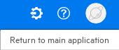Click the gear icon and select **Return to main application**.

Exercise 3: Navigating Octane’s Advanced UI

Octane is built on an advanced UI toolkit (Angular JS) that offers simple, easy-to-use controls and an optimized   
Elastic Search engine for fast UI response. Octane is available on premise, as a docker image or on SaaS.  
In fact, an older release of Octane is actually used to develop the next release of Octane!

Octane’s architecture actually consists of three parts – the Octane server, the database server and the  
elastic search server. For purposes of simplicity these have all been combined into a single docker image in the Nimbus demo environment.

Navigating Module Functions

1. **Verify** that the octane container is running.
2. Have your browser open and **login** to ALM Octane (sa@nga, Password1) and select **default_workspace**
3. **Select** the **BACKLOG** module to get to the **BACKLOG** starting page.
4. **Click** the triple bar to bring up the module navigation menu.

Clicking on the OCT brings you HOME

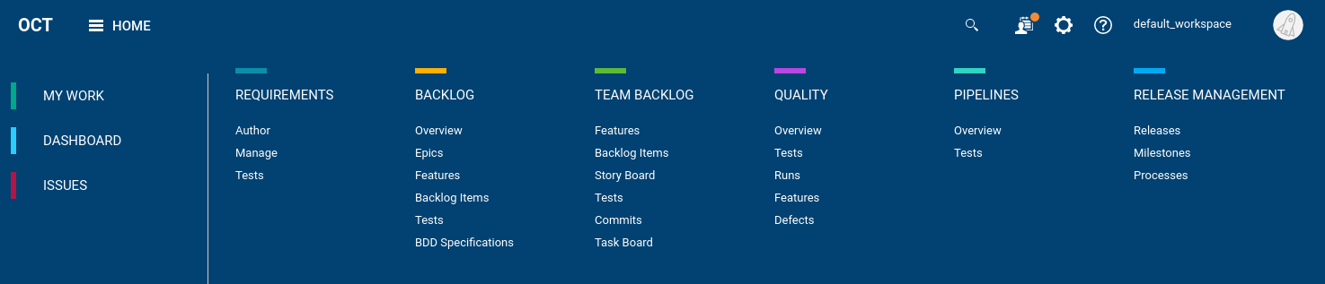

1. This navigation bar is how you’ll switch modules easily. Try clicking some of the links and then **click** the triple bar again to get back to the navigation menu.
2. At the top right corner are some special icons.

Program Filter

(Shows in Backlog)

**Global Search**

Settings

Settings

Display/Change Workspace



Profile and LOGOUT

Help

My Work

1. **Click** on the Global Search magnifying glass and type in **2033**  
   This will bring up the details of a Feature (F), Group (GP) and a Requirement (R) whose ID is 2033.

For each it also displays the item’s name. For the Features this is:  
“PayPal Support”

1. **Clear** the search entry and type “**Mobile**” instead.

This will search for all entities that have “Mobile” in their name or description.

You’ll see several entity types listed.

Scroll down to the Defects section and note that not all 12 defects are shown.

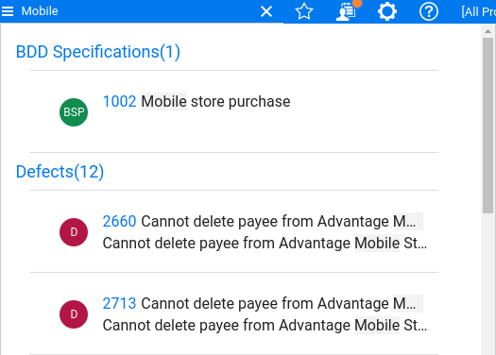

That’s because it just chose a short list – to see all of them, click the link for Defects(12).

Click the numeric link next to the second item (**2713**).

This will navigate you to the details of User Story **2713**.

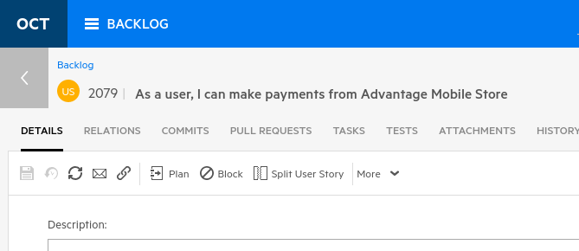

1. **Click** the back arrow as shown above to get back to where you started.
2. Next to the word Mobile in the global search bar is something that looks like three horizontal bars.



**Click** this icon to show the full list of search categories including **Search All** which is the default.

1. **Click** the Defects check box to limit the search to Defects that have Mobile in their name or description.

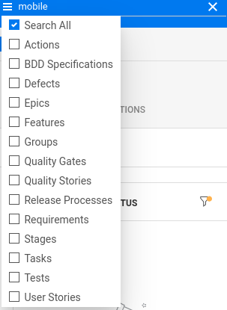

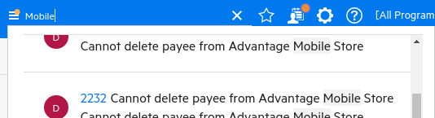

1. Note the small amber circle above the three horizontal bars. This indicates that a filter has been applied. This technique of displaying that circle is universal throughout Octane when filters are active.
2. Change the search option back to **Search All** and then click the **X** to the right of the Mobile text to clear your search.
3. **Click** the OCT triple bar again and select the **BACKLOG** icon to go back to the BACKLOG module.

Manipulating Octane’s Controls

We’re now on the **Backlog** page but not everyone will see the same view. This is because Octane remembers your settings, tabs, filters and many other selections that your login account last had.

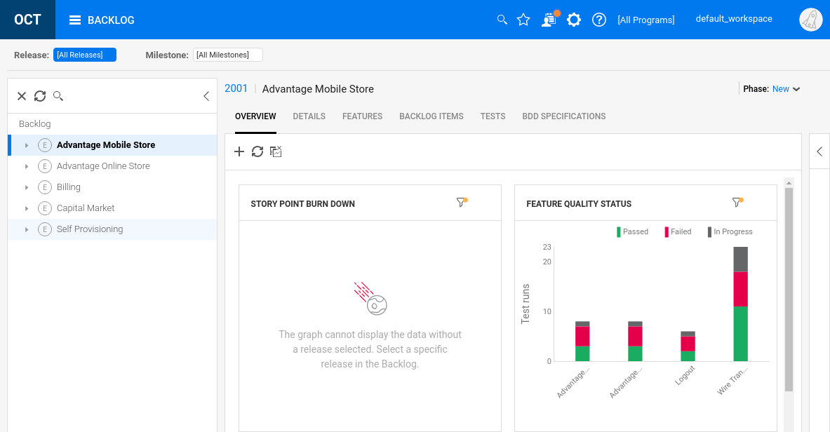

1. **Modify** your settings (**Backlog** tree, **Overview** tab, etc.) so it shows the dashboard view shown above.  
   Most modules offer an Overview mode which is a contextual dashboard for that entity selected on the left. From this section you can create graphs and charts specific to the backlog items.
2. Select the **Backlog Items** tab and the **Grid View** icon.   
   This view shows a convenient grid view of all the backlog items.

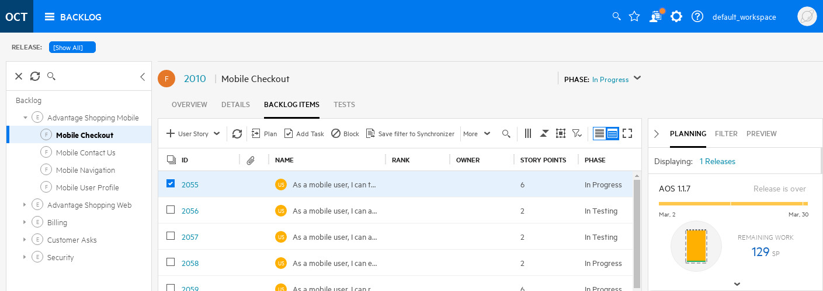

1. Select the **Slim Grid View** to see a more compact and entity-dense view. But it gets even better!

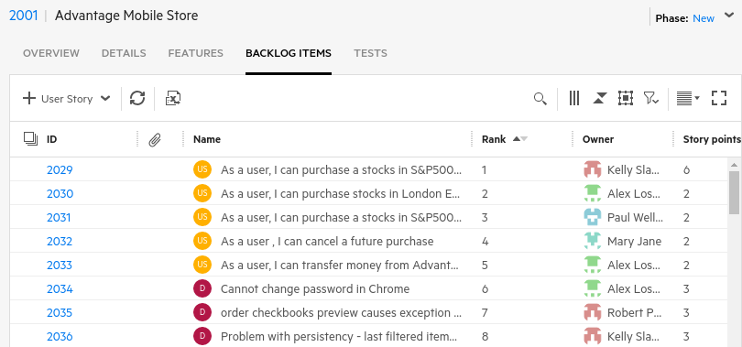

1. Select the **Smart List View** to expose more details on each selected user story.

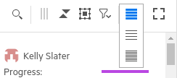

1. From the Smart List View, **select** the topmost user story and click the **expansion triangle**.  
   Now, in addition to a grid-like view you can easily navigate to a user story’s tasks.

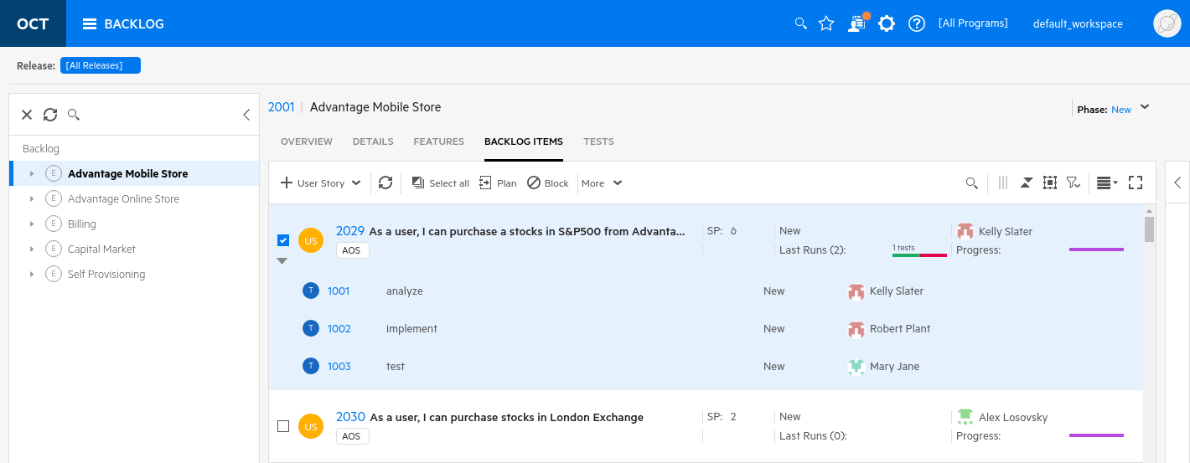

1. **Click** on the left-facing arrow on the right to expand that section.
2. Another advantage in this view is the ease of adding Comments. Comments are notes from developers, scrum masters, management, etc. which offer some question or actions for individuals. ALM Octane even recognizes user names if you precede them with an @ symbol.   
     
   Open the **PREVIEW** tab on the right and **type** the following into the **Comments** section  
   (don’t use copy and paste):



When the box appears, select it.

  
@Alex

I think we should add a test to this user story.

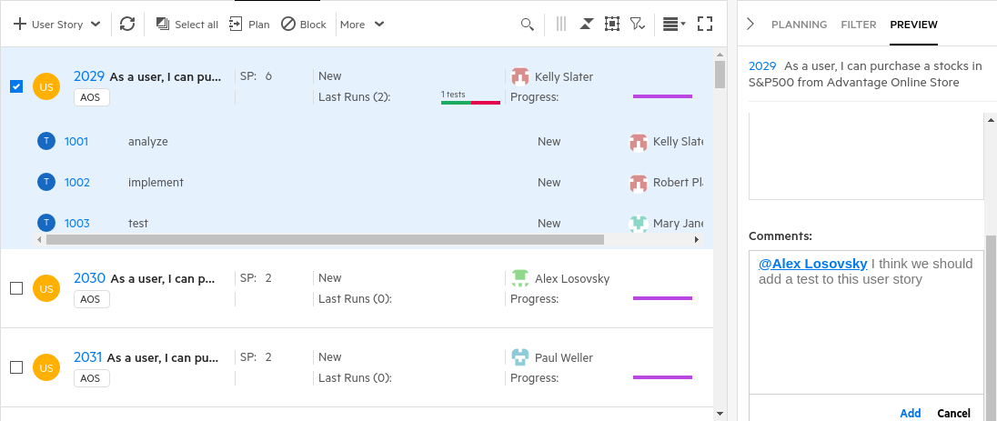

Scroll  
Down

1. Click **ADD**.
2. Click the numeric link for this topmost user story to get to its details page.



1. The details page allows you to edit every field for this User Story (US).

**BUT WAIT** – Where is the **Comment** field I just edited?



If you click the circular icon in the upper right you can view, add, edit or delete comments too.  
You can also **pin** the Comments box so it stays up on the right (try it!).

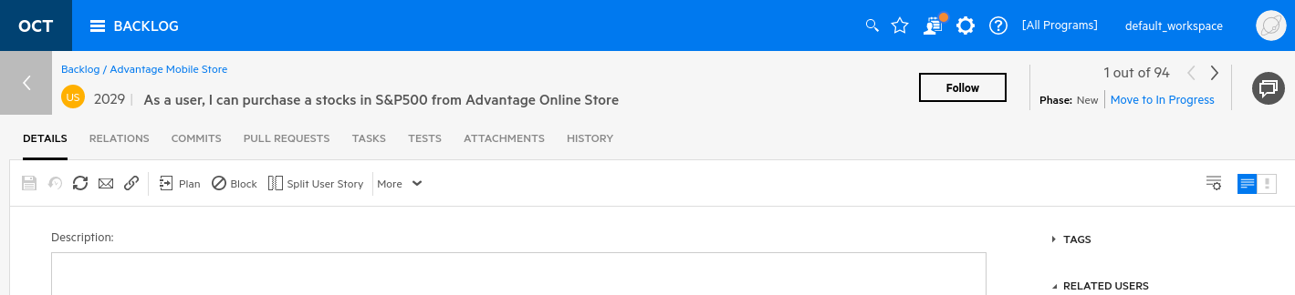

1. Click the **HISTORY** tab to see a history of changes to this User Story. Everything is tracked.

You should see your change to the **Comments** at the very top of this list.

This change and almost all changes are tracked and can be seen in an object’s history.  
  
**WAIT – WHAT IF I DELETE AN ENTITIY – CAN I SEE THAT CHANGE SOMEWHERE?**

You can. In the Settings (administration) module there’s a section called the **Activity Log** where you can see all the changes to Octane’s entities. This is audit capability is very important to some customers, especially government and regulated industries.

By the way, you can change or even delete comments but only those that you authored.

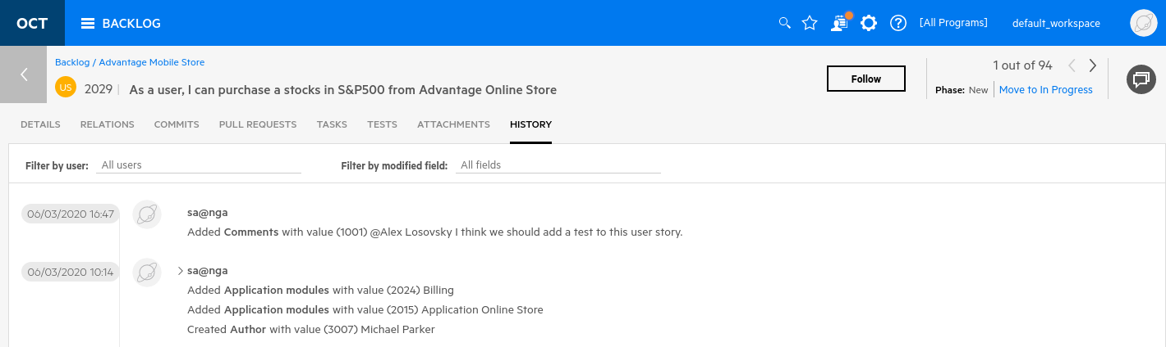

1. **Click** the back arrow symbol to return to the BACKLOG Smart List View.

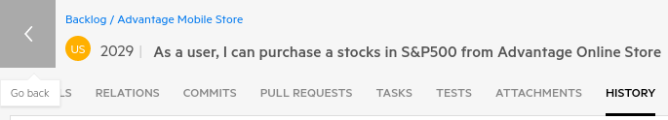

1. Select the **Filter** tab on right side bar.

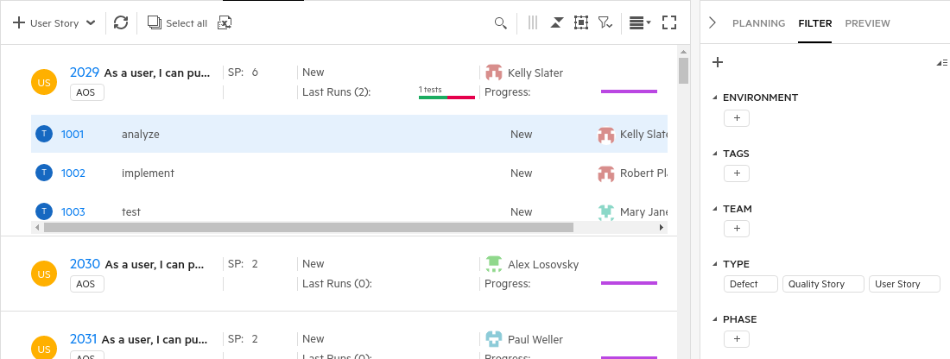

1. In the Filter section under TYPE, click **Defects** to filter and only show items of type Defect.

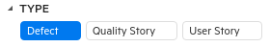

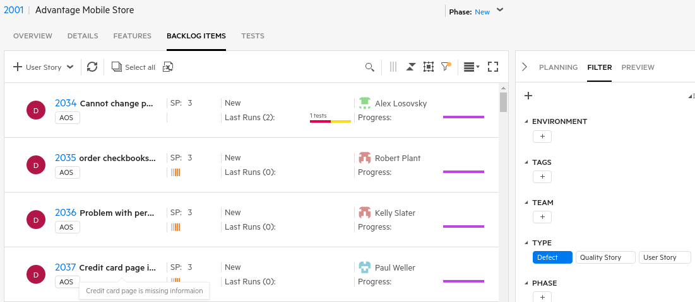

1. If you want to filter *negatively*, **right-click** on the item type to de-select it.

The example below will show everything except defects.

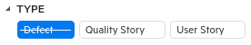

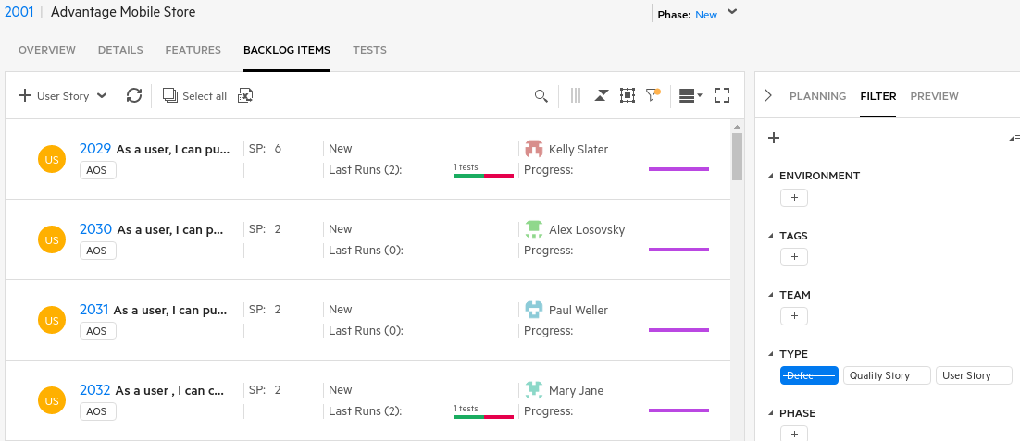

1. Clear any filters before proceeding (they should not be blue or struckthrough).
2. Click on the **Features** tab at the top and then click on the **Rank** header to display the numeric rank.   
   Sort them from lowest to highest (starting at 1). Rank is initially determined by the order in which items are entered but you can always change an item’s rank by dragging and moving the item or by manually editing the rank value. Rank can also be calculated using WSJF (weighted, shortest job first) parameters.
3. Click on **Set Red Line** (be in grid or slim grid view)

This option allow you to see how many Features can be completed based on Story Points or Items.

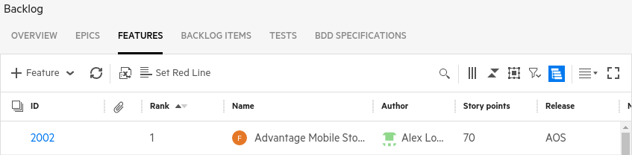

1. **Enable** the Show Red Line and set the value to be **200 Story Points** and click **Set**.

This will show that you can complete the top 4 Features using 200 story points of effort.

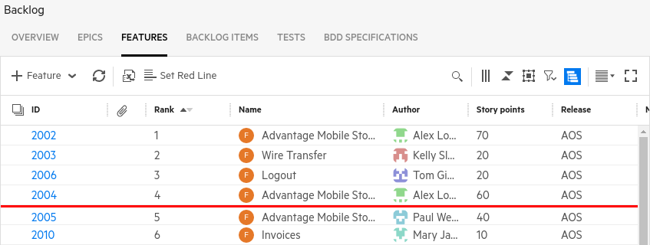

Exercise 4: Building an Agile Backlog

In this exercise you will work on understanding the ALM Octane agile methodology by populating the backlog with some epics, features and user stories.

Backlog Structure/Hierarchy:

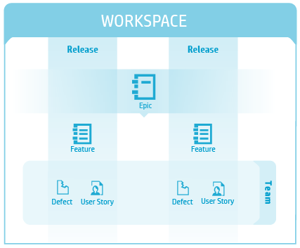

User stories (US) form the basis of what the system does. These are abstracted up into Features which are services that fulfills a stakeholder need. Features are further abstracted into Epics which is even a larger chunk of work that has one common objective.

The backlog consists of the following agile entities:

|  |  |
| --- | --- |
| [**Releases**](https://admhelp.microfocus.com/octane/en/latest/Online/Content/AdminGuide/how_setup_release.htm?Highlight=releases#hp-minitoc-item-0) | A release is a group of application changes made available to your users at the same time that will be distributed as a completed version of the application at the end of the release. The release provides the framework around which you organize the backlog items. Releases can be divided into sprints or milestones. |
| [**Epics**](http://octane-help.saas.hpe.com/en/12.53.20/Online/Content/UserGuide/Legend.htm#hp-minitoc-item-0) | The top-level objectives your product must meet, or the product's high-level functional areas. They are large components or aims for your product or project. Epics can be and are implemented across releases. Epics are divided into features. |
| [**Features**](http://octane-help.saas.hpe.com/en/12.53.20/Online/Content/UserGuide/Legend.htm#hp-minitoc-item-0) | A deliverable unit or mid-size functional goal of the application which is utilized by users. These areas are typically implemented within the scope of a release. They are groups of actions or functions that you plan for your product or project. A feature is divided into user stories, defects, quality stories and tests. |
| [**Backlog**](http://octane-help.saas.hpe.com/en/12.53.20/Online/Content/UserGuide/Legend.htm#hp-minitoc-item-0) **Items** | The functional parts of a feature. Stories include user stories, quality stories, and defects and are assigned first to a team and then to an individual developer.  Typically they are implemented within a sprint cycle. |

Navigating through the Modules

1. Switch back to the Octane tab in your browser
2. Click the **OCT Icon** to see the Octane HOME module.
   1. The Octane triple bar icon allows you to navigate through the different modules, including My Work, Dashboard, Issues, Management, Requirements, Backlog, Team Backlog, Quality, and Pipelines.

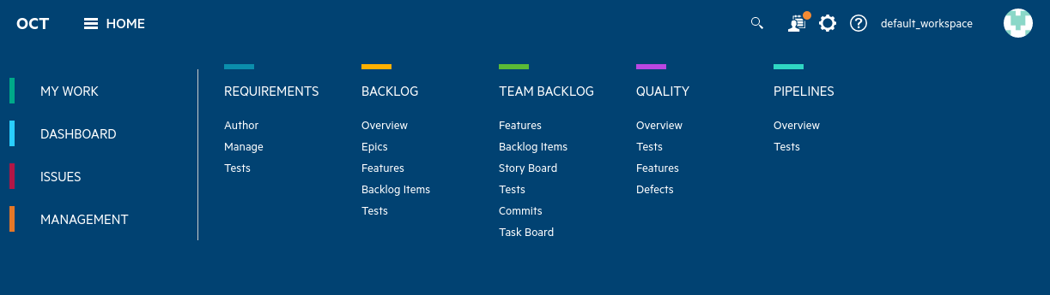

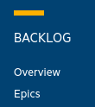Creating an Epic

Select the **BACKLOG > EPICS Module**

1. Select **Backlog** tree title on the left side of the screen.   
   Select the **Epics tab**, and then select the button to add a **new Epic**.

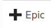

* 1. Epic Name: **Market Expansion**
  2. Epic Type: **Business**
  3. Assign Story Points: **50**
  4. Select **Add**

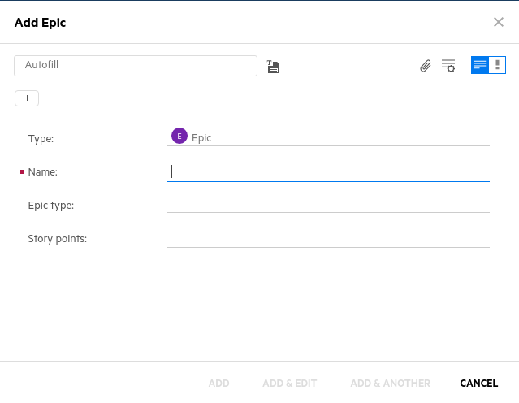

Creating a Feature

1. Select the Epic you just created from the left side tree list.   
   Select the **Features Tab** and click the button to add a **new Feature**.

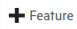

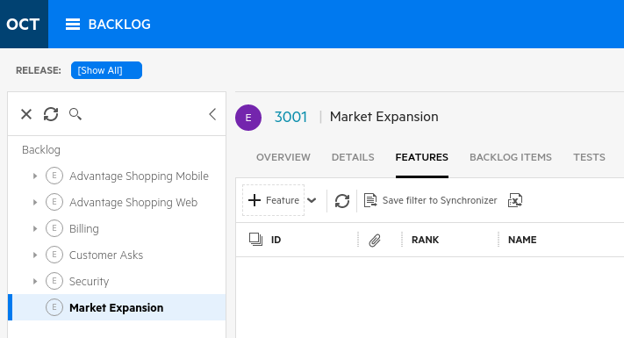

* 1. Feature Name: **Home Security**
  2. Epic: **Market Expansion**
  3. Feature Type: **Business**
  4. Assign Story Points: **20**
  5. Release: **AOS**
  6. Select **Add**

NOTE: Story Points Discussion: At this point we have created a new Epic (Market Expansion) and Feature (Home Security) that we wish to implement. Next we’ll drill deeper and create a user story and the tasks required to complete that user story. Story Points are a rough estimate of the effort it will take to implement it. For our example, consider one story point equals half a day (4 hours) of effort.

Creating a User Story and Tasks

We’re going to do a couple of things next.   
  
First, we’re going to start creating a user story but then save it as a template. This template can then be used by us (or a larger audience) to start future user stories with the same text such as:   
“As a user I want to …”

Secondly we’ll start a real user story, pull up our template and then go on to finish our user story.

1. Select the Home Security feature that you just created in the left side tree. Select the   
   **Backlog Items** tab and select the button to add a new **User Story**.



* 1. User Story Name: **As a user I want to**
  2. Description: **As a user I want to**
  3. Release: **< CLEAR VALUE – empty >**

1. At this point click the disk icon to the right of the Autofill text.

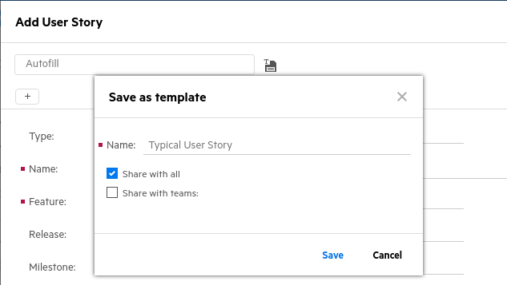

1. Name the template **Typical User Story** and click the checkbox to **Share with all**.  
   This will give a descriptive name to our template and share it with everyone.
2. Click **Save**.
3. Click **Cancel** to cancel editing this user story.

We want to start from scratch to see how our template works.

|  |
| --- |
| A word about form templates Templates, like the one we just created, simplify text entry and speed the sometimes tedious task of typing into various fields. Templates can be used on almost every kind of form entry. Look for the “Autofill” and disk icon in other parts of Octane to see where else you might find a benefit. |

1. Again, select the **Backlog Items** tab and select the **+ User Story** button to add a new **User Story**.
   1. User Story Name: As a user I want to **purchase a security camera.**
   2. Application module: **Security**
   3. Team: **AOS_Infra**
   4. Description: As a user I want to **purchase a security camera.**
   5. Assign Story Points: **10 – DO NOT CLICK “ADD” YET!**

|  |
| --- |
| What’s an Application Module? An application module is a segment of the product’s functional areas. In our example of an online e-commerce site, Security contains items that keep our customer safe. While our top-level categories don’t cover Security devices (the Security application module is concerned with the website’s security) we can begin to market a home security system as a Security item and then expand this into a new Security Devices application module later. |

1. **Scroll Down** on the right to see the **Tasks to generate**: section.
2. Add **Tasks** by typing the task namesin the **Tasks to generate** boxand hitting **Enter** after  
   each task (see image below).

**Add home security device to product list   
Configure home security device price  
Verify security application contains home security device**

1. Select **Add & Edit**

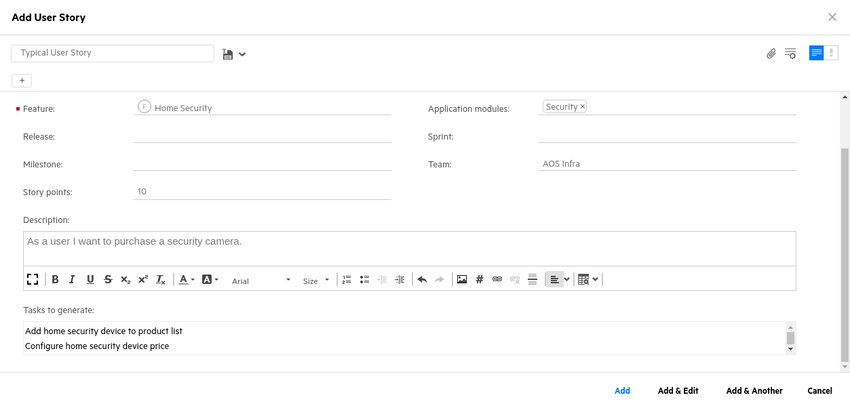

Enter three tasks

Scroll down to see the

Tasks to generate

1. You’ll now see the details on the user story (it automatically created our three tasks).  
   This is a shortcut way to add tasks during the initial creation of a user story.
2. Set the Owner (Select user circle on the right) to be **sa@nga**
3. Select the **Tasks** tab so we can set the Owner for these three tasks.
4. Select the **Slim Grid View** on the right and select all three tasks.
5. Select **More | v -> Bulk Update** and add a field (Owner) and set the owner to be **sa@nga**.  
   You can also just right-click on the selections and choose **Bulk Update**.

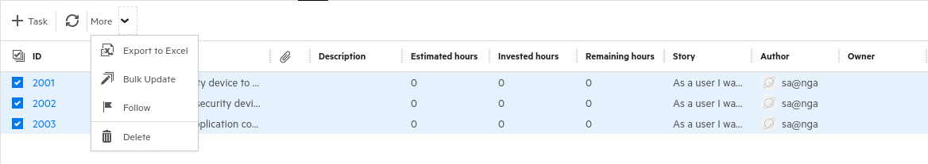

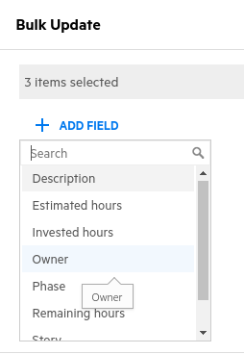

**Bulk Update** is very useful in situations where you need to change one field on a variety of objects. Often you may want to select a number of tasks or user stories and assign them to a specific team or individual.

1. Verify that all three tasks are now owned by **sa@nga**.

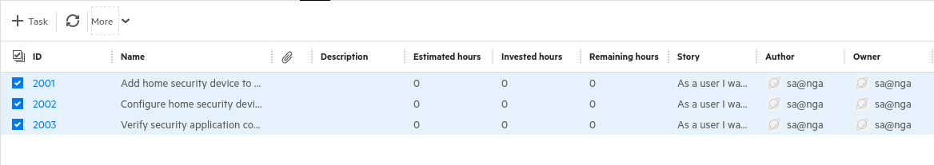

1. Click the **back** arrow to get back to the **Home Security** user story.

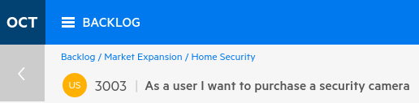

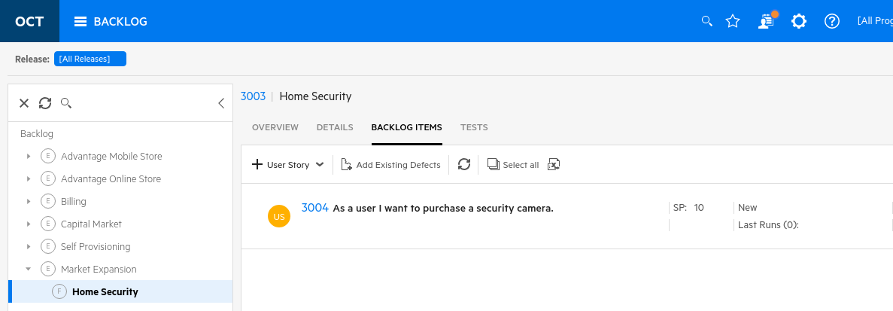

|  |
| --- |
| **What have we just done?**  We started building some new functionality for our application in development. We began by defining a high-level epic called **Market Expansion** and then defined a feature called **Home Security**. Then we built a user story (these are real guts of an agile project) that requested the ability to buy security cameras. This request will necessarily involve multiple tasks to be completed so we added those as well. |

1. Another nice feature that Octane has is the ability to **Quick-Filter** a list based on where you click.

Select the entire **Backlog** on the left side tree.

1. Select the **Slim Grid View** on the right.
2. **Right click** on Kelly Slater’s name under **Owner** and select **Filter by Owner: Kelly Slater**This will filter the list and only show backlog items whose owner is Kelly Slater.

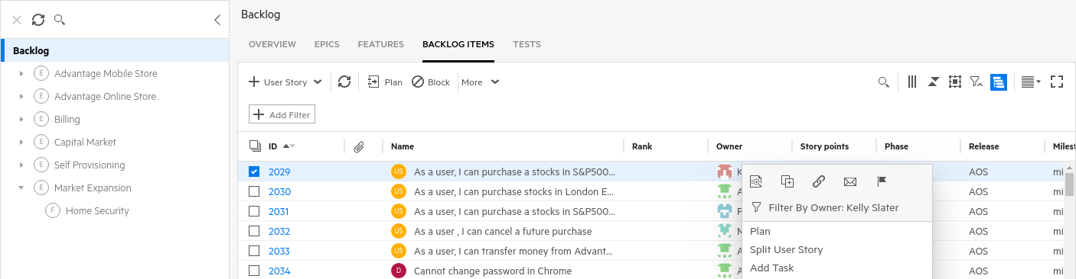

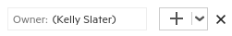

1. **Clear** the filter by clicking the **X** to the right of the filter.

Planning a Release

Releases and Sprints can often be confused. A Sprint is a potential release but often Sprints don’t end up in a release. Instead, think of a Release as a stable build that can be released.



1. Select the entire **Backlog** on the left side tree.
2. Set a release filter for the **OVERVIEW** tab (set to **[All Releases]** ).
3. Set a release filter for the right side **PLANNING** tab (set it to **AOS**).
4. Select the **OVERVIEW** tabto view the custom Graphs and Widgets for the backlog.

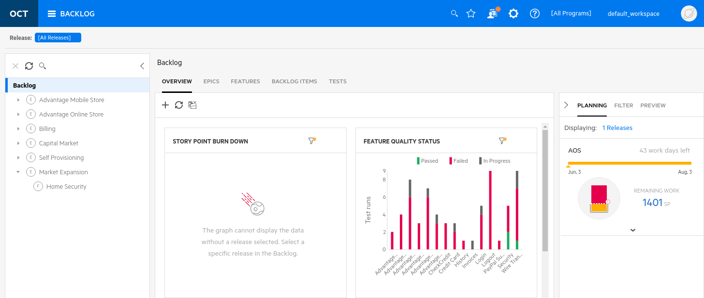

To see the features of Octane’s Release Planning:

1. Assign your User Story to the AOS Release by selecting the **Feature** you created (**Home Security**) from the left navigation tree and then select the **Backlog Items** tab. On the right hand side select the **PLANNING** tab. The PLANNING tab contains the release's planning bucket:
   1. Double-check that you have all filters turned off (except PLANNING > AOS release).
   2. Click the link next to **Displaying:** and verify it shows **1 Releases**.
   3. Select the **User Story** you created and **drag and drop** that item onto the **AOS Release**.

*\*\*You will see the release bucket update to include the user story and story points you just assigned to it.*

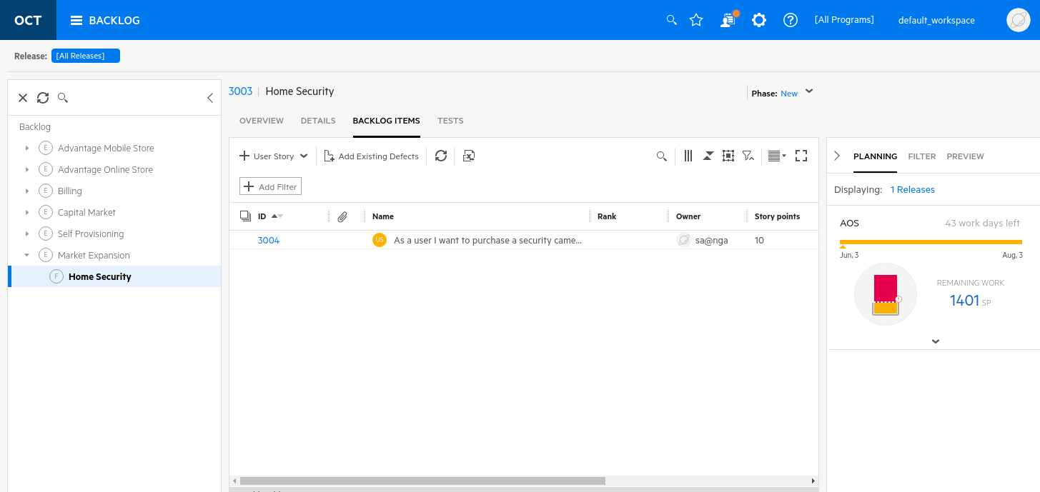

1. Let’s also assign the User Story to a team. Expand the **Planning Bucket** by clicking on the down arrowto view the teams associated with the Release. Click and drag the item to the **AOS Infra Team**.

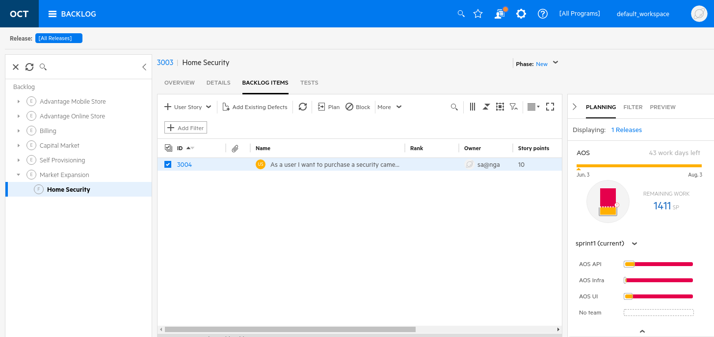

Note the story point increase

To filter by various properties for a Backlog Item:



1. Again, select the entire Backlog on the left navigation.
2. Select the **Filter** tabon the right hand side. Filter the backlog using the out of the box generated tags. Select the **New** tagunder the **PHASE** category. This will filter the backlog items and only display those that whose phase is **New**. Scroll the table to the right to see this field.

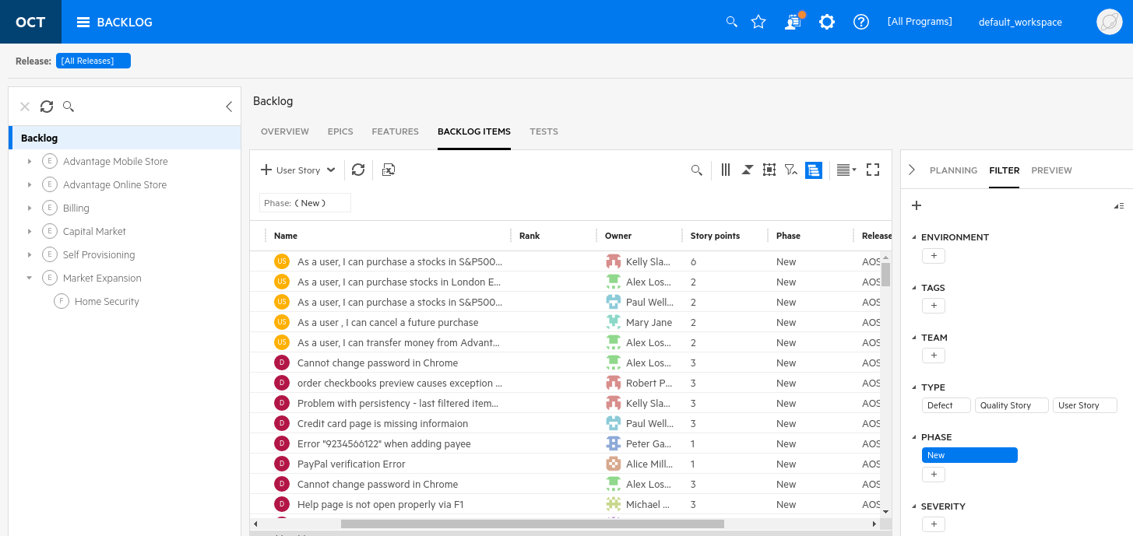



If you want to see addition field columns, select the three vertical bars and you can add them to the view.

You can also move columns around by just dragging them left or right. This only changes your view.

*\*\*Tags are user-defined identifiers and are used to label an item in a meaningful way for a user or an organization. Tags are used as a label on an item and helps when searching or sorting similar items or topics.*

NOTE: Since you can filter in various ways (Filter icon, Filter panel, etc.) and these settings are not always obvious, you can always look for the filter icon to see if your data is currently being filtered.  
  
If it has a yellow circle by it, your data is being filtered.

To **Preview** items from the Backlog module:

1. Select the top row in your **Backlog Items** list.
2. Select the **Preview tab** on the right hand side.
3. From here you can quickly edit the details of your backlog item.

Octane provide multiple ways to enter, edit and filter your agile project data. This is critically important because everyone wants to participate in the process and find issues or patterns needing attention.

*\*\* If you want to gain a high level understanding of a backlog item you can select the entity and view the Preview tab. This will show you a description of the backlog item, the Release and Sprint it is assigned to, and Comments to other team members.*

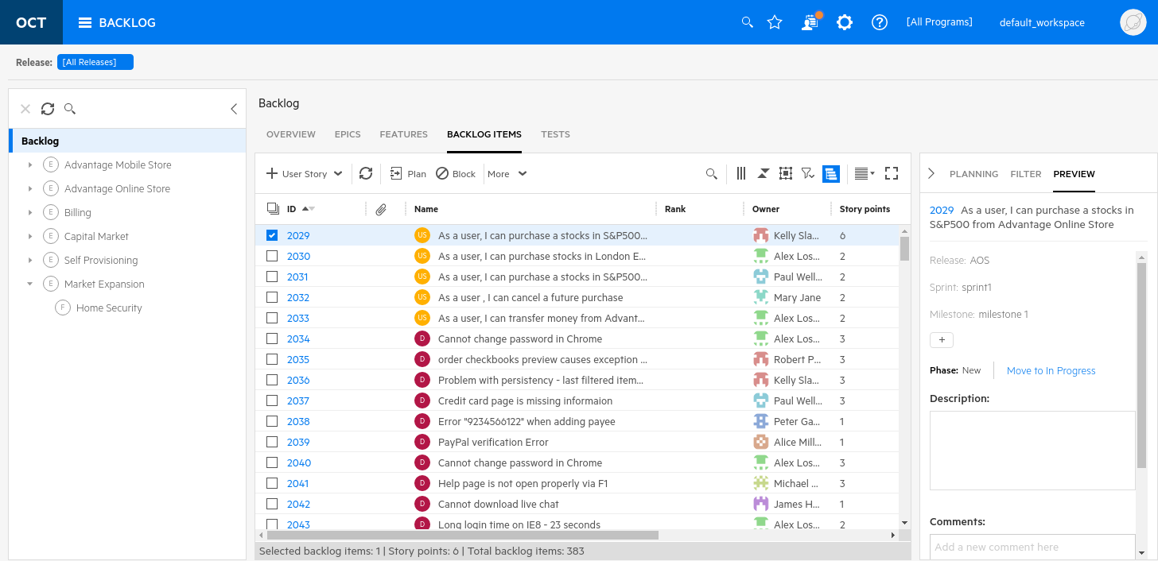

As a final nice feature, checkout the bottom section of the table that not only shows what is selected but also shows its story points and the total count of items listed in this table. Awesome!



Defining Processes and Process Flows

Processes and process flows are a new feature starting with ALM Octane 15.1.60. This capability enables the user to define a series of steps that follow a flow, much like the steps in a build process executing on a CI system like Jenkins. Both sequential and parallel processes are supported.

1. Navigate to the Release Management module and select the Processes tab.

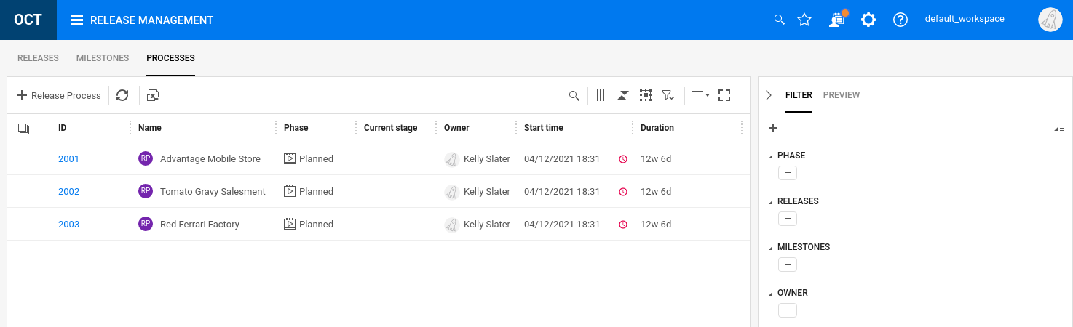

1. Select the first Release Process, **Advantage Mobile Store**, and click the link 2001.
2. Open up the **Stage 1** hierarchy to see the different elements.
3. Examine the hierarchy of Stages, Actions, Quality Gates and Groups.

|  |  |
| --- | --- |
| Item type | Details |
| Stage | The main component of a release process.  **Example:** Prepare test environments |
| Action | A task that a stakeholder should perform as part of a stage.  **Example:** Deploy Windows machine |
| Quality Gate | A step that ensures that a set of criteria is met before moving on to the next stage or action.  **Example:** Check environments are deployed correctly |
| Group | An optional container for actions and quality gates. A group can contain lower level groups. |

**Parallel or sequential execution.** Stages and groups can be defined as parallel or sequential. In a parallel stage or group, all child actions are run at the same time. In a sequential stage or group, an action starts after the preceding action has completed.

1. At the top of our Process Flow table we have a control bar that allows you to start a process, skip an action or group or mark a process complete. You can also duplicate/clone any of these items.



1. Select the Back (<) button to get to the **Release Process** view.
2. Click on the + to create a new **Release Process** called **Post-Build Marketing**.



1. Click on the **Post-Build Marketing** (e.g. 3015) numeric link.
2. Click the + to create a new stage called **Update Marketing**.  
   Set the start date to be **Today** and the end date to be 1 week from today.  
   Set the duration to be **1 week**.  
   Also set the Run Children in Parallel field to be **Yes**.  
      
   Click **Add**.
3. While still selecting the **Update Marketing** stage, create the following hierarchy (including creating the **Update Field** stage). Use the same **1-week** settings on all stages, actions and on the quality gate.

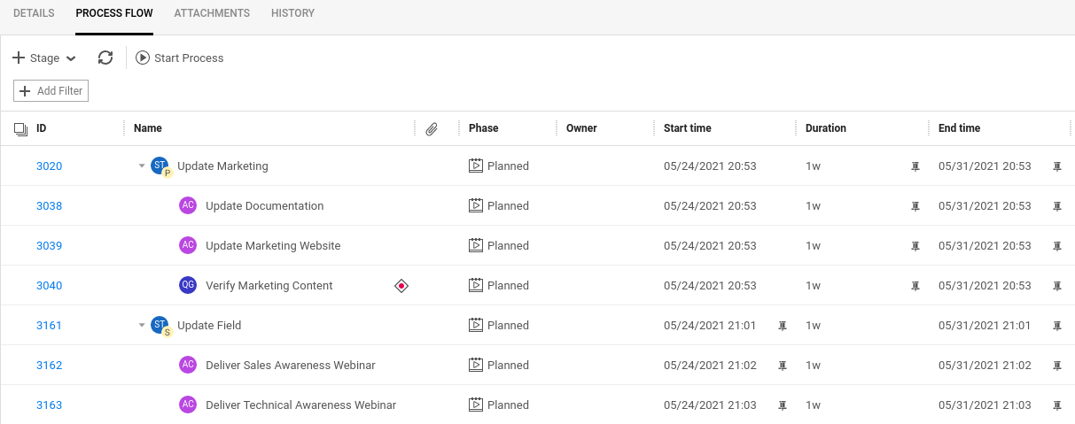

1. Modify the **Verify Marketing Content** quality gate and create the following two **User Input Criterion**:

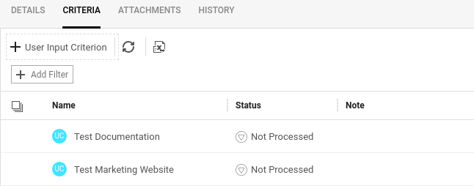

1. Great! – We now have our process model all set.

|  |
| --- |
| Our Processes Model  Like any customer-facing software product, we must create documentation and update our marketing website. Those items can happen in parallel. We also want a quality gate to verify that those activities were performed. In addition, we defined a couple of criterions to test our documentation and marketing website.  These sorts of activities are not software or agile related but yet they have to be tracked and accomplished in a specific order. This one good use of this Processes feature. |
| You can also duplicate a Release Process to act as a template for activities later in your release calendar. |

1. Select the Update Marketing stage and click **Start Process**.

Click **Start** on the process pop-up.



1. Verify that the initial stage is marked **In Progress** and subsequent actions are **Pending**.

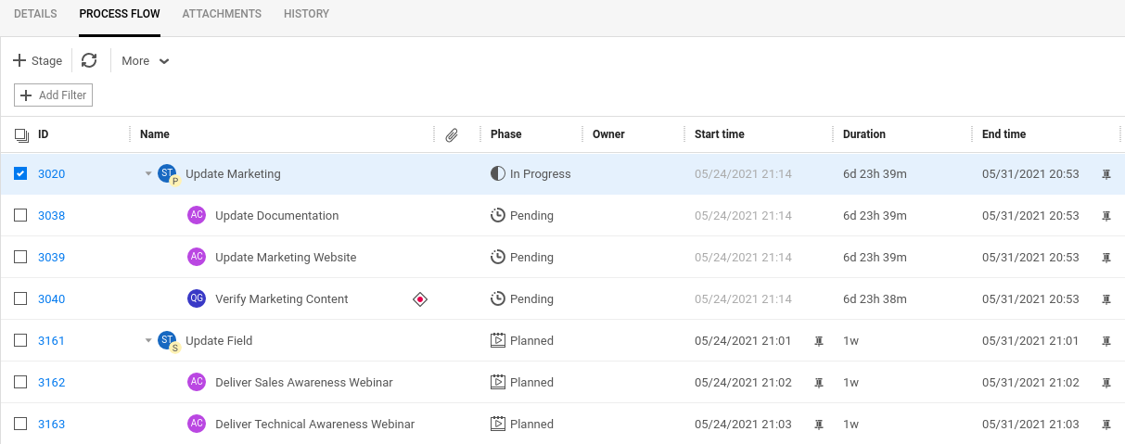

1. Select each of the Pending actions and mark them as **Complete**.

Since these are set for parallel execution, you can mark them **Complete**, independent of each other.

1. Select the **Verify Marketing Content** quality gate and select **Start**.
2. Click the numeric link for the quality gate and set the status for each criterion to be **Passed**.

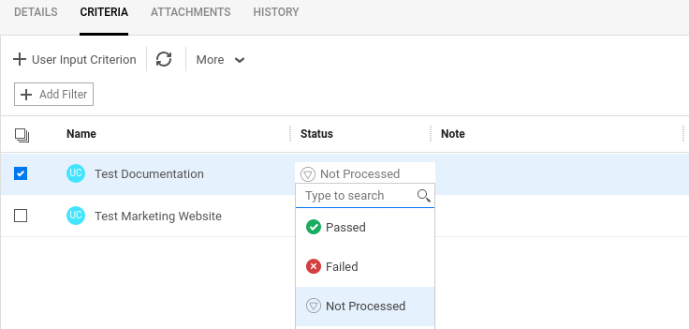

1. Click the back arrow (<) and mark the quality gate as **Complete**.
2. Set the final stage and two action to be **Complete**, in sequence.

Awesome!

You have just built a nice process with process flows.

Awesome!

You have just built a nice agile backlog with process flows.

Exercise 5: Defining Test Coverage and My Work

One of the chief advantages in ALM Octane is its ability to identify where issues have occurred and to locate and prioritize work to bring the project back on track. Octane also houses a My Work module that filters work assigned to an individual that they can focus on tasks they need to complete.

Viewing Test Coverage in the Dashboard



1. Navigate to the **Dashboard Module**.

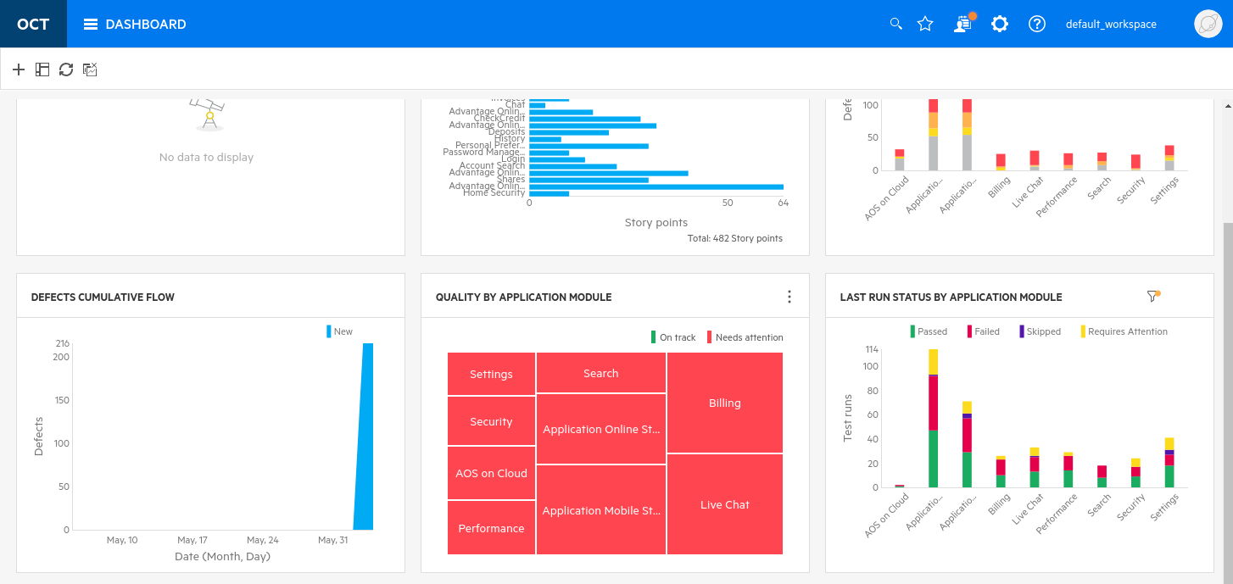

1. Scroll down and select the **QUALITY BY APPLICATION MODULE** graph. This graph shows a heat map of the application modules with respect to which modules are more problematic based on our criteria. The current criteria says to mark any module as red if the associated defect count is greater than 5 defects.
2. Mouse over the **three dots** and select **Configure** to change the criteria.
3. **Change** the **Criteria** to be **More than 30 defects matching filter** and **Save** your change.

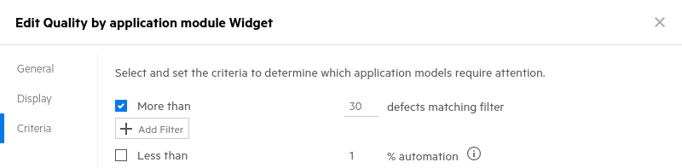

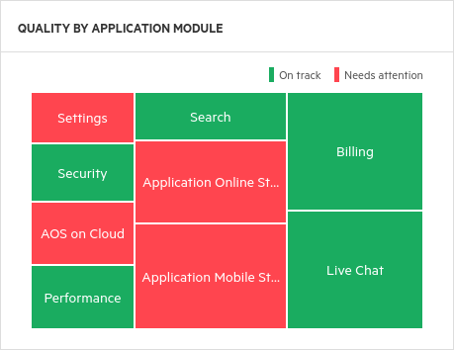

*\*\* The Quality by Application Module graph displays the overall quality of your application. We’ve changed the criteria to be more forgiving (up to 30 defects is acceptable) and thus we see more green areas.*5. Try changing the criteria to show modules with less than 30% automation (uncheck the other criteria)

Creating Test Coverage in the Backlog



1. Navigate to the Backlog Module.
2. Select and click into the **User Story** numeric linkyou created in Exercise 1 (under **Home Security**).

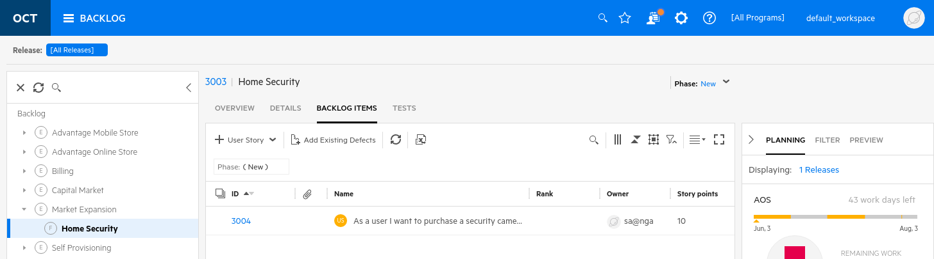

1. Select the **Tests** taband select the pull-down next to **+ Manual Test** to choose to add a   
   new **Gherkin Test**.

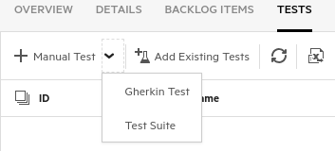

*\*\* Gherkin is a well-known syntax for writing tests using a behavior-driven development (BDD) methodology. This methodology enables you to test using both the developer and user perspectives as you create scenarios of use instead of individual test steps. Gherkin syntax uses plain-text English with a specific structure. It is designed to be easy to learn by non- programmers, yet structured enough to allow specific examples of how the application is used in the real world. When you perform the test, you follow the scenario and use the parameters to perform the test.*

1. Fill in the details of the Gherkin Test as shown below.
   1. Name: **Selection filters meet design criteria**
   2. Application Modules: **Security**
   3. Select **Add & Edit**

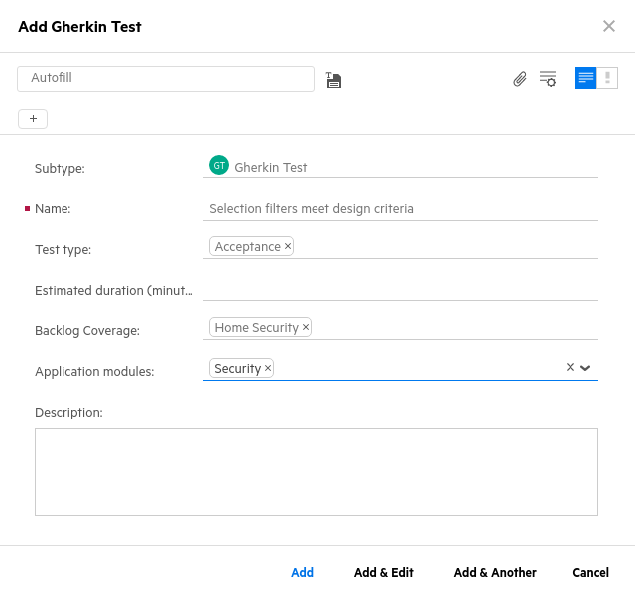

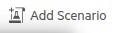

1. Select the **Add Scenario** button.  
   This will add a Gherkin template to define a test scenario.

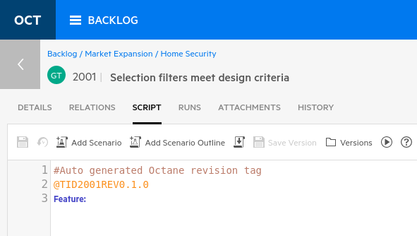

1. Copy the following text and paste it into the scenario section (overwriting the existing Blue text).  
   This creates a test using the Gherkin syntax (the reserved words will automatically be in blue).

**Feature:** Online shopper searches by filter

**Scenario:** Online shopper selects Speakers

**Given** the filters are clear

**And** all speakers are displayed

**When** a maximum price is set

**Then** speakers below the maximum price are displayed

1. Click the **Details** tab and set the **Owner** to be **sa@nga**.
2. Click **Save**.   
   This saves our Gherkin-syntax manual test. This test can actually be automated later and the automation uses these English-language terms as function names.

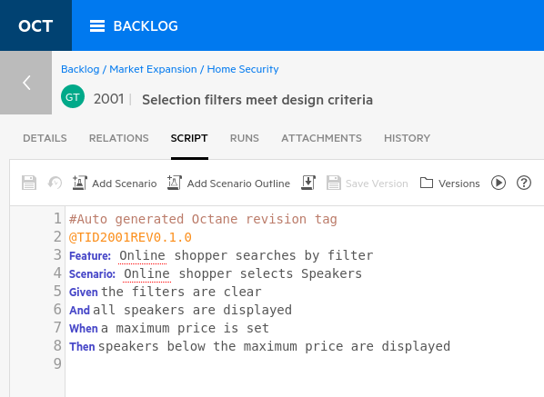

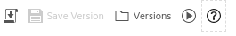Executing a Standard Manual Test

1. Select the **Run test** button to launch your manual Gherkin test.  
     
   Release: **AOS**  
   Environment: **Chrome + QA**
2. Click **OK.**Select **“Let’s Run!”**

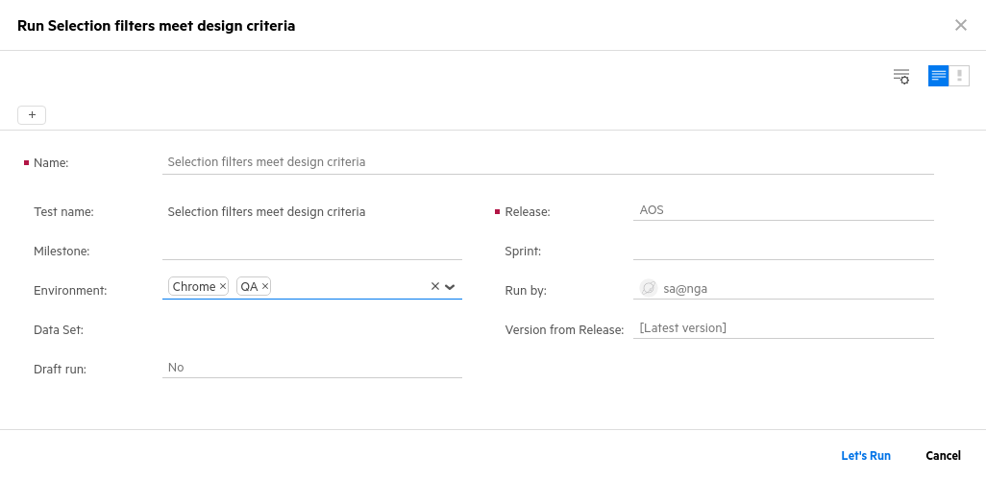

*\*\* In ALM Octane your manual tests are run using the ALM Octane Manual Runner. When you open the test in Manual Runner, perform each step as written in the test or scenario. Then enter actual values for each step or scenario and assign the appropriate status to the validation step, such as Passed, Failed, and so on. If necessary, report defects and add attachments to help others understand the test results.*

|  |
| --- |
| **What is our AUT (Application Under Test)?**  The Demo Data in our Octane instance is an actual application under development that Micro Focus has created called **Advantage Online Shopping** (AOS). This is a mock e-commerce site that Micro Focus employees and partners use to demonstrate a variety of product with. With regard to Octane, we have demo data that’s available plus source code stored in git that we can modify, deploy and test against.  The AOS application is available 24x7 publicly at <https://advantageonlineshopping.com> and is also available locally on Nimbus-based environments at [http://nimbusserver.aos.com:8000/#](http://nimbusserver.aos.com:8000/) |

1. We’re going to simulate running this manual test and then pretend to discover a defect in our application.

In the Manual Runner interface, enter OK for the first two steps and then enter Speaker filter failed on price into the third step as shown below and then select the Create Defect icon.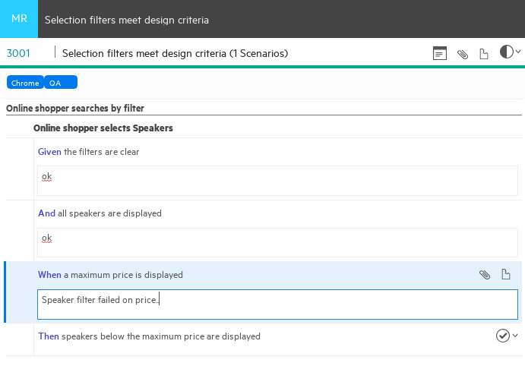

1. Create a **defect** during the test run on the third step (during the **When** step).
   1. Name: **Speaker filter failed on price.**
   2. Feature: **Home Security**
   3. Severity: **Critical**
   4. Application Modules: **Security**
   5. Release: **AOS**
   6. Defect Type:  **Pre-release**
   7. Owner:  **sa@nga**
   8. Click **Add**
2. Once you have added the defect set the status of the manual run to **Failed**.  
   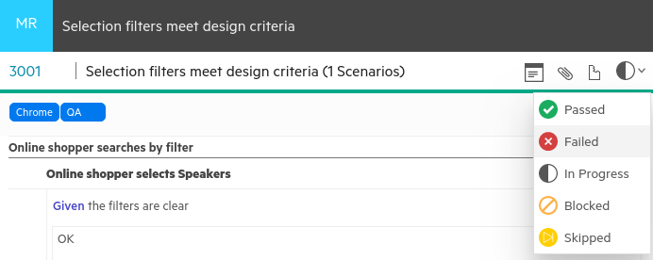
3. Click at the bottom of the manual runner to stop the run and record the failure.

|  |
| --- |
| **What did we just do?**  We created a manual test – the most prevalent kind of testing – and then ran that test. We used the Gherkin syntax, a loosely structured test language as a textual template. During the run, we simulated a defect in one of the test steps and immediately created an Octane defect and then returned to our manual test run and failed that run. This represents a typical scenario that might happen when defining and running manual tests. |

1. Click the back arrow key to go back to the **Home Security** test.

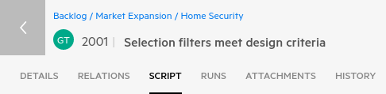

1. Select the **Tests** tab and verify, by the red color under **Last Runs**, the failed test result.

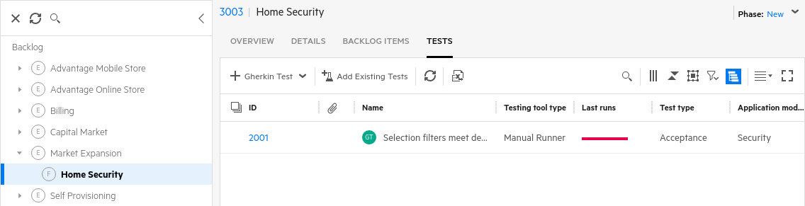

1. Click on the numeric link for the Gherkin Test (2001) to go back to its details.

Reviewing Relations, Test Runs, and Automation Status

1. Select the **RELATIONS** tab. Use your mouse wheel to zoom in and out and to reposition the entities so they are easier to see.

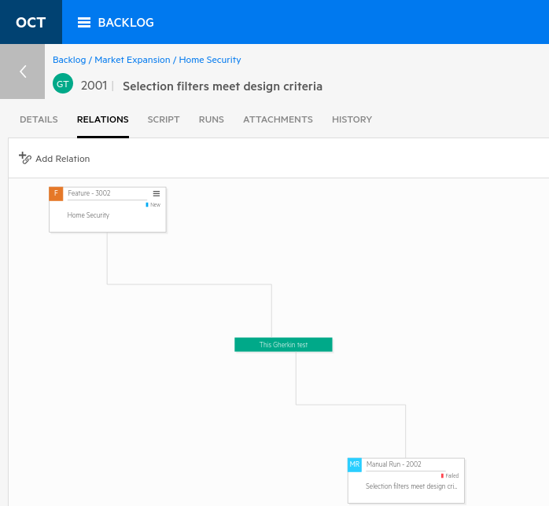

*\*\* A relation represents direct links between entities. Relations show traceability between epics, features, user stories, tests, test runs and defects. To create traceability between your test and another User Story, Requirement or Feature you can select the Add Relation button.*

*Relations are also immediately created during certain activities like creating a user story under a feature or creating a defect while running a test. ALM Octane is very good and understanding these relationships and creates an audit trail of everything that happens to these entities.*

1. Select the **Runs** tab to see all the test runs and their data.

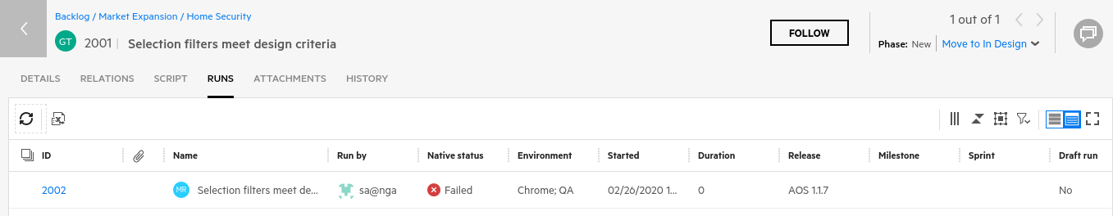



*\*\* You can also adjust your view to see a* ***Grid View*** *or* ***Smart List*** *using these controls:*



1. Notice the round circle icon with **GT** in it. This represents a **G**herkin **T**est.

Almost every item in Octane follow this pattern so you know what kind of object you’re looking at.

Can you think of an agile entity that doesn’t have an icon? __________ a sprint

1. Select the **Details** tab and set:
   1. Automation Status: **Ready for Automation**
   2. Owner: **sa@nga**
   3. Click **Save**

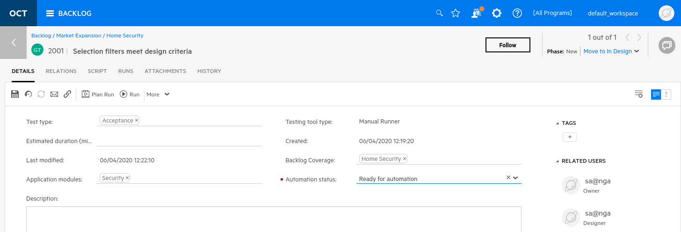

Managing the Team Backlog

After setting up the overall release plan and work in the Backlog, it is important to demonstrate progress by working with your team's backlog items to start carrying out your development plan. In this section we’ll look at some of the specific team-related backlog activities and charts that we can manage.



1. Select **Team Backlog** from the modules menu.
2. Set the:

* Release to: **AOS**
* Sprint to: [**All Sprints]**
* Milestones: **[All Milestones]**
* Team to: **AOS Infra**
* Tab to be: **Tasks**
* Set view to be: **Board View**

1. Expand the topmost item to see its tasks (click the small triangle to the left to do this).
2. Also set the control to **Show Empty swim lanes**

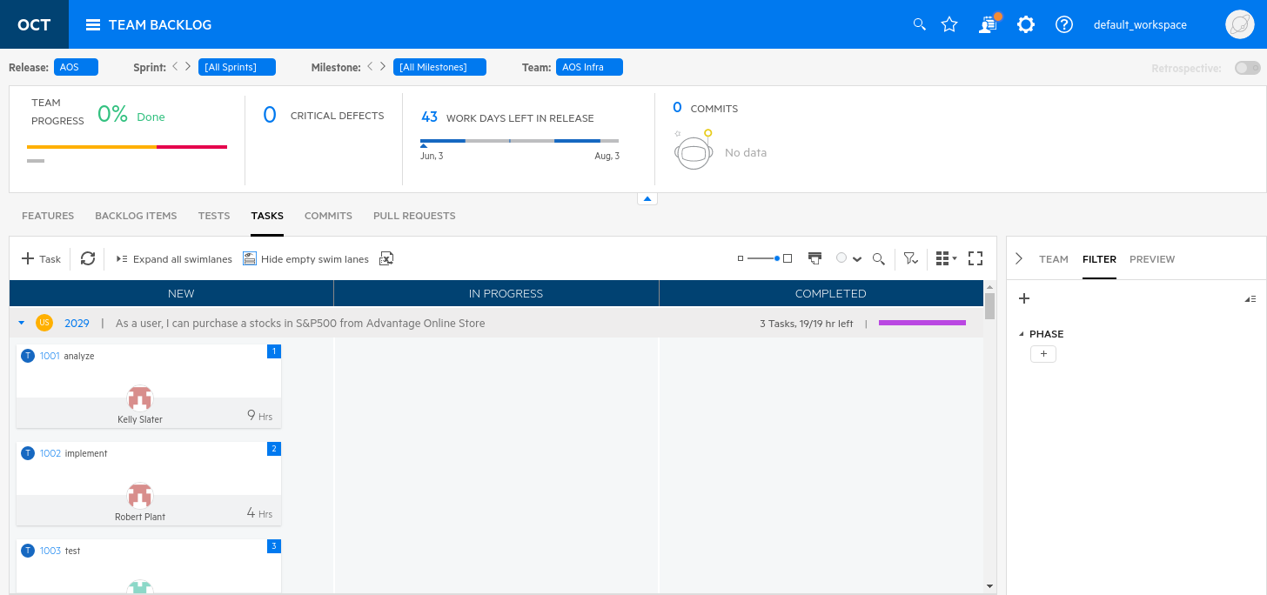

Swim Lanes

Octane even provides a way to shrink this sort of view so it takes up less space (see small red box above).

During the development period, it is important to track individual progress to make sure all parts of the team are progressing toward the stated sprint or release goals. You do this by moving tasks through the swim lanes.

1. 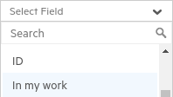Still in the **Tasks** tabcreate a filter for **In my work: Yes**  +  
   You could also use the filter **Story > Author: Me**
2. Expand the user story you created titled **As a user I want to purchase a security camera** to see the task board for it.

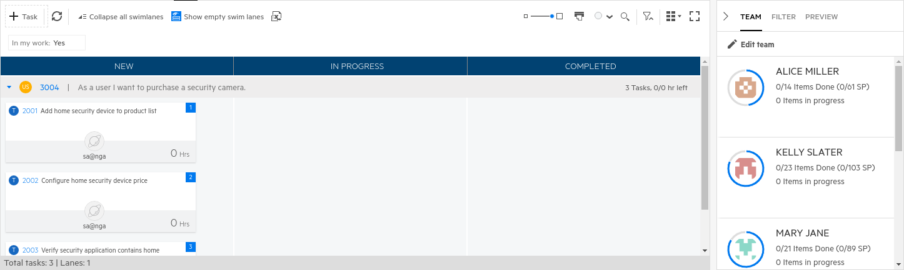

*\*\*In the upper left corner of the Team Backlog module (the sprint summary area), you can view a graph that displays the overall development status in the selected sprint(s). This graph displays the expected and planned velocity in story points. In addition, it also shows the number of critical defects assigned to the team. The progress is measured by the story points assigned to all members of the team in the current sprint cycle.*

1. Move tasks (using drag and drop) from your User Story created through the swim lanes to track progress. Move them into the positions shown below.

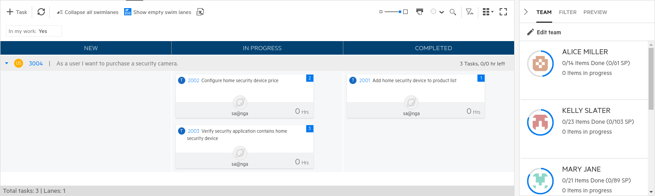

1. Next, we’ll assign a task to a new team member. Select the **Team** tab in the right hand pane and click and drag the verify task (2003) to the team member **Alice Miller**.

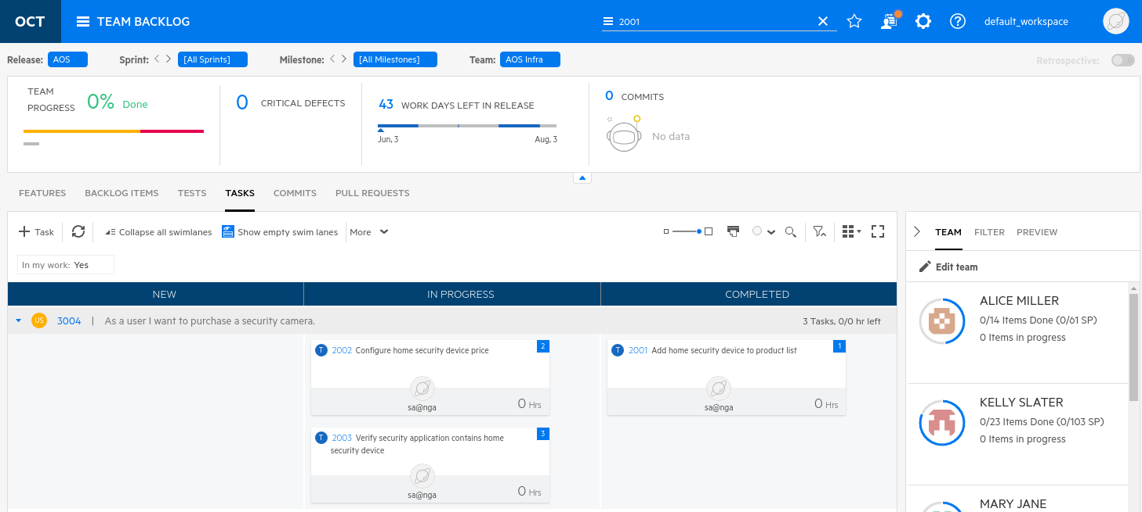

1. You should see the task change owner from sa@nga to Alice Miller.

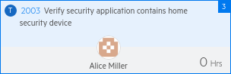

Reviewing My Work

Now that you have planned all the work to be completed in a release, you may want to track your work with a personalized to-do list of work items. The items that appear in the **My Work module** are defined by the ALM Octane administrator. You can customize this as needed in the Workspace settings. Select the **My Work module** located in the menu bar. This module enables you to quickly view and complete the work assigned to you.   
  
1. Select the **My Work** module through the icon on the Octane module menu bar.

*\*\* By default, items are displayed in the My Work page based on the owner of the item. You should see the User Story, Defect, Gherkin Test and Task that you created previously. You can also filter these items by type.*

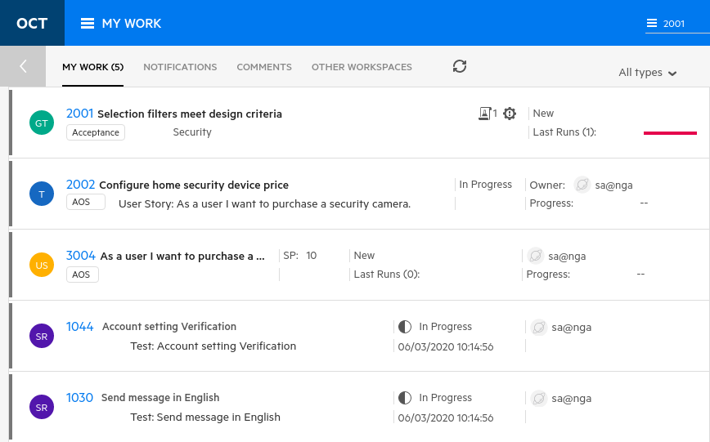

After viewing your work in this module you would typically click the numeric link to drill into that item and begin working on it. Your work items can be moved out of the My Work module by a number of means:

1. Select an item and in the right hand pane, click **Dismiss**. This marks the work as having finished.  
   This works for any item type in the My Work module.
2. Drill into the item and set the owner to be someone else. This removes it from your work and assigns it to someone else.
3. For Tasks, you can move the item into the Completed phase. This also marks it as finished.

**Question**: You created three tasks but only one is shown here – why?

One task was reassigned to Alice Miller and the other was moved to the Completed phase.

This table below shows the types of items listed in **My Work**.

|  |  |
| --- | --- |
| **Assigned items** | Assigned items may include user stories, defects, quality stories, or tasks. By default, these items will be listed if they are in a phase that belongs to the  **New**, **In Progress**, or **In Testing** metaphases.  If your tasks are included in a user story not assigned to you, the task item contains the name and a link of the user story. |
| **Tests** | Tests are listed if they are in a phase that belongs to the **New**, **In**  **Design**, or **Awaiting Revision** metaphase or the **Requires update** phase of a test awaiting automation. You can change a test's phase or add comments. Test descriptions are view-only. |
| **Test runs** | Test runs assigned to you will be listed if they are in **Planned**, **In Progress**, or **Blocked** status. Passed, Failed, or Obsolete runs will not display. Test run releases, environments, and run descriptions are view-only and cannot be changed. |
| **Mention in comments** | Comments addressed to mentioned users are displayed in the **Comments** tab. The mentioned users can click the relevant comment to view the full list of comments related to a particular item and can respond. |
| **Following** | When you select an item to follow (from within the item itself), it is displayed in the list of **Notifications**. You can view relevant details and progress of these items easily from this list. |
| **Other users items** | If you right-click an item in the Backlog module and select **Add to My Work**, ALM Octane displays this item in your My Work list and enables you to edit it. |

One final item about the My Work module is that if you click on an item in My Work it reduces the count of items that show in parenthesis (e.g. My Work (4)). The number in parenthesis shows the count of items you haven’t opened yet.

Great Job!

You have just learned a ton about test coverage and My Work.

Exercise 6: Managing Quality

ALM Octane implements continuous quality in DevOps software delivery. ALM Octane is designed for  
fast-moving App Dev and test teams that are adopting continuous integration (CI) for DevOps. Test execution is intrinsically linked to CI and results are automatically available in ALM Octane’s context-driven quality and defect management dashboards. Once test execution is completed, users can analyze test results, fix defects, as well as monitor both individual releases and overall product quality.

Testing and quality insights are reflected and related to the builds, pipelines, and application modules in Octane so that agile teams can continuously assess the state of quality in the sprint.

Reviewing Failure Analysis in a Pipeline

1. Navigate to the **Pipelines Module**.
2. Select the **Dev Quick Root master DS (Mock)** pipelinein the top bar.

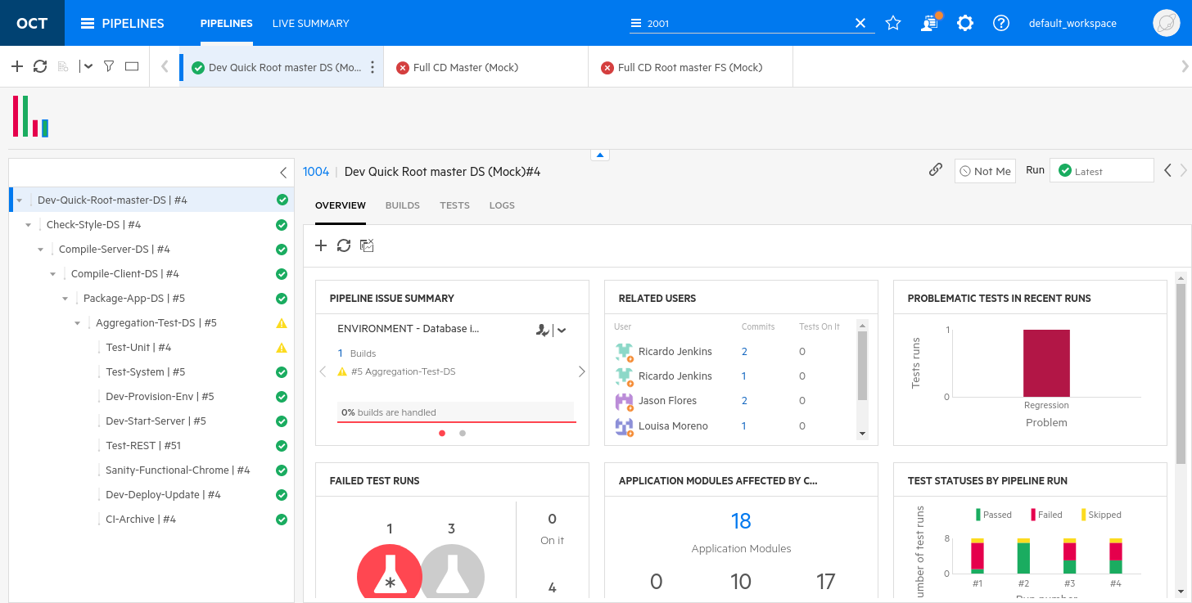

1. Examine the **Recent Pipeline History** chart and **click** on the last failed pipeline run (in red).



*\*\* The top of the Failure Analysis tab displays several widgets that offer insight into your build and product quality. For example:*

* *Failed Test Runs: Displays the total number of tests that failed in this pipeline run. This number is broken down into newly failed runs and runs that failed previously as well. You can click on the number of New or still failing test runs to filter the Failed Test Runs tab accordingly.*
* *Problematic Failed Tests: Shows a breakdown of automated tests that have not been consistently successful, according to the type of problem. Click on the number of tests in a specific category to show only those tests in the Failed Test Runs tab.*
* *Related Users: Shows the people who need to be aware of the failures in this pipeline run. People whose commits were included in this pipeline run. An additional indication is provided if a commit seems to be specifically related to the failure. People assigned to investigate build or test run failures in this pipeline run. These are the users listed in the* ***Who's on it?*** *fields of the failures in this pipeline run. To dive into more detail click on someone in this widget to filter the list of failures. The lists displays only the failures where this person is in the* ***Who's on it?*** *field, or test run failures related to this person's commits.*

Examining a Build Failure

1. Make sure you’re still viewing the **Pipeline** module.
2. Hover over the pop-up status panel and select the number above the **red failed bar** and click the numeric link (e.g. **4**).

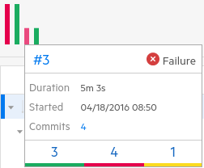

In the last build, **3** tests passed but **4** tests failed and **1** was skipped.

Click on the **Filters** icon to display which filter is being used and examine how this view was created.

Try turning off the **Failed** filter to see all of the tests.

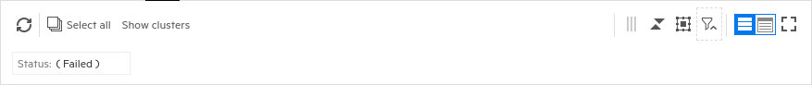

1. Another way to see just the **Passed** tests is to expand the rightmost section and select the **Filter** tab and then add the **Passed** filter as shown below.

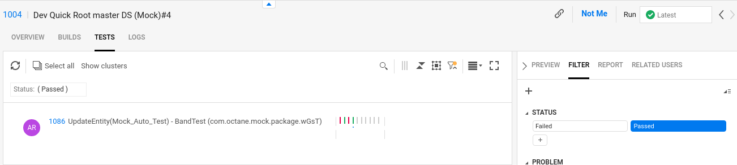

1. Next, **right click** on the **Passed** text to **negate** the filter and show all tests that are not passed (failed and skipped). When the value is negated a line is drawn through the label.

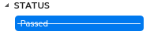

1. Select the **Grid View** (1) and add the column **Status** (2) to create the view below.

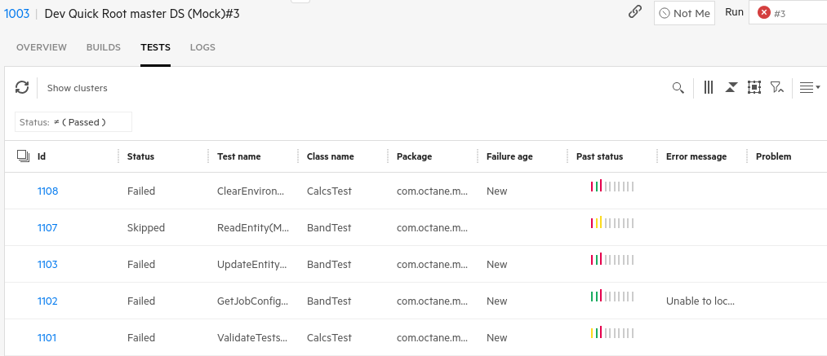

**2**

**1**

Understanding the Quality Module

In ALM Octane, you have the ability not only to monitor the progress of your work but also to track product quality across all areas of your application and project. Octane measures quality in a number of different ways, including test results, defects, and feature quality status. You can view this quality in the Quality module and the Dashboard.

Application modules are the functional areas of the product. These areas are determined or structured according to different user processes, areas of the product, and so on.

Using application modules is important, as in many cases, it is seen that many of the reported defects and testing problems that occur are limited to a small number of areas within an application. By setting up application modules, and associating tests, defects, and features, it helps you see the problematic areas of the application and concentrate testing efforts and development effort toward these areas.

Application modules are release-agnostic, which means that the details you view about the application module are global across all releases and reflect the overall health of the product.

The Quality module is based on an application modules tree. The application modules tree is a logical depiction of the product, reflecting the product's functional areas. It is typically defined by the business analyst. The application modules tree shows how the application is broken down and allows you to track quality by logical business areas.

When deciding how to structure your application models, focus on areas of the product for which you want to track quality, how you structure the application, and how users use the application.

Navigating the Quality Module

1. Select the **Quality** module through the icon on the Octane module menu bar.

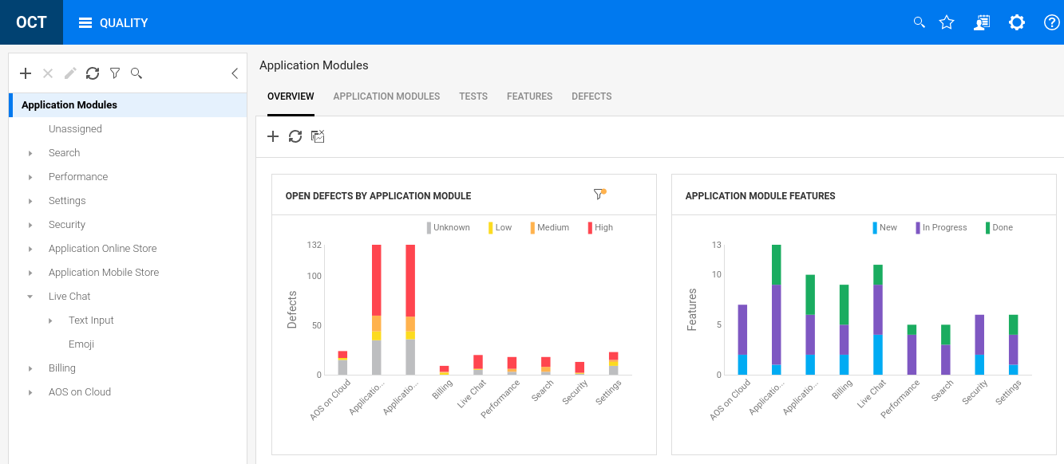

1. Examine the **Application Modules** tree – these are the functional areas of the AOS application.

In this overview dashboard view you can see a chart of the open defects by application modules.  
This shows how ALM Octane can track defects to the functional areas where they were found.

1. Select the **APPLICATION MODULES** tab and you’ll see a flattened hierarchy of the tree on the left.

This view allows you to drill into the individual application modules and their associated tests, features and defects.

1. Select the **TESTS** tab. This table shows all the tests, testing tool type and results history and associated application modules. NOTE: Any given test can have multiple associated application modules.

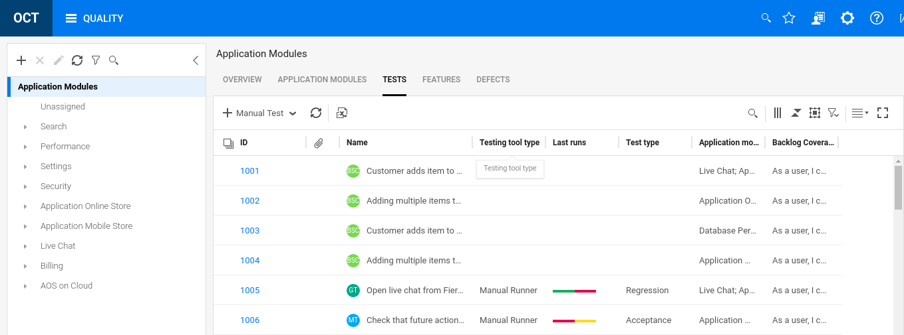

1. Select the **Group By** icon and choose to group by **Test type** and click **OK**.

This will organize all the tests into categories based on their test type. This would be important to identify those tests that haven’t had their test type set yet.

NOTE: You can have up to three levels of nested **Group By** filters to further organize your data.

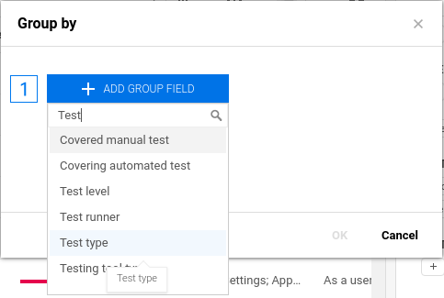

Type “Test” to filter

1. Open the **Acceptance** category of tests to see the list of acceptance tests.

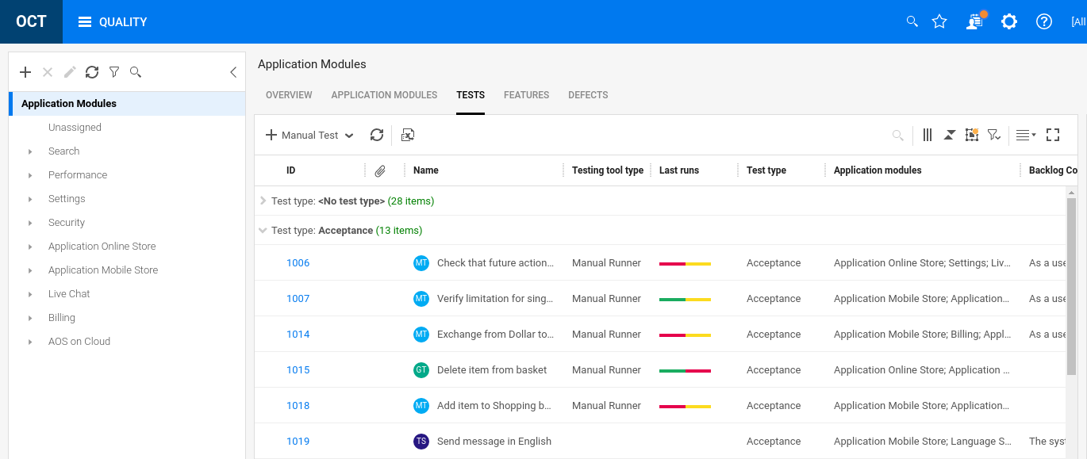

1. Clear the **Group By** filter by selecting the icon again and clicking on the **X** to the right of **Test type**.

Good Progress!

You are learning how to manage overall Application Quality!

Exercise 7: Analyzing Data

Reviewing the Dashboard

The ALM Octane dashboard is the control center for analysis of your application's development and quality. It gives a visual, customizable display of how the application's development is progressing and the quality level.

The dashboard is a collection of widgets designed to share data about your product development and progress. Out-of-the-box widgets include widgets to measure product quality within and across releases, progress within a release, test results, and other analytics. If the out-of-the-box widgets are not sufficient for your analysis needs, create a custom widget to display your data.

For the dashboard widgets, it is possible to customize the information shown in the dashboard such as the type of data reported, the scope and time frame, and how the data is grouped and displayed.

The dashboard also enables you to configure how you want to view widgets and save different widgets as favorites to use on repeated visits to the dashboard.

Dashboard Activities

The Main Dashboard is very much like the Overview Dashboards for individual Backlog items, except it covers all data points associated with the entire Workspace. Users are expected to leverage the data to visualize releases and overall product quality as well as to drill down on specific interest areas.

Octane currently has **53** out-of-the-box (OOTB) charts and graphs and of course you can create your own.

1. Navigate to the **Dashboard Module.**

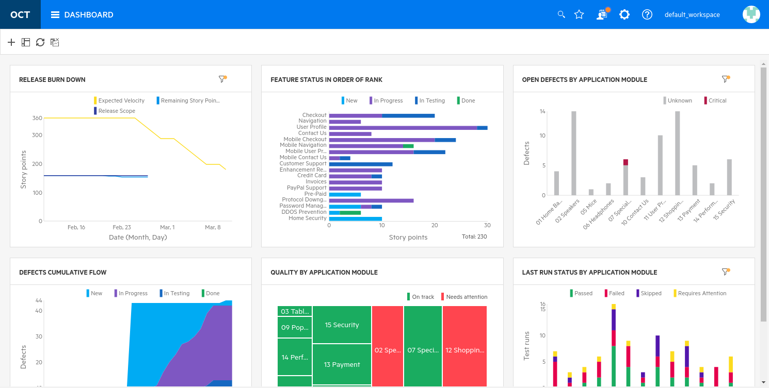

1. Click the **+** on the left to add a new widget and select the **Automation ROI** widget.

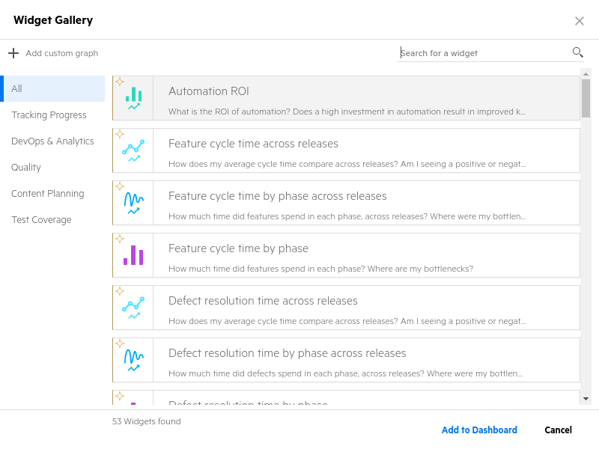

1. Click **Add to Dashboard**.

The Automation ROI widget shows the value of automating over several releases. As the automation percentage goes up and development cycle time will most likely go down. Our demo data doesn’t accurately display this trending (yet).

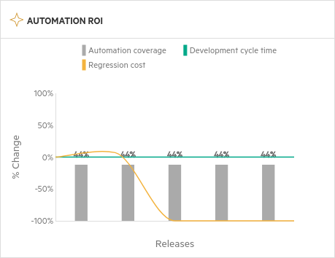

1. Create another new graph in the Dashboard module by clicking on the **+** symbol.  
   From the Widget Gallery select **Quality** on the left and then the **Feature quality status** graph.

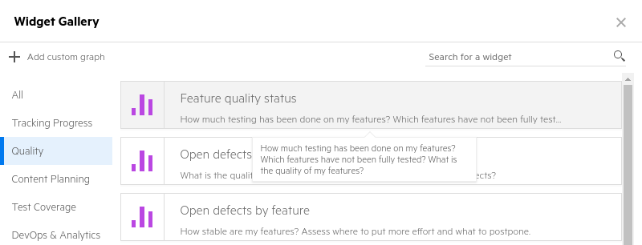

1. Select the **FEATURE QUALITY STATUS** graph. In the legend in the upper right corner, select the **Passed** and **In Progress** optionsto deselect those filters. This will allow you to see only **Failed** and **Skipped** items containing Failed or Skipped Test Runs.

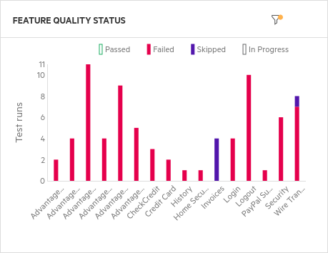

1. Click on the **Home Security** featurecontaining a **Failed Test Run** to drill down into the specific test run details. This is the manual test run we created previously.
2. **Click** on the numeric link to see this test.  
   Note that we can drill into a result and find this test with Native status: **Failed**.

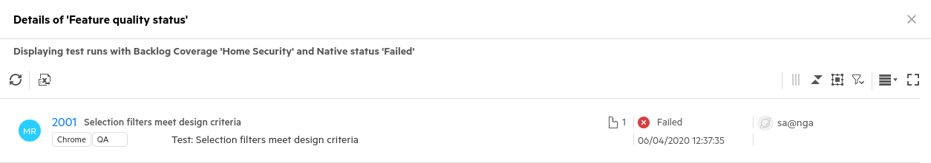

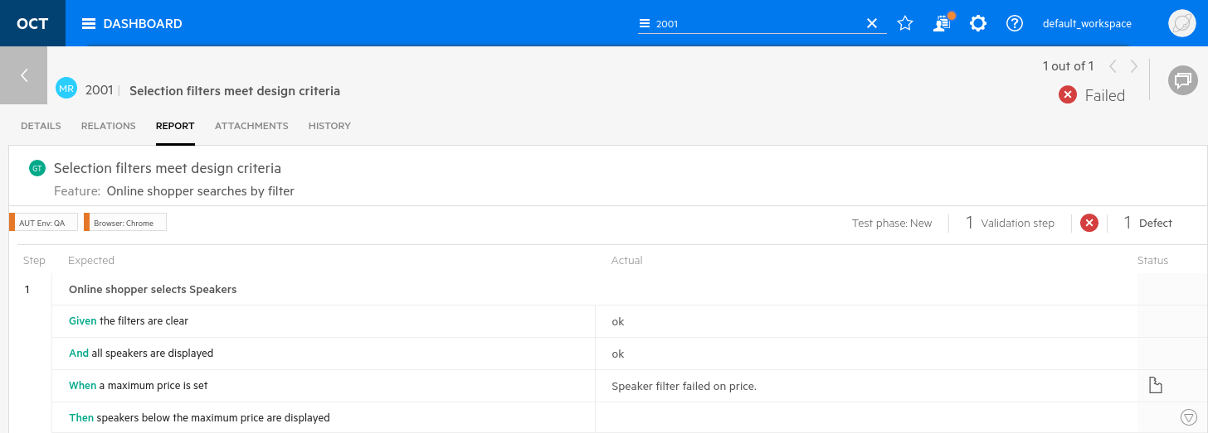

1. **Click** the arrow to **go back** and **Close** the window.
2. Locate the existing graph widget “**Last run status by application module**” and configure it as a pie chart.

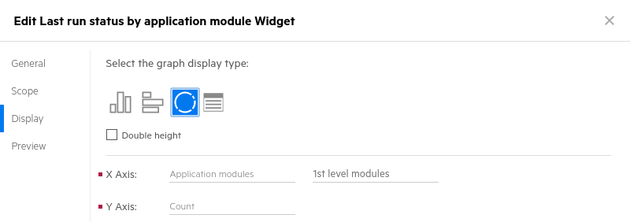

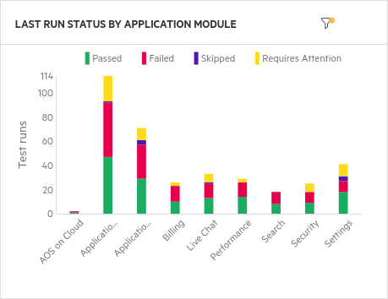 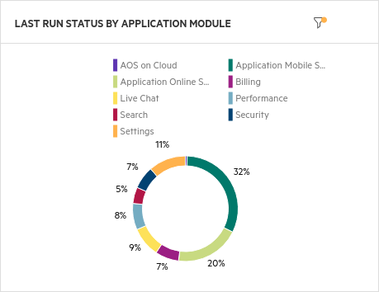

1. Mouse over the **Security** segment to view the test runs associated with that application module.  
   Click on that segment and scroll down to find your manual run (probably the last one in the list).  
   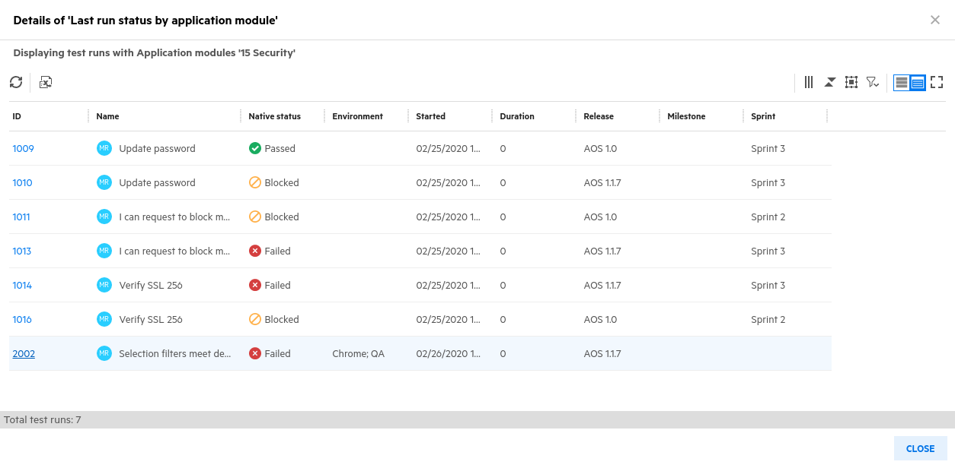  
   ** *You can easily create custom widgets to monitor the quality and status of your application.*
2. **Close** the Details window and create a **Custom Graph** by selecting the **+** icon and then select  
   **Add custom graph** using the following instructions:

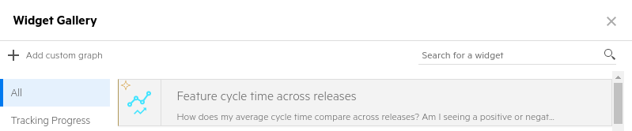

* 1. Graph Name: **Test runs by release -> Next**
  2. Item Type: **Test run history (manual)**
  3. Release: **AOS**
  4. Run started in: **Last 7 days** **-> Next**
  5. X-Axis: **Testing tool type**
  6. Y-Axis: **Count**
  7. Group by: **Author -> Save**

1. Click on the colored bar to see the details of these tests.  
     
   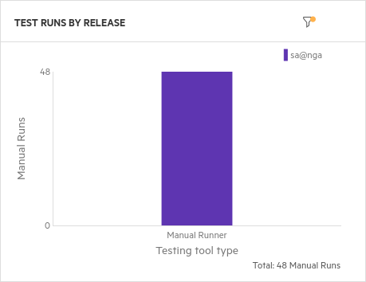

*\*\* This graph displays all tests run in the last seven days including the one that we created previously. Depending on when the container was created you may have more or fewer tests. You can also drill into the chart and find our previous test result and its defect.*

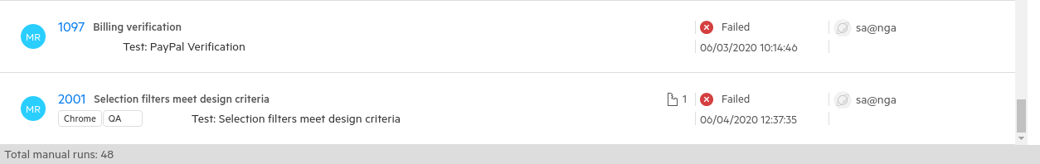

1. **Close** this window when you’re done.

Wonderful!

You have successfully analyzed the test results in the dashboard!

Exercise 8: Administration and Settings

Settings Overview

In this section we’ll explore the configuration settings of ALM Octane

1. In the top banner, click the gear icon to access **Settings** and then select **Spaces**.

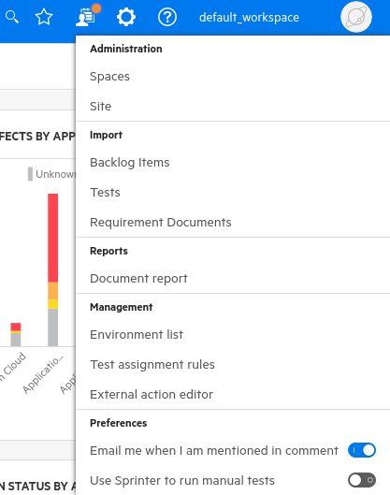

Data in ALM Octane is divided into separate areas within a larger environment. The separate areas are called workspaces. The environment is called the space. The spaces can be isolated or shared.

Workspaces associated with shared spaces can also share data.

|  |
| --- |
| Why do I need shared spaces?  Often, application development projects might be similar but can share a core set of functionality. Imagine a global cellular company that wants to roll our services in North America and is expanding to Brazil. While much of the cellular application functionality remains the same, some pieces can be different with different country rules. For example, data retention might vary per local law. Consumers might also use their devices for different purposes to take advantage of faster (or slower) connection speeds. Billing and tax collection would also be different per country.  For these reasons you may want to compartmentalize these differences but also keep a core set of shared functionality. That’s exactly what shared spaces are made for. |

Shared space admins can create multiple workspaces to represent multiple projects, programs, or products managed on the same ALM Octane site. Shared space admins can also create users, and assign users different roles within workspaces. They also assign workspace admins for each workspace.

Shared spaces are only available in **ALM Octane Enterprise**, one of four editions of ALM Octane. Each edition has a different set of capabilities (and price). The following table outlines these editions and features:

|  |  |
| --- | --- |
| Edition | Description |
| Enterprise | Allows you to scale ALM Octane to large groups with the benefits of cross-workspace and cross-program capabilities. These include:   * Shared customization (such as rules, user-defined fields, workflow, forms, and lists) * Shared entities (such as users, releases) * Cross-workspace reporting on data from multiple workspaces using the same widget * Cross-program functionality for the backlog module * Data access control |
| Pro | Provides you the same set of features as Enterprise Edition within isolated workspaces. Shared space and program capabilities are not provided. |
| Team | Lightweight ALM Octane version to enable DevOps teams to plan, track, build and release applications using Agile and DevOps practices. |
| Developer | Available Nov, 2020 this inexpensive license allows access to My Work, Defects, Team Backlog (Features and Tests) and Pipelines. |

Workspace admins can manage data inside their workspaces that are associated with isolated spaces. This includes releases, teams, users, the backlog, application modules, tests, defects, and so on.

Workspace members can only access workspaces that they are assigned to.

1. Select the **Default Shared Space** on the left side list bar.

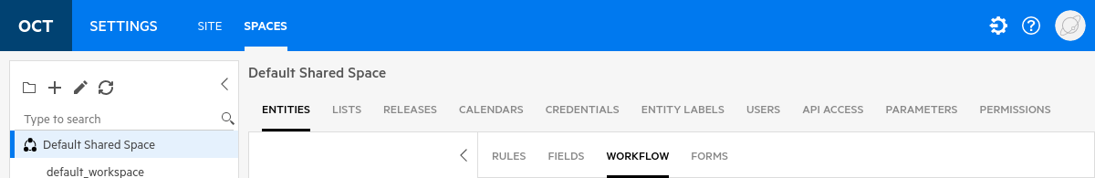

In this view you can see many of the same entities and options you have for the default workspace but changes made here are shared with other workspaces. Across the top of this view are various tabs for modifying Octane’s shared space behavior.

1. Click on each of the section tabs to understand how Octane organizes its shared space data.

The details of these shared entitles is described below:

|  |  |
| --- | --- |
| Shared Space Customization | |
| Entities | Applies to Shared Space - See **default_workspace** description in following table. |
| Lists | Applies to Shared Space - See **default_workspace** description in following table. |
| Releases | Applies to Shared Space - See **default_workspace** description in following table. |
| Calendars | Applies to Shared Space - See **default_workspace** description in following table. |
| Credentials | Applies to Shared Space - See **default_workspace** description in following table. |
| Entity Labels | Entity labels allow you to change (whitelist) the text ALM Octane uses to show various entities. You can even change the initials and plural forms used. In this way you can change the terms used for specific methodologies (e.g. SAFe, Waterfall, Spotify, etc.) |
| Users | Applies to Shared Space - See **default_workspace** description in following table. |
| API Access | Generates an API Key set (Client ID and Client Secret) for authenticating access to other integrated tools. |
| Parameters | A variety of adjustable parameters to control ALM Octanes behavior. |
| Permissions | Controls which roles have permissions to which modules/activities. Basically, who can do what? |

1. Click on the **default_workspace** on the left menu and then click on each of these section tabs to understand how Octane organizes its data.

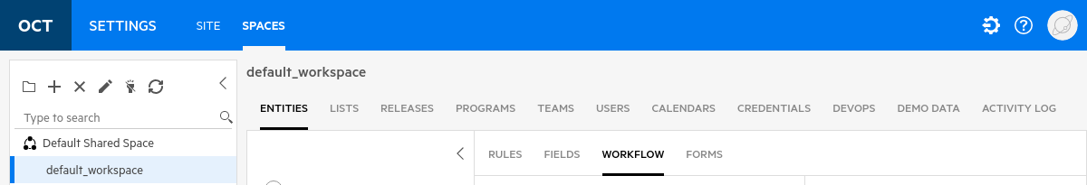

|  |  |
| --- | --- |
| default_workspace Settings | |
| Entities | Entities can be modified here to create transition rules, user defined fields, workflow and form creation. Each Octane entity can be individually modified. |
| Lists | Lists are Octane items with defined values. For example Agile Type can be Kanban or Scrum. These lists are used throughout Octane and can generally be extended or new ones created. The behavior of these items is defined in this section. |
| Releases | Releases are the defined product releases, timelines and sprint count for the application being developed. |
| Programs | Workspaces can be organized into categories called programs. A program represents some kind of dev mission. For example, in a private banking workspace, you might create programs called DirectPay, MyAccount Mobile, MyAccount Web, and Services. |
| Teams | Teams are groups of individuals that work for a common purpose. Individuals can be members of more than one team. |
| Users | Users are the list of users defined in Octane along with their email and role they play.Users are typically also assigned to one or more teams. |
| Calendars | Public holidays along with religious, regional and personal calendars are defined here. |
| Credentials | Some applications require credentials. ALM Octane can supply these credentials when calling these applications from a Trigger Webhook rule. |
| Devops | The Devops section contains integration details for the more common Devops tools like CI, SCM, Security and definitions like Commit Patterns. |
| Demo Data | When evaluating ALM Octane customers may want to see what a mock workspace with connected data looks like. Fortunately, ALM Octane contains this mechanism to create a demo repository for this sort of examination. You can generate this mock data workspace from this section. |
| Activity Log | The Activity Log allow you to see a log of ALL activity on Octane entities at the workspace level. The access to the activity log is controlled via permissions and it enforces the European GDPR standards. |

Adding User-Defined Fields (UDFs)

User defined fields or UDF’s are a way to customize ALM Octane to fit an organization’s needs. Many organizations have historical metrics or data that they want to associate with certain entity types.  
In Octane, you can create custom UDF’s and even develop rules for how they work.

1. Select the **Entities** tab while in the **default_workspace**.
2. Select the **Defect** entity.
3. Select the **Fields** tab.

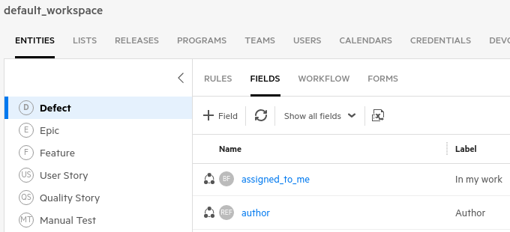



1. Click **+ Field** to add a new Field.
   1. Name: favorite_color_udf **NOTE:** Names must end in “_udf”
   2. Label: What is your favorite color?
   3. Type: String field
   4. 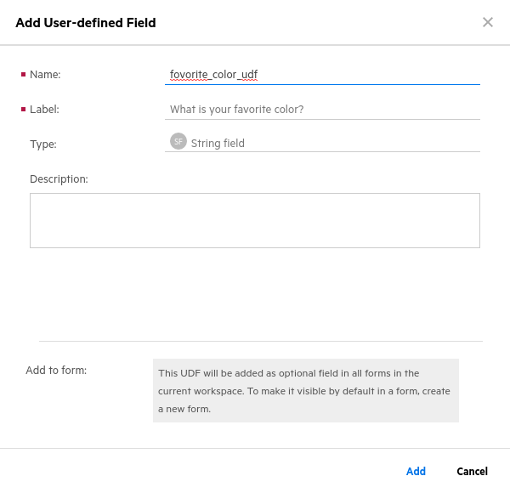Click **Add**

Once you have added this UDF, every new defect will now have this optional field available.

Creating API Keys

API Keys are encrypted credentials that can be used to access ALM Octane’s data. We configured one previously to connect to Jenkins. In this section we’ll create a similar key but we won’t use it for anything.

1. Select **Default Shared Space** on the left. Make sure you change this from **default_workspace**.  
   Select the **Spaces** tab in the top left menu bar.  
   Select the **API Access** tab.

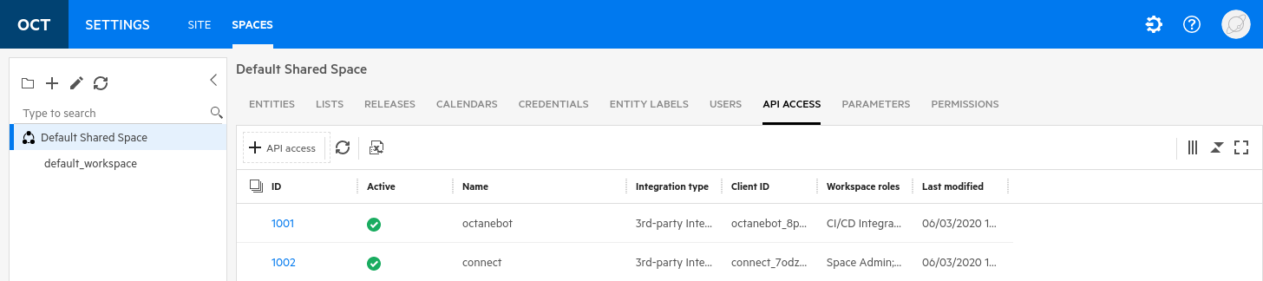

*\*\* Set up API access once for each application that will communicate as a client with ALM Octane. This grants the application registered access keys to use for authentication. Two keys are created: Client ID and Client secret. For the exercises today we set up a second API key to integrate ALM Octane with Jenkins.*

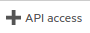

1. Select to create API keys.
   * Name: mock_jenkins
   * Role: CI/CD Integration
   * In Workspace: default_workspace

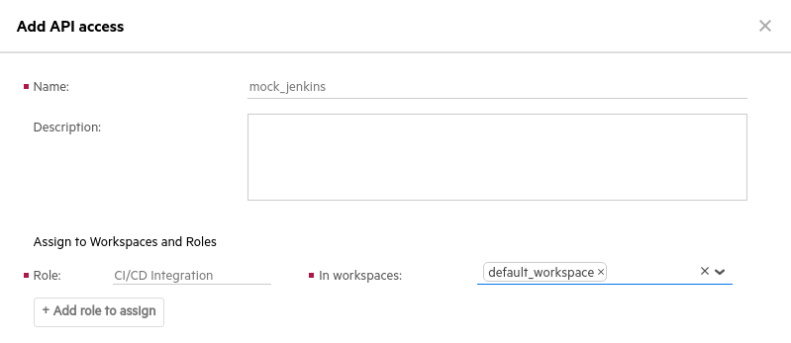

1. Click **Add**.
2. Write down or **Copy** the generated **Client ID** and **Client secret**.  
   You won’t see them again.

Once you have the **Client ID** and **Client Secret** you can use them to connect to other tools like Jenkins.

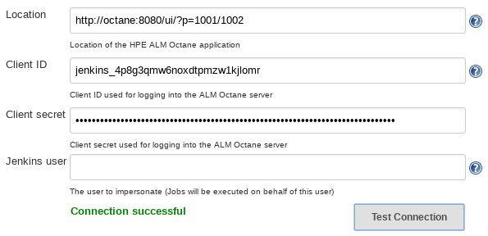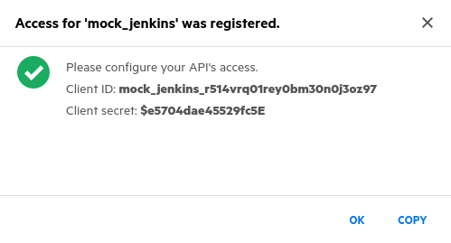

1. **Don’t make any changes** in Jenkins now – we were just showing you how the process works.

Creating Workflow Transitions

For many items (entities) in ALM Octane, you can define rules, workflow phases, lists, forms, and so on. One of the admin's early tasks is to make sure these items are defined according to the site's needs.

Customizing items is essential to maximizing user productivity.

You can define the logical workflow for each item. The workflow determines what statuses the item can advance through as it is created, completed, and so on.

Workflows have metaphases, phases, and transitions. You can customize phases and transitions.

* **Metaphase:** The logical status of an item. Each metaphase contains one phase or more.
* **Phase**: The statuses of the item. A phase can be defined as the **Start phase**, which means it must be the first phase in the workflow.
* **Transition**: The permitted directions in which the flow can advance to another phase. You can set transitions as primary transitions, which indicate the main path for the flow.

1. Select the **Default Shared Space** on the left-side menu.  
   The Default Shared Space is used since it has more privileges to change the workflow.
2. Select the **Entities** tab.
3. Select the **User Story** item.
4. Click **Workflow**. The current workflow for the item displays.

Below is the default workflow for a user story. In this model, a user story cannot go from **New** to **Done**, without first being set to **In Progress** and then **In Testing**. This is the primary flow and these are shown as solid lines. Optional transitions are shown with dashed lines.

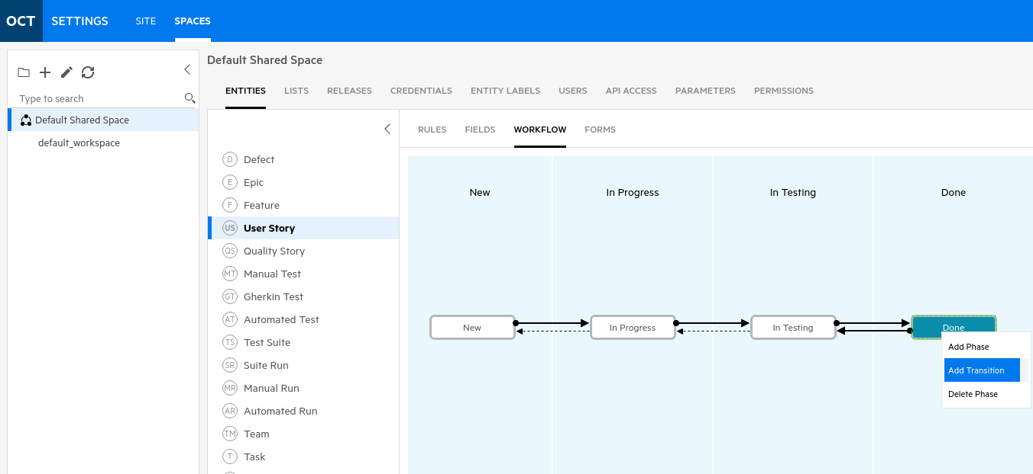

1. You can use the workflow editor to modify the workflow for the item.
2. Add a transition from **Done** back to **New** by right clicking **Done** to add a **Transition**.  
   If you can’t add a transition you might not be in **Default Shared Space** but are in **default_workspace**.

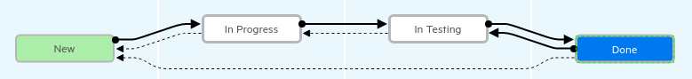

1. Save your change by exiting the Settings section by clicking on .
2. Using your newly acquired skills in Octane, create a **user story** that is in the **Done** phase and see if you can now change it back to **New**. You’ll have to move the user story through **In Progress**, **In Testing** and finally into **Done**.

If you can verify that this is now possible, HURRAY!

1. Then go back and **delete** your transition (right click on it and select **Delete Transition**) to put things back the way they started. Nice Work!

Congratulations!

You have mastered the Administration and Settings section!

Exercise 9: Configuring DevOps Connections

ALM Octane forms the nerve center of the ADM portfolio. From Octane you can design and manage your application, backlogs and sprints and even run pipelines from Jenkins (via the devops container). Next we’ll start the devops, octane and SSC containers so we’ll have a CI system, an agile lifecycle management system and a software security system at our fingertips.

Starting the DevOps, Octane and SSC Containers

1. If you haven’t already, open a **terminal** on **NimbusServer** and start the DevOps container:  
     
   **$ nimbusapp devops:3.2.3 start**
2. If Octane and SSC aren’t running, start them from the **terminal** on **NimbusServer** by typing:

**$ nimbusapp octane:16.0.400.79**  **start**

**$ nimbusapp ssc:21.2.1 start**

1. Verify that your containers have started properly by typing:

**$ docker ps (or dps)**

1. These three containers take a little while to start up so **monitor** your Linux CPU activity with the desktop icon **System Monitor**. Once the activity settles down to under 30 % CPU, these applications are probably ready to interact.
2. Once the activity has settled down, open a browser tab to the **Octane** shortcut and log in.

Username: **sa@nga**

Password: **Password1**

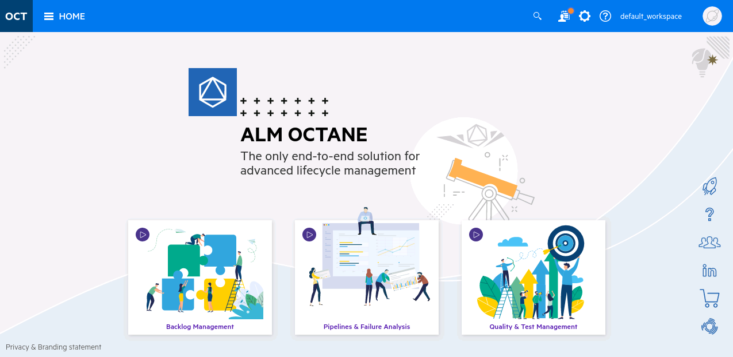

Configuring the Jenkins-Octane Connection

Octane and Jenkins (which is housed in the devops container) need to communicate. An Octane administrator sets this up by creating an **API Access** key. This has already been done in the Octane container and these values need to be placed in the devops/Jenkins container. Both Octane and SSC need to be configured.

As Octane versions progress, and the Octane plug-in for Jenkins gets updated, these values can get out of sync. Fortunately, we can check this connectivity and correct it if needed.



1. From Octane select the **Settings** cog and navigate to the **Spaces** section.
2. Select **Default Shared Space** on the left and choose the **API Access** tab.

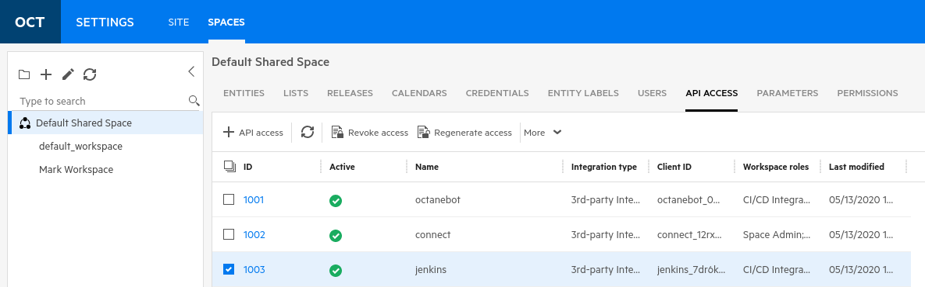

1. Look at the list and find the entry for Jenkins. This line contains the **Client ID** that needs to match with that field in Jenkins. There’s also a **Client Secret** that is paired with this value but it’s only visible when you first create the key (hence the secret part).
2. Right click on the Jenkins line and select **Regenerate access**.

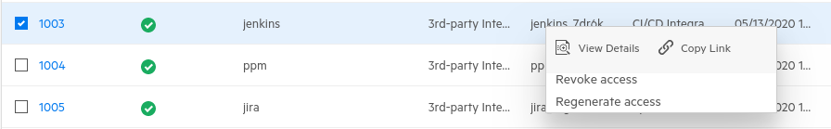

1. Leave this window open and **Copy** just the **Client ID** number.

Don’t select the Copy button since it copies both values and you’ll need to split them apart.

Also, don’t select the OK button since this will close the window but, you can always regenerate it again.

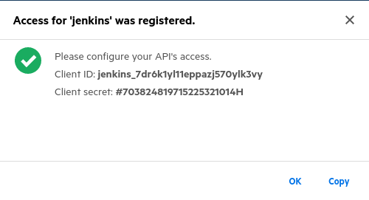

1. Open a second tab in your browser to the **Jenkins** shortcut and click **Manage Jenkins** on the left menu.
2. Click on the **Gear** icon to **Configure System**.
3. **Scroll** down to the section labeled **ALM Octane CI** (about 2/3 of the way down).

It’s here that we’ll enter the two values from Octane.

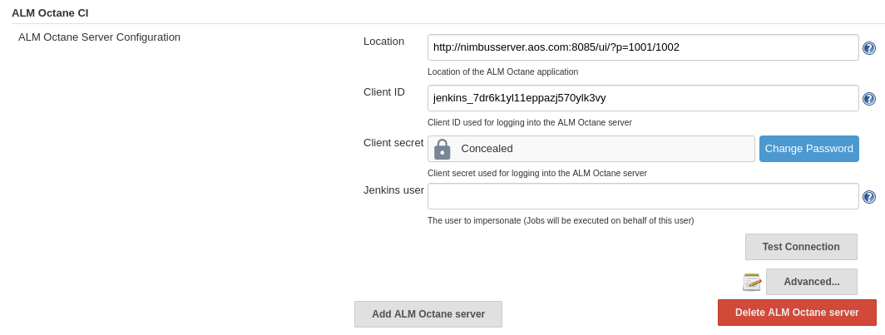

1. **Paste** the value you copied (the Client ID) into the Client ID section of this form.
2. Go back to the Octane tab and **Copy** the Client Secret from the popup.
3. Switch back to the Jenkins tab and click **Change Password** and **Paste** the Client Secret in there.
4. **Click** on the **Test Connection** button. It should display **Connection successful**.

If it doesn’t display this message, try and regenerate a new key again.

1. Click **Save** to save your changes – **THIS IS CRITICAL THAT YOU SAVE YOUR CHANGES**!

Jenkins will discard this and you’ll have to start over if you don’t save the changes.

Configuring the Jenkins-Software Security Center (SSC) Connection

Similar to what we just did by configuring settings in Jenkins for Octane, next we’ll configure Fortify Software Security Center (SSC) to work with Jenkins as well. Just like we had a script to do this for Octane, we also have a script to do this for SSC.

1. If SSC isn’t running, start it from the **terminal** on **NimbusServer** by typing:

**$ nimbusapp ssc:21.2.1 start**

It can take a couple of minutes for the server to finish starting up.

1. Open a **browser tab** and select the Fortify Software Security Center (SSC) link under the ADM Products folder shortcut link (or go to <http://nimbusserver:8086/ssc/#!/> ).
2. Log into **Fortify SSC** (admin, Password1)

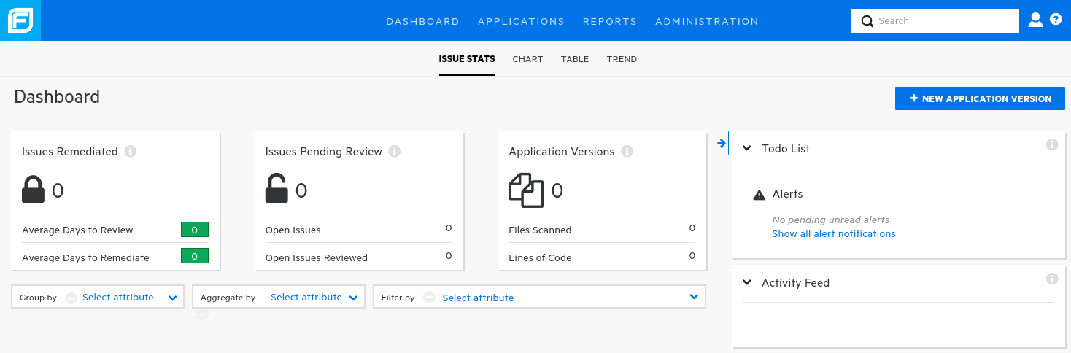

1. Select the **ADMINISTRATION** module at the top.
2. Select the **Users > Token Management** section on the left edge.

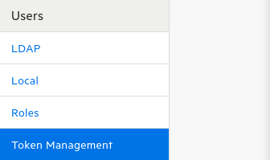

1. To the right, select and copy the Description text – this is your **Authentication token** for the SSC Jenkins plug-in.



1. Open a second tab in your browser to the **Jenkins** shortcut and click **Manage Jenkins** on the left menu.
2. Click on the **Gear** icon to **Configure System**.
3. **Scroll** down to the section labeled **Fortify Assessment** (about ¾ of the way down).

That token has been prepopulated in the container so we don’t need to create a new one.

1. **Paste** the Description value into the Authentication token field and click **Test SSC connection**

After a little wait it should show Connection successful.

1. Click **Save** to save your changes – **THIS IS CRITICAL THAT YOU SAVE YOUR CHANGES**!

Jenkins will discard this and you’ll have to start over if you don’t save the changes.

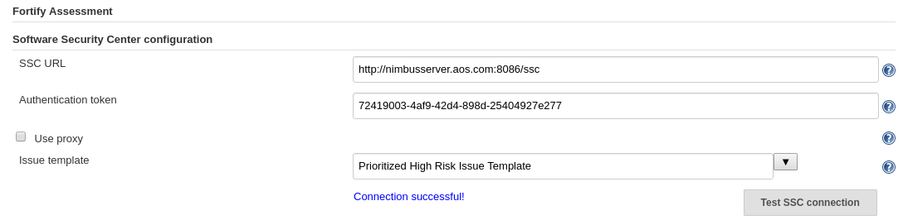

**Nifty!  
  
You have just configured the octane, devops and ssc containers!**

Exercise 10: Jenkins and DevOps Integrations

Jenkins is a freeware continuous integration (CI) system that manages and automates the building, deployment and testing of most modern applications. Because of its extensive library of plugins, Jenkins has become a multi-functional CI tool that can do almost everything in the DevSecOps arena.

In this section well look at all the things that Jenkins can do along with how it integrates with ALM Octane.

The Nimbus DevOps Architecture

The containers available in Nimbus typically house an application, a webserver and a database. However, some containers, like devops or intelliJ, are more multifunctional and consist of several applications.

In the diagram below you can see how these two containers interact and clone/commit changes to each other.

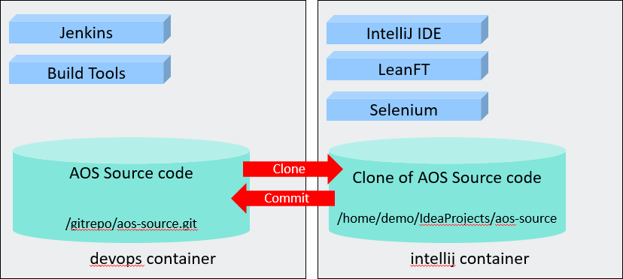

UFT Dev

In addition, the AOS (Advantage Online Shopping) application is divided into three containers.  
As our e-commerce demo application, AOS was split up to represent a more typical docker architecture and also to allow for the ease of virtualizing the **aos-accountservice** using Micro Focus Service Virtualization.  
  
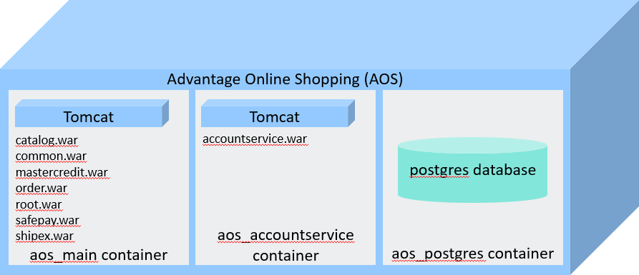

Getting Started with Jenkins

Jenkins at its core is a sophisticated task execution tool. You define jobs (or builds) in Jenkins and describe how to execute them. Jenkins, in return, keeps track of the execution with attention to the status of whether things passed or failed. With the help of “plugins” Jenkins connects with other tools to read build configurations like Maven’s POM files and publish results to Fortify SSC or Octane.

**NOTE**: You must have completed Exercise 9: Configuring Jenkins Connectivity before starting this exercise.

1. From the NimbusServer VM, start (or verify) the **DevOps** container by typing:

**$ nimbusapp devops:3.2.3 start**

1. Wait a minute or so and then open the **Chrome** browser and select the Jenkins shortcut and the main **Pipelines** dashboard view as shown below.

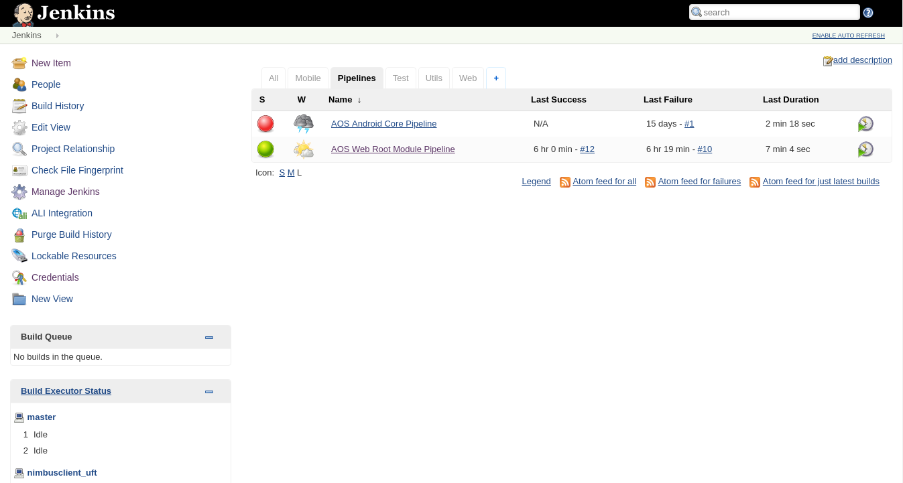

Click on “Jenkins”  
to get back to the

Home page.

The devops container has multiple software installations and purposes. In addition to housing Jenkins, it also serves as a git repository and can compile and build the AOS applications. It also houses the source code for Advantage Online Shoppins (AOS) in its local git repository.

The Jenkins Interface

The home page of Jenkins contains a list of jobs (also called builds or tasks) along with some links to configure Jenkins and to see if has any remote agents where Jenkins jobs can be run.



There are four areas here worth knowing about:

* 1. **New Item** – This link allows you to define new jobs and pipelines for Jenkins to run.
  2. **View tabs** – This tabbed section shows your jobs and is filtered to show different types of jobs.  
     If you have trouble finding a job by name, try the **All** tab since it always shows everything.
  3. **Manage Jenkins** – This link allow you to configure Jenkins itself and install its plugins.
  4. **Build Executor Status** – This section shows which remote execution agents are active.  
     In this case, the NimbusClient VM has a remote agent that allows running tasks like UFT tests.

These remote machines have agents running on them that communicate with Jenkins.  
Remote machines are also referred to as **nodes**.

Managing Jenkins

* 1. Click on the **Manage Jenkins** option on the Jenkins home page.
  2. Click on the **Configure System** option.  
     You can ignore any notices about security items or reverse proxies – these are just notices.



This section of Jenkins allow you to configure how Jenkins works and adjust settings for the installed plugins. Scroll down through the categories and we’ll look at some of these options.   
For most of these sections, data has been pre-populated – you shouldn’t need to edit them.

* + 1. **Maven Project Configuration**

Apache Maven is a build automation tool used primarily for Java projects. There’s usually a POM (Project Object Model) file that contains dependency and configuration details which are used when building the software.

* + 1. **SonarQube Servers**

This third-party plugin gathers details on code metrics and vulnerabilities.

* + 1. **Micro Focus LoadRunner Enterprise Integration**

This option produces additional debug information for LoadRunner Enterprise.

* + 1. **DA Server**

This section contains the locations and parameters for MF Deployment Automation.

* + 1. **Fortify on Demand**

This section contains the location of the demo FOD instance.

* + 1. **Application Lifecycle Management (ALM QC)**

This section contains the name and server URL of the ALM QC container.

* + 1. **UFT Mobile**

This section contains the name and server URL of the Mobile Center container.

* + 1. **ALM Octane CI**

This section contains the name, server URL, Client ID and Secret and Jenkins user for the ALM Octane container. Since we’re logging into Jenkins anonymously, we don’t need to specify a Jenkins user. If your Octane container is running, you can click **Test Connection** and verify that Jenkins can communicate to Octane. Communications with ALM Octane goes through this plugin.

* + 1. **Service Virtualization**

Communications to the SV Server is configured via this section.

* + 1. **LoadRunner Cloud**

This section contains the connection details for LoadRunner Cloud.

* + 1. **Fortify CloudScan**

This section contains the connection details for Fortify CloudScan.

* + 1. **Fortify Assessment**

This section contains the details to connect to Fortify SSC (Software Security Center).

* + 1. **ALI Integration**

This section contains the details for the ALI integration with the ALM QC container.

Managing Plugins

Part of Jenkins’ popularity is its vast collection of publicly available plugins. A plugin is some additional functionality that can be added to Jenkins, like git integration. In this section we’ll look at some of this useful functionality and examine some of the more popular devops plugins.

1. Click on the **Manage Jenkins** option on the Jenkins home page.
2. Click on the **Manage Plugins** option.  
     
   
3. The plugins section is divided into four tabs:
   * **Updates** – If any of your installed plugin have a publicly available update, they are shown here.
   * **Available** – If you want to search the list of publicly available updates, they are shown here.
   * **Installed** – The list of installed plugins on your Jenkins instance are shown here.
   * **Advanced** – Here you can set a proxy or upload a plugin file directly. Not all plugins are public.
4. Examine the list of **Installed** plugins. These plugins get updated very regularly and it’s not uncommon to have many updates available (just like apps on your smart phone).

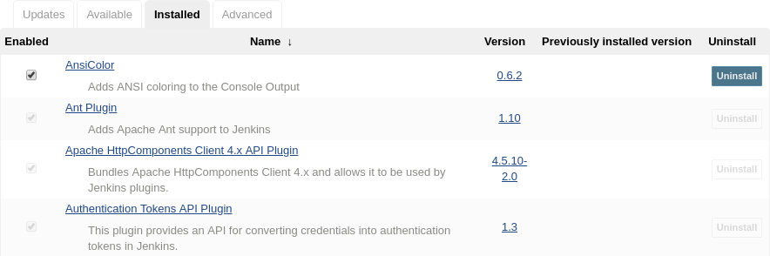

|  |
| --- |
| Note: Jenkins plugins have either a .jpi or .hpi extension. This stands for either Jenkins or Hudson Plug In. These files are actually just zip files and contain the directories and files of the plugin that will be installed into the Jenkins directory. These plugins all get renamed to have a .jpi extension and get placed in /usr/share/jenkins/ref/plugins/ inside the devops container. |

1. Many plugins have a counterpart in the **Manage Jenkins** section but often these can have different names. For instance, the **DA Deploy** plugin corresponds to the **DA Server** section in **Manage Jenkins**.



1. Scroll down through the list of Micro Focus related plugins.

How many can you find that are directly related to Micro Focus? _______ 8

1. **Navigate** back to the Jenkins main dashboard by clicking on Jenkins (if prompted, select **Leave**).

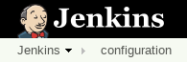

The Octane - Jenkins Integration

The ALM Octane – Jenkins integration incorporates data from your Jenkins CI pipelines into your application delivery process, helping you analyze quality and progress.

This section is somewhat a review of the Exercise 9: Configuring Jenkins Connectivity Octane settings.

You can find more information on the Octane - Jenkins integration here:  
<https://admhelp.microfocus.com/octane/en/latest/Online/Content/AdminGuide/jenkins-integration.htm>

1. From the NimbusServer VM, start (or verify) the **DevOps** and **Octane** containers by typing:

**$ nimbusapp devops:3.2.3 start  
  
$ nimbusapp octane:16.0.400.79 start**

1. Click on the **Manage Jenkins** option on the Jenkins home page.
2. Click on the **Configure System** option.  
   
3. Scroll down to the section called **ALM Octane CI**.

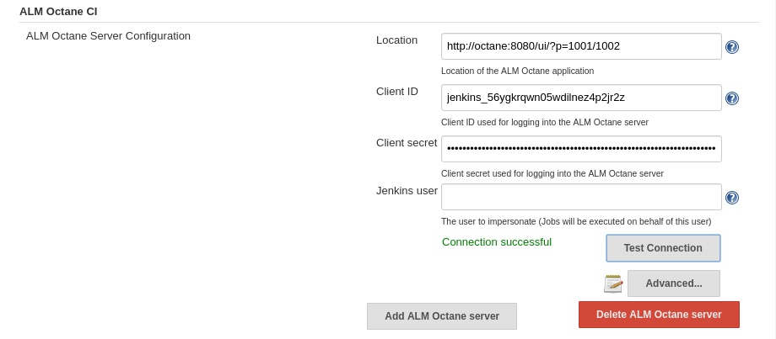

1. This section (which is pre-populated in our devops container) contains the connection details for Octane including:
   1. **Location**: The URL and shared space ID parameter
   2. **Client ID**: The unique client ID generated by Octane
   3. **Client secret**: The unique client secret generated by Octane
   4. **Jenkins user**: The user to be impersonated (blank in our case)
2. Open a new browser tab to the Octane shortcut and click **Login**.
   * **Name**: sa@nga
   * **Password**: Password1
3. Click on the gear (Settings) icon in the topmost tool bar and select **Spaces** under Administration.  
     
   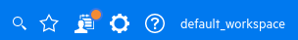
4. On the left side select **Default Shared Space**.
5. In the tabs to the right select **API ACCESS**

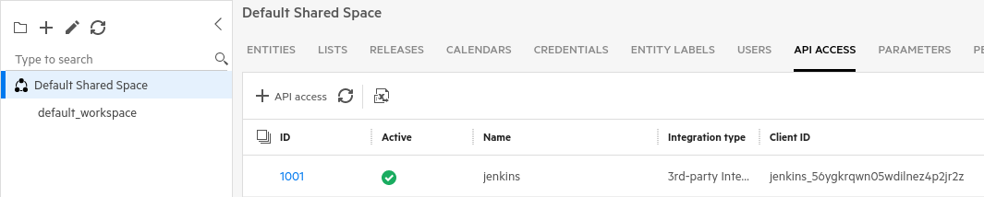

This section of Octane’s administration function is where you configure the integration with Jenkins.  
  
**Verify** that the Jenkins Client ID here matches the one shown in the Jenkins **ALM Octane CI** section.

Running a Jenkins Pipeline

When Jenkins runs a typical job it creates a temporary place to house files and artifacts. This could be the intermediate files of a compilation or the output results of a test execution. The details on what happened during a job build can typically be found in the build’s **workspace**.   
  
A pipeline is a collection of jobs that run sequentially, but certain tasks can also run in parallel.  
In our Jenkins instance we have defined two pipeline jobs that build:

1. The AOS Android Mobile app
2. The AOS Web application

Pipelines don’t have their own workspace but the jobs they contain typically do.

These pipelines do more than just compile code – they perform the following types of tasks:

1. Create a Jenkins build workspace
2. Check out code from a git repository
3. Compile the AOS source code (using a Maven **P**roject **O**bject **M**odel file (POM file))
4. Scan the code for security vulnerabilities and code health
5. Run JUnit tests as part of the build process
6. Un-deploy and redeploy the AOS web modules
7. Run regression tests (LeanFT and Selenium) to validate the newly built application

In the following section we’ll run a simple Pipeline job and examine what comes out of it.

Always wait a couple of minutes after each **nimbusapp** command to give it time to boot.

1. From the NimbusServer VM, start (or verify) the **DevOps**, **AOS, IntelliJ and Octane** containers:

**$ nimbusapp devops:3.2.3 start**

**$ nimbusapp aos:3.2 start**

**$ nimbusapp intellij:3.2.1 start  
$ nimbusapp octane:16.0.400.79 start**

NOTE: The IntelliJ container runs UFT Developer but it closes it down after4 hours of inactivity. If your IntelliJ was running for over four hours you must restart UFT Dev from the menu UFT Developer > **Disable UFT Developer** followed by UFT Developer > **Enable UFT Developer**

1. From the NimbusServer VM, open a browser to the **Jenkins** home page and select the **Pipelines** tab and **click** on the pipeline **AOS Web Root Module Pipeline**
2. Select **Build Now** (on the left border) and wait while the pipeline finishes.

**Click** on the flashing ball icon and you can see the **console output** showing every step.



Near the final stage of this pipeline, it runs a test called **AOS Web Regression Test**

We’ll examine this test to learn more about Workspaces.

1. Once the pipeline has completed, go back to the Jenkins home page and click on the **Tests** tab and then click on the test **AOS Web Regression Test**

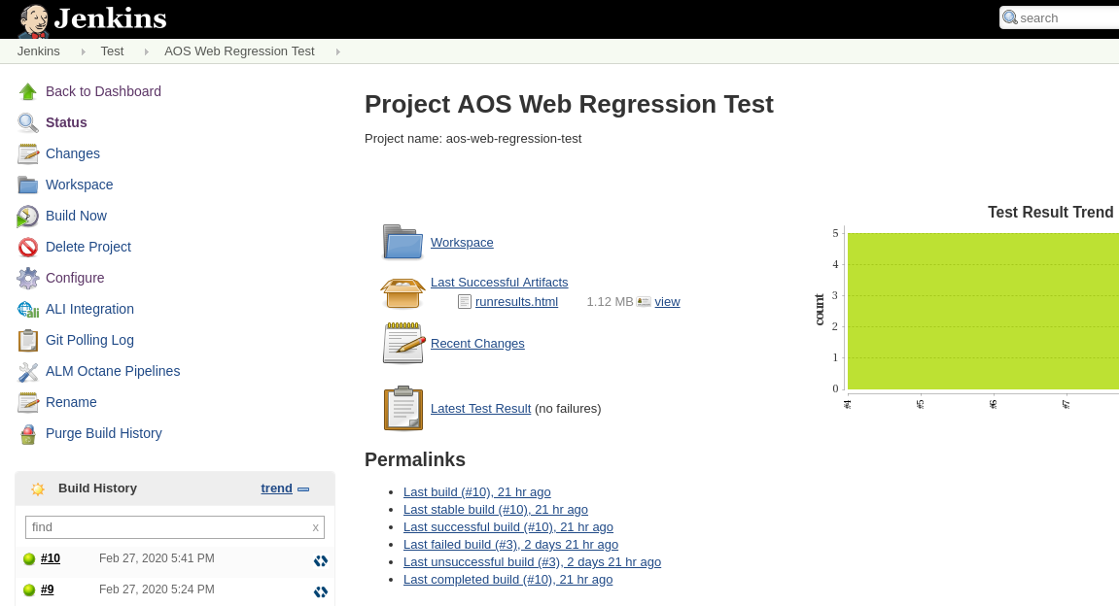

1. From this view you have links to the full **Workspace** folder, the **runresults.html** file and to the  
   **UFT Dev report** icon.
2. Click on the **runresults.html** link and view the last successful UFT Dev run results.  
   Note that if this test had failed, you wouldn’t see that failed set of results here. You would need to drill down to the specific run (e.g. click on the #6) and look inside its workspace.
3. Click the **back** arrow on your browser to go to the previous page.
4. **Click** on the **Workspace** link.

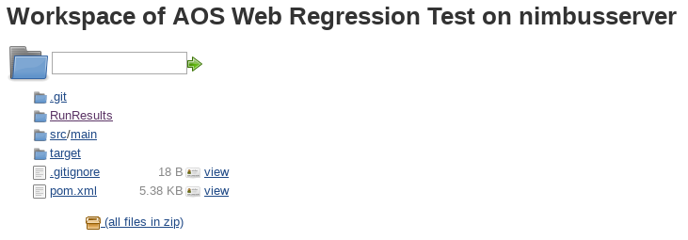

1. Here you can see the entire contents of the workspace.  
   Click on the **RunResults** folder and then on the **runresults.html** file.

This is the same results that you saw before (because this test was most recently passed).

Go **back** to the previous page via your browser back button.

1. Click on the **UFT Dev** icon in the Build History section.  
     
     
     
   This is a quick way to instantly navigate to the **LeanFT run results** for that build.

Go **back** to the previous page via your browser back button.

1. Click the **Configure** link on the left side and scroll down to the **Build Environment** section.

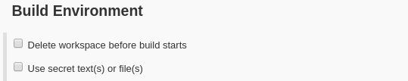

1. Note that we’ve not checked the option to “**Delete workspace before build starts**”.  
   This would remove all old artifacts (like UFT Dev Run Results) before it starts a new run.
2. Scroll down to the **Post-build Actions** section.

This option will save all the specified files to the job’s workspace.

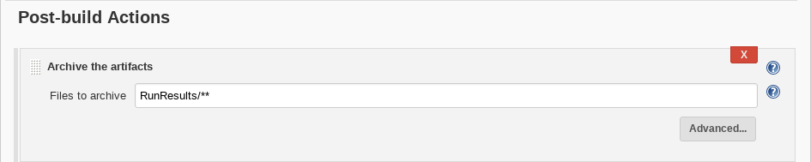

For UFT One or UFT Dev tests it makes sense to have this enabled since you can quickly navigate to the results of any specific test run.

1. From the AOS Web Regression Test, click the **Latest Test Result** link.

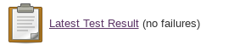

1. Continue to drill down on the links ( (root) > LeanFTTest) until you find the status of the five tests that were run. Note that one of the tests explicitly checks the label of the Speakers category. That test will play an important part a little bit later.

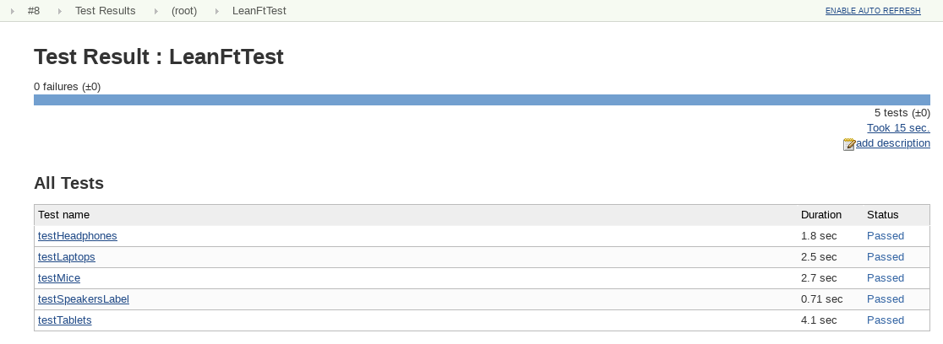

1. Click on the **Jenkins** breadcrumb to go back to the Jenkins home page.

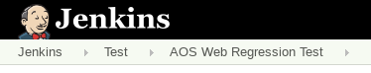

Exercise 11: Tracking Code Changes in Octane

Octane and IntelliJ communicate by means of the Octane integration and also the IntelliJ plugin. With these mechanisms in place we can link source code commit changes to octane backlog items. This process also makes for a great DevOps demo since we create a defect, assign it to a developer, fix the defect and push the change and then build a new application along with testing.

**NOTE**: You must have completed Exercise 9: Configuring DevOps Connections before starting this exercise.

1. First we need to make sure all of our other containers are up and running.  
   From the NimbusServer VM, start (or verify) the following set of containers by typing:

**$ nimbusapp devops:3.2.3 start  
$ nimbusapp aos:3.2 start**

**$ nimbusapp octane:16.0.400.79 start**

**$ nimbusapp sca:21.2.1 start**

**$ nimbusapp ssc:21.2.1 start**

1. Open a browser and navigate to the Octane browser shortcut.  
   **Username**: sa@nga

**Password**: Password1

1. Click the Octane **HOME** button and select **ISSUES**.

We’re going to create a defect and then associate that defect to code that we’ll change later.



1. Create a new defect by clicking on the + Defect sign and enter the following fields:  
   **Name**: Need to change Speakers label to Audio to cover more device types.

**Severity**: Medium

**Application Modules**: Application Online Store

Click **ADD & EDIT** andset the **Owner** of the defect to be **sa@nga** as shown below:

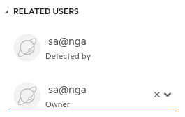

1. Click the save icon to save your changes.

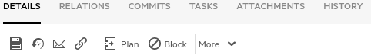

We’ve now created a new defect and assigned sa@nga to work on it.  
Next we’ll go to our **IntelliJ IDE** and change the code to fix this defect.

1. Next we need to start the **IntelliJ** container which holds the IntelliJ IDE and the UFT Dev agent.

**$ nimbusapp intellij:3.2.1 start**

1. In a few seconds you should see the IntelliJ splash page appear (you may need to scroll to the bottom and agree to the terms and conditions). The UFT Dev agent starts automatically when IntelliJ starts.

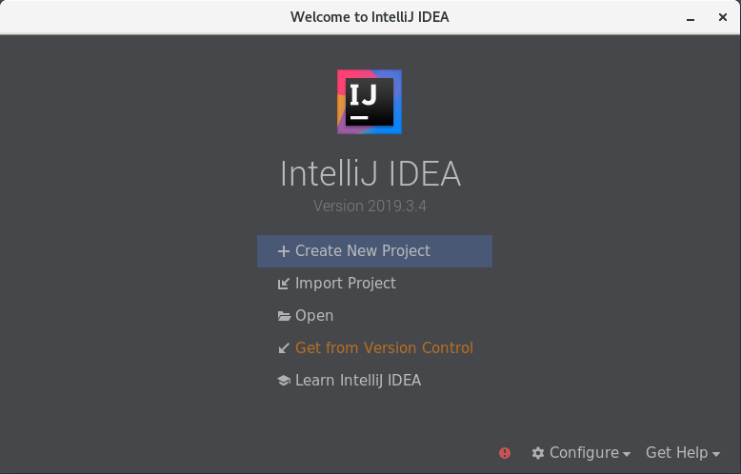

1. You may also note that the UFT Dev agent has been started (look for a small icon in the upper right corner of your screen). This can be used to verify that UFT Dev is ready to execute tests.

NOTE: This icon may not always appear – don’t be concerned if you don’t see it.



Examining the DevOps File System

Since both the DevOps and IntelliJ containers can each have source code on them, we’ll investigate the directories where that code lives.

1. Type the following command into a terminal window. This logs you into the devops container.

**$ docker exec –it devops bash (or $ de devops)**

1. We’ve now logged into the devops container which is where our Git-based projects live.  
   Type the following commands:

**# cd /gitrepo**

**# ls -al**

You should see a list of IntelliJ project directories located in the gitrepo ( /gitrepo ) directory.  
It’s these projects that we’ll clone into the IntelliJ container and work with.

1. From the **IntelliJ** splash page **click** “**Get from Version Control”** and copy/paste the following **URL**

Use **CTRL+V** to paste in the value - (Version control = Git) and click **Clone**.  
  
**http://nimbusserver.aos.com:8091/git/aos-regression-test-web.git**

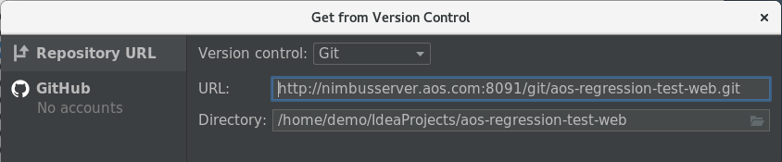

In the popup **Checkout From Version Control** click **Yes** to open the project.

When a Maven popup appears, select **Enable Auto-Import**

In the **Maven Projects** panel at the upper right, select the **Reimport All Maven Projects** button.

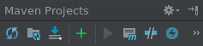

Wait for the project to index fully (a minute or two) and then select **View-> Tool Windows->Project.**

You can also do this by typing **ALT+1**. This view allows you to navigate the files contained in this project.

1. **Go back** to your terminal window and type the following commands:  
   **# exit**

**$ docker exec –it intellij bash (or $ de intellij)**

**$ ls –al ~/IdeaProjects**

1. This final command will list the cloned projects contained in IntelliJ. You should see a directory called:  
   **AOS_Regression_Test_Web/**

This is the IntelliJ project that we just cloned. The other item of note is the **~** (tilde) character.  
In Linux this denotes your home account’s directory. So, the full directory path is

**/home/demo/IdeaProjects**

1. From IntelliJ, select **File->Close Project** to close the project but keep IntelliJ running.  
   In your terminal window type the following to exit the IntelliJ container’s file system.

**# exit**

That IntelliJ project contained the code that runs our regression test using UFT Dev.

1. From the IntelliJ **File** menu choose **Close Project**.

This will close that project and bring up back to the IntelliJ splash page.

Next we’ll examine a different project that contains the source code for the AOS website.

Modifying the AOS Source Code

1. From the **IntelliJ** splash page **click** “**Get from Version Control”** and copy/paste the following **URL** (Version control = Git) and click **Clone**.

**http://nimbusserver.aos.com:8091/git/aos-source.git**

This project contains the full source code for the Advantage Online Shopping mock ecommerce site.

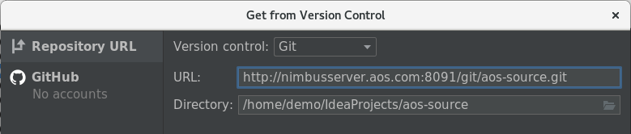

1. When prompted, click **Yes** and choose any additional **default** options and then click **Finish**.

Wait as IntelliJ loads this project and indexes the files. This can take several minutes.

1. If it appears, click the **Add as Maven Project** in the lower popup (or click the **Reimport** button).

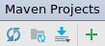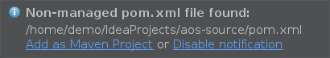 OR

1. Type **ALT+1** to show the **Project** tree on the left. It can take several minutes to load completely.

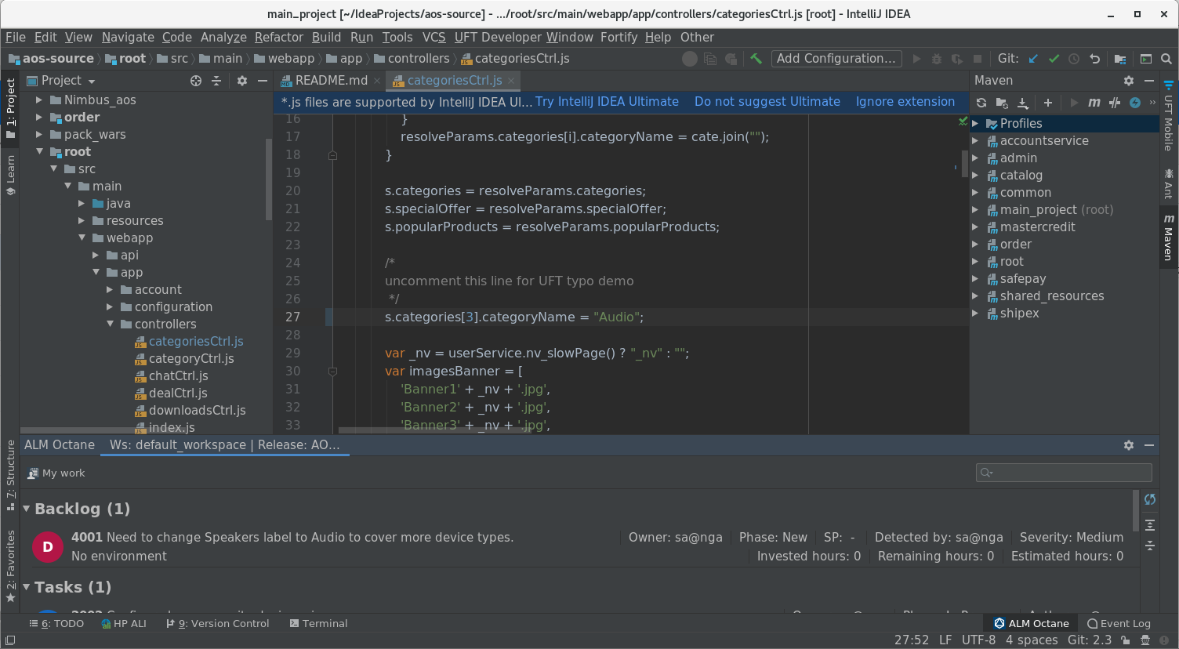

1. At the bottom of the editor, open the Octane window and connect to Octane.

Click the link in that window to go to Settings and configure the connection with the following data.

Server URL: http://nimbusserver.aos.com:8085/ui/?p=1001/1002

Space: 1001

Workspace: 1002

Username: sa@nga

Password: Password1

Click **Test Connection** and then click **OK**.

You should now see the **Backlog Defect** you just created and assigned to sa@nga.

1. Open the following path in the project tree on the left by clicking on the expansion triangles as shown:  
     
   **Project > aos-source > root > src > main > webapp > app > controllers**
2. In the controllers section, double click on the **categoriesCtrl.js** file to open it.  
   This code segment contains a place where we can change the category label.
3. In the code view in the middle, scroll down to **line 27**.

This line contains code that can change the value of the **Speakers** category in AOS to **Audio**.

|  |
| --- |
| The DevOps Story  As part of our DevOps story we consider that a change request came in from marketing that the Speakers category should be changed to Audio to reflect a broader class of devices. Development takes this enhancement request and edits the code on line 27 and then commits the change and pushes it back to the Git source repository. Then, a Jenkins pipeline job is run to rebuild the AOS application and deploy it for testing. A regression test and a Selenium test are run as part of that Jenkins build to verify that everything works as expected.  If you change this value to something like Audio and rebuild the application it will be reflected in the Main AOS home page as shown below.  However, this will also cause a failure in the regression test (to be expected) that would need to be adjusted.  Such is the life of a developer! Fix one thing and another thing breaks. ☺ |



1. **Remove** the **two** leading slash comment characters ( // ) so the line reads as:  
   s.categories[3].categoryName = **"Audio"**

NOTE: In IDE’s like IntelliJ, code changes are automatically saved locally (but not committed to Git).

1. In the Octane integration section, right click on the defect and select **Copy Commit Message**.

This tags the commit of code to the defect we created in Octane.

You could also have selected **Start work** / **End work** which tracks how long it take to fix the code.

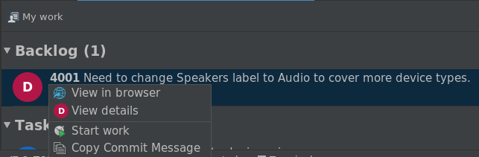

1. From the IntelliJ VCS menu, select **Commit…**

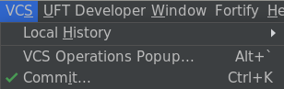

1. In the **Commit Changes** dialog, **paste** the commit message and **click** on the down arrow near Commit to select **Commit and Push**.

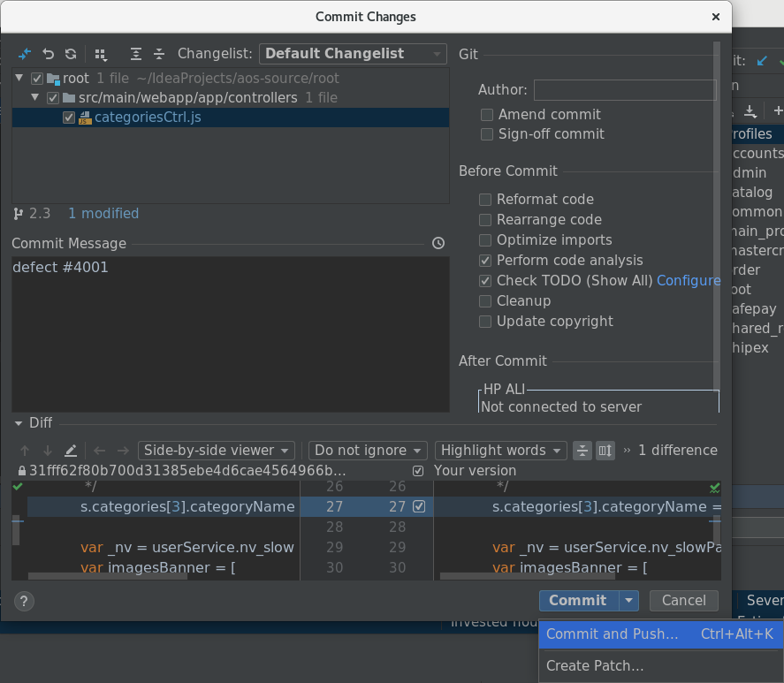

1. When prompted, enter the following email address for demo: **demo@default.com** (or any email address). The click **Set and Commit**. This just happens when you first commit something in Git.
2. In the **Push Commits** dialog select **Push**



1. **Minimize** (but DO NOT Close) the IntelliJ window.
2. We’ve now done the following:
   1. Created a new defect in Octane.
   2. Assigned that defect to sa@nga.
   3. Opened the AOS Source code in the IntelliJ IDE.
   4. Retrieved the defect commit code from Octane.
   5. Tagged our Git commit with the commit code from Octane.
   6. Committed our code back to the git repository on the devops container.

Next we’ll need to rebuild and deploy our AOS application to include our change.

Running the Pipeline from Octane

In this section we’ll connect a Jenkins pipeline to a pipeline in Octane and then run our pipeline from Octane.

1. Open a browser to the **Octane** shortcut and login.
2. Select the **Pipelines** module from the main tool menu.



1. Select the plus sign ( + ) on the left and add a new pipeline with the values below:

Name: **Jenkins CI** (or the default value)  
Job: **aos-web-root-module-pipeline**

Pipeline Name: **aos-web-root-module-pipeline**

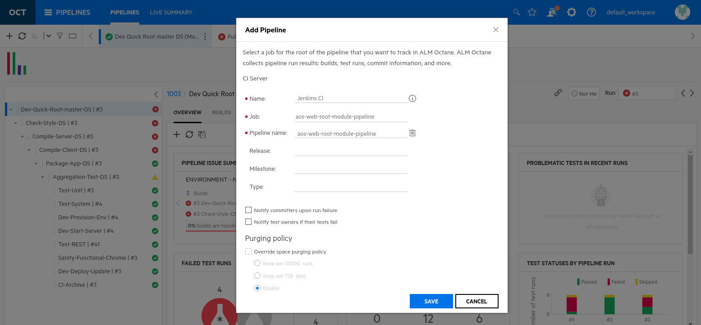

1. Click **SAVE**.
2. In the resulting window, select the new pipeline and click the **Menu Action** button (three dots) and choose **Run** to start running the pipeline. The pipeline will start to execute in Jenkins.

Anytime this pipeline runs (either through Jenkins or Octane) its results are sent to Octane.

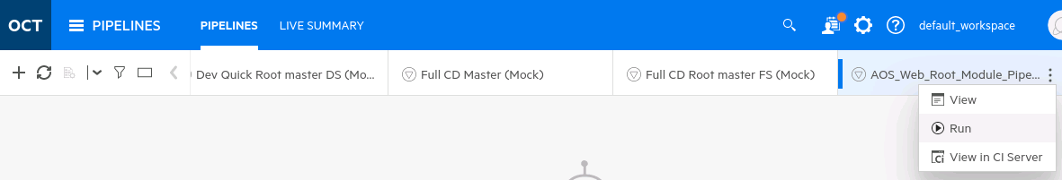

1. Switch to the **Jenkins** tab and verify that the job is started and progressing.
2. Switch back to Octane and wait for the job to finish and then examine the results in the Pipelines tab.

You may need to refresh your view and wait a few minutes to get the results viewable in Octane.

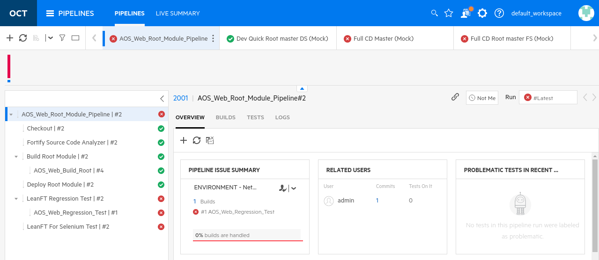

Viewing Code Changes in Octane

1. This build will fail during the regression tests. This is because those tests check that our category was named **Speakers** and now it’s called **Audio**. Eventually we’ll need to fix the regression test too.

In the Overview section, locate the dashboard called RELATED USERS and click on the **1** link.

This identifies our code commit and was done as admin – we can actually map this to our sa@nga account if we want.

**Select** the item listed and note the file that was changed – it should match the file from IntelliJ.

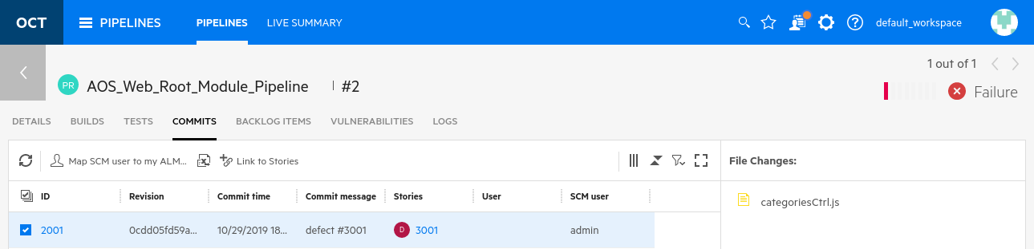

1. Click the option to **Map SCM user to my ALM Octane user**  
   This associates your **sa@nga** user with the SCM **admin** user.

**Nice!  
You have just tracked code commits from IntelliJ to Octane!**

Exercise 12: Workin’ with Gherkin

ROLE: Integration or Automation Engineer

Cucumber is a software tool used by computer programmers for testing other software. It runs automated acceptance tests written in a behavior-driven development (BDD) style. Central to the Cucumber’s BDD approach is its plain language parser called Gherkin. ALM Octane stores and manages Gherkin defined tests and integrates with IntelliJ to automate them. ALM Octane ties these tests to agile Features.

**NOTE**: You must have completed Exercise 9: Configuring DevOps Connections before starting this exercise.

Creating a Gherkin Test in ALM Octane

1. We need to have the following VM’s running for this exercise:

* NimbusServer

1. Start the following Docker containers for this exercise.

**$ nimbusapp octane:16.0.400.79 start**

**$ nimbusapp aos:3.2 start**  
**$ nimbusapp intellij:3.2.1 start**

**$ nimbusapp devops:3.2.3 start**

1. If you changed **Speakers** to **Audio** in IntelliJ, change it back to **Speakers** and commit & push that change.

Then re-run the **AOS_Web_Regression_Test** so it runs successfully.

1. From **NimbusServer**, open a browser tab to the **Jenkins** shortcut.
2. Select the **Test** tab and click on the **AOS_Web_ UFT_Developer_Gherkin_Test** job.

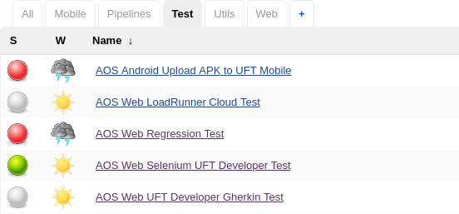



1. Verify that your **UFT Dev Agent** is active from IntelliJ by finding the UFT Dev icon at the top.

NOTE: since this icon doesn’t always appear, you can also just Disable/Enable UFT Dev from the menu.

1. Click **Build Now** and watch the console (click the ball icon). Wait for the job to finish.

The job should **pass**. This happens because the price in our UFT Dev Gherkin test matches the expected price**.**

1. To see this result in an HTML report, select the **AOS Web UFT Developer Gherkin Test** and click the **UFT Dev icon** to view the results (right click to open it in a new tab).
2. The test we ran does not yet exist in Octane. Next, we’ll build a new test in Octane and run that.  
   From **NimbusServer**, open a new browser tab to the **Octane** shortcut.
3. **Login** to Octane (sa@nga, Password1).
4. Navigate to the **Quality** module -> **Tests** tab.

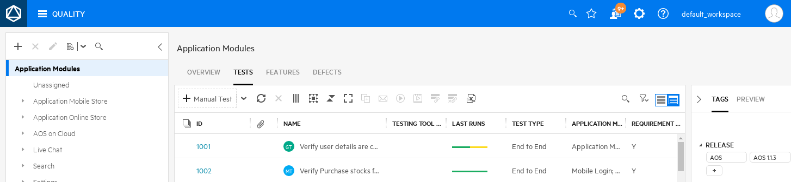

1. Select the **+ button** and create a new **Gherkin Test** and name it **UFTDev_Gherkin**.

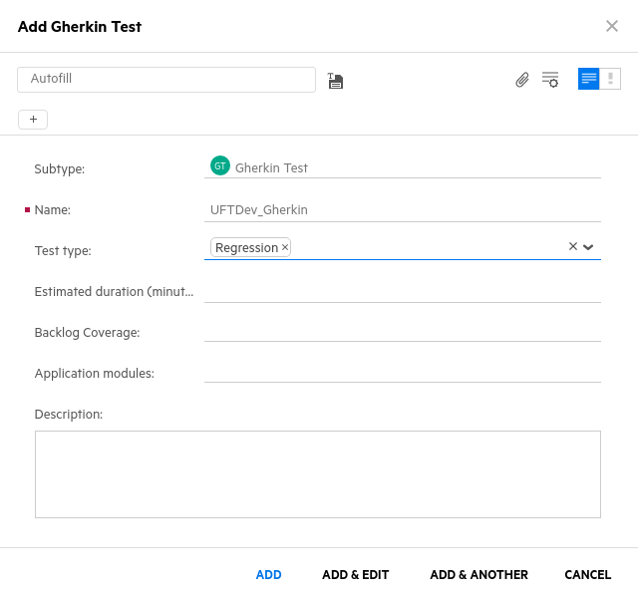

1. Verify that the **Subtype** is a **Gherkin Test**.
2. Change the **Test Type** to be **Regression**.
3. Click **Add & Edit**.
4. **Type** the following Gherkin code in to replace **Feature.**

Make sure you have **blank lines** between sections.

**Do not change any other section or text**.

**Feature: Advantage Online**

**verify multiple scenarios**

**Scenario Outline: verify mice color**

**Given I am in the site**

**And I select the Mice category**

**When I filter by "<color>" color**

**Then the mouse price is "<price>"**

**Examples:**

**| color | price |**

**| white | $29.99 |**

**| purple | $15.99 |**

1. **Save** your changes by clicking the floppy disk symbol.
2. Click the **Details** tab and set the **Owner** to be **sa@nga**



1. Change the Automation state to be **Ready for automation**



1. Set the Backlog Coverage to **Advantage Online Store -> Advantage Online Store Purchase** as shown.

If you can’t find this backlog item, select one on your own – it’s not critical that you choose this one.

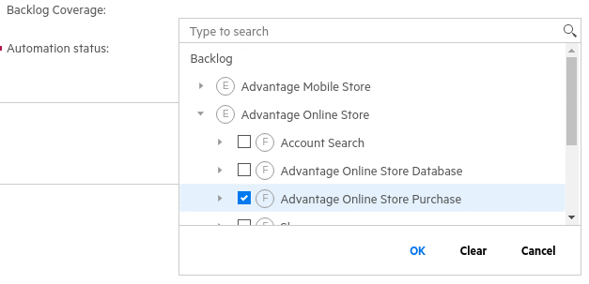

1. **Save** your changes again by clicking the floppy disk symbol.   
   By updating these settings, we make this this test visible in IntelliJ as a test needing automation and owned by someone (i.e. sa@nga).

Automating a Gherkin Feature File

Now that someone has defined a Gherkin test for us we need to automate it. Thankfully we won’t have the write the code that does this – it’s been done for us in an IntelliJ project called **uftdev-aos-web-gherkin**.

1. Switch to the IntelliJ window.
2. From the **IntelliJ** splash page **click** “**Get from Version Control”** and copy/paste the following **URL** (Version control = Git) and click **Clone**.

**http://nimbusserver.aos.com:8091/git/uftdev-aos-web-gherkin.git**

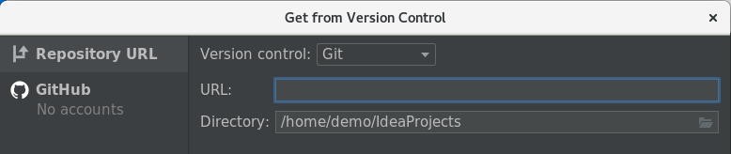

1. Click **Yes** when prompted to **Open** it.
2. Once the project loads, select **View -> Tool Windows -> Project** (or just type **Alt + 1**)

This opens the project navigation view so you can examine the project structure.

1. When a Maven popup appears, select **Enable Auto-Import**

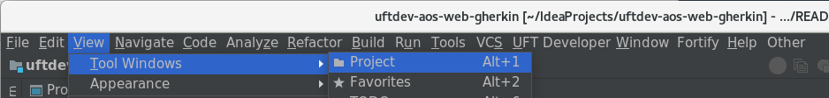

1. In the left side project view, open it up as shown below, exposing **advantage.feature**.

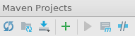Double click on **advantage.feature** to see the feature file.

NOTE – If you don’t see the full tree, click the Maven refresh icon.

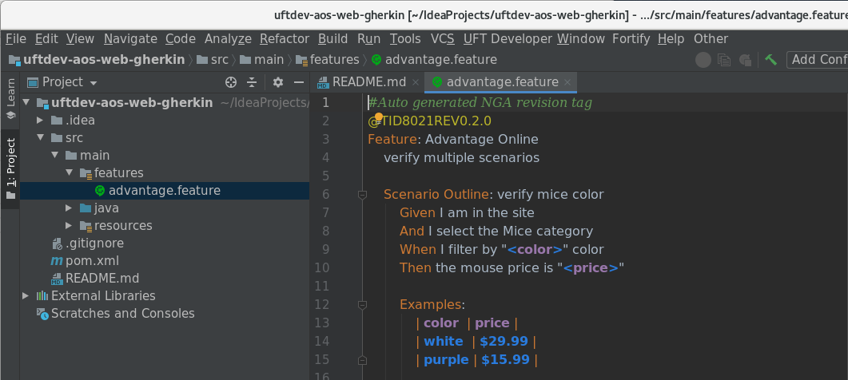

This **advantage.feature** file is similar to the one we created but is really just a placeholder for us.  
We’ll replace it in the next few steps. For now this just helps us know what we’ll eventually be creating.

1. Verify that your Octane window at the bottom is showing and connected to Octane.

If not, from the IntelliJ top menu select Tool Windows -> ALM Octane.

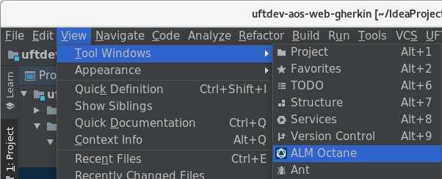

A window at the bottom will open displaying tasks and tests that might need your attention.

If this windows doesn’t connect, **click** the link and enter your Octane credentials and test it.  
 ( http://nimbusserver.aos.com:8085/ui/?p=1001/1002 sa@nga Password1 )  
  
NOTE: Sometimes IntelliJ will forget your password when you switch IntelliJ projects.

1. In the Octane plug-in window at the bottom, right click on your UFTDev_Gherkin test and select the option **Download Script**.

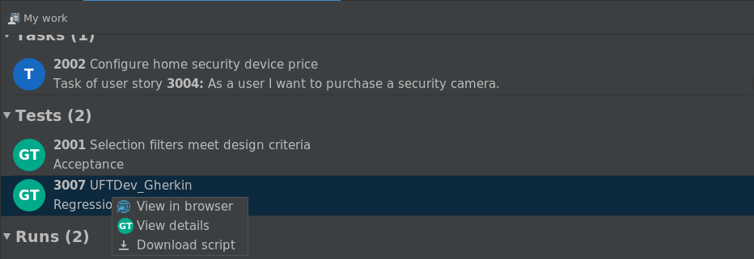

1. Choose to put the feature file into the **src/main/features** directory – you may need to scroll down.  
   Click **OK**.

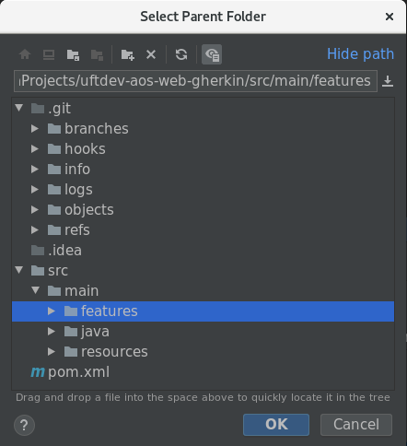

1. You’ll see a new Feature file appear in the feature folder (in red).

We now have to put that file under Git control to get it officially part of this project.

**Select** the new file and **right click** and choose **Git -> + Add** (the file name will turn green)

(HINT: You can also do this with CTRL + ALT + A)

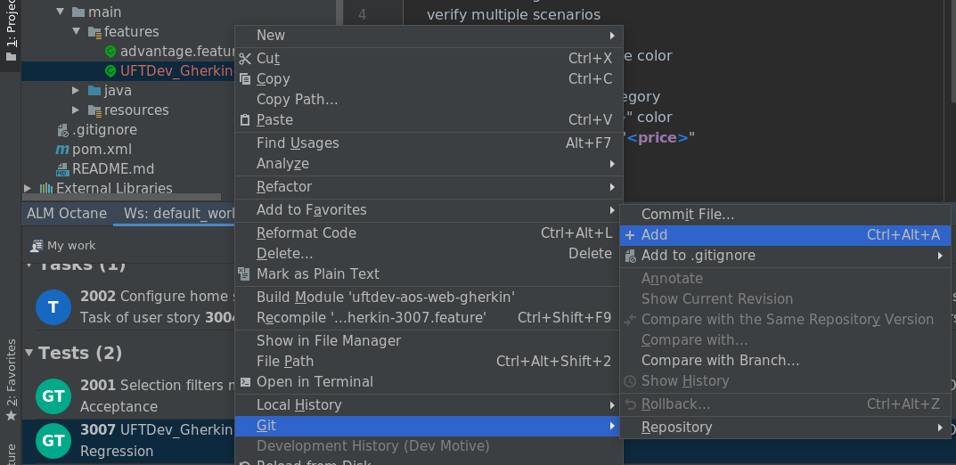

1. In the Project tree under **java > net.mf > presales**, double click on the **LeanFtTest** java file.

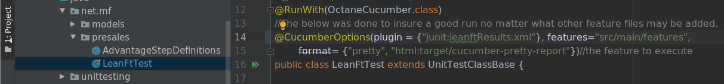

1. In the code on **line 14**, change the section inside the quotes to read:

**features="src/main/features"**

This will allow this and any future feature files to be part of this project.

1. Select the original **advantage.feature** file from the left Project tree and **delete** it (we won’t need it).

|  |
| --- |
| NOTE: The ID that’s attached to the feature file name allows it to be tracked to Octane.  You can stay with this new feature file for all your future demos. |

1. Select **VCS -> Commit** and enter “**Updated Octane feature file**” as the commit message and hover over the **Commit** button and choose **Commit and Push**. If a warning comes up just click Commit and Push and if it asks for an email use [admin@default.com](mailto:admin@default.com).
2. In the **Push Commit** window select **Push**. Ignore any items about Warnings.

You should see a **1 File Committed** message.

1. To verify that your changes worked, **right click** on the **LeanFtTest** under java>net.mf>presales and select **‘Run LeanFtTest’** (or select Ctrl + Shift + F10)

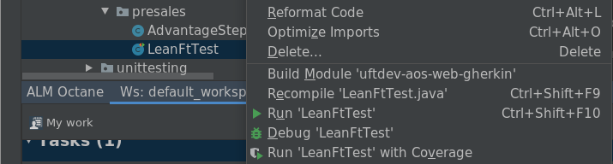

1. An execution window will open at the bottom and then a browser will open and start running the test.  
   If everything went fine it should run two scenarios and they should both pass.

If you get an error, click the “Reimport All Maven Projects” option and then select

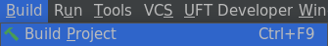**Build -> Build Project**

Then try to ‘**Run LeanFtTest**’ again.

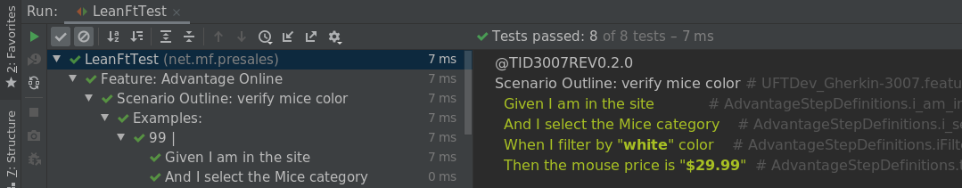

1. Switch back to Jenkins and run (build) the **AOS_Web_UFT_Developer_Gherkin_Test** job.  
   It should run **successfully** now!

|  |
| --- |
| What did we just do?  By swapping the feature file and linking it to Octane, we essentially replaced the original Gherkin test (that wasn’t stored in Octane) with one now managed by Octane. Going forward, we can make changes in Octane to the Gherkin code and it will sync them with the test that runs in Jenkins. |

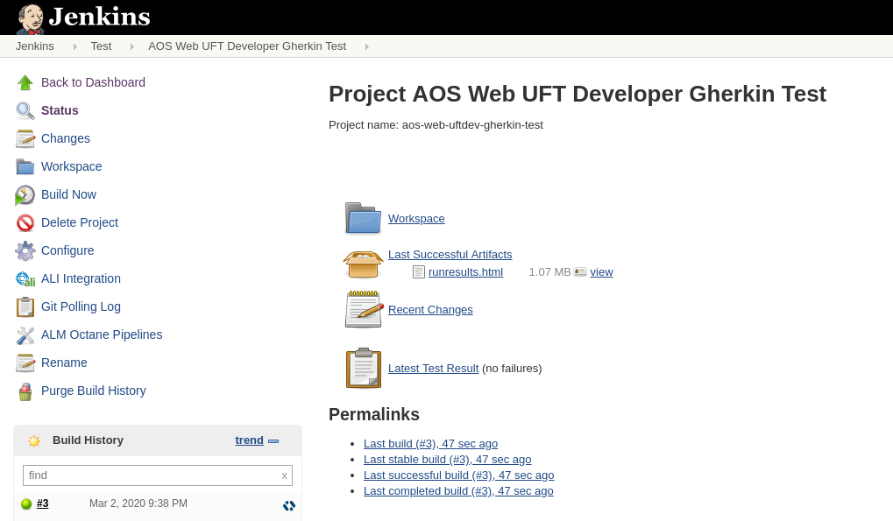

1. Click on the **UFT Dev RunResults** icon to see the detailed UFT Dev report for your Gherkin test.

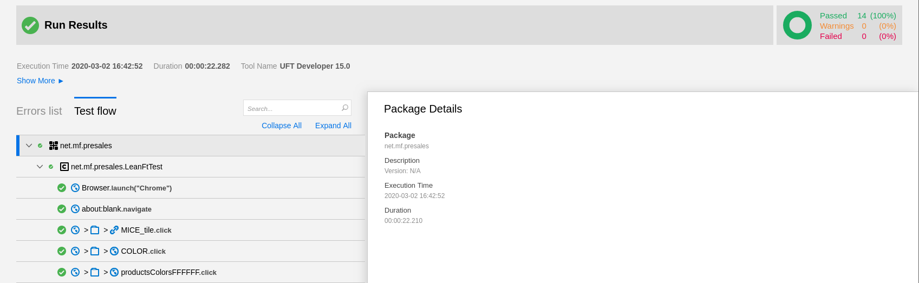

1. To get our results into Octane we need to create a pipeline for it.  
   Switch back to **Octane** and select the **Pipelines** module.
2. Click the **+** sign and add the **AOS_Web_UFT_Dev_Gherkin_Test** pipeline.

Name: **Jenkins CI**

Job: **aos-web-uftdev-gherkin-test**

Pipeline name: **aos-web-uftdev-gherkin-test**  
Click **Save.**

1. **Select** and **Run** the pipeline (it should pass).

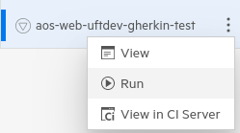

1. **Navigate** to the **Quality -> Tests** module in Octane and locate your test (probably at the bottom).

Try searching for **Gherkin**  
  
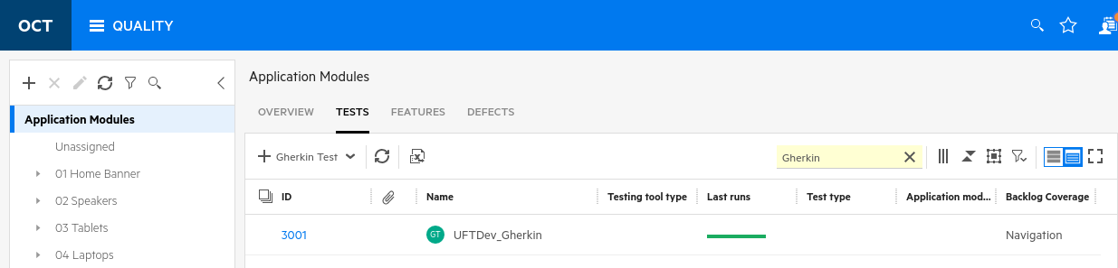

1. **Locate** your test and click on its numeric link to see your results (in the **Runs** tab).

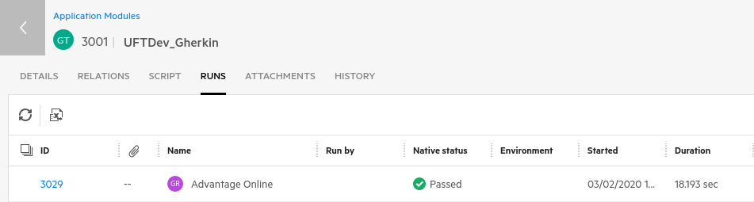

Exercise 13: Creating Testing Jobs in Jenkins

**Role: Integration or Automation Engineer**

Projects (or jobs or builds) and pipelines form the basis of what Jenkins manages. In this section we’ll automate running a UFT One test from both a file location and from within ALM QC. Normally you would pull a file-based test from an SCM but for this example we’ve not included that.  
  
NOTE: This exercise requires that the **UFT Dev Agent** is **NOT** running on NimbusClient (since we’re using UFT One, only one test type is allowed at a time).

Running a UFT One test from a file

1. We need to have the following VM’s running for this exercise:

* NimbusServer
* NimbusClient

1. Start the following Docker containers for this exercise.

**$ nimbusapp devops:3.2.3 start**

**$ nimbusapp aos:3.2 start**

1. Open a CMD window on NimbusClient and run the following two commands to get a copy of the **AOS_UFT_WEB_Regression** in the Documents/UFT One folder :

**git clone http://nimbusserver:8091/git/uft-one-aos-web-regression.git**

**Xcopy /E /I uft-one-aos-web-regression\AOS_UFT_WEB_Regression C:\Users\demo\Documents\UFTOne~1\ AOS_UFT_WEB_Regression**

1. From a browser on **NimbusServer**, open the Jenkins shortcut.  
   Verify that your connection to **nimbusclient_uft** is enabled and looks like this:  
   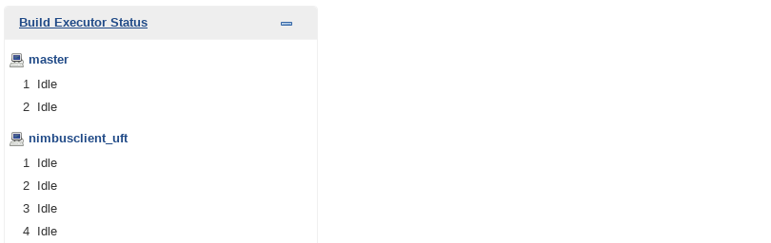

The four **idle** connections indicate that you can run up to four Jenkins jobs at once.

If not, try rebooting NimbusClient and wait about 5 minutes for it to connect.

1. From the **Jenkins** main dashboard, select **New Item**.  
   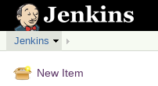
2. Select **Freestyle project** and enter the item name: **AOS_Web_Regression_Test_UFT_File**

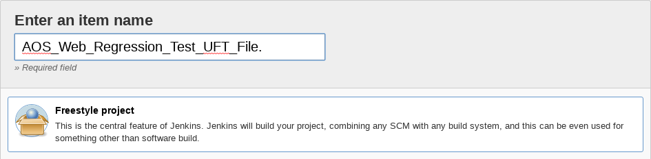

1. Click **OK**. This will save the file and bring you into the **Configure** section of this job definition.
2. In the **General** section select the checkbox **Restrict where this project can be run** and type **nimbusclient_uft** (lowercase) into the label expression.  
     
   You may need to backspace the last space character for Jenkins to accept the text.

By restricting where this job is run, we are ensuring that this UFT test runs on the Windows platform (NimbusClient) since UFT One tests must run on a Windows machine.

1. Scroll down to the **Build** section and select **Add Build Step**
2. Select **Execute Micro Focus tests from file system**
3. In the **Tests** box type:  
    **C:\Users\demo\Documents\UFTOne~1\AOS_UFT_WEB_Regression**

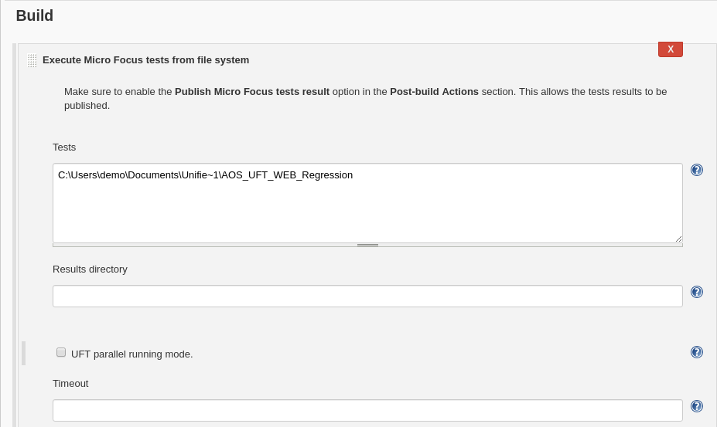

1. In the **Post-build Actions** section, click **Add post-build action** and select  
   **Publish Micro Focus tests result** and set the value to be **Always Archive test reports**.

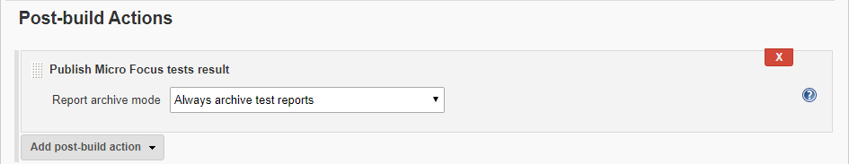

1. Click **Save** to save your changes.

|  |
| --- |
| What did we just do?  We’ve just created a simple Jenkins job that will run a UFT test on NimbusClient and save the HTML results so that it’s viewable in Jenkins. This job could now be part of a larger pipeline of activities. |

1. From Jenkins, click **Build Now** on the left side.



This will start running your job which executes a UFT test on the NimbusClient VM.  
If you like, you can switch to the **NimbusClient VM** and watch the test execute.

1. As the test runs, you’ll see a flashing ball symbol and a progress bar.

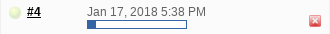

**Click** on the flashing ball to see a textual console description of what’s happening.

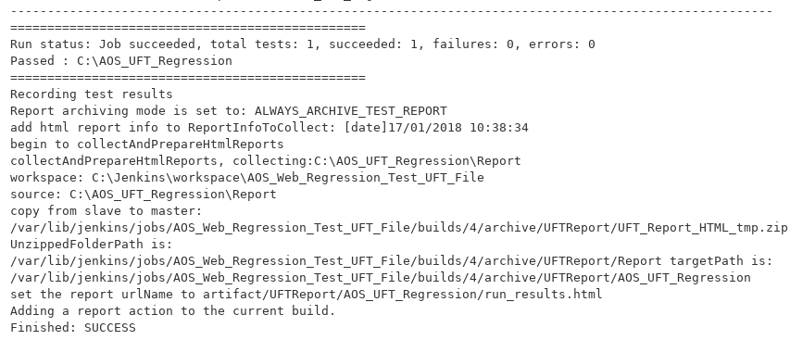

1. After the console data finishes, click on the **Last Successful Artifacts**



1. Next, click on the left side **UFT Report** to see the **HTML Run Results** report.

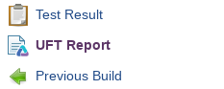

1. Right Click on the **AOS_UFT_Regression** link to have Jenkins open the report in a new tab.

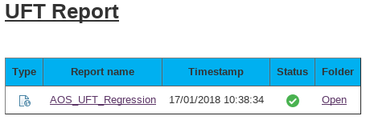

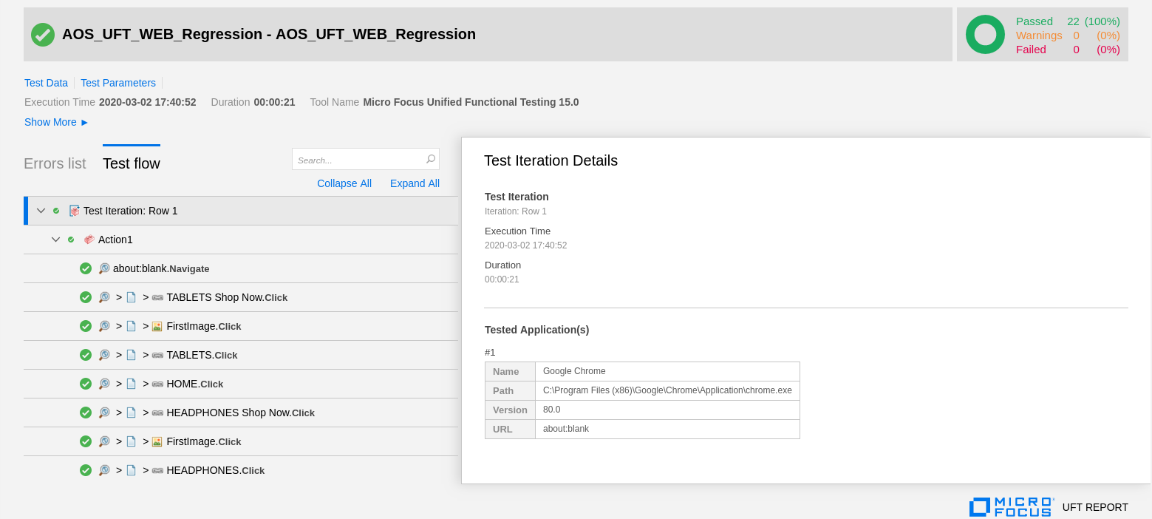

**Great!**

**You’ve run a UFT One Test from Jenkins on a different machine!**

Running a UFT One test from ALM QC

In this section we’ll configure Jenkins to run a test that’s stored in an ALM QC project.  
Initially we’ll copy the test we just used into the AOS project tree and then we’ll set up a Jenkins job to run it.

**Setting up ALM**

1. Start the ALM container by running the following command from **NimbusServer**:

**$ nimbusapp alm:16.0.1 start**

1. **Wait** for ALM to finish booting up (watch your **System Monitor**).
2. From **NimbusClient**, open **Internet Explorer** and select the **ALM/QC** shortcut from the **ADM Products** folder shortcut ( http://nimbusserver.aos.com:8082/qcbin/ ).
3. Select the **ALM Desktop Client** link and (if prompted, choose to **Install** the client.) enter your ALM QC login credentials (admin, Password1) and select to connect to the **DEFAULT** domain and **AOS** project. (NOTE: Not the **AOB** project)
4. From **IE** in the left side menu select **Testing -> Test Plan** and create a new **Folder** under the **Subject** folder called **Regression**.  
     
   

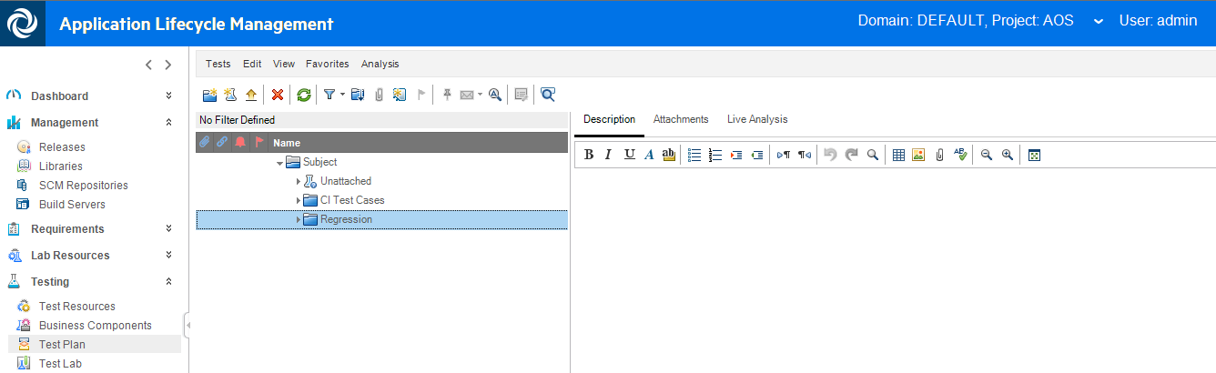

1. Start **UFT** **One** from the desktop shortcut (**ADM Products** folder > **Micro Focus Unified Functional Testing**) and select just the add-in for **Web** and open the following test:

**C:\Users\demo\Documents\Unified Functional Testing\AOS_UFT_WEB_Regression**.

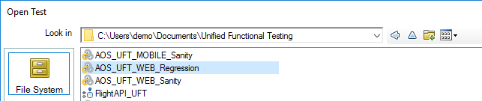

1. From **UFT One**, select **ALM -> ALM Connection** from the menu and enter the same credentials   
   (http://nimbusserver.aos.com:8082/qcbin/ admin, Password1, DEFAULT, AOS) and then click **Close**.

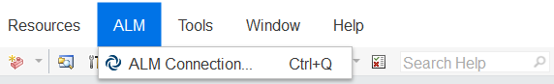

1. From **UFT One**, select **File -> Save AOS_UFT_Web_Regression as** into ALM in the **Regression** folder in the test plan (see screenshots below).

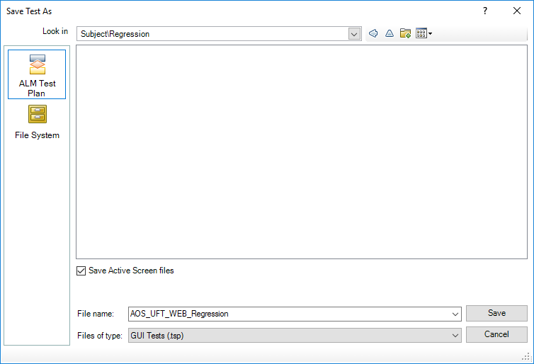

If you switch back to ALM it and refresh it, it should look like this:

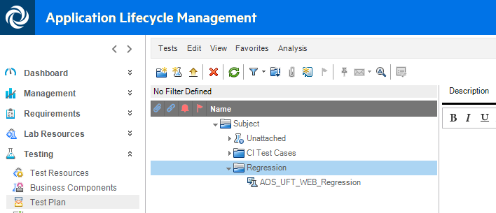

1. From ALM QC in IE select the **Test Lab** module and create a folder under the **Root** folder called **Regression**. This is different from what you did before.

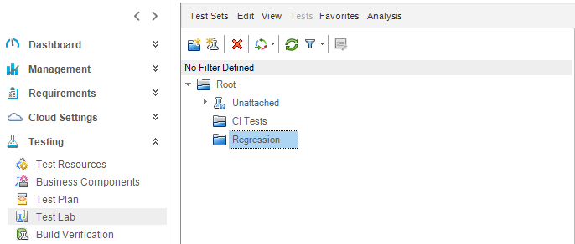

1. Under the **Regression** folder, create a **Test Set** called **AOS_Regression_Testset**.
2. Click **Select Tests** and **add** the **AOS_UFT_Regression** test to the **AOS_Regression_Testset** as shown.

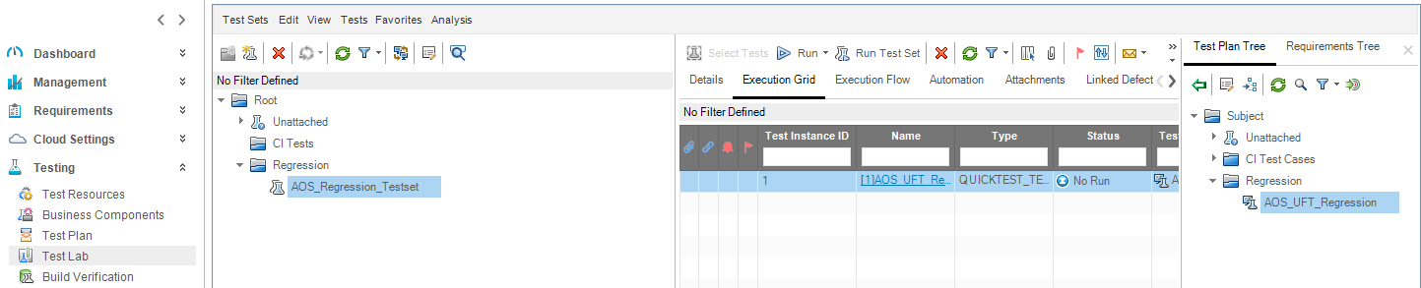

**Setting up Jenkins**

1. At this point you can **close** **UFT One** and **Internet Explorer**.
2. Open a **new tab** in **Chrome** on **NimbusServer** and select the **Jenkins** shortcut.
3. From the Jenkins main dashboard, select **New Item**.



1. Select **Freestyle project** and enter the item name: **AOS_Web_Regression_Test_UFT_ALM**
2. Click **OK**. This will save the file and bring you into the **Configure** section of this job definition.
3. In the General section select the checkbox **Restrict where this project can be run** and type **nimbusclient_uft** (lowercase) into the label expression.

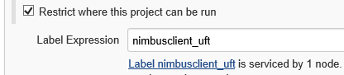

1. Scroll down to the **Build** section and select **Add Build Step.**

Select **Execute Micro Focus functional tests from Micro Focus ALM**

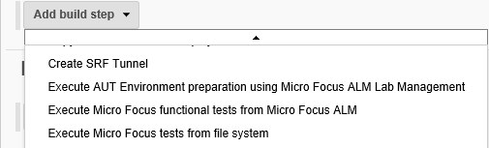

1. **Set** the following fields:

Client ID:  **<leave blank – despite the warning>**

Client Secret:  **<leave blank – despite the warning>**  
User name: **admin**  
Password: **Password1**  
Domain: **Default**  
Project: **AOS**  
Test Sets: **Root\Regression\AOS_Regression_Testset**  
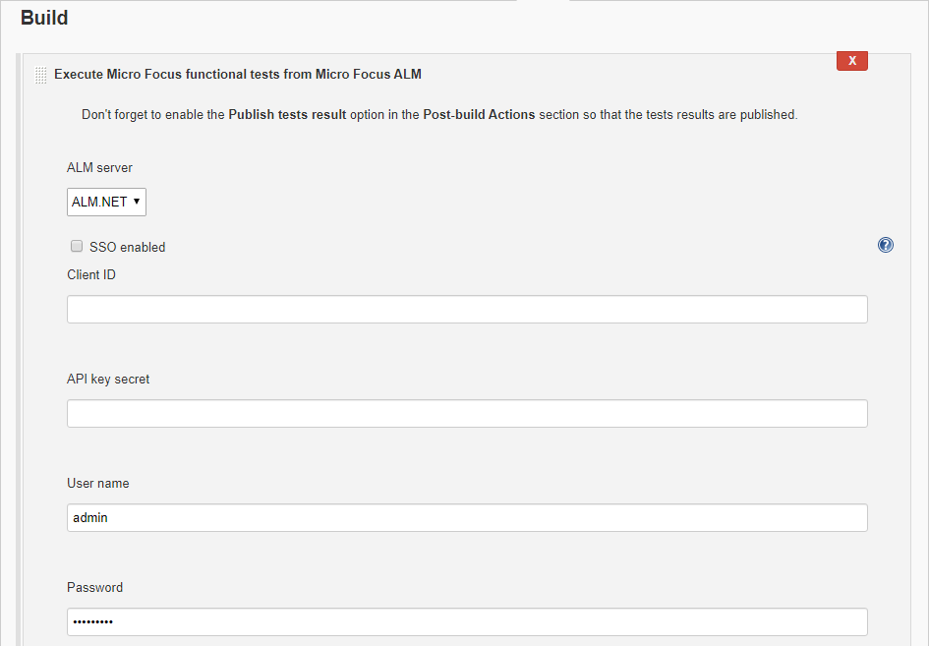

1. In the Post-build Actions, add the **Publish Micro Focus tests result** and set the **Report Archive** mode to **Always archive test reports** and click SAVE.



1. From the Jenkins dashboard, select the **All** view tab and locate your new job.  
   
2. Click on the **AOS_Web_Regression_Test_UFT_ALM** linkand select **Build Now**.  
   This will start running your job which executes the UFT test from ALM on the NimbusClient VM.  
   If you like, you can switch to the **NimbusClient VM** and watch the test execute.
3. As the test runs you’ll see a flashing ball symbol and a progress bar.



1. **Click** on the flashing ball to see a textual console description of what’s happening.  
   Locate the link to your test results in ALM QC (HINT it begins with td:// )  
   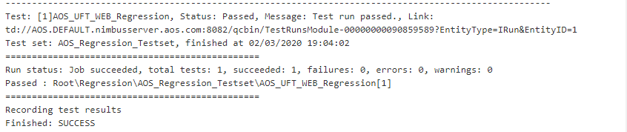

14. Copy and paste that link into Internet Explorer (must be logged into ALM/QC) to see your results!

Bonus Question #1

How can you find the results of a previous build? Select the ball icon for that run.  
____________________________________________________________________________________

Bonus Question #2

Where can you see the HTML results of the test run from ALM? In ALM under the Test Runs module.

____________________________________________________________________________________

Challenge Exercise #1

Create one Jenkins project that runs both the UFT One from File and UFT One from ALM tests.

Exercise 14: Integrating UFT One tests in Octane

Octane can integrate with existing UFT tests that are stored in Git (either locally or in GitHub) and be able to run those tests and track their results. This exercise explains how to configure this integration and execute UFT tests from Octane as a pipeline build.

Configuring Jenkins for UFT execution

Jenkins acts as the script executor when running UFT tests from Octane. In order for Jenkins to run UFT tests it needs to connect to a windows machine with UFT One installed on it. Jenkins also need an execution node configured for that machine. These have already been configured for our Nimbus environment.

1. We need the following VM’s to run this exercise:

* NimbusServer
* NimbusClient

1. Start or verify the following running Docker containers for this exercise.

**$ nimbusapp octane:16.0.400.79 start**  
**$ nimbusapp aos:3.2 start**  
**$ nimbusapp devops:3.2.3 start**

1. From the **NimbusClient**, open a browser and open the **Jenkins** shortcut link.
2. Verify that the **nimbusclient_uft** node is online.  
     
   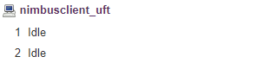

If it shows open a **PowerShell admin** window on NimbusClient and run the following commands:

C:\Users\demo> **cd C:\jenkinsagent**

C:\jenkinsagent> **StartJenkinsAgent.ps1**

Wait at least a minute and then check if the agents come online.

If they still don’t show as Idle, check with your instructor.

Configuring a Git repository for UFT tests

In order for Octane to manage UFT tests they must be stored in either a local or remote Git or Subversion repository. Luckily, our devops image has just such a repository already located at http://nimbusserver:8091/git

In this section we’ll create a new, empty repository (bare) in the devops container and then clone that to NimbusClient. This creates a remote repository where we can store UFT tests. Then we’ll copy some pre-existing tests into that directory and push them into the Git repository on devops.

Git is actually a fairly simple, yet powerful version control system. Once you initialize a Git repository (it’s just a directory), anything you place in that directory can and will be managed by Git. You just have to run a commit command to place them under Git’s control.

There are two types of Git repositories – local and remote. Typically, you “pull” from a remote repository and you get a local repository where you can work and make changes. When you’re ready to share those changes, you “push” them back to the remote so everyone else can see them.

**Basic Git commands:**

|  |  |
| --- | --- |
| Command | Description |
| git init | Creates a git repository in the current directory. All files and directories (recursively) in that directory can be managed by git. Git places a .git folder in this directory and stores its information in there. |
| git init --bare | Creates an empty git repository. Usually used to create an empty remote repository which is cloned elsewhere and then files added locally and pushed to the remote. |
| git add myfile | Git adds the file “myfile” to its repository of tracked files. This file is called “staged” since it’s ready to be committed. Git add is often used ad “git add .” to add all files in a directory. |
| git commit –m “message” | Git commits all the “staged” files and create a “branch”. Once a commit is done, the directory and Git’s snapshot of the directory are in sync. Git requires a message (describing what was done) to be supplied. |
| git remote add origin URL | Git assigns a remote repository URL to the local repository for pushing and pulling. |
| git push | Git pushes its latest snapshot of the repository to a remote repository. |
| git pull | Git pulls files and directories to your local repository |
| git clone | Git creates a copy of a remote repository and remembers and sets the remote repository location. |
| git status | Git shows the status of the current repository and lists the files in staging. |

1. On the NimbusServer VM, open a terminal window.
2. From the terminal window type the following commands (do not type the prompt commands - $ or #):

**$ docker exec -it devops bash (or $ de devops)**  
**# git init --bare /gitrepo/UFT_Tests.git  
# chmod -R 777 /gitrepo/UFT_Tests.git**

NOTE: The UFT-Octane integration insists that the remote directory ends in .git.  
That’s not all bad since naming a Git repository ending in .git is a recognized common practice.

1. Switch to the **NimbusClient VM** and open an Explorer window and navigate to **C:\Users\demo\Documents\UFT One**
2. Open a command window in this directory by selecting in the path bar and typing “cmd” + RETURN

Type “cmd” + RETURN



1. Type the following command in the CMD window:

**git clone http://nimbusserver:8091/git/UFT_Tests.git C:\UFT_Tests\**

Ignore the message about cloning an empty repository. This command does two things:

* 1. Creates a copy of the empty directory in this remote repository
  2. Sets the remote locations for this local repository to be the specified URL.

1. From the command window, **copy and paste** the following commands:

**git clone http://nimbusserver:8091/git/uft-one-aos-web-regression.git**

**git clone http://nimbusserver:8091/git/uft-one-aos-web-sanity.git**

**Xcopy /E /I uft-one-aos-web-regression\AOS_UFT_WEB_Regression C:\UFT_Tests\AOS_UFT_WEB_Regression**

**Xcopy /E /I uft-one-aos-web-sanity\AOS_UFT_WEB_Sanity C:\UFT_Tests\AOS_UFT_WEB_Sanity**

1. Git also needs to be configured with your global user and email. Type the following commands:

**git config --global user.email <your email address>**

**git config --global user.name "<your first and last name>"**

1. **Close** the command window.
2. Navigate to the **C:\UFT_Tests** folder that was just created in steps 5 and 6.

NOTE: When Git clones these repositories it removes the .git extensions.

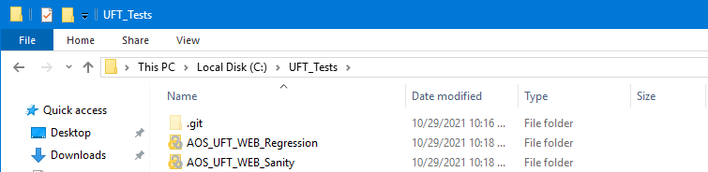

1. Close any explorer windows and open UFT One from the desktop ADM Products Folder (**Micro Focus Unified Functional Testing** icon) and load just the **Web** add-in.
2. Open the UFT One project: **C:\UFT_Tests\AOS_UFT_Web_Regression**
3. From the **View** menu select the **Output** option. At the bottom of your UFT One window you’ll now see the **Ouput** tab. This window will allow you to view the Git commands as they are executed.

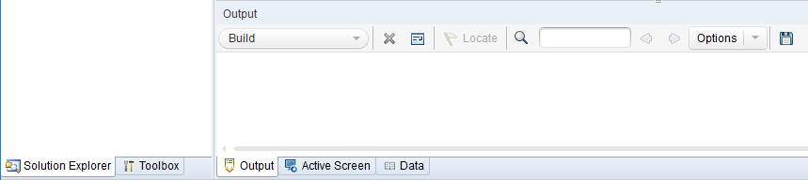

1. Notice below, the small **red** symbols on this project that indicate that this project is not yet in sync with Git. These will turn **green** when the project has been committed.

From the **Solution Explorer** panel on the left, select the **AOS_UFT_Web_Regression** project at the top and right click to bring up the project options and select **Git Commit**.

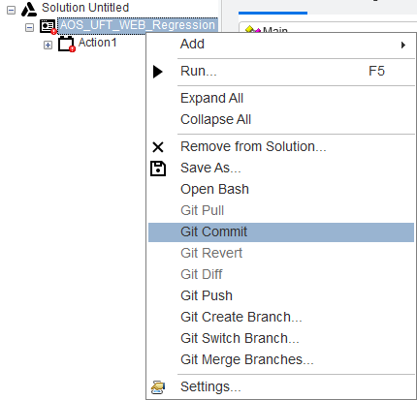

1. In the Commit message text box type “**Initial commit**” and click **OK**.

You should see status messages in the Output window and your project icons should turn **green**.

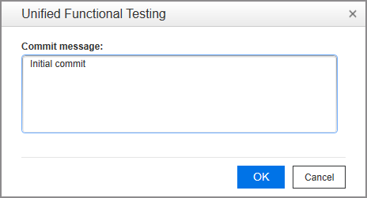

1. Again, select the **AOS_UFT_Web_Regression** project and right click to bring up the project options
2. 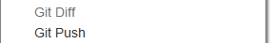Select **Git Push.** Click **OK** on the warning popup.

This will push this project to our remote Git repository in the devops container.

When prompted, enter **root** for the Login and **Password1** for the password and click **OK**.

It’s important that we do both a “**Commit**” and a “**Push**” for any repository we create.

1. Select **File->Close Solution** (or CTRL+Shift+F4) to close this project.
2. Perform steps **11-17** again, substituting **AOS_UFT_Web_Sanity** for the UFT One project name.
3. **Close** UFT.

|  |
| --- |
| What did we just do?  We created a Git folder on C:\ to hold all of our UFT Tests that are managed by Git. Then we copied two UFT tests into that folder and sync’d (committed) them with Git. Finally, we pushed those two tests to the remote folder we defined when we cloned the Git repository. Next we’ll set things up in Octane by creating a creating a Test Suite and adding our tests to that test suite. |

Configuring the Octane integration with UFT One

We’re almost ready to run our tests in Octane but first we need to tell Octane about the Git repository we created and then we have to create a Test Suite to hold our UFT One tests. We’ll do that next.

1. From **NimbusClient**, open a Chrome browser tab and select the **Octane** shortcut and login.

Name: sa@nga

Password: Password1



1. Click the **Settings** gear icon and then click on **Spaces** on the **Administrator** option.
2. Select the **default_workspace** on the left panel.

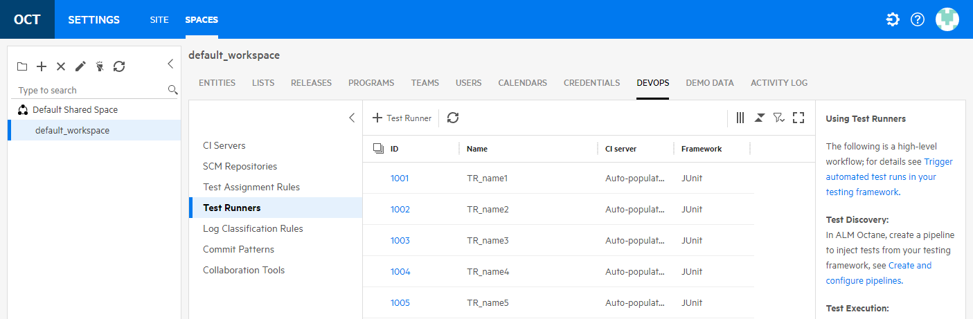

1. Select the **DEVOPS** tab on the top.
2. Select the **Test Runners** option on the left menu.

This option allows you to connect to a Git managed UFT One tools repository.

NOTE: You can only define one testing tool connection per workspace.

1. Click the **+ Test Runner** and fill out the fields as listed below.

Name: UFT_Jenkins

Framework: UFT

CI Server: Jenkins CI

SCM Type: Git

Repository: http://nimbusserver:8091/git/UFT_Tests.git

**Authentication**: New Credentials

User name: <blank>

Password: <blank>

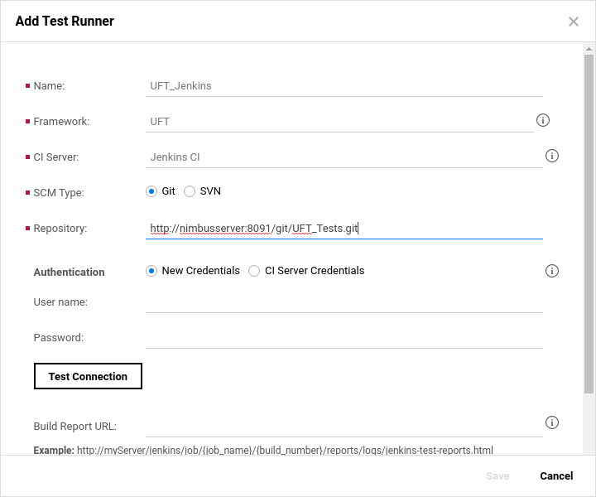

1.  Click the **TEST CONNECTION** button to make sure the configuration is correct.

If everything’s correct you’ll see

1. Click **Save** to complete the connection.

ALM Octane creates a Jenkins job that connects to the repository and discovers the UFT One tests and data tables. You can see this job in Jenkins if you open the **Test** tab (the name will be similar).



The test scripts and the data table content are available in UFT only.

If you add a new test in UFT or change an existing one, the changes are reflected in ALM Octane.



1. In Octane, select the gear icon and choose **Return to main application**.
2. In Octane, select the **Quality** module -> **Tests**
3. In the **Applications Modules** panel on the left, select the **Unassigned** option.

This will display the two UFT tests that we placed in the Git repository (refresh if they don’t show).

These tests are currently unassigned until we edit and assign them to an application module.

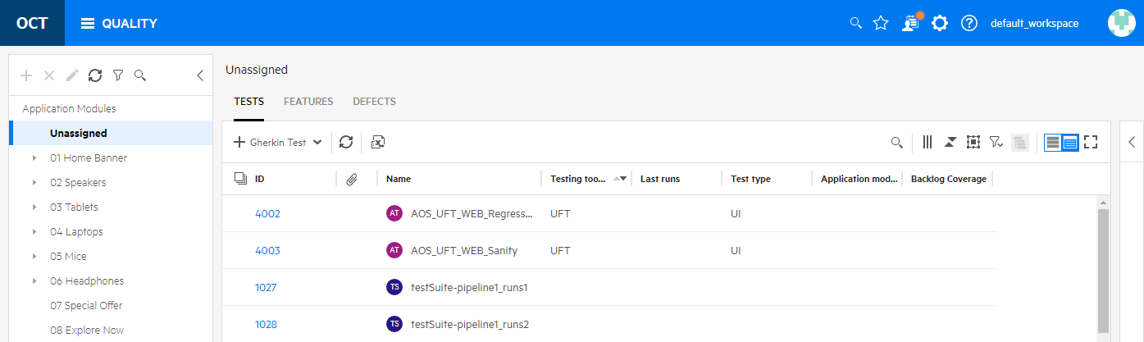

1. Next we need to create a **Test Suite** in Octane.  
   A Test Suite is a collection of tests to be run as a group or in a pipeline.  
   This is similar to a **Test Set** in ALM QC.

Select the **+** option and fill out the form as shown below.

Subtype: Test Suite

Name: AOS_UFT_Test_Suite

Test type: Regression + Sanity

Application model: Application Online Store

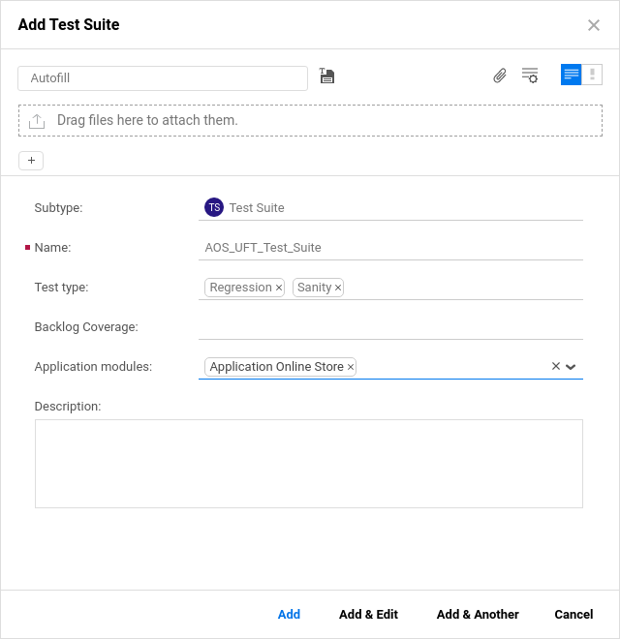

1. Select **Add & Edit**.
2. Select the **Add Existing Tests** option and click the test flask icon on the left to add tests.

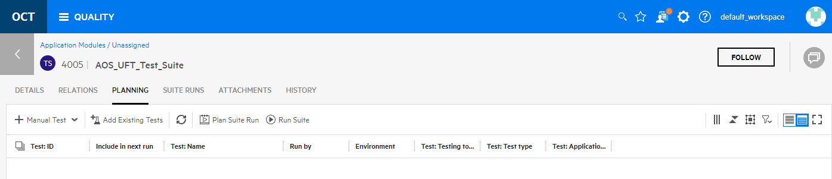

1. Select the **+ Add Filter** option and select **Subtype : Equal to : Automated Test** to select UFT One tests.

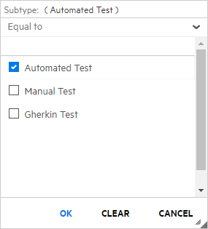

1. Select both tests and click **Add & Close** to add them to the Test Suite.

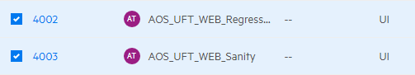

You’ve now added these two tests to the Test Suite we created. When you run this test suite, both tests will run in the order shown, top to bottom. You can also drag and drop tests to reorder them or turn on or off specific tests.

1. Click the option to **Run Suite** to run the entire test suite.

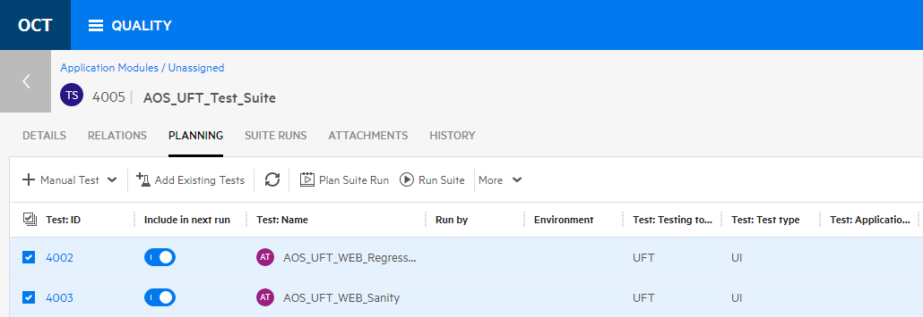

1. In the **Run AOS_UFT_Test_Suite** dialog, leave all the defaults and click **Let’s Run!**
2. If you look at the **Jenkins** tab you should see a Jenkins job starting to run.  
   Eventually you’ll see each test opening a tab in your browser and running through their test steps.
3. After the tests have finished running, wait a few seconds and then select the **Suite Runs** tab.

You should see that the Test Suite’s status now displays **Passed**.

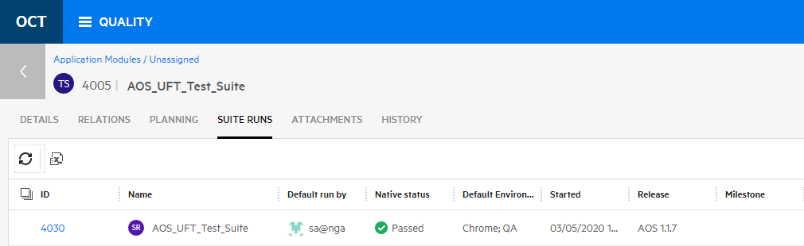

1. Select the **numeric link** for the test suite and then select the **RUNS** tab.  
   You should see both test run statuses.

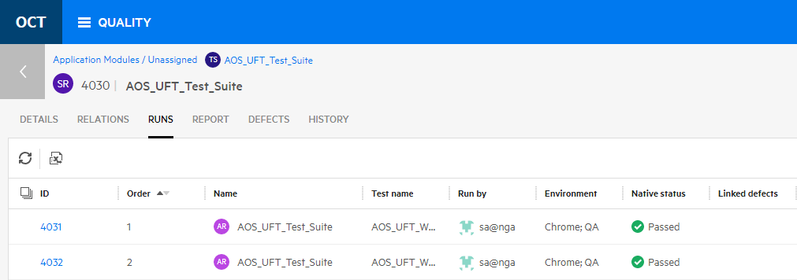

1. Select one of the test’s numeric link to drill down into the results of your automated run (AR).

From here you can go to the test, report a defect or drill into the Jenkins run results.

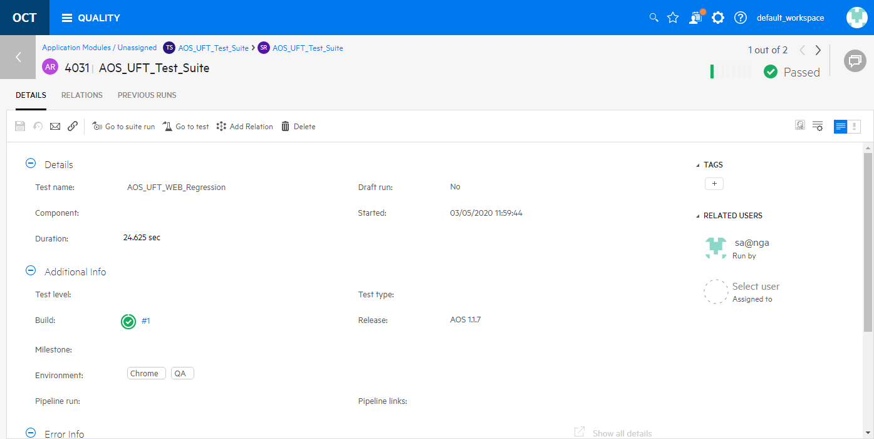

1. Select the build number (e.g. **#1** in the image above) and **Accept** any redirect to Jenkins.
2. From Jenkins, click on the **UFT Report** link and then click on the report name link to see the actual UFT One run results details.

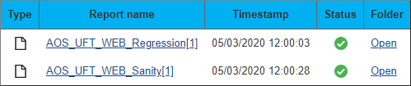

Exercise 15: Creating UFT One Tests on SAP

SAP is one of the world’s leading producers of software for the management of business processes. SAP offers several different products and interfaces to its software lineup. When creating functional or performance tests, often the most difficult part is identifying the correct data to search for and use. In this exercise we’ll provide a connected set of data that we can use for a few specific business processes.

SAP can be a bit non-traditional in some of its SAP GUI behavior. Here’s a few items to keep in mind:

* When recording, avoid using calendar pop-ups and just type the dates to the input field instead.
* Some fields may come pre-populated with a value and UFT One will not record that unless you interacted with the widget. As a result, if a field that you need to record on already has a value in it, just change the value to something else and then change it back. You can always remove that change in the script later.
* SAP is case-insensitive so any input to the SAP interface (not counting customer data) can use lower, upper or mixed case.

Configuring UFT One and the SAP VPN

1. We need the following VM’s to run this exercise:

* NimbusClient

1. In the **ADM Solutions** folder (on the desktop), click on the **SoftEther VPN Client Manager**.

Double-click the **SAP-VPN** connection to connect to the SAP system.  
NOTE: If you don’t have this connection, you can import it from the FTP site in the SAP folder.

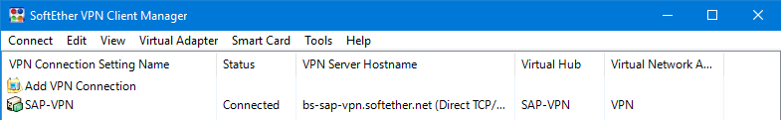

1. From ADM Solutions folder – launch **Micro Focus UFT One** and select all the **SAP** plus the **Web** add-ins.

We’ll use the Web add-in later when we record against Fiori, which has a web interface.

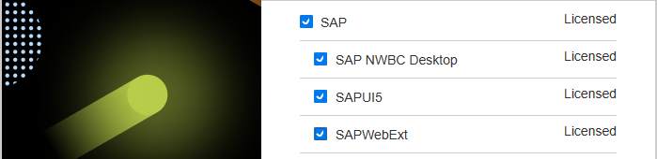



Understanding the VA01 Transaction on SAP Gui

SAP has a concept of “transaction codes” or T-Codes which are shorthand notations for specific business transactions. As users repeat the same process over and over, they become familiar with specific T-Codes and can skip the normal navigation and just type in their T-Code. This saves a lot of time during data entry.

In this exercise, we’ll use T-codes **VA01** (Create sales order) and **VA02** (Modify sales order).

1. Start the **SAP Gui** interface by double-clicking **SAP Login** from the **ADM Solutions** desktop folder.
2. We’ll start by getting familiar with our business process **VA01** before we start recording. That way we know what to do and how to fix any issues that might come up during recording.

Double-click the **S4/HANA 2020 FPS01** option in the SAP Login application.

This will bring you to the SAP Gui login page.

1. Enter the following credentials (Note: SAP Gui doesn’t have a paste option so use **CTRL-V**):

Username: s4h_sd_dem

Password1: Welcome1

1. Enter **VA01** into the SAP T-code input area in the **SAP Easy Access** screen.

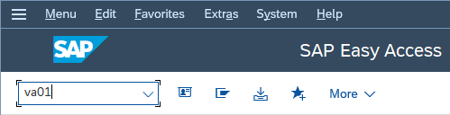

1. Enter the following data into the **Create Sales Documents** screen and hit **ENTER** or click **Continue**.

Order Type: OR

Sales Organization: 1710 NOTE: If this came pre-populated, change to 1711 then back to 1710

Distribution Channel: 10

Division: 00

Sales Office: <leave blank>

Sales Group: <leave blank>

1. Enter the following into the **Create Standard Order: Overview** screen.

Sold-To Party EWM17-CU02

Ship-To Party: EWM17-CU02

Cust. Reference: 450000019998

Cust. Ref. Date: 07/28/2022 NOTE: This date must be within one month prior to today.

1. **Scroll down** to see the table at the bottom and enter the following (use TAB to move between fields):

Item: 10

Material: EWMS4-01

Req Segment: <leave blank>

Order Quantity: 1

UN: PC

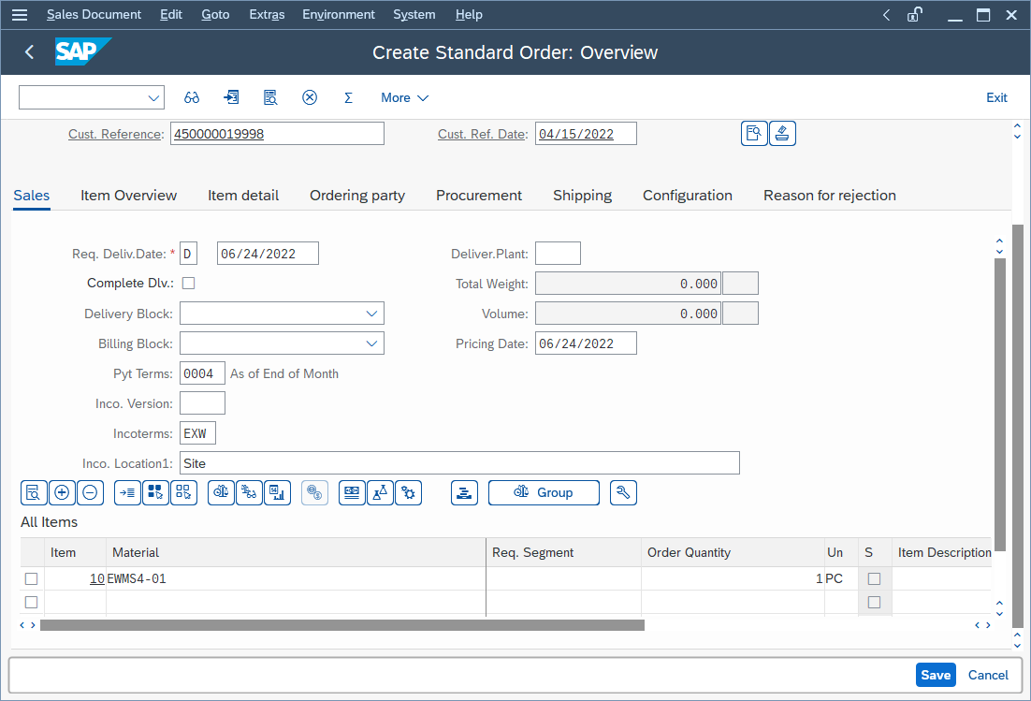

1. Click **Save** (or hit F11) and on the next page click **Continue**.

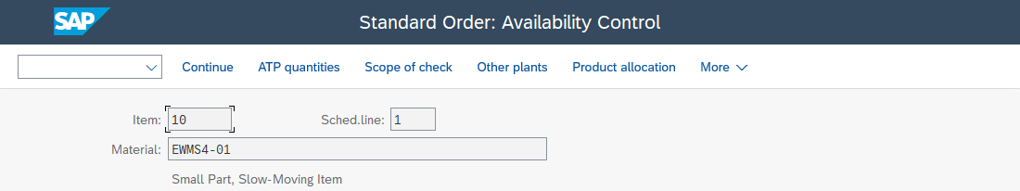

You should see an **Order Number** at the bottom of that screen (in the status bar).

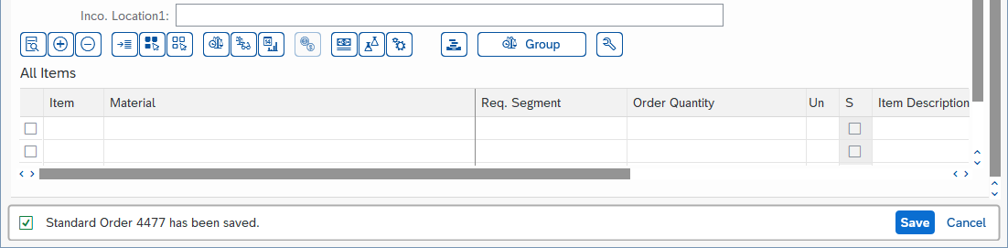

1. On the upper right corner, click **Exit** and then **Exit** again to close this session.

Click **Yes** in the Logoff window.

You should now be back at the **SAP Login** screen.

1. **Close** the **SAP Login** screen.

Now that you have a feel for the business process and where the fields and buttons are, we can repeat this as a recording in UFT One.

Recording the VA01 Transaction with UFT One

In this section we’ll repeat the process above while recording your steps in UFT.

1. Make sure all your SAP login and SAP Gui interfaces are exited and your SAP-VPN connection is still connected.
2. From UFT One, select to add a new GUI test and call it **VA01-create-sales-order** in the folder: **C:\Users\demo\Documents\UFT One.**
3. Click the **Record** button and set the following SAP-specific fields in the **Record and Run Settings** dialog as shown below:

Server Description: S/4HANA 2020 FPS01

* Enable auto-logon

User: s4h_sd_dem

Password: Welcome1

Client: 100

Language: en

* Remember password
* Do not record and run on sessions that are already open
* Wait for web pages to load before running steps

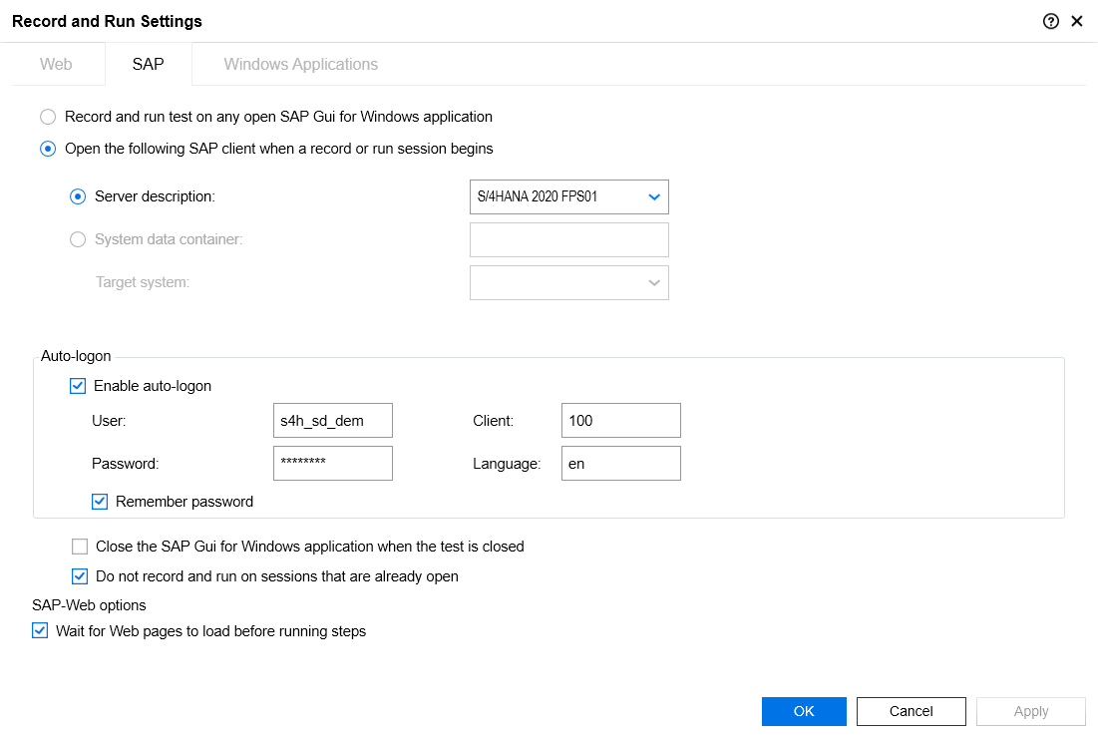

1. Click **OK** to start recording.
2. The **SAP Login** page may briefly appear and then it will transition to the **SAP Easy Access** screen.
3. Enter **va01** into the SAP T-code input area in the **SAP Easy Access** screen.

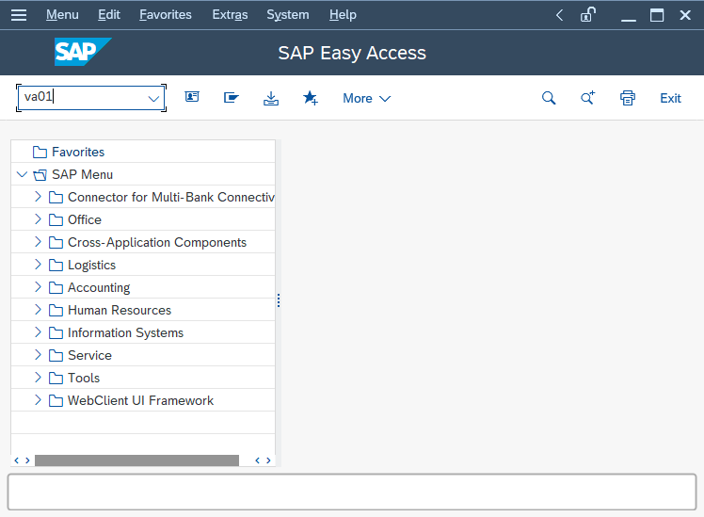

1. Resize the SAP window to be a reasonable size.  
   Enter the following data into the **Create Sales Documents** screen and hit **ENTER** or click **Continue**.

Order Type: OR

Sales Organization: 1710 NOTE: If this came pre-populated, change to 1711 then back to 1710  
Distribution Channel: 10

Division: 00  
Sales Office: <leave blank>  
Sales Group: <leave blank>

1. Enter the following into the **Create Standard Order: Overview** screen.

Sold-To Party EWM17-CU02

Ship-To Party: EWM17-CU02

Cust. Reference: 450000019998

Cust. Ref. Date: 07/28/2022 NOTE: This date must be within one month prior to today

1. **Scroll down** to see the table at the bottom and select the Item Overview tab.

Enter the following (use TAB to move between fields):

Item: 10

Material: EWMS4-01

Req. Segment: <leave blank>

Order Quantity: 1

UN: PC

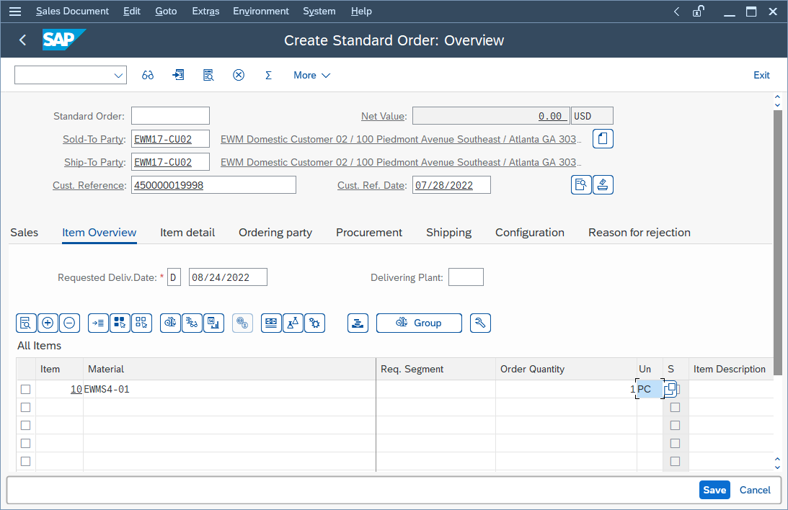

1. Click **Save** (or hit F11) and on the next page click **Continue**.

You should see an **Order Number** at the bottom of that screen (in the status bar).



1. From the UFT Recording toolbar, select to add a **Standard Output Value** and click on the Status bar at the bottom of the screen. This will allow us to capture the dynamic order number.

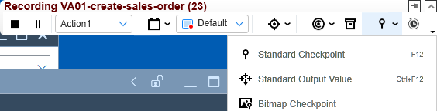

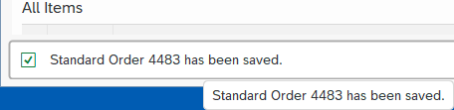

1. Click **OK** on the pop-up window confirming the object you clicked on.
2. Select the **item2** checkbox and rename the output name to be **OrderNum** and click **Modify**.

UFT is able to break apart SAP Status messages into different parts that can each be identified.

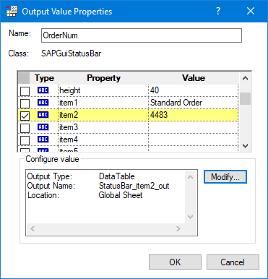

1. In the **Output Options** dialog, set the parameter name to be **OrderNumber** and click **OK** and **OK** to close the **Output Value Properties** window.

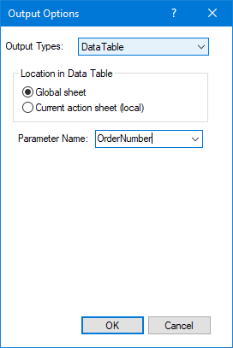

1. From the UFT Recording toolbar, select to add a **Standard Checkpoint** and rename the checkpoint to **OrderNumCheckpoint.**

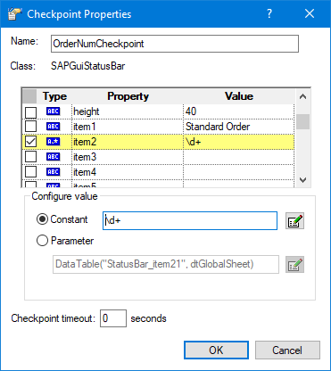

1. Choose to edit the **Constant** value and change it to be a regular expression = **\d+**

When asked if you want to “Add the backslash…” select **No**.

NOTE: The regular expression \d+ means to match digits (\d) and the + means 1 or more of them.

1. Click **OK** to close the **Checkpoint Properties** window.
2. Type **/n** in the **SAP Easy Access** T-code field to end the business process and go to the SAP home screen.
3. On the upper right corner, click **Exit** to close this session.

Click **Yes** in the **Log Off** window.

You should now be back at the **SAP Login** screen.

1. **Close** the **SAP Login** screen and **stop** recording.
2. **Examine** your test script and remove any errors, extra or duplicate statements.
3. **Run** your test and verify that it passes. If it doesn’t, go back and fix any errors – if needed, you can always re-record your steps.
4. In the results report, select to view the **Test Data** and open the **Default.xls** file and the **Global** data tab.  
   **Verify** that your order number is displayed there and that it’s **different** from what you recorded in your script.

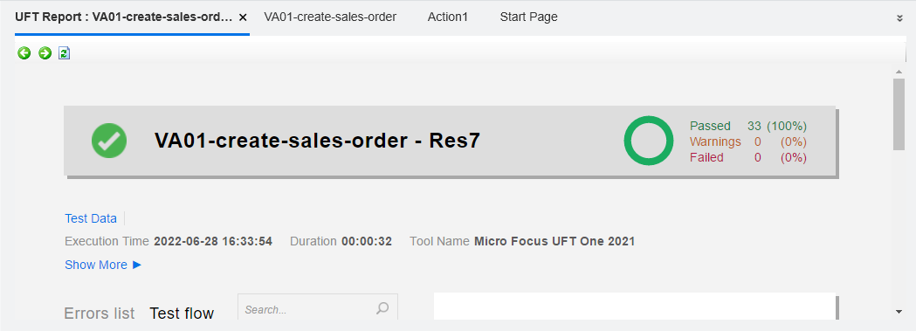

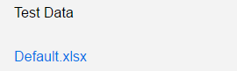

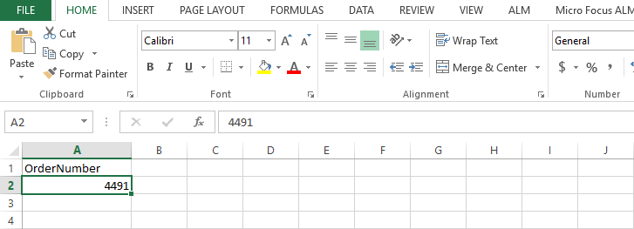

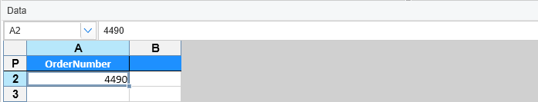

Adding the VA02 Transaction to UFT One

In this advanced exercise we’ll utilize the VA02 transaction to change our order quantity and reorganize our script with the following (exacts steps provided later):

* 1. Rename Action1 to VA01.
  2. Add two more actions (VA02 and z-exit-SAP).
  3. Save the test as VA01-VA02.
  4. Start a new recording in VA02.
  5. Replace the OrderNumber from VA02 with the value saved in VA01.
  6. Start a new recording in z-exit-SAP.
  7. Run the test to make sure it passes.

1. Organize your test to have two new actions (VA02 and z-exit-SAP) as shown below.

Each action should have its own object repository. We named the “exit” action to start with “z” so it shows last in the Solution Explorer list.

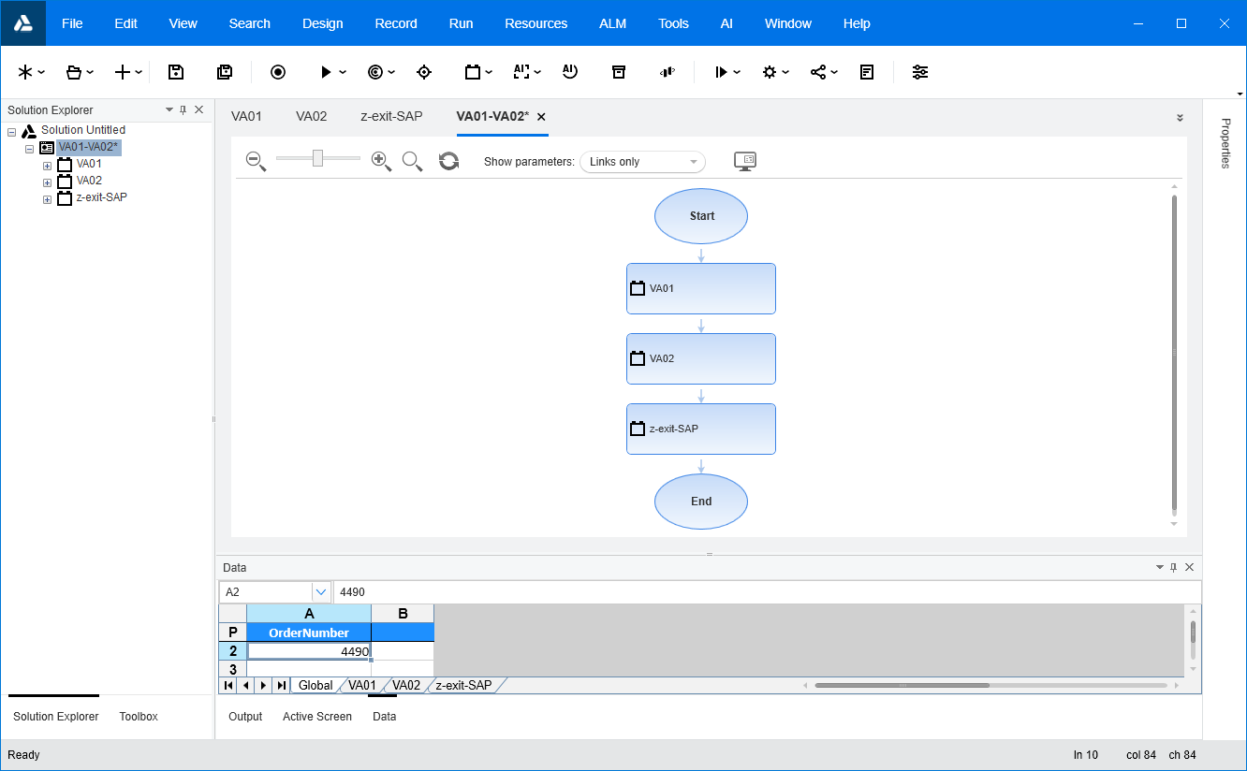

1. Save the test with a new name: **VA01-VA02**. Note the Order Number ____ that was saved with the test.
2. From the VA01 action, **remove** the following lines  
   We’ll re-record those steps in the z-exit-SAP action later.

SAPGuiSession("Session").SAPGuiWindow("SAP Easy Access").SAPGuiButton("Exit").Click

SAPGuiSession("Session").SAPGuiWindow("Log Off").SAPGuiButton("Yes").Click

1. In UFT One, open the **VA02** tab and place your cursor on the first (empty) code line.

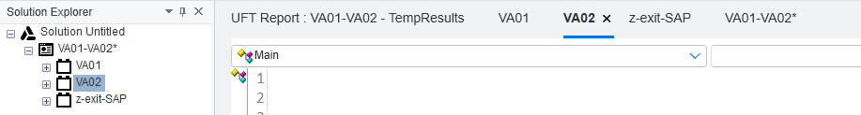

1. Enter **va02** into the SAP T-code input area in the SAP Easy Access screen.
2. Enter your previous order number (e.g. 4490) into the search field and hit **ENTER** or click **Continue**.
3. Select the **Item Detail** tab.

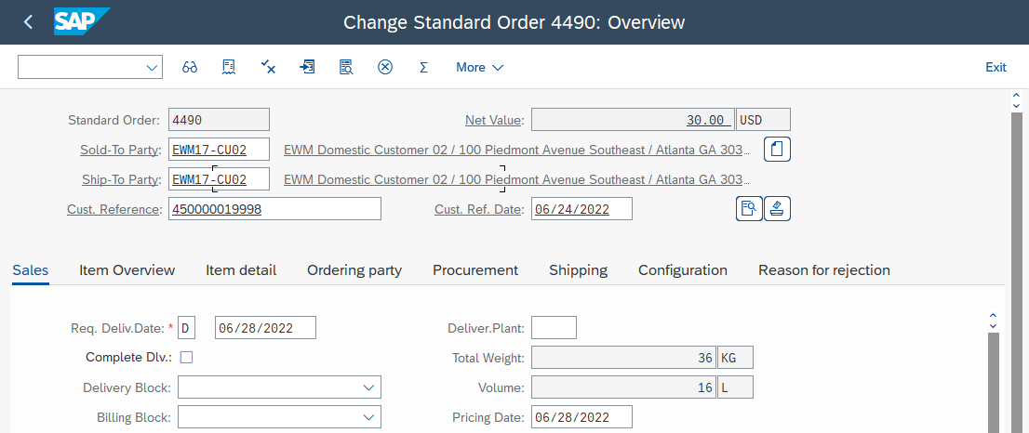

1. Change the Order Quantity to **2** and hit **ENTER** or click **Save**.

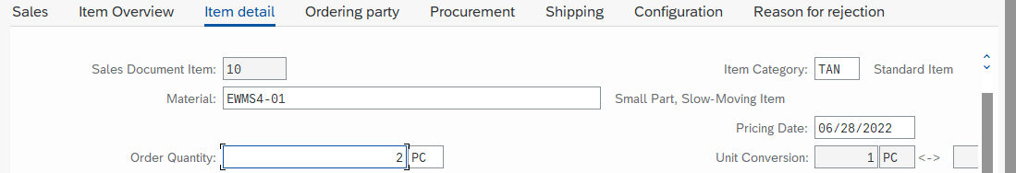

1. If you don’t see the **Change Sales Documents** search page again, click **Continue** to go to the next page.  
   This additional page can appear if we have exhausted the inventory for this item.
2. **Stop** recording.
3. Edit the line where you entered the Order Number and replace the hard-coded value with:  
     
   DataTable("OrderNumber", dtGlobalSheet)

NOTE: This substitutes the value from the global data table into the searched field so we can change the most recently created order. You can also do this easily from UFT One’s **Keyword View**.

Also, understand that while the value contained in the data table for **OrderNumber** remains constant, there is a separate runtime data table (see the Default.xlsx in the results) that contains the value that was capture during playback. For clarity you could change the value in the data table to something like **<Captured Order Number>**.

1. In UFT One, open the **z-exit-SAP** tab and place your cursor on the first (empty) code line.
2. **Start** recording.
3. From SAP, click **Exit** and then **Exit** on the next two screens and **Yes** in the **Log Off** dialog.





1. **Stop** recording and **save** your test as **VA01-VA02**.
2. Edit the **z-exit-SAP** script and add the following final line to close the main SAP window:

SystemUtil.CloseProcessByName "saplogon.exe"

1. **Run** the test and make sure it completes without error.

Understanding the VA01 Transaction on Fiori

SAP Fiori is a web-based SAP implementation that doesn’t rely on the SAP Gui. In this section we’ll use UFT’s  
AI capabilities to record on the Fiori website in a Chrome browser.

In this exercise, we’ll also use the T-code **VA01** (Create sales order).

1. From **NimbusClient**, open Chrome and the SAP Fiori website (listed as **SAP S/4HANA Fiori LaunchPad**) :

<https://sap-hana.mfdemoportal.com:44300/sap/bc/ui2/flp#Shell-home>

If you see any certificate security issues, just choose to click past those – you’ll only see them once.

We’ll again start by getting familiar with our business process **VA01** in Fiori before we start recording. That way we know what to do and how to fix any issues that might come up during recording.

1. Enter the following credentials and click **Log On**:

Username: s4h_sd_dem

Password1: Welcome1



1. Wait for and then click on the magnifying glass (search) icon in the upper right corner and type **VA01** and hit **ENTER**.
2. In the resulting page, click on the box **Create Sales Order** VA01.
3. In SAP Fiori, we’ll need to enter data from the bottom up. This is due to a quirk in the Fiori interface which displays a help window when typing in a field. This help window can obscure fields on replay so just remember to **enter the bottom-most fields first**.

Enter the following fields (in this order). Use CTRL-V to paste values:  
  
Division: 00

Distribution Channel: 10

Sales Organization: 1710

Order Type: OR

1. Click **Continue** in the lower right corner or hit ENTER.
2. Enter the following data (in this order):

Cust. Ref. Date: 07/28/2022 NOTE: This date must be within one month prior to today.

Cust. Reference: 450000019998

Ship-To Party: EWM17-CU02

Sold-To Party EWM17-CU02

1. Click **Save** to save your order. You should see an order confirmation at the bottom of the page.



NOTE: SAP can actually save the order without any item information. Current our AI solution doesn’t support the item entry fields in the table.

1. Click **Exit** in the upper right corner and then click on the **SAP Logo**   to go to the home screen.

Recording the VA01 Transaction with UFT AI

In this section we’ll repeat the process above while recording your steps in UFT AI.

1. **Log out** of SAP Fiori and make sure all your SAP interfaces are exited and your SAP-VPN connection is still connected.
2. **Close** UFT One, if it is still running.
3. **Start** UFT One and add a new GUI test and call it **VA01-Fiori-AI** in the folder: **C:\Users\demo\Documents\UFT One.**
4. Select **Record > Record and Run Settings** from the top menu bar.
5. On the **SAP** tab, select **Record and run test on any open SAP Gui for Windows application**
6. On the **Web** tab and set the **Record and Run** settings to be as shown below and click **OK**.

Use: Local Browser

URL: <https://sap-hana.mfdemoportal.com:44300/sap/bc/ui2/flp#Shell-home>

Browser: Google Chrome

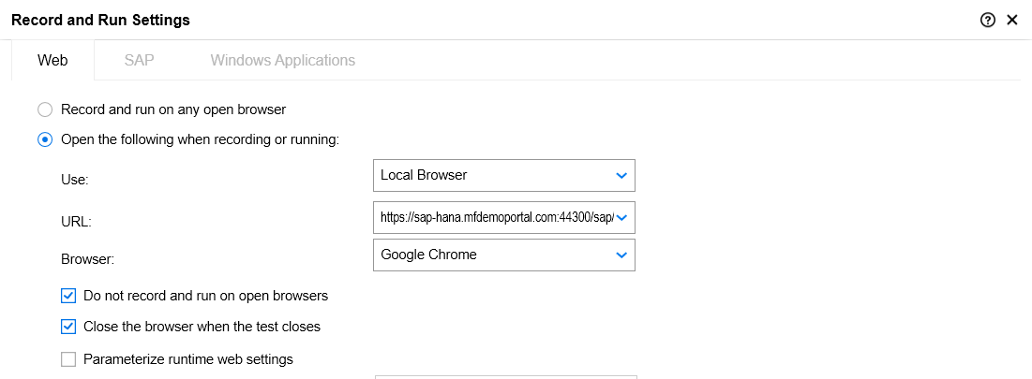

1. **Open** a Chrome browser, **maximize it** (AI works best that way) and navigate to:  
     
   <https://sap-hana.mfdemoportal.com:44300/sap/bc/ui2/flp#Shell-home>
2. In UFT One, start recording with **AI Record** .

When UFT AI starts you’ll see the recording bar that prompts you to click on a web page window.

Remember that your browser window should be **maximized** – that make AI recordings more reliable.

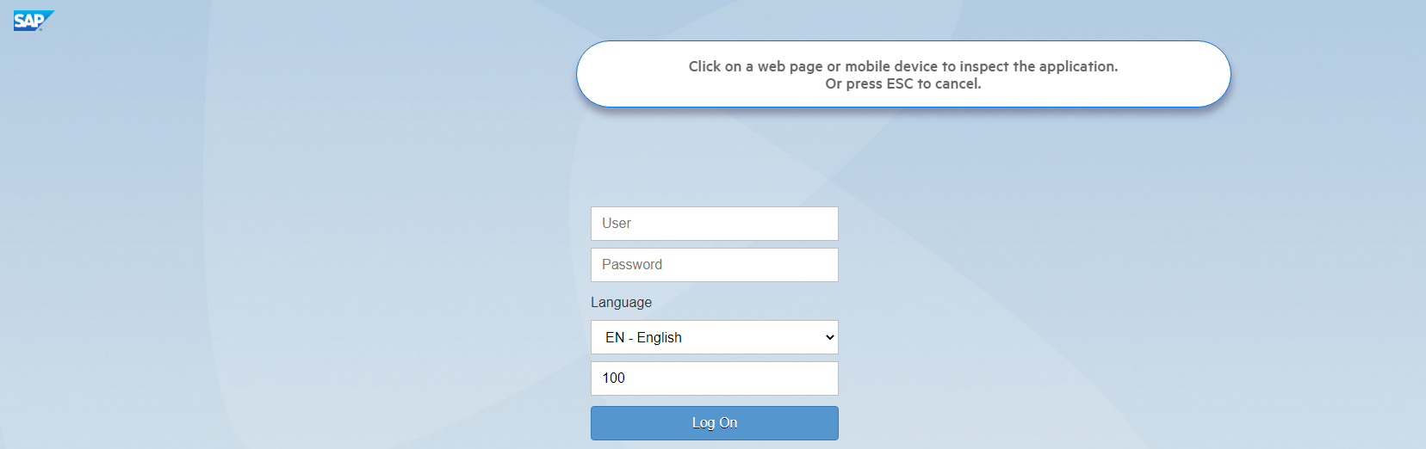

1. **Click** somewhere on the **Fiori Log On** web page (but not on an edit field).

After selecting the web page, UFT AI will inspect the page and identify objects and text.

In the screenshot below it has identified text boxes, text blocks, buttons, and a down triangle.

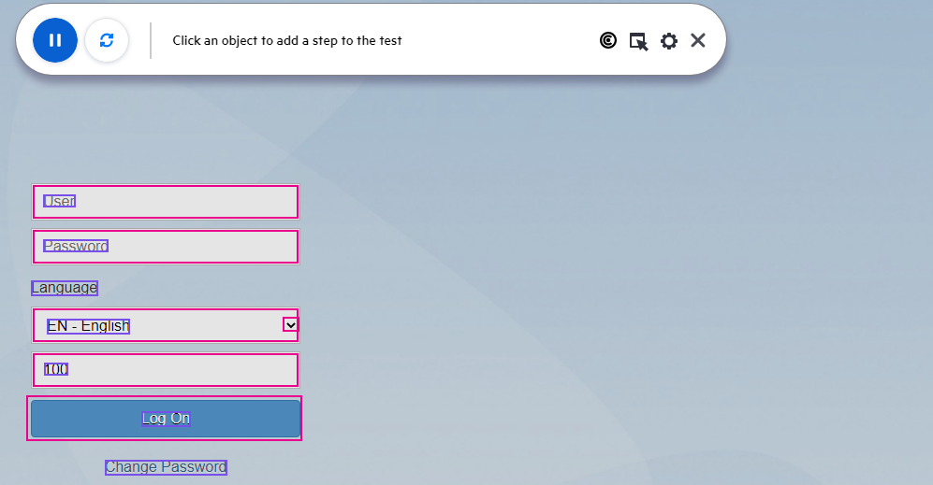

You can **move** the **recording bar** at any time, so it doesn’t obscure parts of the application.

1. Click on the **User** box (not the text) and then enter the username (s4h_sd_dem) into the box as shown:

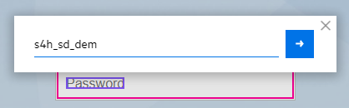

1. Click the **blue arrow box** or hit **ENTER** to record this step.

For every text entry you should always be clicking the blue arrow box or hit ENTER to record your steps.

1. Enter the following credentials and then click **Log On**:

Username: s4h_sd_dem

Password1: Welcome1

1. Click on the magnifying glass (search) icon in the upper right corner and type **VA01** and hit **ENTER**.

If it’s not recognized with a magenta box, click the Reinspect button.

1. In the resulting page, click on the Text block labeled **Create Sales Order** VA01 and select **Click**.

If it’s not recognized, click the Reinspect button.

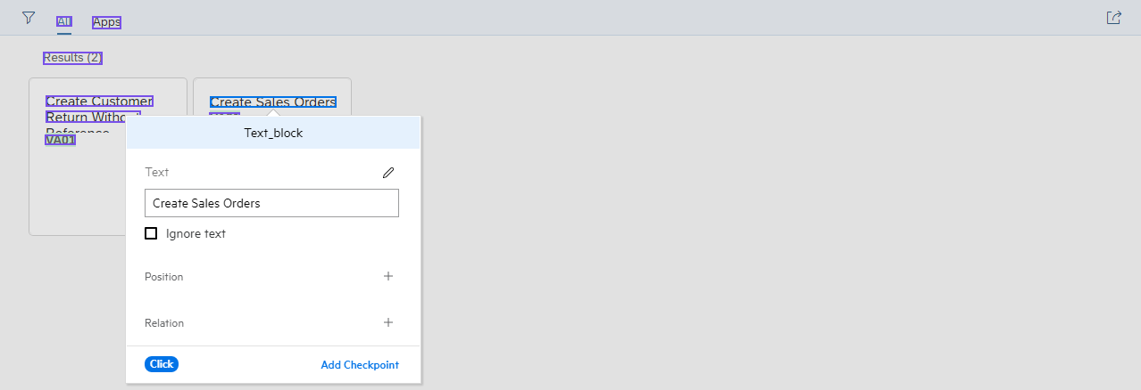

1. In SAP Fiori, we’ll need to enter data from the bottom up. This is due to a quirk in the Fiori interface which displays a help window when typing in a field. This help window can obscure fields on replay so just remember to enter the bottom-most fields first.

Enter the following fields (in this order). Use CTRL-V to paste values:

Division: 00

Distribution Channel: 10

Sales Organization: 1710

Order Type: OR

1. Click **Continue** in the lower right corner.
2. Enter the following data (in this order):

Cust. Ref. Date: 07/28/2022 NOTE: This date must be within one month prior to today.

Cust. Reference: 450000019998

Ship-To Party: EWM17-CU02

Sold-To Party EWM17-CU02

1. Click **Save** (bottom right corner) to save your order.  
   You should see an order confirmation at the bottom of the page.



NOTE: SAP can actually save the order without any item information. Current our AI solution doesn’t support the item entry fields in the table.

1. Click **Exit** (upper right corner) and then click on the **left triangle** (upper left corner).
2. Click on the **Home** text (upper left corner) to go to the home screen.
3. Click on the **Profile** icon and then click on **Sign Out**.
4. Click on **OK** in the Sign Out dialog.
5. **Pause** the recording and then exit the recording bar by selecting **X**.
6. **Save** your test and close the Chrome browser.
7. **Run** your test and check for any timing issues with replay. If necessary, add **wait** statements to slow the replay and make the script work. It’s also possible to add code to wait for the objects to be ready.

Using AI with SAP Fiori can be a bit of a challenge because of how SAP ghosts or gray’s-out pages during transitions. Since UFT One’s AI periodically scans the pages, it may find expired or incorrect objects on the grayed-out page and try and interact with them. In addition, some SAP Fiori objects may appear and exist but aren’t quite ready to be interacted with, so UFT overruns the interface.

You can combat these sorts of SAP Fiori behavior with a variety of techniques and functions.  
Here’s an example of waiting for an image that doesn’t appear initially:

**'Wait for an image to exist in a loop up to 15 times**

**Function** WaitUntilImage(inputText)

counter = 0

**Do**

counter = counter + 1

**Wait** 1

**If** counter >= 15 Then

Reporter.ReportEvent micFail, "Item not found", "The item >" & inputText & "< didn't appear within " & counter & " tries, please check the application."

ExitTest

**End If**

**Loop** Until AIUtil(inputText).Exist

**End Function**

WaitUntilImage("search")

For objects that exist but aren’t quite ready to be clicked on, you can check for the existence of the next object you want to interact with and keep clicking on the first object until that second object appears.

Here’s an example of waiting for the next object while continuing to click on the first:

**'Keep trying to click on Create Sales Orders until Division: exists**

**While NOT**(AIUtil("text_box", "Division:").Exist)

**Wait** 1

AIUtil.FindTextBlock("Create Sales Orders").Click

**Wend**

AIUtil("text_box", "Division:").**Type** "00"

Exercise 16: Integrating Security Testing

Role: Integration or Automation Engineer

Security testing is often left as the last step in a DevOps process. That’s not right. Security, like all testing should be continuously checked for issues or defects. Fortify offers multiple options that can scan your code and website and produce a comprehensive report.

In this exercise we’ll scan part of the AOS source code (scanning the full 500,000 lines takes over 10 hours) and produce a report (a Fortify Project Report or .fpr file) which can be viewed with the **Fortify Audit Workbench** (AWB). This tool is really an Eclipse IDE in disguise and FPR files are Eclipse projects. Since understanding the relationships and dependencies between code modules is critical to finding errors, it makes sense to use an established IDE engine to also display security issues.

**NOTE**: You must have completed Exercise 9: Configuring DevOps Connections before starting this exercise.

Running a Fortify Security Scan

1. We need to have the following VM’s running for this exercise:

* NimbusServer

1. Run the following commands or verify that these containers are already running.  
   Allow enough time for these containers to settle down (5-8 minutes or so).

**$ nimbusapp sca:21.2.1 start  
$ nimbusapp ssc:21.2.1 start  
$ nimbusapp aos:3.2 start  
$ nimbusapp devops:3.2.3 start**

**$ nimbusapp intellij:3.2.1 start**

1. From **NimbusServer**, start Chrome and open the **Jenkins** shortcut.  
   Verify that from the Jenkins home page that **sca** shows as a connected, idle node.  
     
   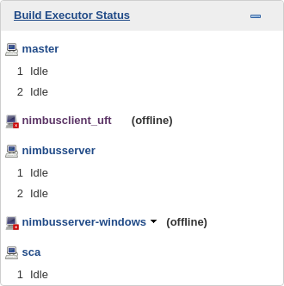
2. From the Jenkins home page, **run** the **AOS_Web_Root_Module_Pipeline** and verify that the Fortify Source Code Analyzer stage ran successfully. This can take a few minutes to finish.



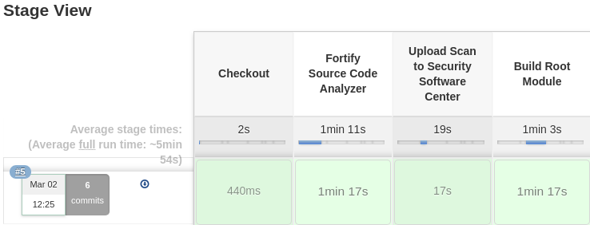

As the result of a code scan, Fortify produces an **FPR** file (Fortify Project Report).

Since we configured the scan for the root module in the AOS code it produced a **root.fpr** file.

That file was also uploaded to Fortify SSC (Software Security Center) in the next stage.

Using the Fortify Audit Workbench

Next, we’ll copy the file to the Audit Workbench (AWB) container so we can view the vulnerabilities that it produced. AWB can open this file, but it can also be viewed in SSC’s scan database. Fortify’s SCA (Source Code Analyzer) contains the graphical interface for AWB, but it can also scan source code from command line statements or application plugins like that found in IntelliJ.

1. Start the Audit Workbench Docker container by running the following command:

**$ nimbusapp auditworkbench:21.2.1 start**

1. If prompted to check for updated rules, select **Yes**.

Fortify’s security team regularly updates the rules it uses to scan code for the latest, discovered code vulnerabilities so it’s important to always use the latest rules.

1. We can’t immediately view this file so we’ll copy it to somewhere else where we can look at it.

Open a terminal on NimbusServer and type the following two commands:

**$ docker cp sca:/var/jenkins/workspace/aos-web-root-module-pipeline/root.fpr /home/demo**

**$ docker cp /home/demo/root.fpr auditworkbench:/root/root.fpr**

We’re moving the file to the auditworkbench container because that container has an FPR viewer capability. Docker’s copy command (cp) is a nice way to move files between different containers.

The Fortify Audit Workbench is actually a modified version of the Eclipse IDE.

1. In the AWB window select **Open Project…**

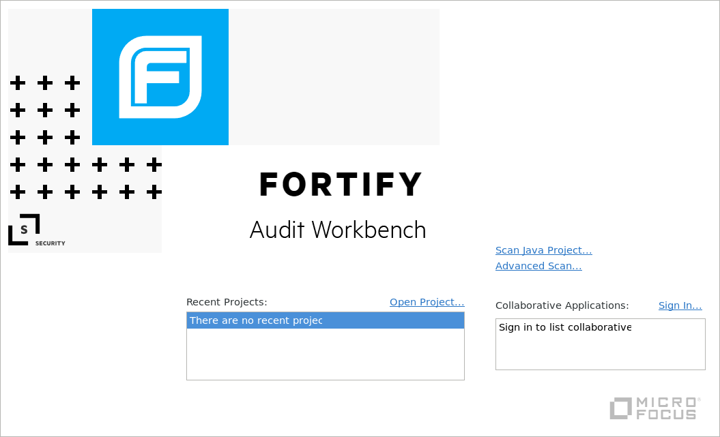

1. Browse to the root directory (+ Other Locations - **/** ) and select the **root.fpr** file to open.
2. When **AWB** finishes loading you’ll see **1 High error** and **3 Critical errors**.

**Open up** the tree view on the left.

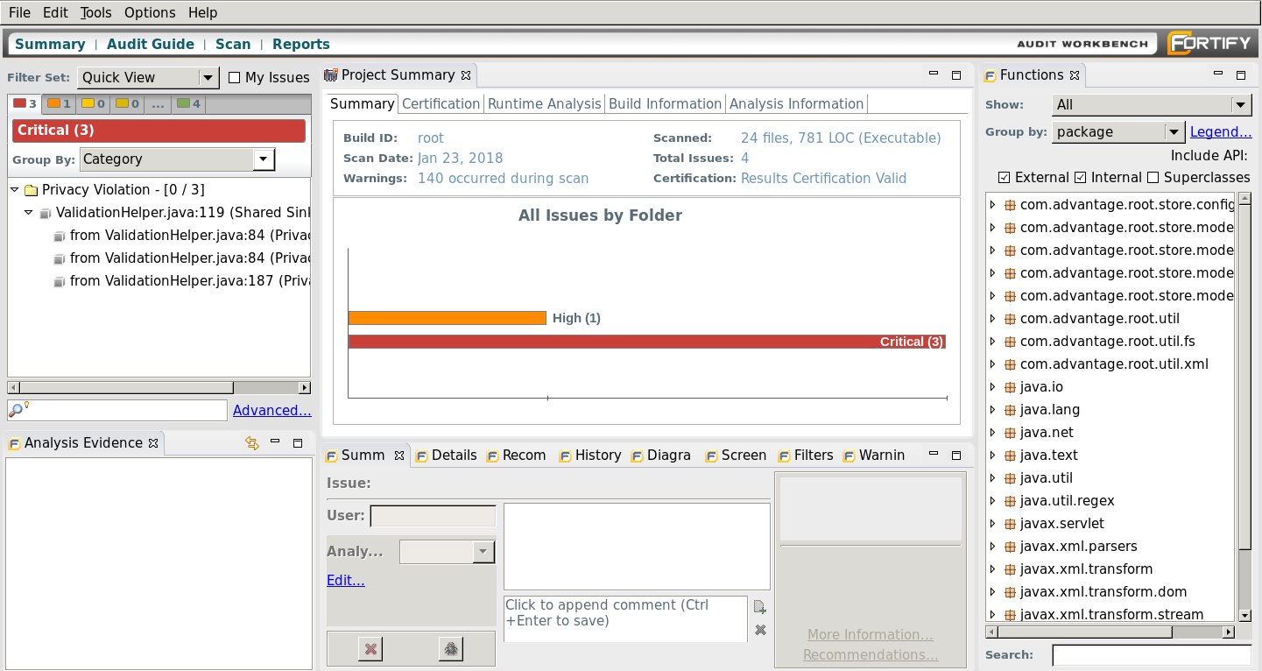

1. Select the **High** filter in the top left menu and examine the error.

The scan found a hard-coded password pattern in the code.

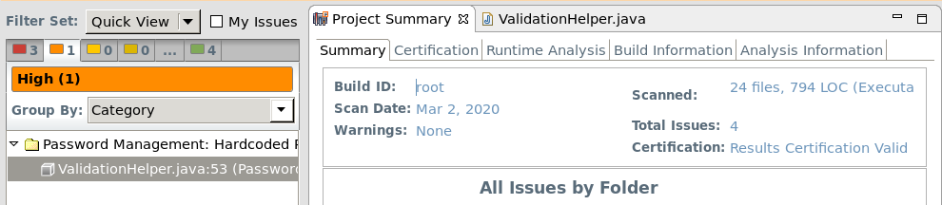

You can also find the following scan statistics for the root module in the **Project Summary**:

* 24 files
* 794 Lines of Code (LOC)
* 4 total issues

1. **Browse** around in the interface and see what you can find.

Previously we did scan the whole AOS source code and its libraries but it took several hours (it’s over 500,000 LOC). The complete source code is on the DevOps container.

1. Run the following command to start Intellij (or verify that it’s already running):  
     
   **$ nimbusapp intellij:3.2.1 start**
2. If IntelliJ is open on a project other than the regression test, you can “Close Solution” to go home.   
     
   If you’ve already opened the aos-regression-test-web project you can just click on that project in the left pane from the IntelliJ home page.

Otherwise, from the **IntelliJ** splash page **click** “**Get from Version Control”** and copy/paste the following **URL** (Version control = Git) and click **Clone**.  
  
**http://nimbusserver.aos.com:8091/git/uftdev-aos-regression-test-web.git**

1. Once IntelliJ has finished loading, select the Fortify menu at the top:  
     
   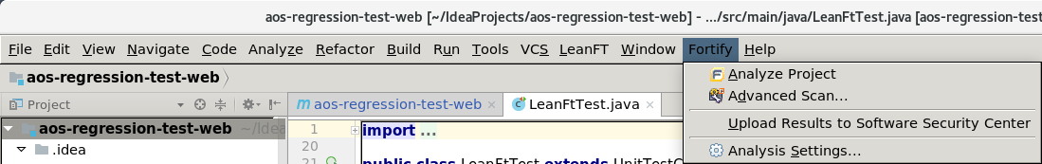
2. There are four options listed:

* Analyze Project
* Advanced Scan…
* Upload Results to Software Security Center
* Analysis Settings

1. Select **Analyze Project** and let it run the scan.  
   When the analysis is complete, you’ll be prompted for the login credentials for SSC:

* Username: **admin**
* Password: **Password1**

1. Select the latest release (e.g. **3.2**) from the popup and click **OK**.  
     
   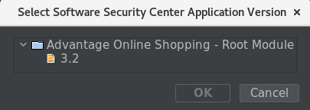
2. After the scan is finished you can open Software Security Center, login and examine the results.
3. **Close** the **Audit Workbench** UI and the **Intellij** UI when you’re done browsing through them.

Using the Fortify Software Security Center

The Fortify Software Security Center (SSC) is a web-based application that houses the results from security scans and consolidates and aggregates the data into actionable tasks.

1. We need to have the following VM’s running for this exercise:

* NimbusServer

1. Run the following command or verify that this container is already running:

**$ nimbusapp ssc:21.2.1 start**

1. **Open** your browser to the **Fortify Software Security Center (SSC)** shortcut.
2. **Login** with these credentials:

Username: **admin**

Password: **Password1**

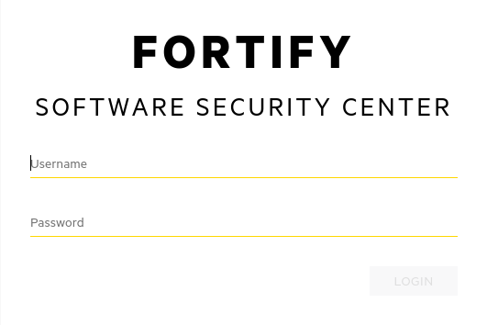

1. Once logged in you’ll see the dashboard.

In this SCA container we’ve uploaded the **root.fpr** scan file from the previous exercise.

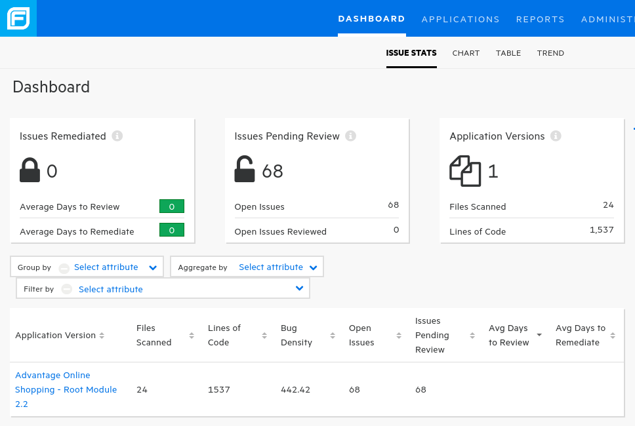

1. **Examine** some of the **Issue Stats** and then **click** on the **Advantage Online Shopping – Root Module 2.2** link. This bring you into the **Audit** section of SSC.

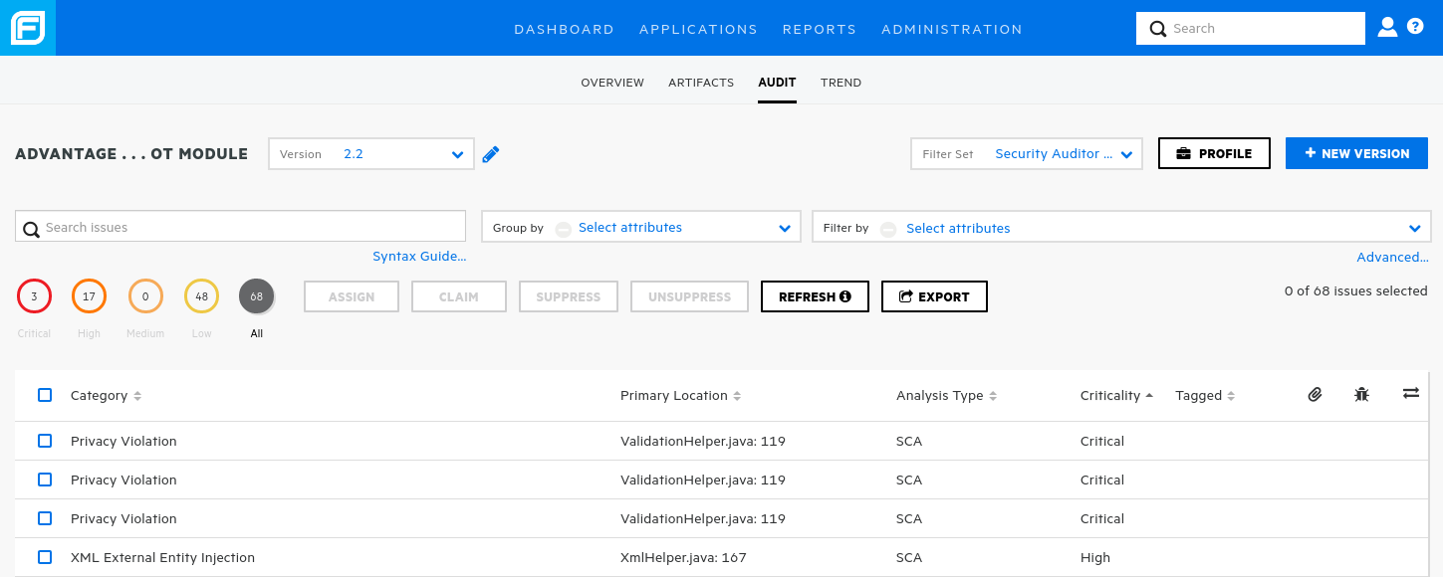

Some of the data you can find on this screen:

Total Issues: 68

Critical Priority Issues: 3

High Priority Issues: 17

Medium Priority Issues: 0

Low Priority Issues: 48

1. In the **Search Issues** box at the upper left enter **Password** and hit **Enter**.
2. Click on the **Privacy Violation** text to view the source code.

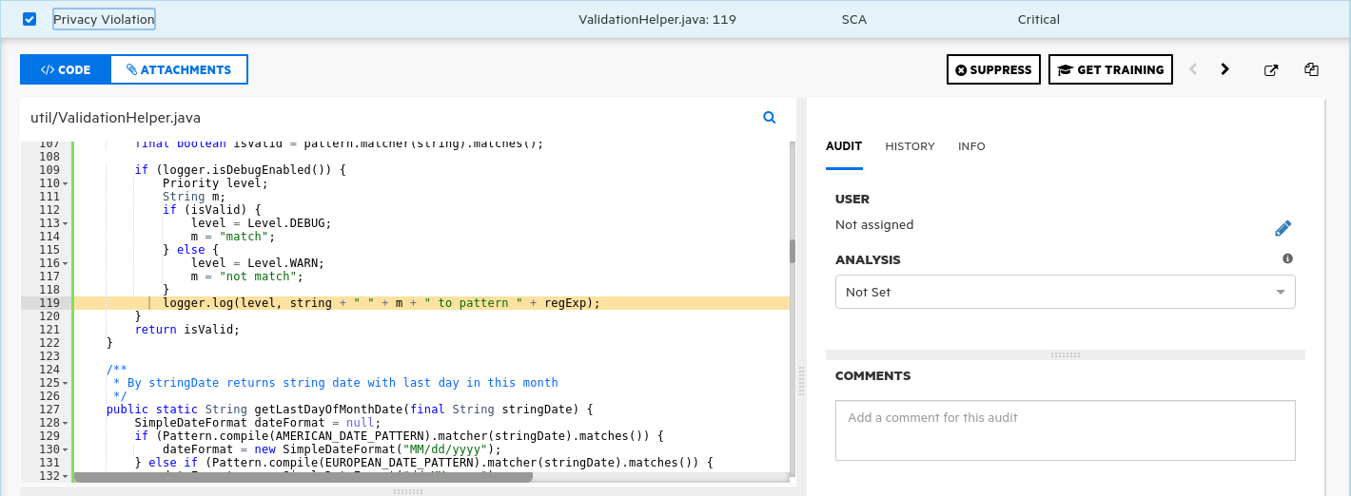

1. The item shows the same file **(ValidationHelper.java)** that we saw directly in Audit WorkBench.

The next step in a security scan is to either suppress the issue or assign it to someone to be resolved.

1. Browse around this interface and see what else you can find.

Integrating Fortify results in Octane and the Jenkins CI

This exercise describes the process needed to integrate the Fortify results from SSC and viewing them in Octane.

Basically, the vulnerabilities data will only appear when NEW code vulnerabilities are found. So, the first time you run a scan and it is populated into SSC, the data will come into Octane. All future scans will not produce any vulnerabilities and thus no new data. So, you can only see the initial vulnerabilities with the first pipeline scan that populates into SSC. However, if you change the code and introduce new vulnerabilities, they will show up (but not the original ones, just the changed code ones).

1. We need to have the following VM’s running for this exercise:

* NimbusServer with at least **25 GB** of available memory (do not attempt with less)

1. Run the following commands which will start the devops and AOS containers.

**$ nimbusapp devops:3.2.3 start**

**$ nimbusapp aos:3.2 start**

1. Run the following commands which will reset the SSC container to its initial condition (empty).  
   Select **Y** (Yes) to delete the container when prompted and wait about 4 minutes.

**$ nimbusapp ssc:21.2.1 down**

**$ nimbusapp ssc:21.2.1 up**

1. Open **Octane** to the **Pipelines** module and, if it exists, **delete** the aos-web-root-module-pipeline pipeline by selecting the three dots and **View** and then click on the trashcan icon.

We’ll recreate a new one a bit later.

1. Run the following command which will start the IntelliJ container and the UFT Dev agent.

**$ nimbusapp intellij:3.2.1 start**

1. In the desktop **System Monitor** wait for the CPU activity to settle down.

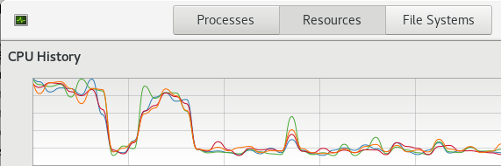

1. **Login** to ALM Octane (sa@nga, Password1) and navigate to the **Pipelines** module.
2. Create a new pipeline ( + ) based on **aos-web-root-module-pipeline** and select the **Type** checkbox  
   for **security** (you must do this) before clicking **SAVE**.



security

1. Ok – Now we should have everything in place.  
   1. SSC should not have a current application nor results showing in it.
   2. Octane should have a pipeline defined (AOS_Web_Root_Module_Pipeline) but it hasn’t been run as an Octane pipeline yet.
   3. Jenkins has all the configured connections which have been tested.
   4. The UFT Dev agent in IntelliJ is still active and it hasn’t been more than four hours since it started.
2. Double-check (using **$ docker ps**) that all nine of these containers are running:

|  |  |  |
| --- | --- | --- |
| autopass | aos-main | intellij |
| devops | **aos-postgres** | **sca** |
| octane | **aos-accountservice** | **ssc** |

1. Check that you still have at least **2.4 GB** of memory **available** on NimbusServer by running   
   the **System Monitor** on your desktop.
2. In Jenkins configuration, verify that the **ALM Octane CI** plugin shows that the **Test Connection** succeeds.  
   If not, run the utility job called **Update Octane API** and check it again.
3. In either Jenkins or Octane run/build the **AOS_Web_Root_Module_Pipeline** job.
4. Watch the progress in Jenkins. If the job fails, find out why and correct it – you’ll also have to delete/recreate the Octane pipeline again.
5. When the job finishes, wait about 4 minutes before bringing up Octane and **refreshing** the Pipelines module. Initially it may appear that the Security data isn’t showing up. Just refresh your browser.
6. You should see something like the following:

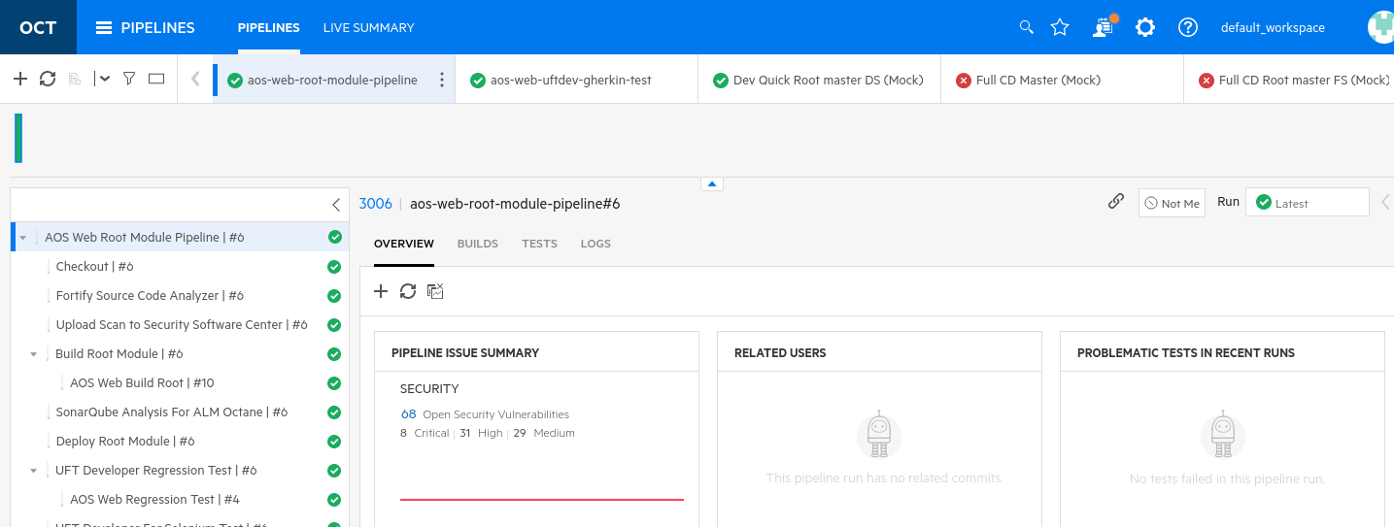

1. Select the pipeline run ID link and then select the **Vulnerabilities** tab.  
   You can also get there by clicking on the 68 Open Security Vulnerabilities link
2. You should see the data similar to below.

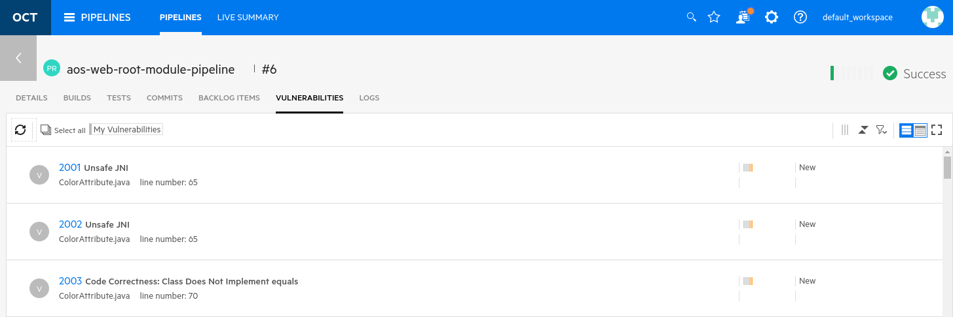

1. Pat yourself on the back for correctly configuring this integration!   
     
   NOTE: If you re-run the **AOS_Web_Root_Module_Pipeline** again, you won’t see the vulnerabilities appear again. This is because no **NEW** vulnerabilities were detected. If you want to see your original vulnerabilities again, just click on the Run pulldown and find the previous run where you did get data from the Fortify scan (see image below).

If you changed the code to add new vulnerabilities, then only those new vulnerabilities would appear.

If you want to see the vulnerabilities scan of a **previous** pipeline run, select that run from the dropdown on the right as shown below:

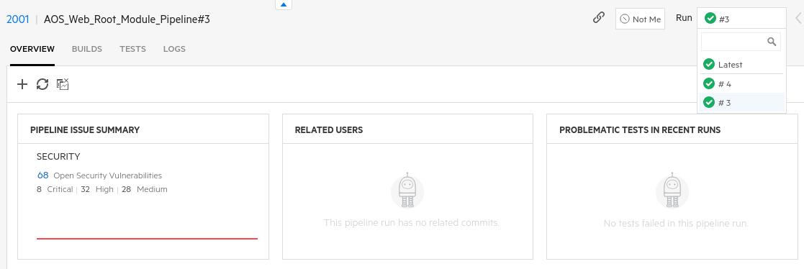

Also note that if you delete the pipeline from Octane and re-add it, if there is still vulnerability data from a previous run, it won’t appear again in Octane (unless new vulnerabilities are published to SSC). The only way to get this data back into Octane is to remove both the pipeline in Octane and the scan artifact in SSC and then set the integration up again.

You can remove the scan artifact in SSC by selecting the artifact application link and then selecting Profile. From the Profile window, select Application Settings and then you can delete the artifact by clicking on the DELETE button.

**Nicely Done!**

Running WebInspect Dynamic Scans

This exercise describes how to run a WebInspect dynamic scan on the AOS website and produce a Fortify report.

1. We need to have the following VM’s running for this exercise:

* NimbusServer
* NimbusClient

1. Run the following commands or verify that these containers are already running.  
   Allow enough time for each of these containers to settle down (4-6 minutes or so).

**$ nimbusapp aos:3.2 start**

**$ nimbusapp devops:3.2.3 start**

1. Open **NimbusClient** and then open WebInspect from the **ADM Solutions** desktop shortcut

(WebInspect 20.1.0). WebInspect should start up and an activation window will appear. A license has already been applied we just have to activate it.

1. Click **Activate Now** and then select **Connect directly to Micro Focus corporate license server** and click **Next**.
2. On the next screen leave the defaults and click **Next** and then click **Finish**.  
   Your copy of WebInspect is now activated.
3. If prompted about updates, click **Yes** and download any security vulnerability updates.
4. **Close** the WebInspect window. We’ll be running our scan remotely from Jenkins.
5. In your Chrome browser on NimbusServer select the **Jenkins** browser shortcut.  
   Verify that the **nimbusclient_uft** agent has four idle connections.
6. On the left edge, select the **New item** option and then click **Freestyle Project**.
7. Name the new item to be **AOS_Web_Dynamic_Scan**
8. Set the description to be “**This job runs a WebInspect scan on the local Nimbus-based AOS website.**”
9. Set the value “Restrict where this project can be run” to be on **nimbusclient_uft**
10. Add the following code to the **Build** section pulldown as **Execute Windows batch command**  
    (DO NOT select “Execute managed windows batch” – that’s different)

This command will run a quick (~10 minutes) vulnerability scan on the AOS website and produce a project report (FPR file) and a PDF report.

"C:\Program Files\Fortify\Fortify WebInspect\wi.exe" -u "http://nimbusserver.aos.com:8000/#" -CrawlCoverage Quick -s "C:\ProgramData\HP\HPWebI~1\Settings\Default.xml" -ep C:\AOS_CmdScan1.fpr -r "Vulnerability" -y "Standard" -f C:\AOSAppVuln.pdf -gp

1. Click **Save** to save your changes. This will create a new job called **AOS_Web_Dynamic_Scan** in  
   the **All** tab in Jenkins.
2. In Jenkins, select to **Build** the **AOS_Web_Dynamic_Scan** job.
3. Switch to the **NimbusClient** image and if a security warning about a certificate pops up, click **OK**.
4. Click the flashing ball in Jenkins to view the log of the run. It should take about 20-25 minutes to finish.
5. Once finished you can view the results in Jenkins or in WebInspect.   
   To view it in **Jenkins**, navigate to the following file and open it:   
     
   C:\jenkins\workspace\AOS_Web_Dynamic_Scan\$WORKSPACE\SecScan\AOSAppVuln.pdf  
      
   To view it in **WebInspect**, start WebInspect and select **Open** and open the latest scan report.

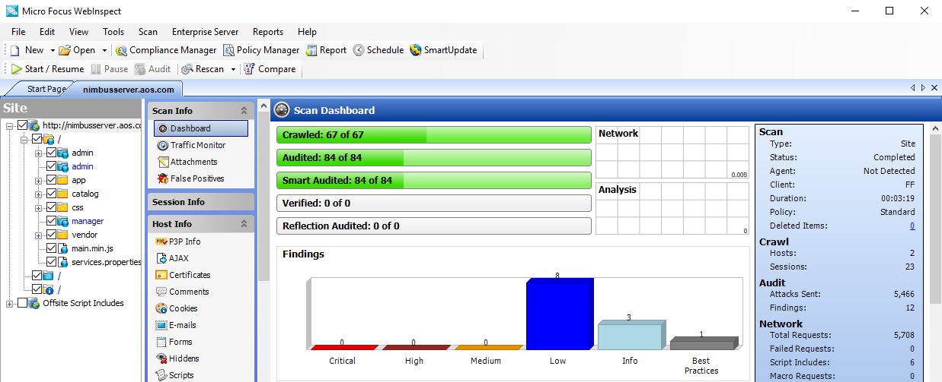

Challenge Exercise #2

Start the SSC container and copy the FPR file that was produced and upload it into SSC.  
This may take some online research. Show the results to your instructor.

Exercise 17: Synchronizing with MF Connect

Configuring the Jira Cloud instance

Jira is a common Agile management and defect tracking tool that many organizations use. Those organizations often want to sync their Jira data with ALM Octane. In this section we’ll explore that integration.  
  
Jira is available as a cloud-based trial from Atlassian and that’s what we’ll use for this exercise.

1. Start the following Docker containers for this exercise. (The AutoPass container also needs to be running, but it starts automatically with NimbusServer.)

**$ nimbusapp octane:16.0.400.79 start**

**$ nimbusapp mfconnect:4.4.2 start**

1. Signup for a free Jira Software instance here and click **Next** at the bottom. <https://www.atlassian.com/software/jira/free>

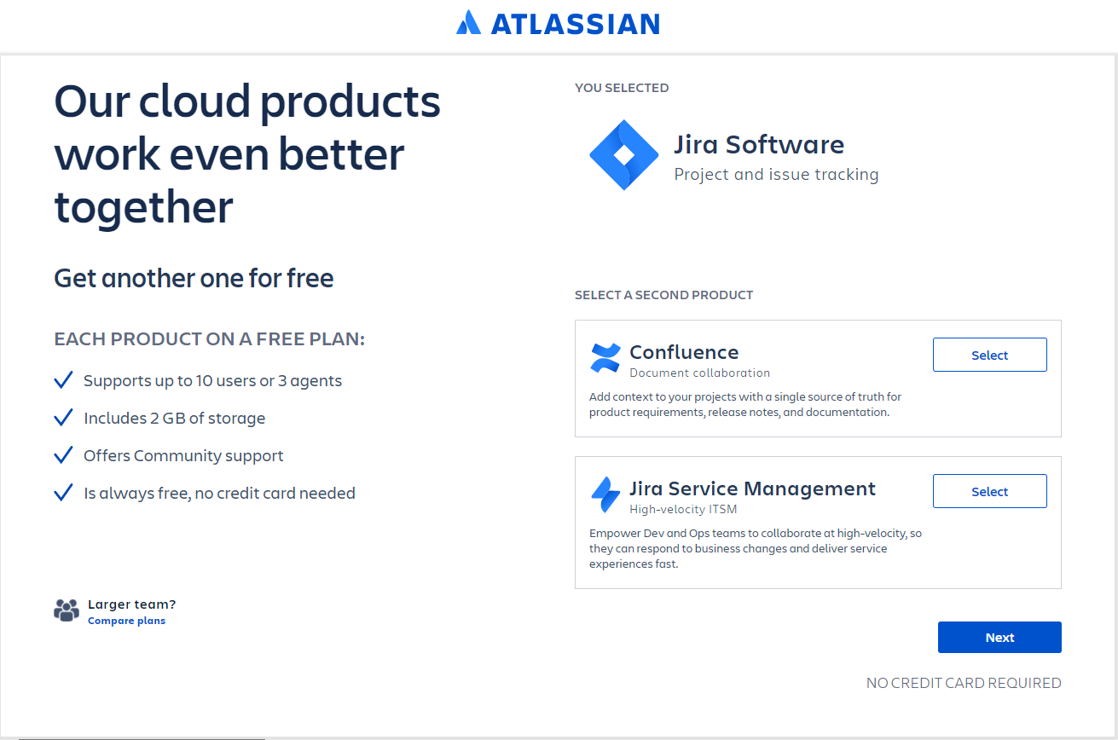

1. Enter your email address, password, first and last name and click **Agree**.  
   If you already have an Atlassian account click the **login to continue** option.

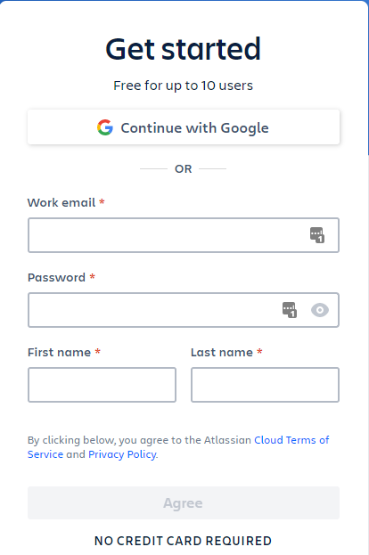 OR 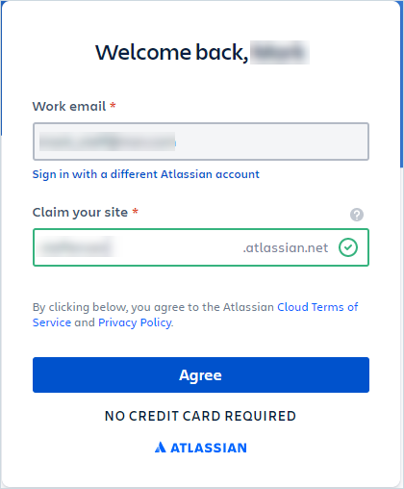

1. When asked to **Claim your site**, choose a valid name (like first initial and last name) and click **Agree**.
2. On the **Welcome to Jira Software** page, choose **Skip question**. You will do this twice.

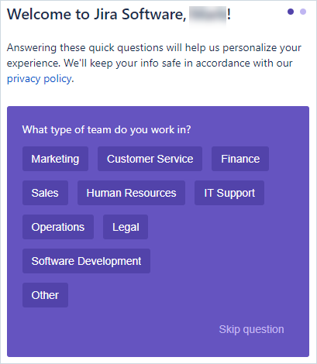

1. On the **Invite your teammates** page, don’t fill out anything and just click **Continue**

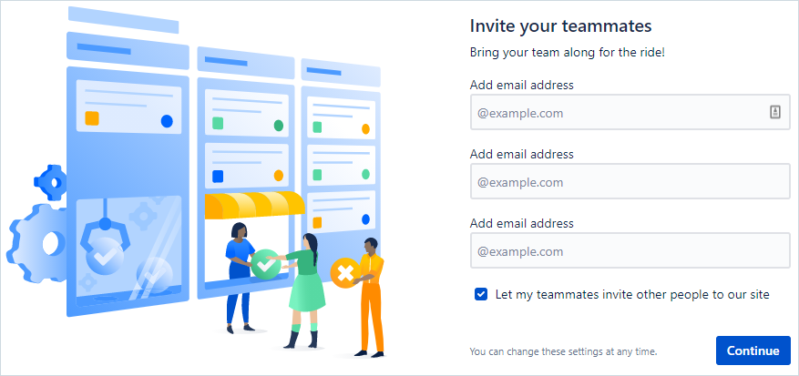

1. On the **Help us set up your Jira** page, select the **Skip** option.

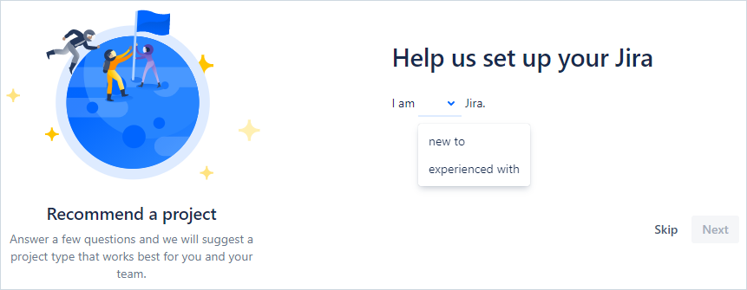

1. On the **Choose a classic template** page, select the **Scrum** option.

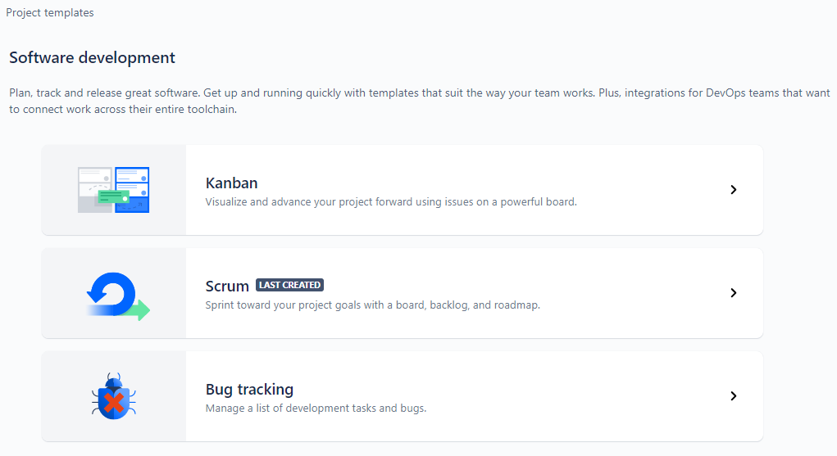

1. Select **Use Template**.

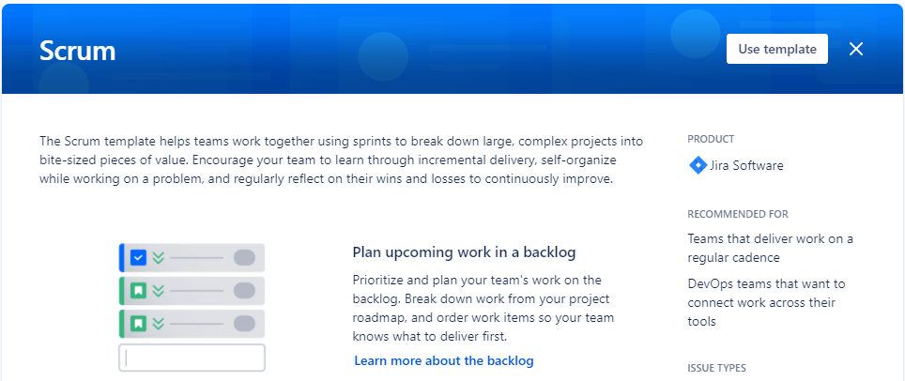

1. Under **Choose a project type,** click **Select a company-managed project**.

You **must** use company-managed projects or they won’t sync (as of Octane 16.0.110.90).



1. On the **Create project** page, name the project **Sample** with Key **SAM** and click **Create**.

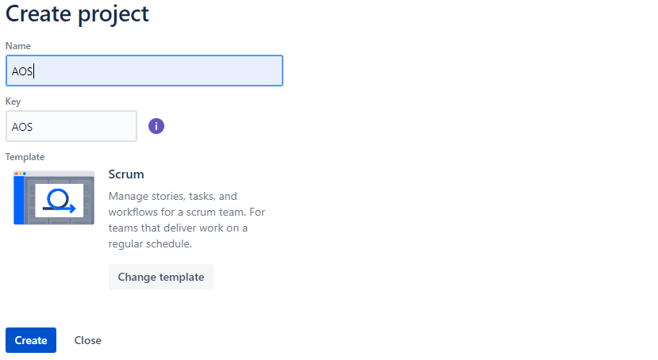

SAM

Sample

1. This will create an empty project in Jira called Sample. We won’t be using this project (since there’s no data) but will instead create a different project called **AOS** which will contain some sample data.

You should now be logged into your Atlassian account and showing your **Sample** project:

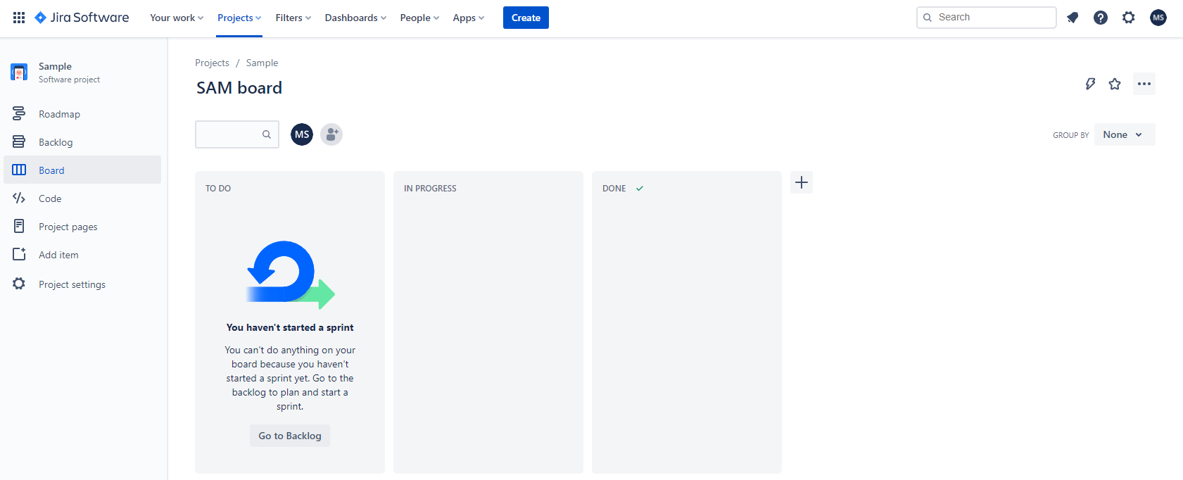

1. On the upper right, select the **Search** option and choose **Boards**.

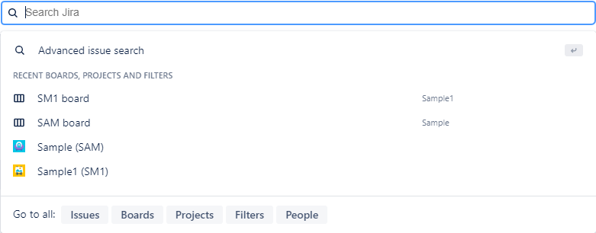

1. From the Boards view select **Create board**.



1. On the popup window select the link **Create a Scrum board with sample data**.

This will create both a new project and a new board.

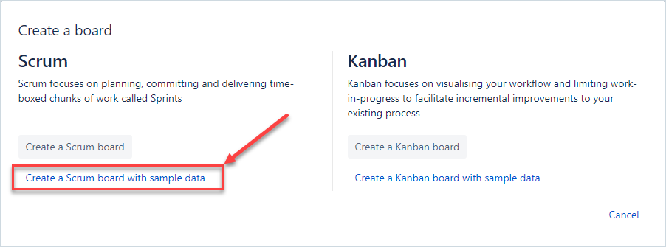

1. Set the Project name and Project key to be **AOS** and click **Create board**.

You **MUST** set these values to **AOS** for this exercise. This will create a **Company Managed** project.

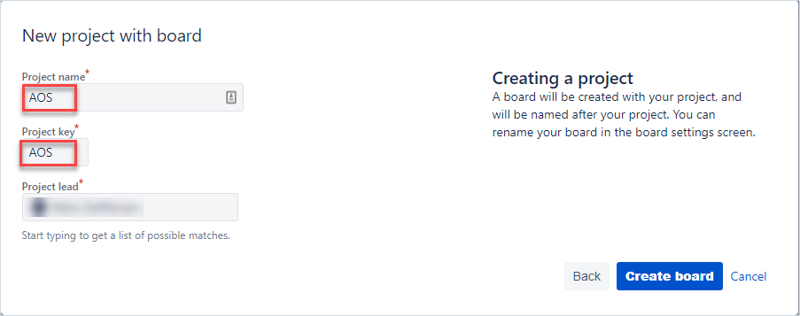

1. You should now see the following screen:

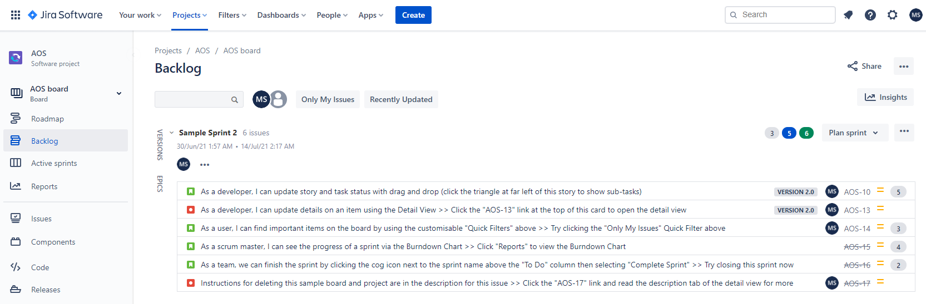

1. Next, we need to create an API token so MF Connect can login and synchronize data.

To generate an API token, go to <https://id.atlassian.com/manage-profile/security> and select

**Create and manage API tokens** on the right.

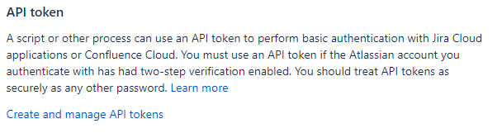

1. Click the **Create API token** button and label the token **Connect**.

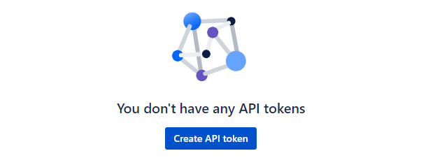 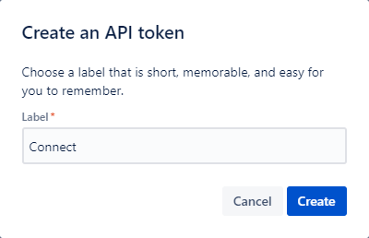

1. **View** and **Copy** the token that was created.

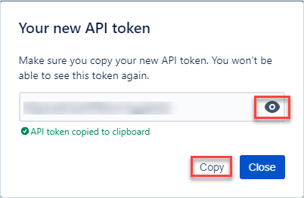

Configuring MF Connect to communicate with Jira

We need to put the API token we just generated into MF Connect so it can communicate with Jira.

1. In a new browser tab open the **MF Connect** shortcut link.
2. Log in to MF Connect with the following credentials:

Username: **admin**

Password: **Password1**

* 1. Click on the **DATA SOURCES** tab on the top and select the **Cloud Jira AOS** option in the list on the left.
  2. A popup will occur stating a validation error – click **OK** to close the popup.
  3. On the right side, in the **PROPERTIES** tab, you’ll see the configuration that MF Connect will use for communicating with Jira.

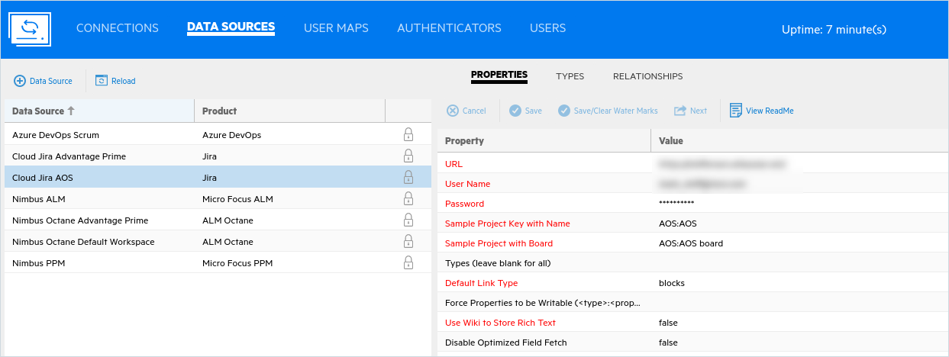

1. Modify the **URL**, **User Name** and **Password** fields:

• Enter the **URL** of your Jira instance (replacing the value shown)

• Enter your Jira **User Name** that is probably an email address, (not username - admin)

• Enter your API token in the **Password** field.

1. Click the **Next** option above the **Value** label.

It should save your changes without displaying any errors.

1. In MF Connect, click the top right gear button and choose **Settings**.These global settings control items like the frequency of synchronization (when running continuously).

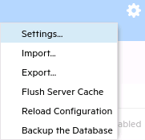

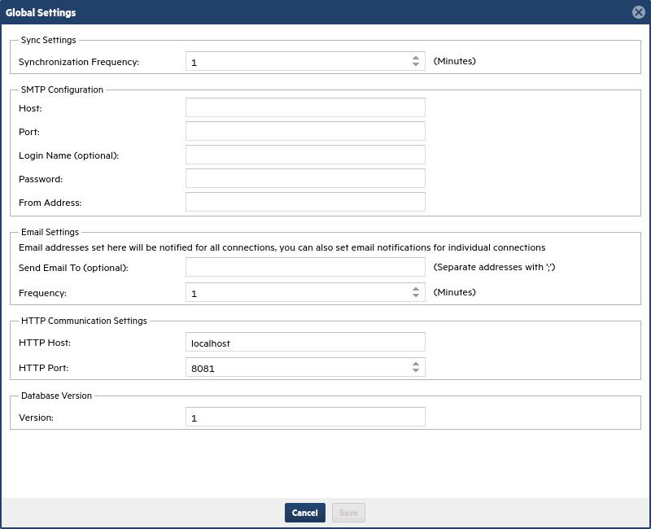

1. Click **Cancel** to close the Settings window.

Connecting the Octane API

The first step in synchronizing ALM Octane and Jira is to make sure they can communicate via their APIs.  
We’ll start by generating an Octane Client ID and Client Secret and then copying those to MF Connect.

1. Open a new browser tab and login to Octane with:
   * Username: **sa@nga**
   * Password: **Password1**
2. Click on the Settings (gear) icon in the topmost tool bar and select **Spaces** under Administration.  
     
   
3. On the left side select **Default Shared Space**.
4. In the tabs to the right select **API ACCESS**



The **MF Connect** API access key is called **connect**.

1. **Locate** the **connect** API access section and select the numeric link to edit it.



**Verify** the following roles from CI/CD and if needed, **Save** your changes:

Role: **Space Admin**

Role: **Workspace Admin** In workspaces: **default_workspace**

**NOTE:** You should also see **master_workspace** appear as well. This is normal.

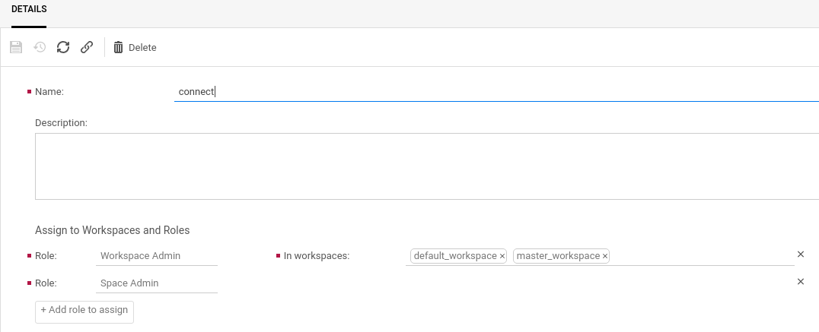

1. Select the **Go Back** arrow (make the browser full screen) and then click **Regenerate access** and copy the new **Client ID** and **Client Secret**. You’ll only see the new **Client Secret** in the popup.

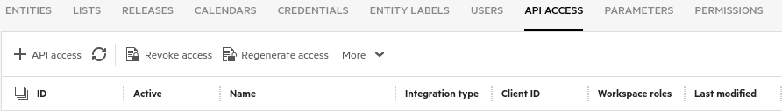

1. Open your terminal window and **paste** the content into it.

You’ll get a couple of warnings but you’ll have preserved the values for **Client ID** and **Client Secret**.

1. Click the **Settings** (gear) icon to return to the main Octane application.
2. On the **MF Connect** tab in your browser, select the **DATA SOURCES** tab.
3. Select the **Nimbus Octane Default Workspace** data source on the left panel. You’ll get a validation error popup. Ignore this.
4. Paste in the new values for the **API Clientid** and **API Client Secret** on the right.

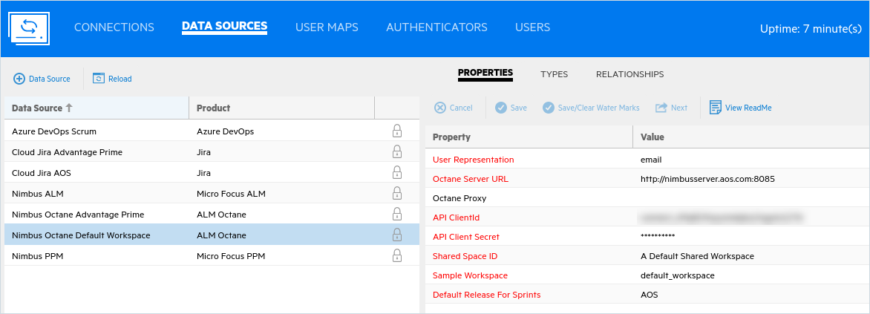

1. Click **Next** to continue. It will take a moment to load, but then it shows your saved changes. You’ve now configured the Octane Data Source connection.
2. While still on the **DATA SOURCES** tab and the **PROPERTIES** tab, select the **View ReadMe** option on the right. This displays the latest details on the **Octane Connector**.
3. Click on the **TYPES** tab and then on the first entry **Defect** to see the fields that are sync’d for defects.

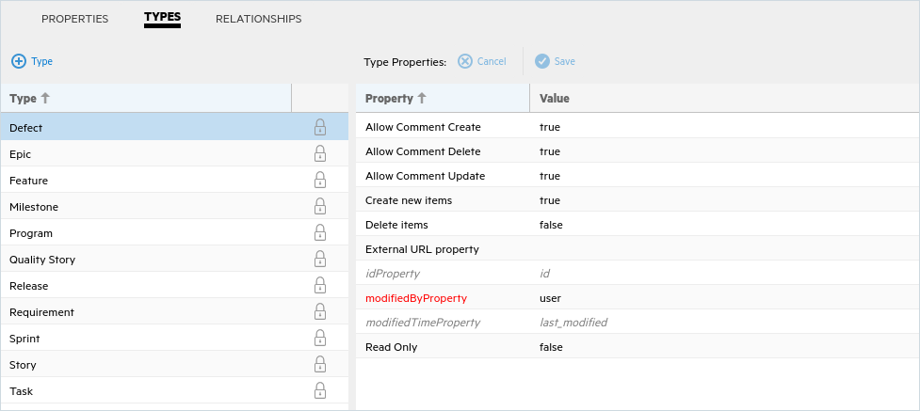

1. Click on the **RELATONSHIPS** tab to see the entities and their related entities that are sync’d.

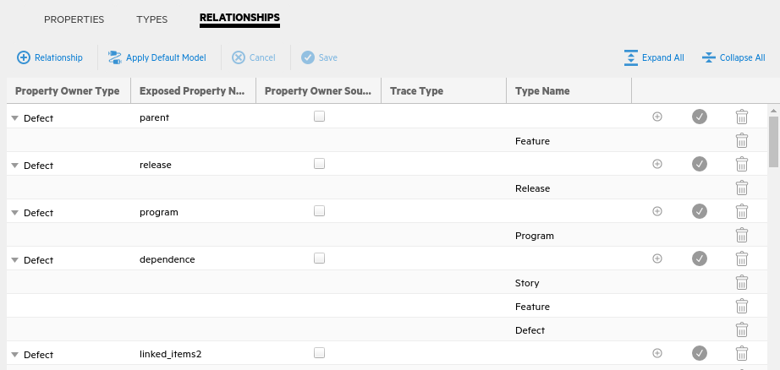

Synchronizing Jira and Octane

Now we’re ready to sync data from ALM Octane and Jira. Since our Jira instance is empty, it will be the recipient of the selected Octane data. Only fields and links that have been mapped will sync to Jira. If you create new items in Jira at a later point in time, they will get synced to Octane since this is a bi-directional synchronization.

1. Select the **CONNECTIONS** tab at the top in **Connect**. We have seven pre-configured connections in  
   MF Connect:
   1. Nimbus ALM AOS with Azure DevOps AOS Scrum – This syncs ALM QC with Azure DevOps
   2. Nimbus ALM AOS with Jira AOS – This syncs an ALM QC instance with Jira
   3. Nimbus ALM AOS with Octane Default Workspace – This syncs an ALM QC instance with Octane
   4. Nimbus Octane Advantage Prime with Cloud Jira AOSP – This syncs Octane Advantage Prime with Jira AOSP
   5. Nimbus Octane Default Workspace with Azure DevOps AOS Scrum – This syncs Octane with Azure DevOps
   6. **Nimbus Octane Default Workspace with Jira AOS** – This syncs an Octane AOS with Jira AOS
   7. Nimbus PPM Octane Default Workspace

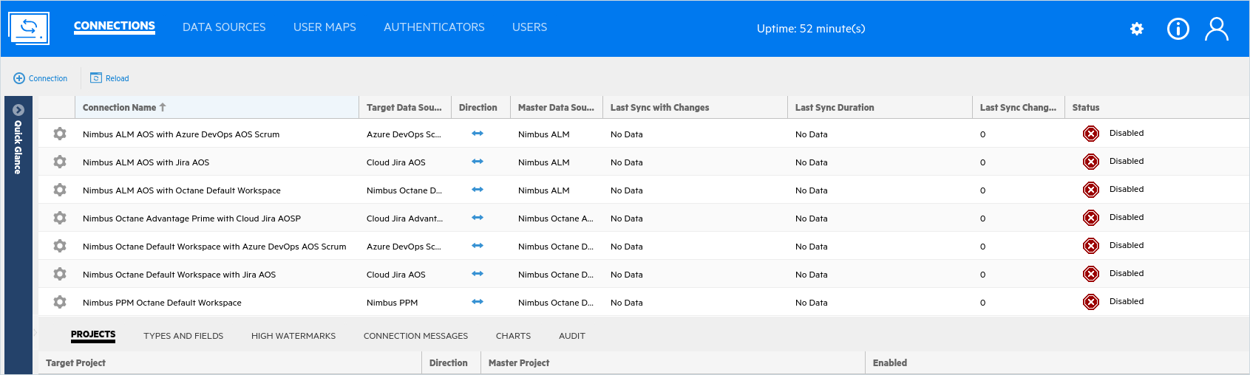

1. Scroll down or expand your window to show all seven connection types.

**Left click** on the gear icon to the left of the **Nimbus Octane Default Workspace with Jira AOS** connection. Select **Run One Iteration**.

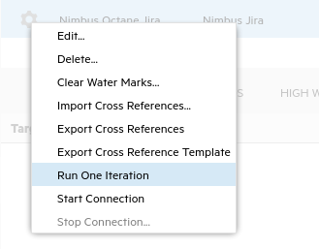

**NOTE: if you get errors about the sprint name, edit the connection and remove SprintName from the Epic.**

This will run just one synchronization cycle. If you want it to run a continuous sync you would choose **Start Connection**.

1. 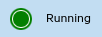The **Disabled** icon will turn green to show the synchronization cycle has started.  
   It should take 25-35 minutes to finish the sync cycle.
2. Periodically, click the **Reload** button to update your display.

You can also just click again on the Connection Name line to refresh the display.

Be patient – this can take quite a long time since there are hundreds of items to sync.

1. Wait for the synchronization to finish.

You can see how many items were synced under the **Last Sync Changes** column (count will vary).





1. While you have the connection selected (it’s blue), you can select the tabs in the bottom section to view the following information (you may need to refresh your page to see this):

**TYPES AND FIELDS**

The **TYPES AND FIELDS** tab shows a list of the synchronized types and the fields that were synced. Each type can be expanded to show the associated fields and the direction of the sync.

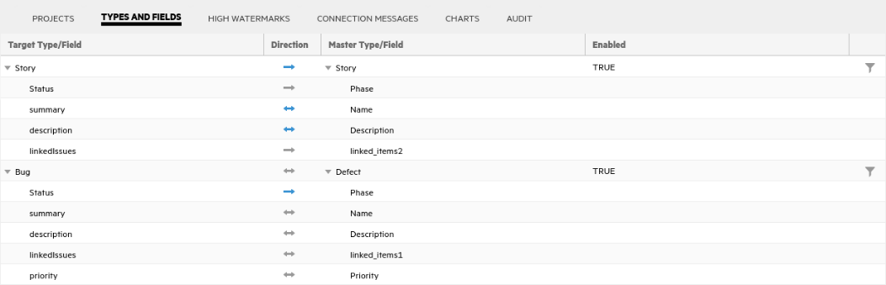

**HIGH WATERMARK**  
  
High Watermarks allow MF Connect to know what has previously been synchronized. It acts as a time and place marker so that MF Connect compares what has been updated, added, deleted and so forth, after the High Watermark was made.

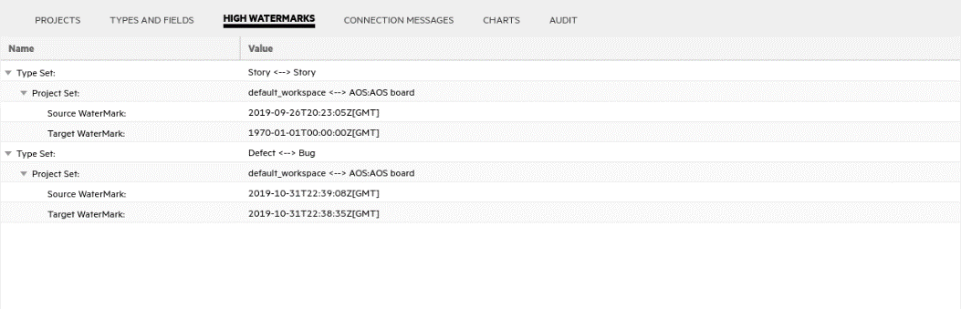

**CONNECTION MESSAGES**

The **CONNECTION MESSAGES** tab shows a summary log of the synchronizations that have occurred. A list of the different types and the number of items found and synced is shown, along with any error messages.

NOTE: When you are running a sync, if the messages aren’t displaying, click again on the blue connection line where you selected “Run One Iteration”. This will re-sync the connection messages.

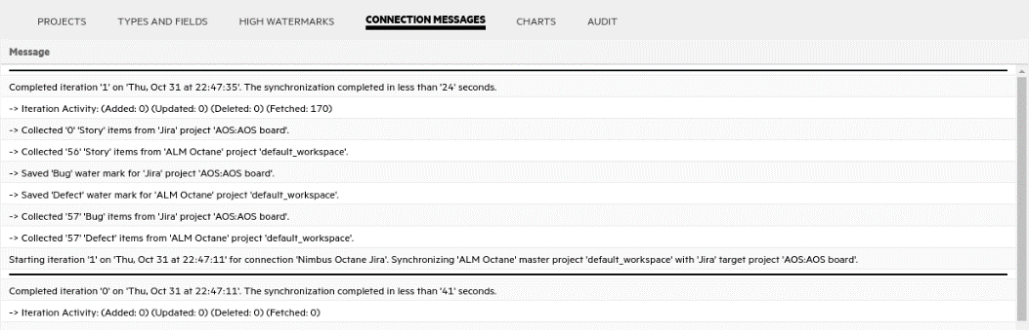

**CHARTS**

Charts track volume, changes, and errors. Each item is denoted by a specific colored line:

* Green: denotes volume, indicating the quantity of items read.
* Blue: denotes changes, indicating the quantity of items modified.
* Red: denotes errors, indicating failed changes.
* Hover over a data point to view detailed information.

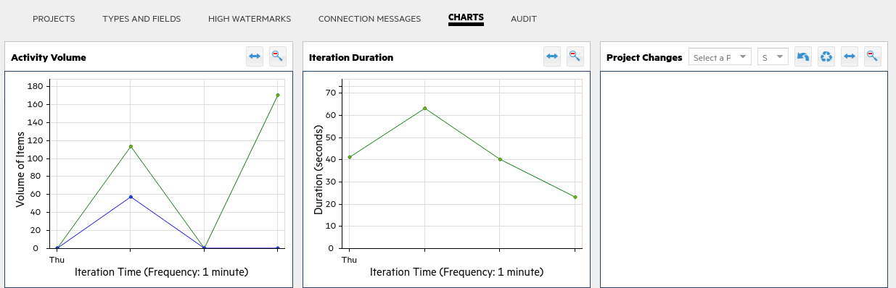

**AUDIT**

The **AUDIT** shows the details of what was added, updated or failed to sync during a given iteration for a given connection. In the case of sync failures, there will be a stack trace that you can click into and get full details. After a sync run you can try this out by clicking on **Run** and expanding the sections.

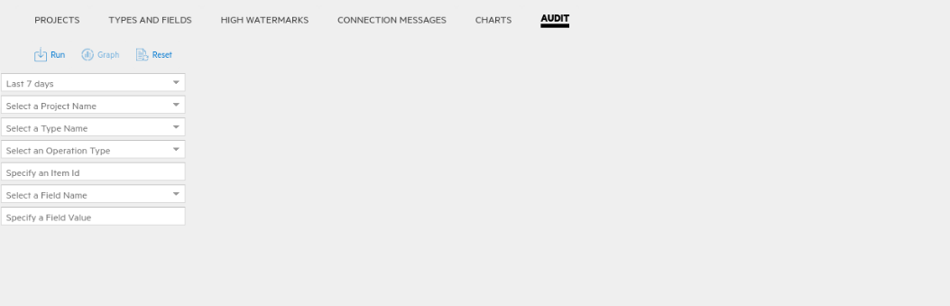

1. While still on the **CONNECTIONS** tab with the **Nimbus Octane Default Workspace with Jira AOS** connection left-click the **gear** icon and then select **Edit…**

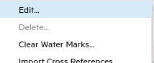 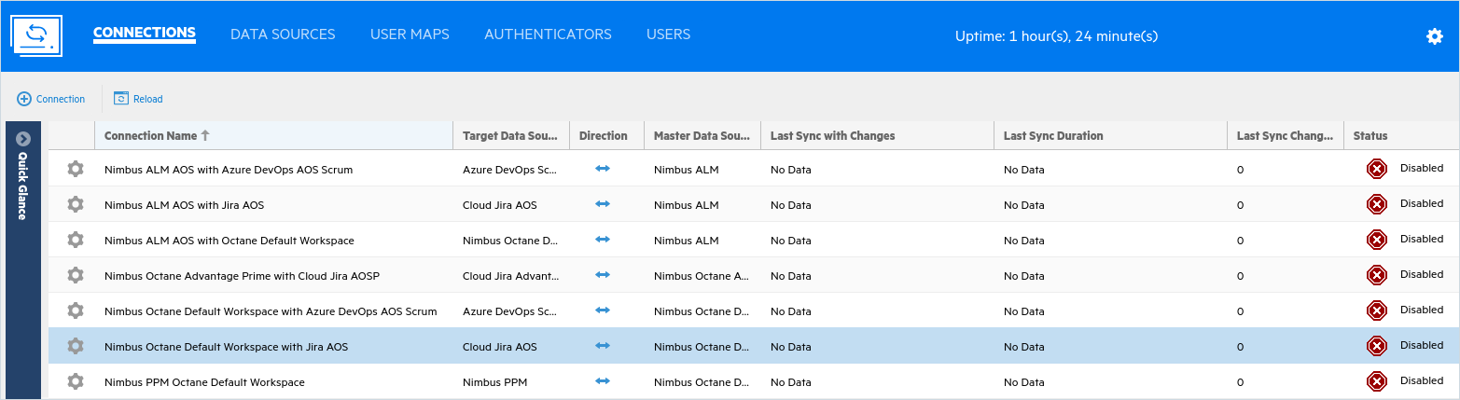

1. In this interface you can design the **Data Source**. The first tab allows you to change the synchronization frequency (in minutes) for this connector which overrides the global frequency.

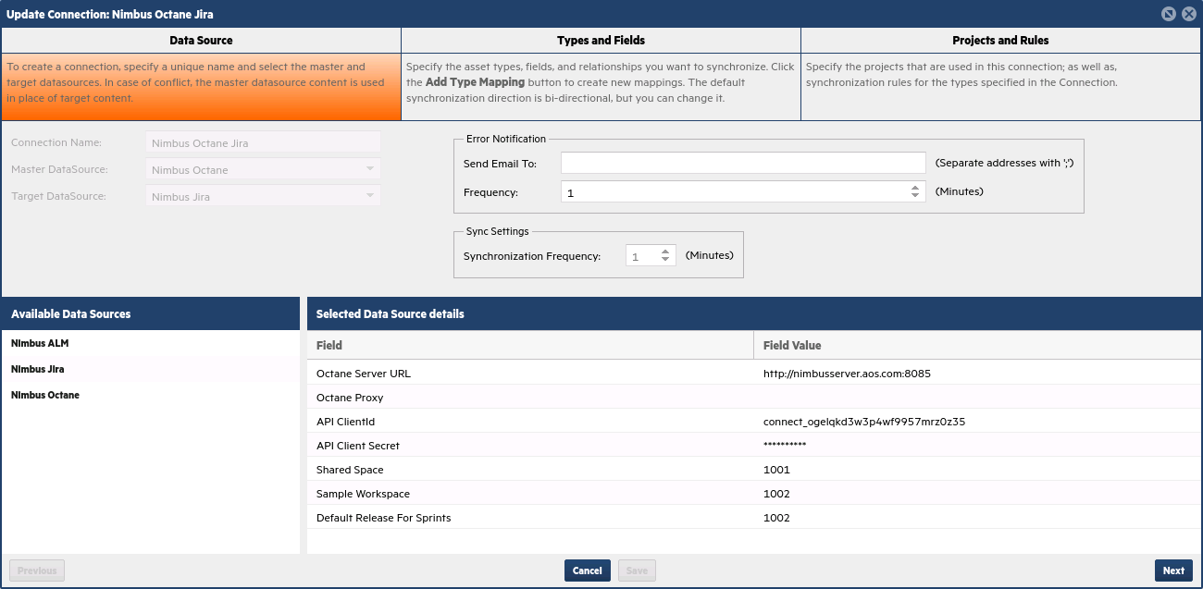

1. Click **Next** and then open the **Story** and **Bug** expanders to see how the fields are mapped.

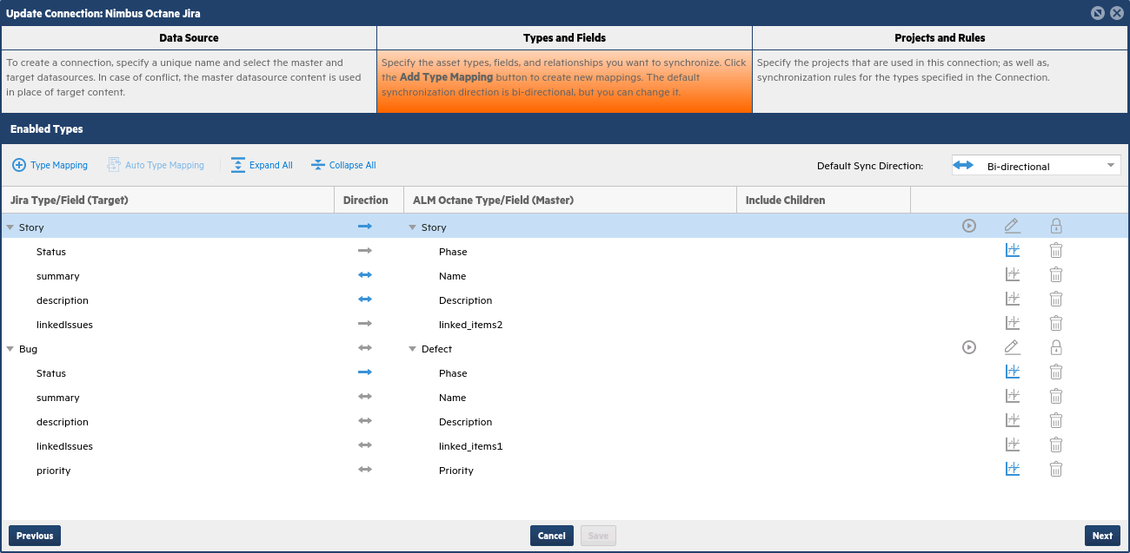

1. Select the pencil (edit) icon for **Story** to see how to edit this type mapping.

The top section **Direction:** indicates who can create new entities in the other tool (Jira can create stories in Octane). However, with this mapping, user stories in Octane are not created as new stories in Jira.

In the bottom section, the mapping indicate what happens when existing entities are changed.

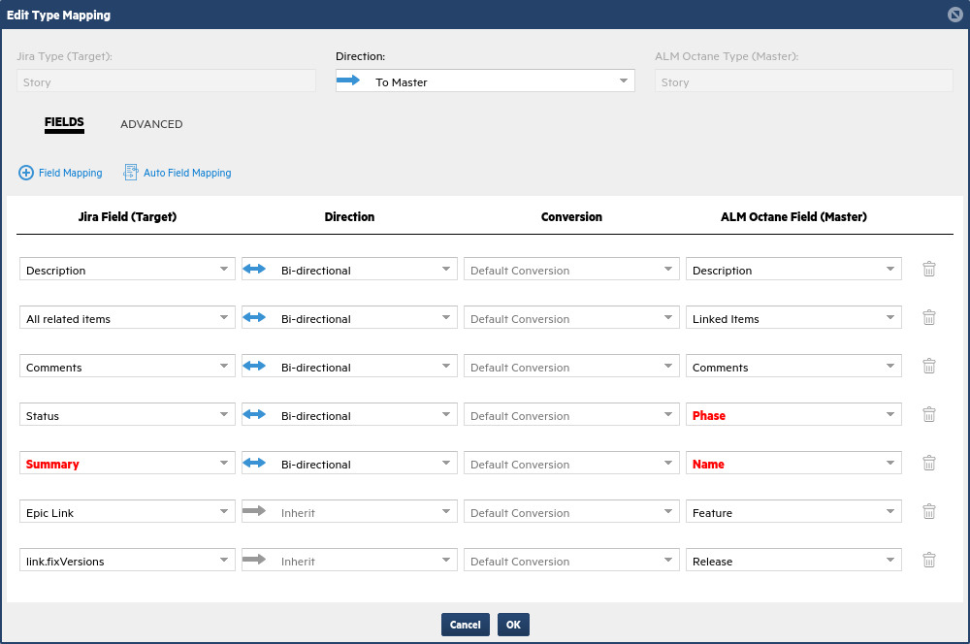

**Top Section**

**Bottom Section**

NOTE: Fields in **Red** are required fields that must exist in that product’s schema.

1. Click **Cancel** when you are done viewing the **Edit Type Mapping** interface (don’t make any changes).
2. Click **Next** to see the **Project Mapping** and other special rules.

In our case, we’re only synchronizing the Jira **AOS:AOS** project with the Octane **default_workspace**.

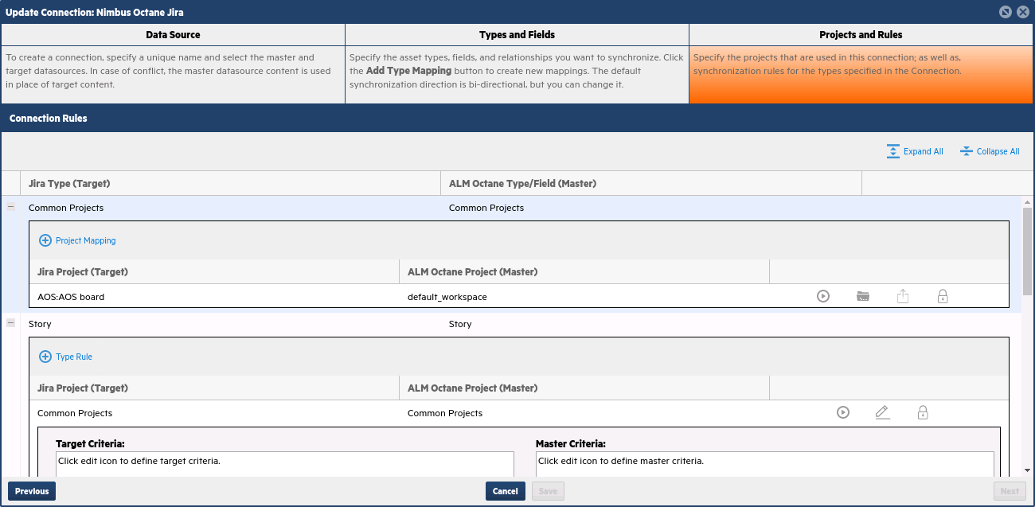

1. Click **Cancel** to return to the main view.

Verifying data in Octane and Jira

The next step is to verify that the data in Octane has been successfully synced into to Jira.

* 1. In ALM Octane, navigate to the **Backlog** module and select the **BACKLOG ITEMS** tab.
  2. Use the Columns option and add both **Author** and **Creation Time** columns.
  3. Sort by the newest creation time and you’ll see the new **User Stories** and **Defects** that came from Jira.

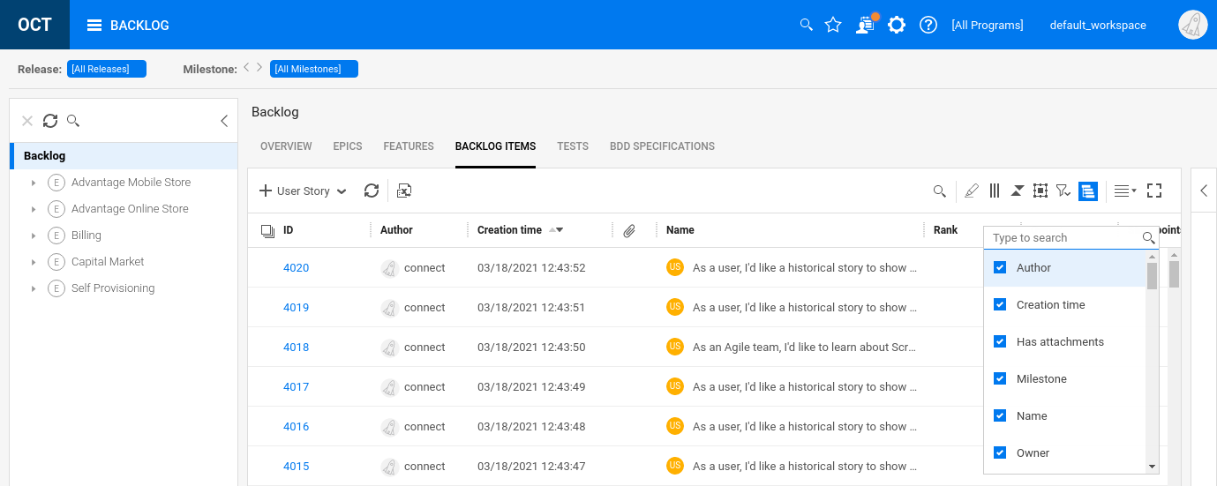

* 1. Create a filter and select Type as **Defect** to show only defects.



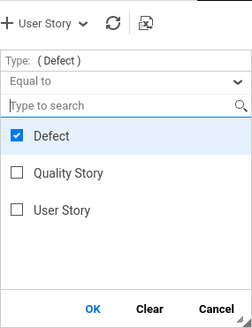 + +

* 1. Look at the bottom of the grid view and note the total number of backlog items that are defects.

Your total backlog items count may be different than what is shown.

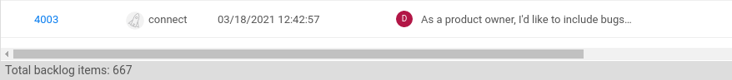

* 1. Open the Jira tab in your browser and select the **AOS** project.
  2. Select the **Issues** icon on the left edge and set the filter to show **Type Bug**.

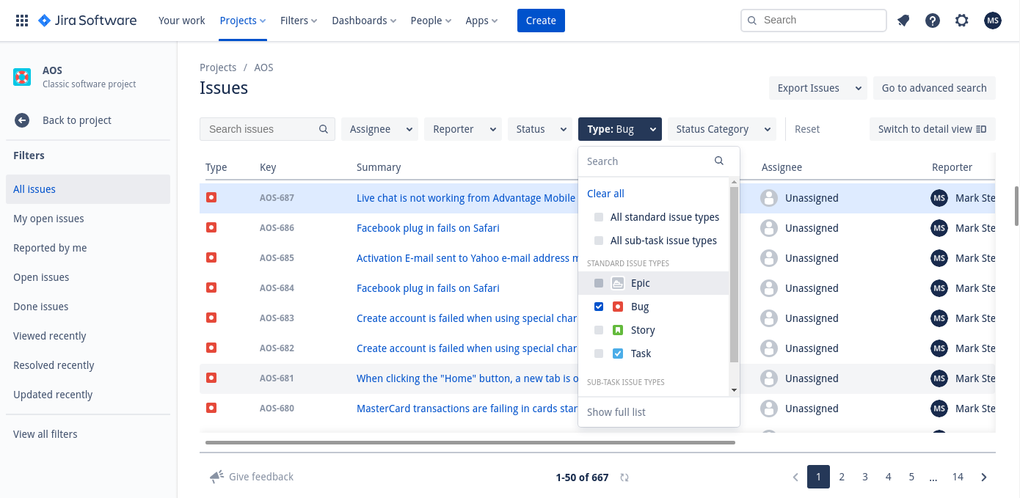

* 1. Verify that the number of issues in Jira is the same as the number of defects in Octane.

In the screenshots we see both defect (bug) counts to be **667**. Your counts may be different.

* 1. In **Octane**, add the **Priority** column to your view and locate a defect that doesn’t show a priority.

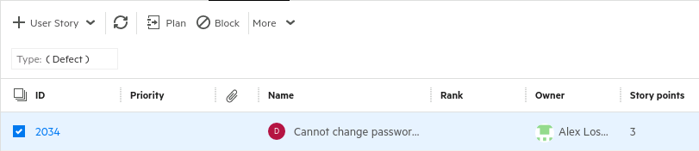

* 1. Switch to **Jira** and locate the same issue (use Search) and note the **Priority** shown. Why is it different?

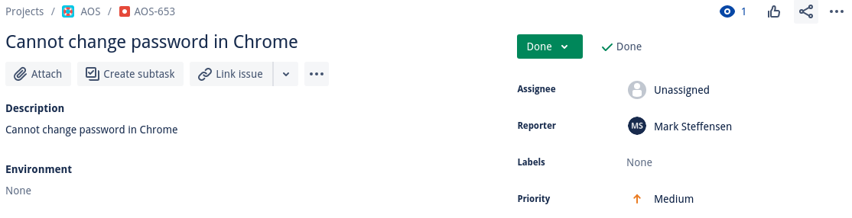

The priority is different because Jira requires a priority to be set and the default priority is **Medium**.

* 1. The table below shows the exact mappings of **Priority** field values from Jira to Octane.

You can view or change these values if you choose to edit a connection.

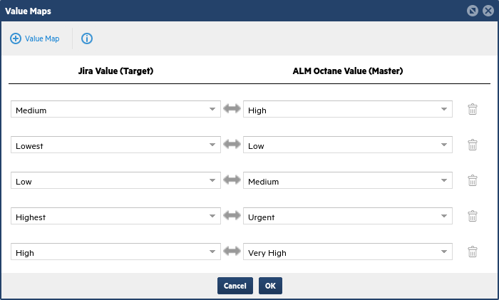

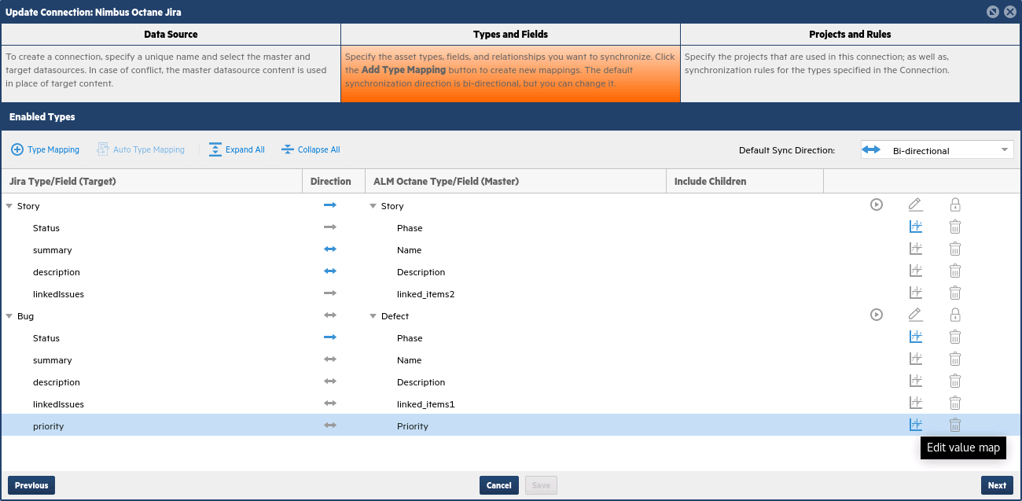

Challenge Exercise #3

Change the **6. Nimbus Octane Default Workspace with Jira AOS** connection to allow bidirectional synchronization of Stories and Statuses. Verify your results by creating stories and defects in Jira and synchronizing them.

Challenge Exercise #4

Create a new connection and synchronize Epics (in Jira) with Features in Octane.

Synchronizing Jira and ALM QC

Now that we have some data in Jira let’s also sync that to ALM QC.

1. Verify that you have both **NimbusServer** and **NimbusClient** up and running.
2. Start or verify the following Docker containers for this exercise.   
   (The AutoPass container also needs to be running, but it automatically starts with Nimbus Server.)

**$ nimbusapp alm:16.0.1 start**

**$ nimbusapp mfconnect:4.4.2 start**

1. **Data Source Configuration**: In ALM, you must have a user with the default username “admin” and the default password of “Password1”. Additionally, you must have the preconfigured domain and projects that come as part of the ALM container. These have been set up for you.
2. Switch over to the **NimbusClient VM** and open **IE** or **ALM Client Launcher** and log in to ALM QC.

(NOTE: You may need to install the ALM QC Desktop Client – if so, just accept the prompts)

Username: **admin**

Password: **Password1**

Domain: **DEFAULT**

Project: **AOS**



1. Select the **Defects** module on the left and click **Select Columns** to set the following columns order:
   1. **Summary**
   2. **Priority**
   3. **Status**
   4. **Severity**

This will make it easier to verify the defects when they come over from Jira (there won’t be any in QC).

1. Switch back to the **NimbusServer** VM and the **MF Connect** tab in your browser.
2. Select the **CONNECTIONS** tab at the top in **Connect**. You should see seven pre-configured connections in Connect:
   1. Nimbus ALM AOS with Azure DevOps AOS Scrum – This syncs ALM QC with Azure DevOps
   2. **Nimbus ALM AOS with Jira AOS** – This syncs an ALM QC instance with Jira
   3. Nimbus ALM AOS with Octane Default Workspace – This syncs an ALM QC instance with Octane
   4. Nimbus Octane Advantage Prime with Cloud Jira AOSP – This syncs Octane Advantage Prime with Jira AOSP
   5. Nimbus Octane Default Workspace with Azure DevOps AOS Scrum – This syncs Octane with Azure DevOps
   6. Nimbus Octane Default Workspace with Jira AOS – This syncs an Octane AOS with Jira AOS
   7. Nimbus PPM Octane Default Workspace



1. **Left click** on the gear icon to the left of the **Nimbus ALM AOS with Jira AOS** connection.   
   Select **Run One Iteration**. This will run just one synchronization cycle. If you want it to run a continuous sync you would choose **Start Connection**.





1. The **Disabled** icon will turn green to show the synchronization cycle has started.  
   It should take 4-10 minutes to finish the sync cycle.



You can see how many items were synced under the **Last Sync Changes** column (your count may vary).

1. After a short time, click the **Reload** button to update your display.

Wait until the synchronization has finished.

1. Switch back to **NimbusClient** and **IE** or **ALM Client Launcher** and click on the **Refresh** icon.  
   NOTE: the AOS project had no defects prior to this sync so these will all be new.
2. **Select** one of the defect rows.

Note the number of defects that were sync’d by looking at the bottom of the table.

Jira Stories are transformed into ALM Requirements.

NOTE: You may want to organize the columns **Summary**, **Priority**, **Status** and **Severity** to the far left.

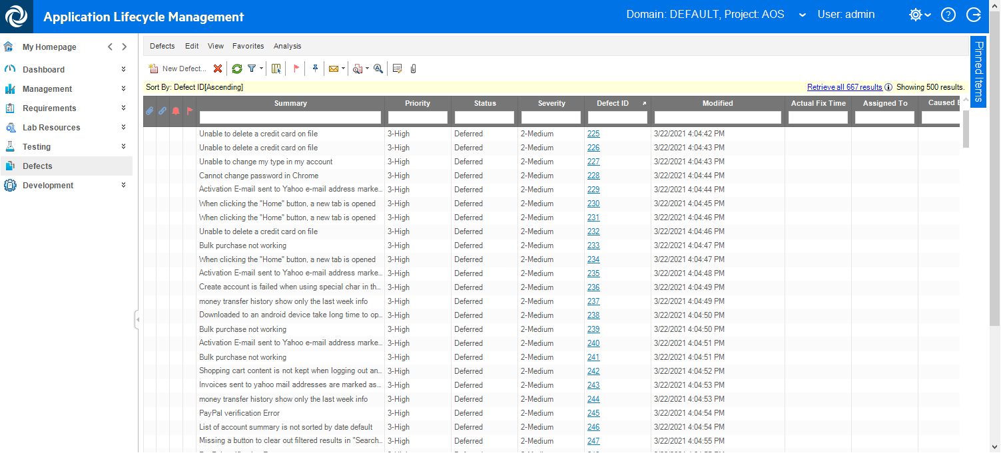

1. Switch back to your browser and the **Jira** **cloud** instance and click on the **Backlog** item on the left.

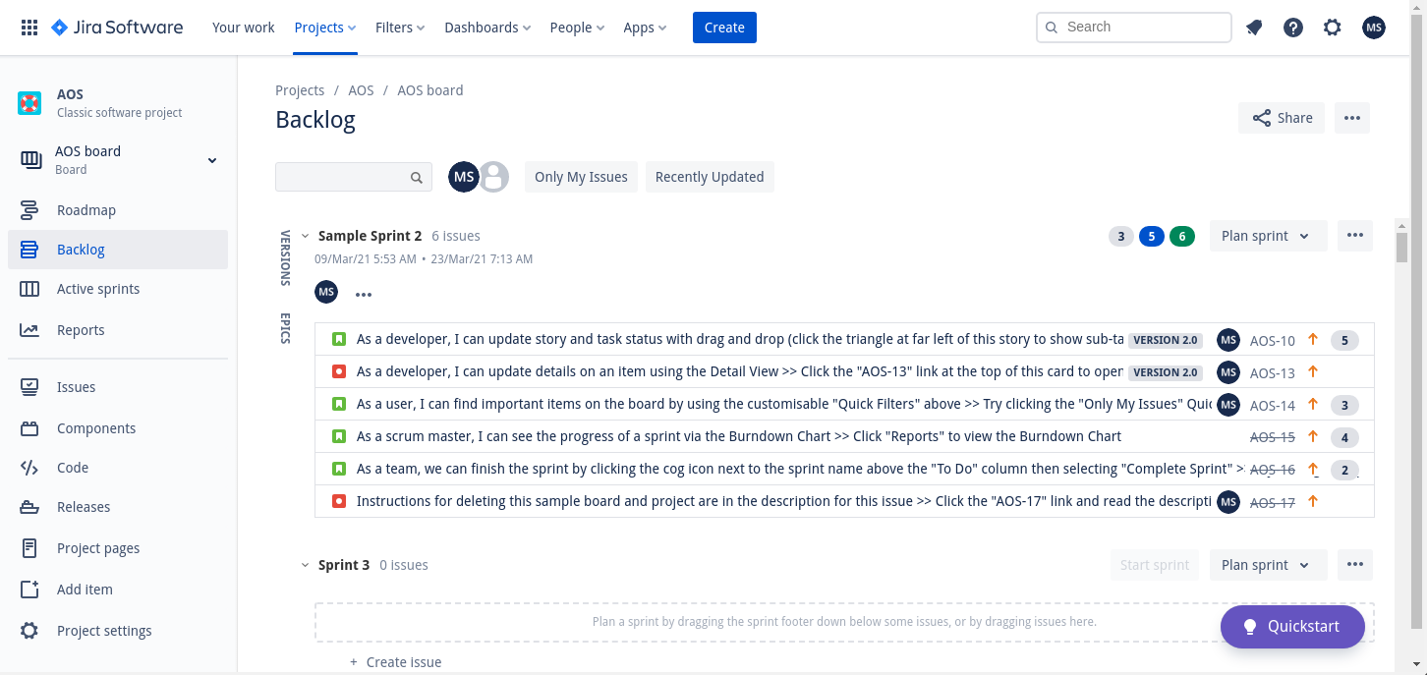

1. Click **Create** (at the top) to create a new **Backlog** item.
2. Create a new story item called: “**New backlog item that will become a requirement in ALM.**”  
   Do this for both **Summary** and **Description** and click **Create**.

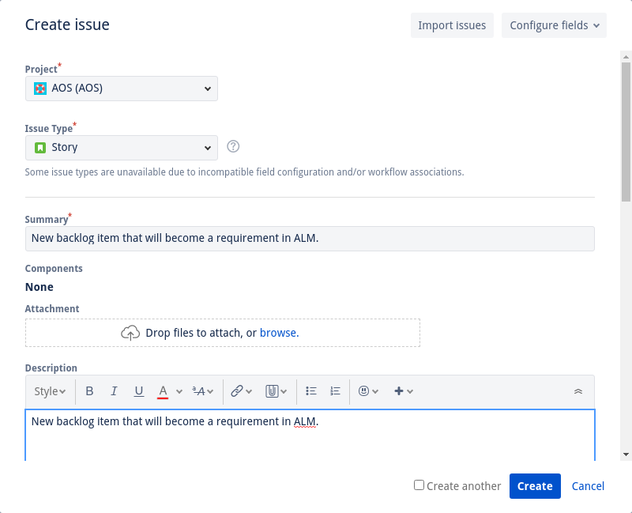

1. Go back to the **NimbusServer VM** and the **MF Connect** tab and left click the **Nimbus ALM Jira** gear icon and select **Run One Iteration**.
2. After the synchronization has finished, go back to the **NimbusClient VM** and **ALM** and select the   
   **Requirements** module.
3. Click the **Refresh** icon and verify that your new Jira story has been sync’d as a new requirement.

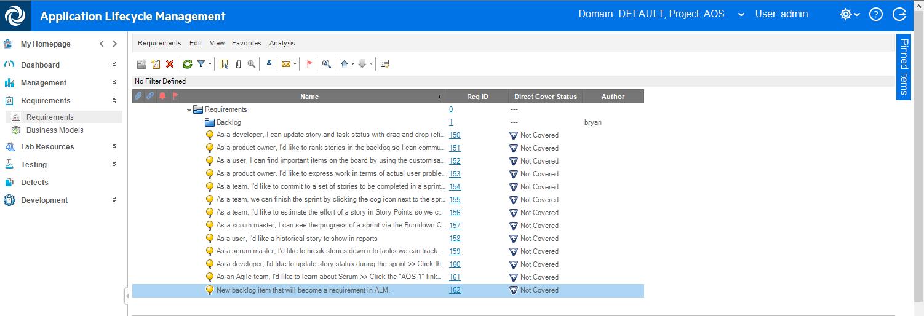

Challenge Exercise #5

Change the **Priority** of the new ALM requirement to **Low** and sync again. Verify that the corresponding story in Jira has its priority changed to **Lowest**.

Challenge Exercise #6

Create a Custom UDF in ALM called **Jira ID** on Defects and map Jira’s ID to this field. Synchronize and verify that your new field is showing and set properly.

Synchronizing ALM QC and Octane

Next we’ll look at synchronizing defects and requirements in ALM QC with ALM Octane.

1. Verify that you have both **NimbusServer** and **NimbusClient** up and running.
2. Start or verify the following Docker containers for this exercise.   
   (The AutoPass container also needs to be running, but it automatically starts with Nimbus Server.)

**$ nimbusapp alm:16.0.1 start**

**$ nimbusapp mfconnect:4.4.2 start**

**$ nimbusapp octane:16.0.400.79 start**

1. **NOTE**: if you previously sync’d defects into ALM, reset the container state with the following commands:

**$ nimbusapp alm:16.0.1 down** (Choose **Y** when asked to remove the container)

**$ nimbusapp alm:16.0.1 up**

1. **Data Source Configuration**: In ALM QC, you must have a user with the default username “admin” and the default password of “Password1”. Additionally, you must have the preconfigured domain and projects that come as part of the ALM container. These are preconfigured in the standard ALM container.

In ALM Octane, you must have a user with the default username “sa@nga” and the default password of “Password1”. These are preconfigured in the standard Octane container.

1. Switch over to the **NimbusClient VM** and open **IE** or **ALM Client Launcher** and log in to **ALM QC**:

Username: **admin**

Password: **Password1**

Domain: **DEFAULT**

Project: **AOS**



1. Select the **Defects** module and click on **Select Columns** to set the following columns order:
   1. **Summary**
   2. **Priority**
   3. **Status**
   4. **Severity**

This will make it easier to verify the defects when they come over from Octane.

1. Switch back to the **NimbusServer** **VM** and the **MF Connect** tab in your browser.
2. Select the **CONNECTIONS** tab at the top in **Connect**. You should see seven pre-configured connections in Connect:
   1. Nimbus ALM AOS with Azure DevOps AOS Scrum – This syncs ALM QC with Azure DevOps
   2. Nimbus ALM AOS with Jira AOS – This syncs an ALM QC instance with Jira
   3. **Nimbus ALM AOS with Octane Default Workspace** – This syncs an ALM QC instance with Octane
   4. Nimbus Octane Advantage Prime with Cloud Jira AOSP – This syncs Octane Advantage Prime with Jira AOSP
   5. Nimbus Octane Default Workspace with Azure DevOps AOS Scrum – This syncs Octane with Azure DevOps
   6. Nimbus Octane Default Workspace with Jira AOS – This syncs an Octane AOS with Jira AOS
   7. Nimbus PPM Octane Default Workspace



1. **Left click** on the gear icon to the left of the **Nimbus ALM AOS with Octane Default Workspace** connection. Select **Run One Iteration**. This will run just one synchronization cycle. If you want it to run a continuous sync you would choose **Start Connection**.





1. The **Disabled** icon will turn green to show the synchronization cycle has started.  
   It should take 5-7 minutes to finish the sync cycle.



You can see how many items were synced under the **Last Sync Changes** column.

Of the sync’d items there are two requirements folders and the rest are defects.

1. After a short time, click the **Reload** button to update your display.

Wait until the synchronization has finished.

1. Switch back to **NimbusClient** and **IE** or **ALM Client Launcher** and click on the **Refresh** icon.
2. **Select** one of the defect rows.

Note the number of defects that were sync’d by looking at the top or bottom of the table.

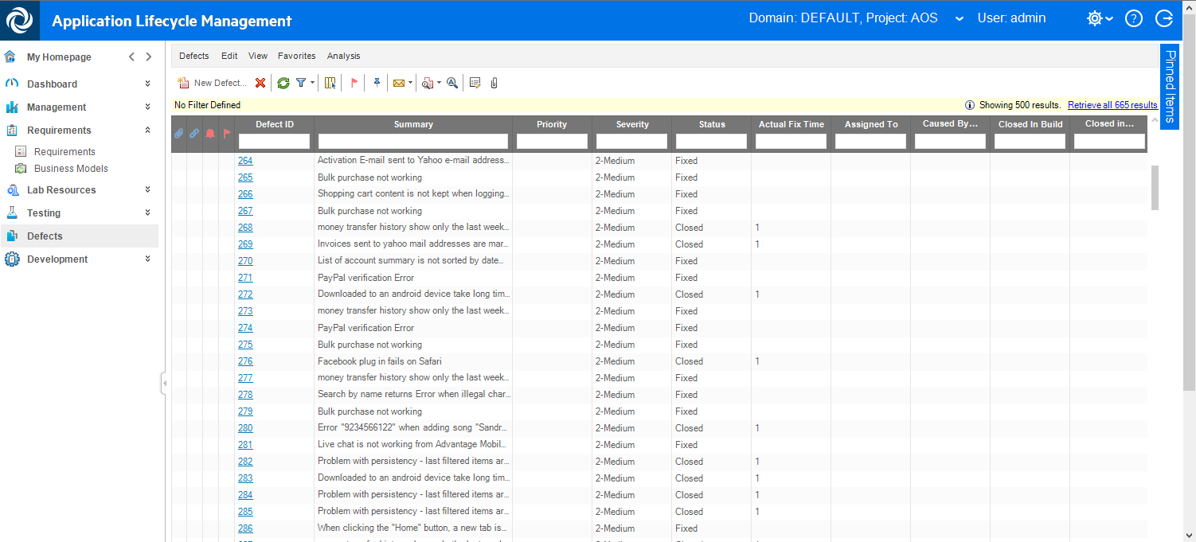

1. Switch back to **NimbusServer** and **Octane** in your browser and click on the **Requirements** module.

At the bottom of the page you should see a new category and sub-requirement as shown.

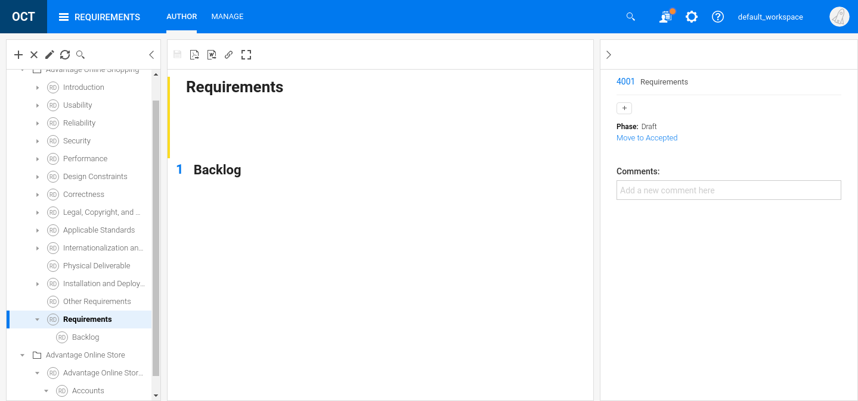

1. The number of items sync’d should be two more than the number of defects since these two requirements were brought from ALM into Octane. This connection moves requirements from ALM to Octane and bi-directionally sync’s the defects in each.

Exercise 18: Integrating SonarQube Code Coverage

Role: Integration or Automation Engineer

Code Coverage provides an automated and impartial way to judge the quality of code. Tools like SonarQube and JaCoCo (Java Code Coverage) are often used to check the quality of code and determine if the embedded unit tests actually cover enough of the code. They also provide a variety of other code quality metrics.

Jenkins offers integration with these tools and ALM Octane can integrate this data into charts that show a summary of coverage by pipeline run and by package

In this exercise we’ll look how to configure this integration.

Starting SonarQube

1. We need to have the following VM’s running for this exercise:

* NimbusServer

1. Run the following commands or verify that these containers are already running.  
   Allow enough time for these containers to settle down (5-8 minutes or so).

**$ nimbusapp aos:3.2 start**

**$ nimbusapp devops:3.2.3 start**  
**$ nimbusapp intellij:3.2.1 start**

**$ nimbusapp octane:16.0.400.79 start**

**$ nimbusapp sonarqube:7.7 start**

**$ nimbusapp ssc:21.2.1 start**

**$ nimbusapp sca:21.2.1 start**

1. From **NimbusServer**, start Chrome and open the **Jenkins** shortcut and select the **Pipelines** tab.
2. We’ll start by making a copy of an existing pipeline and then customizing it to our needs.

Select the **New Item** option on the left alley.

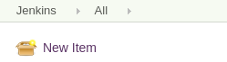

1. At the top input box, name the new item **AOS_Web_Root_Module_SonarQube_Pipeline**  
   We’ll be reusing this name in another location so it’s important to use this exact name.
2. Scroll to the bottom and in the **Copy from** field enter **aos-web-root-module-pipeline**  
     
   

aos-web-root-module-pipeline

1. Click **OK**.

Modifying the Pipeline Code

1. Edit the Jenkins configuration for **AOS_Web_Root_Module_SonarQube_Pipeline** and replace the entire **pipeline code** with the following code.

In order to preserve the format, copy the text below and paste it into Notepad on your desktop before copying and pasting it into Jenkins.

def nodetest() {

echo ('alive on $(hostname)')

}

pipeline{

agent none

environment {

AOS_VERSION=get_aos_version()

}

stages{

stage ('Checkout')

{

agent { label 'master'}

steps{

git branch: "${AOS_VERSION}", url: '/gitrepo/aos-source'

}

}

stage(' Fortify Source Code Analyzer')

{

when {

beforeAgent true

expression { Jenkins.instance.getNode('sca').toComputer().isOnline() }

}

agent { label 'sca'}

steps {

echo "SCA node is online: Running Source Code Analyzer"

git branch: "${AOS_VERSION}", poll: false, url: 'http://devops/git/aos-source'

script {

env.FILE = sh (

script: "find ${env.WORKSPACE}/root/src -name '*.java'",

returnStdout: true

).trim()

echo "${env.FILE}"

fortifyClean addJVMOptions: '', buildID: 'root', logFile: '', maxHeap: ''

fortifyTranslate addJVMOptions: '', buildID: 'root', excludeList: '', logFile: '', maxHeap: '', projectScanType: fortifyJava(javaAddOptions: '-cp ${WORKSPACE}/"SecScan/WEB_INF/lib/*', javaClasspath: '', javaSrcFiles: "$env.FILE", javaVersion: '1.8')

fortifyScan addJVMOptions: '', addOptions: '-machine-output', buildID: 'root', customRulepacks: '', logFile: '', maxHeap: '', resultsFile: 'root.fpr'

}

archiveArtifacts 'root.fpr'

stash includes: 'root.fpr', name: 'root.fpr'

}

}

stage(' Upload Scan to Software Security Center')

{

agent { label 'master'}

when {

expression { Jenkins.instance.getNode('sca').toComputer().isOnline() }

}

steps {

unstash 'root.fpr'

fortifyUpload appName: 'Advantage Online Shopping - Root Module', appVersion: "${AOS_VERSION}", failureCriteria: '', filterSet: '', pollingInterval: '0', resultsFile: ''

}

}

stage('Build Root Module')

{

steps{

//=== AOS Web Build Root Module ===

//=== This build requires the AOS containers and either Inteliij container or LeanFT container ===

build job: 'aos-web-build-root'

}

}

stage('SonarQube Analysis For ALM Octane')

{

agent { label 'master'}

when {

expression {

return sh (

script: "curl -L -s --head --request GET http://nimbusserver.aos.com:8020 | grep '200'",

returnStatus: true

) == 0

}

}

steps {

withSonarQubeEnv ( "SonarQube" ) {

addALMOctaneSonarQubeListener pushCoverage: true, pushVulnerabilities: true, sonarServerUrl:env.SONAR_HOST_URL, sonarToken:env.SONAR_AUTH_TOKEN

copyArtifacts filter: '**/jacoco.xml', fingerprintArtifacts: true, flatten: false, projectName: 'aos-web-build-root', selector: lastSuccessful()

sh ( script: "ls -la" )

sh "mvn sonar:sonar -P DA -pl root -am -Dsonar.login=$SONAR_AUTH_TOKEN \

-Dsonar.coverage.jacoco.xmlReportPaths=${WORKSPACE}/common/target/site/jacoco/jacoco.xml,${WORKSPACE}/root/target/site/jacoco/jacoco.xml \

-Dsonar.host.url=http://nimbusserver.aos.com:8020 -Dsonar.analysis.buildNumber=${currentBuild.number} \

-Dsonar.analysis.jobName=${JOB_NAME} -Dsonar.test.inclusions=**/*Tests.java -Dsonar.java.binaries=/ \

-Dsonar.exclusions=root/src/main/webapp/scripts/nv_files/**,root/src/main/webapp/languages/english.js,root/src/main/webapp/Gruntfile.js,root/src/main/webapp/app/**/index.js,**/module.js,**/main.js,root/src/main/webapp/utils/noUiSlider.8.2.1/nouislider.js,root/src/main/webapp/r.js,root/src/main/webapp/api/**"

}

}

}

stage('Deploy Root Module')

{

agent { label 'master'}

steps{

script {

DA_ONLINE = sh (

script: "curl -L -s --head --request GET http://nimbusserver.aos.com:8089/da | grep '200'",

returnStatus: true

) == 0

echo "Deployment Automation Online: ${DA_ONLINE}"

if (DA_ONLINE) {

echo '=== AOS Web Deployment Automation Publish and Deploy Root To Dev ==='

build job: 'aos-web-da-publish-deploy-root-dev'

}

else {

//undeploy root module from Tomcat

httpRequest authentication: '94c1b1e6-5013-4d2d-a78a-a9b2b8adc9e5', responseHandle: 'NONE', url: 'http://aos-main:8080/manager/text/undeploy?path=/'

//copy artifacts from build

copyArtifacts filter: '**/*.war', fingerprintArtifacts: true, flatten: true, projectName: 'aos-web-build-root/com.advantage.online.store:root', selector: lastSuccessful()

//update configuration

configFileProvider([configFile(fileId: 'b9df64b1-0f01-4587-8f2a-fda77d8f7cf3', targetLocation: './config-aos-war.sh')]) {

sh 'chmod +x ./config-aos-war.sh && ./config-aos-war.sh'

}

//deploy to Tomcat

sh "curl -v -u tomcatadmin:Password1 -T root*.war 'http://aos-main:8080/manager/text/deploy?path=/ROOT&update=true'"

}

}

}

}

stage('UFT Developer Regression Test')

{

steps{

catchError(buildResult: 'FAILURE', stageResult: 'FAILURE') {

build 'aos-web-regression-test'

}

}

}

stage('UFT Developer For Selenium Test')

{

steps{

catchError(buildResult: 'FAILURE', stageResult: 'FAILURE') {

build 'aos-web-selenium-uftdev-test'

}

}

}

}

}

def get_aos_version() {

node('master') {

return env.AOS_VERSION

}

}

1. Click **Save** to save your configuration changes.

Configuring Jenkins to work with SonarQube

1. In Chrome, open the **SonarQube** URL (<http://nimbusserver.aos.com:8020>)
2. 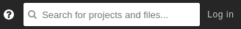In the upper right corner, log in as Administrator with  
   Login: admin

Password: admin

1. Select **My Account** under the **A** pull-down.

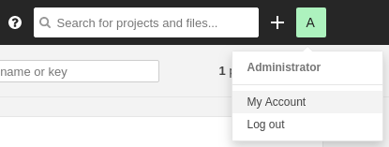

1. Select the **Security** tab and **generate** a new token called **sonar.**

**Copy the token that is generated.**

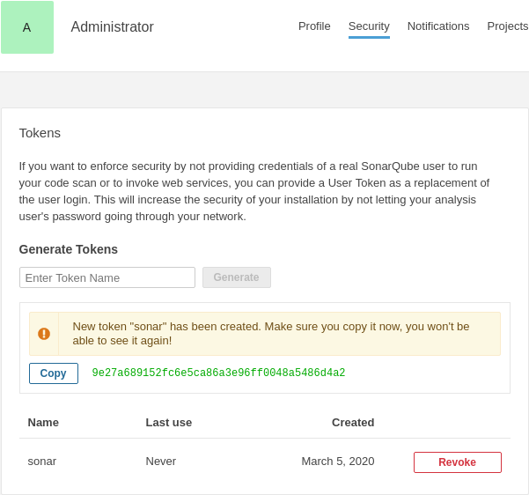

1. Switch back to Jenkins and select the **Manage Jenkins** and **Configure System**.
2. Locate the section for **SonarQube servers**.
3. Set the following:

* Enable injection checkbox is **checked**
* Name: **SonarQube**
* Server URL: <http://nimbusserver.aos.com:8020>

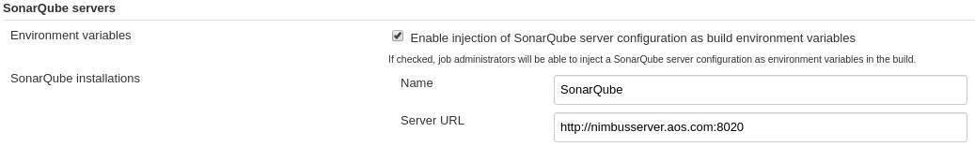

1. Under the **Add** pull-down select **Jenkins**.

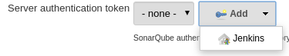

1. Select **Kind** to be **Secret Text** and set the following fields:

Secret: **<paste in the value from step 4 above>**

ID: **sonar**

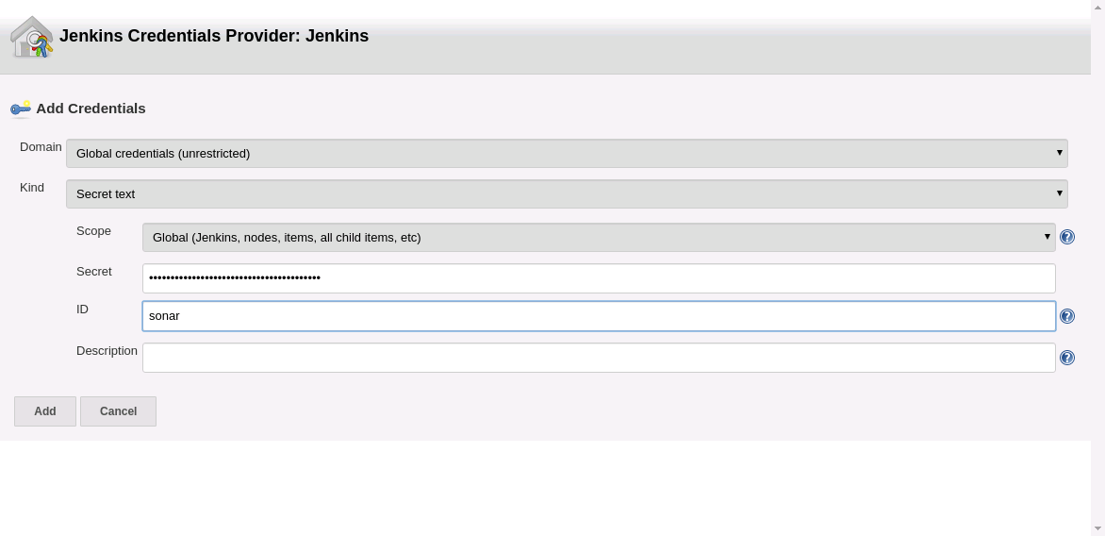

1. Click **Add** to create this credential.
2. From the pull-down select **sonar** and click **Save**.

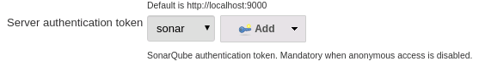

1. Open the Octane shortcut and create a new Pipeline in Octane from **AOS_Web_Root_Module_SonarQube_Pipeline**
2. Run the **AOS_Web_Root_Module_SonarQube_Pipeline** pipeline from Octane or Jenkins.
3. When the pipeline finishes, add the following two new charts to this pipeline.  
   You may have to remove other charts to fit these new charts in.

* CODE COVERAGE BY PIPELINE RUN
* 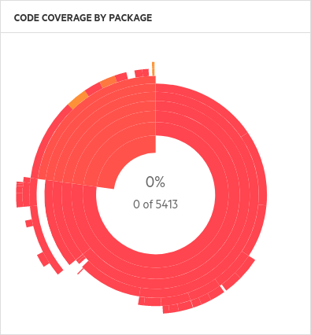CODE COVERAGE BY PACKAGE

1. You should see charts similar to the following:

Sunburst Chart

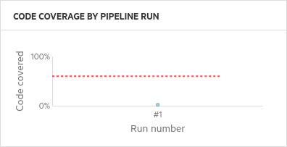

1. To see the full SonarQube results, click the SonarQube icon from the Jenkins **Build History** page to go to the SonarQube website. This displays the full results of the SonarQube analysis.

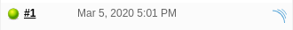

Exercise 19: Building the Account Service Module

In our current **AOS_Web_Root_Module_Pipeline**, we build and deploy the root module. That’s just one of eight modules contained in the AOS application. In this section we look at how we can change this process to build and deploy the accountservices module instead. Of course we could even build and deploy all eight modules but during a demo this might take too long so we’ve condensed this process to just focus on one module at a time.

By building a new accountservice module, we can verify changes in the accountservice module when it is virtualized with Service Virtualization. Once the accountservice service is virtualized, we can effectively turn off this container and run with just the virtualized service. We’ll save this option for a future exercise.

Cloning the Root Module Jobs in Jenkins

In the section we’ll make copies of a Jenkins **job** and **pipeline** and modify them to work with accountservice.

1. From the NimbusServer VM, start (or verify) the followingset of containers are running:

**$ nimbusapp aos:3.2 start**

**$ nimbusapp devops:3.2.3 start  
$ nimbusapp intellij:3.2.1 start**

1. From the NimbusServer VM, open a browser to the **Jenkins** home page and select the **All** tab and locate the job called **AOS_Web_Build_Root** (don’t click on it).  
   We’re going to make a **clone** of this job to build the accountservice module instead of Root.
2. Select the **New Item** option on the left alley.



1. At the top input box, name the new item **aos-web-build-account**  
   We’ll be reusing this name in another location so it’s important to use this exact name.
2. Scroll to the bottom and in the **Copy from** field enter **aos-web-build-root**  
     
   

aos-web-build-root

1. Click **OK**.
2. You’ll now be configuring your new **aos-web-build-account** Jenkins job.  
   Scroll down to the Build section and enter the following for the maven command:

**clean install -P DA -pl accountservice -am**

We’re basically replacing the compilation of the root module with accountservice.

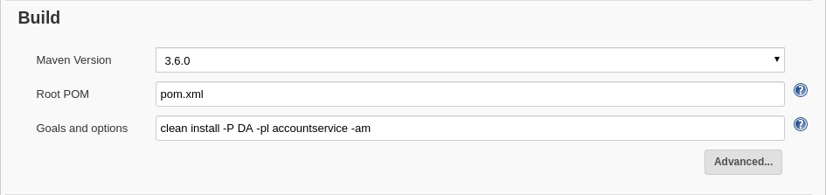

|  |
| --- |
| Thanks to Maven (which maps out all the module dependencies) we can easily change the module we want to build. Maven uses a file called pom.xml to contain those dependencies.  The output of this build is the accountservices.war file and this gets deployed on a Tomcat server. |

1. Click **Save** to save your changes.
2. Navigate back to the **Jenkins home page** after saving your changes.
3. Select the **New Item** option again on the left alley. This time we’ll clone a pipeline.
4. At the top, name the new item **AOS_Web_Account_Module_Pipeline**
5. Scroll to the bottom and in the **Copy from** field enter **aos-web-root-module-pipeline**
6. Click **OK**.

We now have copies of both a pipeline job and a build job. We’ll configure and link those together so that they build an updated version of the account service.

Updating the Pipeline Script

1. You’ll now be configuring your new **AOS_Web _Account_Module_Pipeline** Jenkins pipeline.  
   Scroll down to the **Pipeline Script** section and **replace** the code with the following code.

In order to preserve the format, copy the text and paste it into your desktop Notepad first.

def nodetest() {

echo ('alive on $(hostname)')

}

pipeline{

agent none

environment {

AOS_VERSION=get_aos_version()

}

stages{

stage('Checkout')

{

agent { label 'master'}

steps{

git branch: "${AOS_VERSION}", url: '/gitrepo/aos-source'

}

}

stage('Build Account Module')

{

steps{

//=== AOS Web Build Account Module ===

//=== This build requires the AOS containers ===

build job: 'aos-web-build-account'

}

}

stage('Deploy Account Module')

{

agent { label 'master'}

steps{

script {

//undeploy accountservice module from Tomcat

httpRequest authentication: '94c1b1e6-5013-4d2d-a78a-a9b2b8adc9e5', responseHandle: 'NONE', url: 'http://aos-accountservice:8080/manager/text/undeploy?path=/'

//copy artifacts from build

copyArtifacts filter: '**/*.war', fingerprintArtifacts: true, flatten: true, projectName: 'aos-web-build-account/com.advantage.online.store:accountservice', selector: lastSuccessful()

//update configuration

configFileProvider([configFile(fileId: 'b9df64b1-0f01-4587-8f2a-fda77d8f7cf3', targetLocation: './config-aos-war.sh')]) {

sh 'chmod +x ./config-aos-war.sh && ./config-aos-war.sh'

}

//deploy to Tomcat

sh "curl -v -u tomcatadmin:Password1 -T account*.war 'http://aos-accountservice:8080/manager/text/deploy?path=/accountservice&update=true'"

}

}

}

}

}

def get_aos_version() {

node('master') {

return env.AOS_VERSION

}

}

We’re actually not changing much in this script – we’re deleting the security and testing stages to simplify and speed things) and replacing the stage that gets built (**Deploy Account Module**) and also replacing the root module references with that of the accountservice module.

1. Click **Save** to save your changes.

## Building the Account Services Module

1. You now have the pieces in place to build and deploy your new accountservices service.

Any changes you made to the AOS_Source in the accountservice module that is committed to the AOS source code will now get deployed as a modified version of the AOS website.

For example, if you changed an error message and then triggered that message, the new error message would now appear.

1. In IntelliJ, open the AOS Source project and navigate to: **aos_source/accountservice/src/main/java/com.advantage.accountsoap/model/Account.java**
2. Change the error message from **line 54** in **Account.java** to something you would recognize like  
    **User name already exists – Got it!!!**

Don’t forget to commit and push your changes.

1. From Jenkins, run the **AOS_Web_Account_Module_Pipeline** and then try creating a new account called **Mercury** (case sensitive). Since that account already exists you should see your new error message (it only appears briefly).

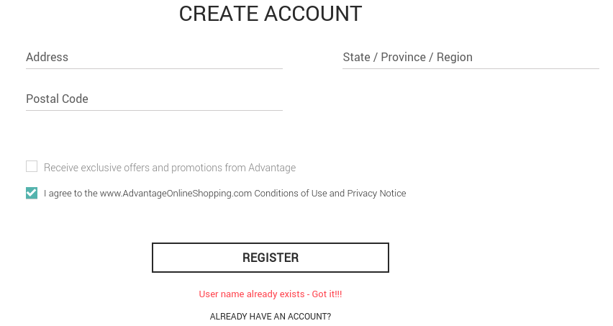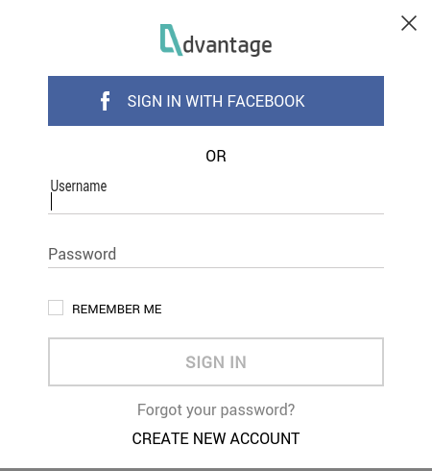

**Mercury**

Exercise 20: Using the Octane Interactive API Client

**ROLE: Integration Engineer**

Octane has a convenient API access interface to allow external tools to integrate with it. This makes it easy for third parties to create sophisticated integrations that provide tremendous value for ALM Octane customers.  
  
This interface uses Swagger which is an embedded GUI-based control that allows you to test out REST commands graphically and see exactly how to communicate with Octane via its API.

Under Review

## Setting up the API Access

1. We need to have the following VM’s running for this exercise:

* NimbusServer

1. We need to have the following Docker containers running for this exercise:

* octane

1. From NimbusServer, open a browser to the **Octane** shortcut and **log in** (sa@nga, Password1).
2. Click the settings cog and select **Spaces**.
3. Select the **Default Isolated Space** on the left and the **API Access** tab.

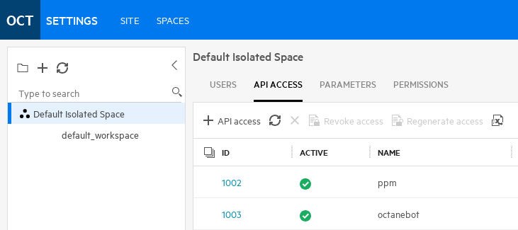

1. Click **+ API Access** and use the following labels:

Name: **Swagger_UI**

Role: **CI/CD Integration**

Workspaces: **default_workspace**

1. A window will appear with your **Client ID** and **Client secret** and key.

**Copy** these values down.  
(Open a terminal and type **$ gedit** and then copy/paste the values in there).  
  
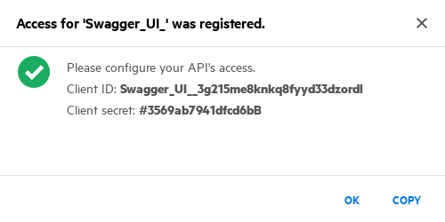

1. **Click** the cog symbol (settings) and return to the main application.
2. **Click** the **Help** symbol and select **Interactive API Client**.

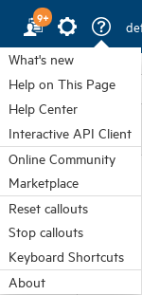

1. At the top right, enter your copied **Client ID** and **Client secret** and click **Login**.



1. Click on **Generic APIs** and open **gherkin_tests**. It may take a while for the categories to show up.

We’ll attempt to find details on the gherkin test we created in Exercise 6.

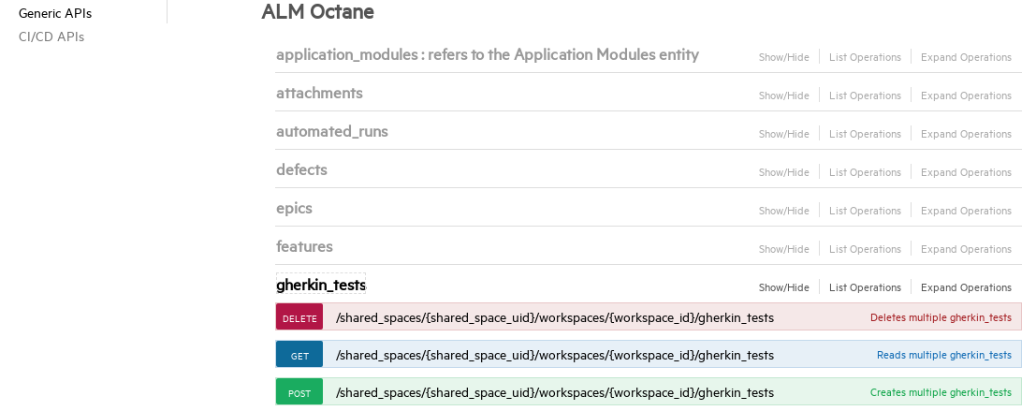  
Complete details on how to use the **Interactive API** can be found here:

<https://admhelp.microfocus.com/octane/en/latest/Online/Content/API/Interactive_API.htm>

## Using the Interactive API Client

1. Click the blue **Get** box to open the Get options.

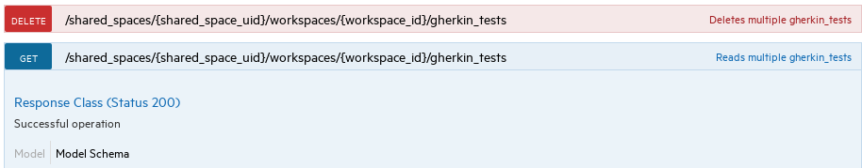

1. Scroll down to the **Parameters** section and enter the following:

**Fields** (hold down **Ctrl** to select multiple fields)

* name
* run
* test_type

**Query** (include the double quotes)

"id EQ 3001"

1. Click **Execute.**

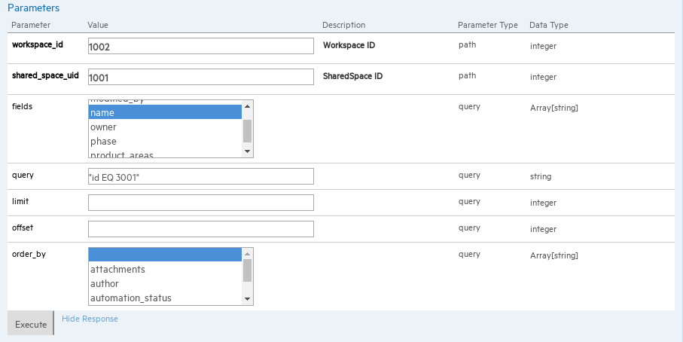

1. **Scroll** down a bit more and look at the **Response Body**.

You should see details about the test we created called **LeanFT_Gherkin**.

|  |
| --- |
| NOTE: When creating a query, it must be included in two sets of double quotes. Also, when using a string in a query it needs to be inside a set of caret symbols (e.g. ^mystring^). |

1. Open a **second browser tab** to **Octane** and navigate to **Quality -> Tests**.
2. Click on the **LeanFT_Gherkin** ID link.  
     
   
3. **Click** on the **Runs** tab and verify the ID of the **Gherkin Auto Run** entity.

The number should match what you previously entered.

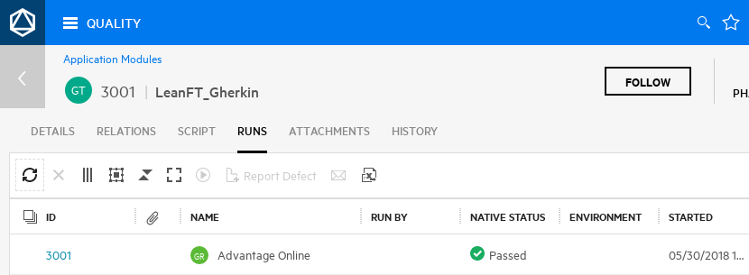

Challenge Exercise #3

Run the following cross-filter query on the entity **gherkin_tests**: **"author EQ {id EQ 1001}"**

What test comes back? Create a query to find the author of that test.

Challenge Exercise #4

Using just the Interactive API create a query on the **defects** entity to find how many defects  
have **PayPal** in their names.   
Total: ________ 6 Query: ________________________ "name EQ ^*PayPal*^"

**Wow!  
  
You have now mastered the Octane Interactive API Client!**

Exercise 21: Using OData for Extended Reporting

Role: Integration Engineer or Project Manager

ALM Octane supports OData (Open Data Protocol), the OASIS REST-based standard for accessing data. You can use OData to extend and improve reporting capabilities, above and beyond the functionality provided by ALM Octane dashboard widgets.

Under Revision

In this exercise we’ll connect to OData via an Excel spreadsheet extension running on the NimbusClient machine. In order to connect to OData, a user first needs to configure “Basic Authentication” with the Octane machine. This is accomplished by running a special Linux shell script (add_basic_authentication.sh) but can also be done by various REST/API clients. The parameters used when running this script are:

* **The Octane URL** (e.g. http://nimbusserver:8085)
* **The Username** (e.g. sa@nga)
* **The Password** (e.g. Password1)

At the time of this writing, the Octane OData functionality is still considered a Tech Preview.

Connecting to Octane from Excel and OData

1. We need to have the following VM’s running for this exercise:

* NimbusServer
* NimbusClient

1. If using Excel 2016, Power Query is already included (*open the* ***Data*** *tab*).

If using Excel 2013 you may need to install **Power Query**.

**The NimbusClient 2018.05 and 09 VM’s have Power Query pre-installed.**

If you need to install Power Query, follow this link:

<http://www.microsoft.com/en-us/download/details.aspx?id=39379>

1. We need to have the following Docker containers running for this exercise:

* octane

1. From the **NimbusClient** machine, open **Excel** from the start menu.

Choose to open a **blank** workbook.

1. Open the **POWER QUERY** tab (**Excel 2013**) *or the* ***Data*** *tab (****Excel 2016****)*.

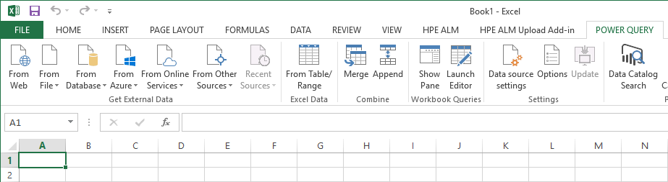

1. From Excel 2013 pulldown menu item “**From Other Sources**” select **From OData Feed**.

*From Excel 2016 pulldown menu item “****Get Data****” and* ***From OData Feed***.

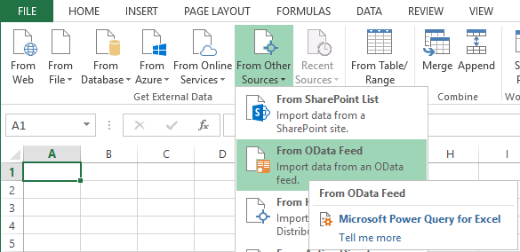

1. In the OData Feed box select **Basic** and enter the following URL and click **OK**:

**http://nimbusserver:8085/odata/v2/shared_spaces/1001/workspaces/1002**

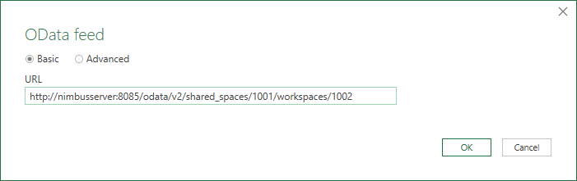

1. If prompted, select the **Basic** tab and enter the following credentials and click **Connect**:

Username: **sa@nga**

Password: **Password1**

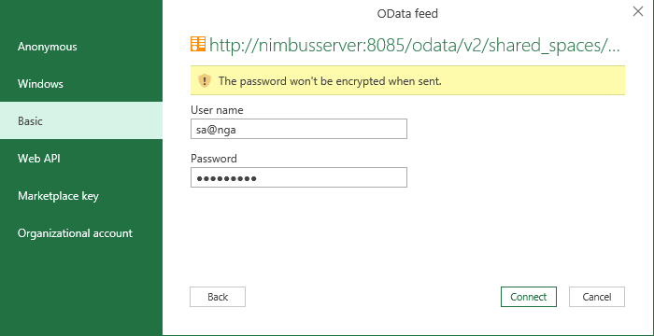

Querying the Octane Database through OData

1. We’ve now connected to a special Octane API that allows us to build worksheets in Excel. Yeah!

You’ll see the **Navigator** window open up with a list of Octane database entities.

Select the **stories** table and click **Edit**.

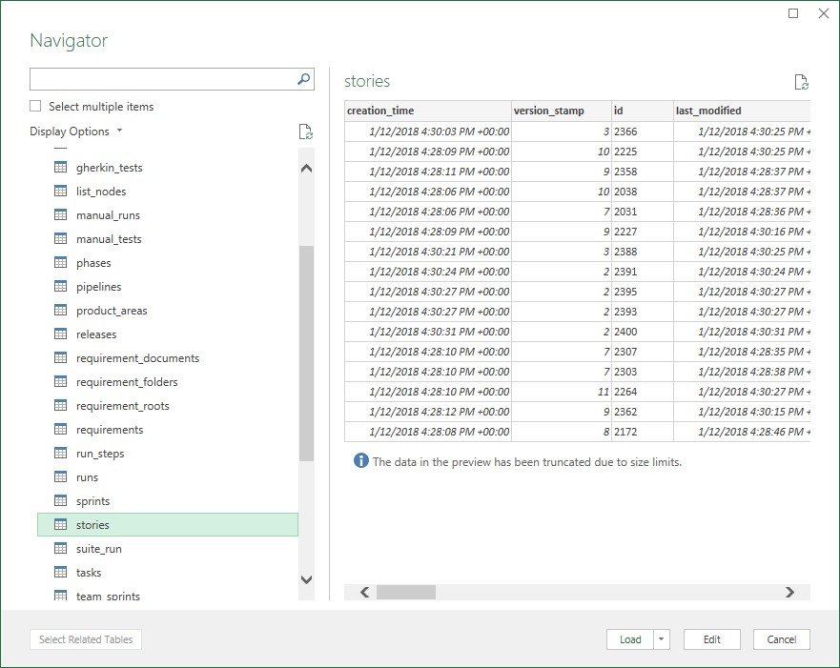

1. Let’s now select just the columns we want to see. Under Manage Columns, click **Choose Columns**.

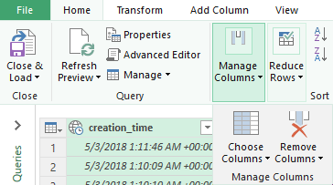

1. **Unselect** (Select All Columns) and just select **id**, **name**, **release** and **test**.

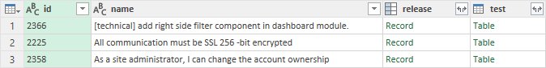

1. **Releases** and **tests** are references to other entities. We can get more information about releases and tests by clicking on the right button above these columns to expand them. This allows us to get data from a linked entity.



Click the button above the **release** column.

We would like to see the name of the release, so select just the **name** column. You column will change to **release.name**. We’ll filter on this later.

1. Similarly, for the **tests** column, click the button above the column and select just the **name** and **ID** attributes.
2. Next we’ll filter just to show tests related to specific release.  
   Click the **filter** button above the **release.name** column and select just **AOS 1.1.5**

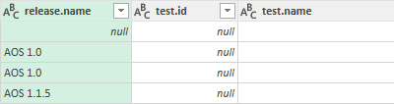

1. Next we’ll filter to just show specific tests.  
   Click the **filter** button above the **test.id** column and select just the following test id’s:  
   **1001, 1005, 1007, 1004, 1010, 1012**

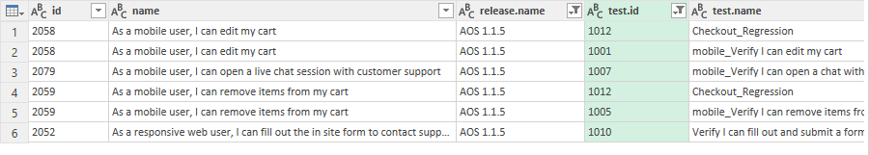

1. Click **Close and Load** from the upper left menu (*or* ***Close and Apply***).  
     
   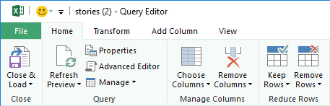
2. You should now see the results of your query.

This table represents the list of tests assigned to release AOS 1.1.5 that belong to a subset of test ID’s (1001 – 1012).

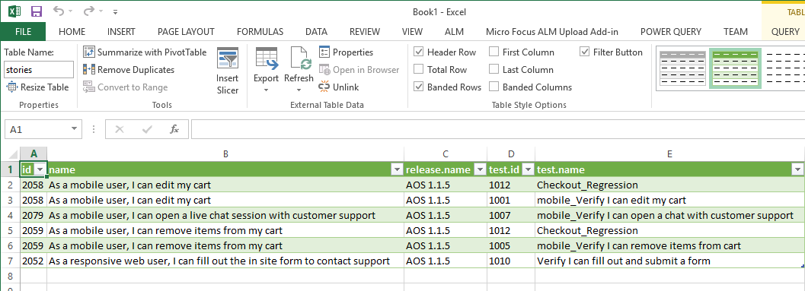

This data is not all contained in one table in Octane’s database but Power Query allows us to easily join tables and display the results of those joins.

In this way you can query and connect different Octane tables to produce valuable reports.

Using Microsoft Power BI for Reports

Microsoft also produces a visualization piece of software called Power BI. Power BI is a business analytics service provided by Microsoft. It provides interactive visualizations with self-service business intelligence capabilities, where end users can create reports and dashboards by themselves, without having to depend on information technology staff or database administrators.

Typically you wouldn’t need to demo the complete configuration of an OData feed tool but the results make for a very colorful and custom report.

1. A trial of **Microsoft Power BI** has been installed on your NimbusClient desktop.  
   We’ll use that trail to examine a preconfigured **ALM Octane Dashboard** project.
2. From the **NimbusClient VM,** double-click on the **ALM_Octane_Dashboard.pbix** icon in the  
   **ADM Products** folder on your desktop.
3. If any credential boxes come up, attempt to sign in and then dismiss the dialog box by clicking on the upper right **X** symbol.
4. Examine the **Feature Coverage** tab. This example is set to view the Features from the **AOS 1.1.3** feature in the ALM Octane demo data.

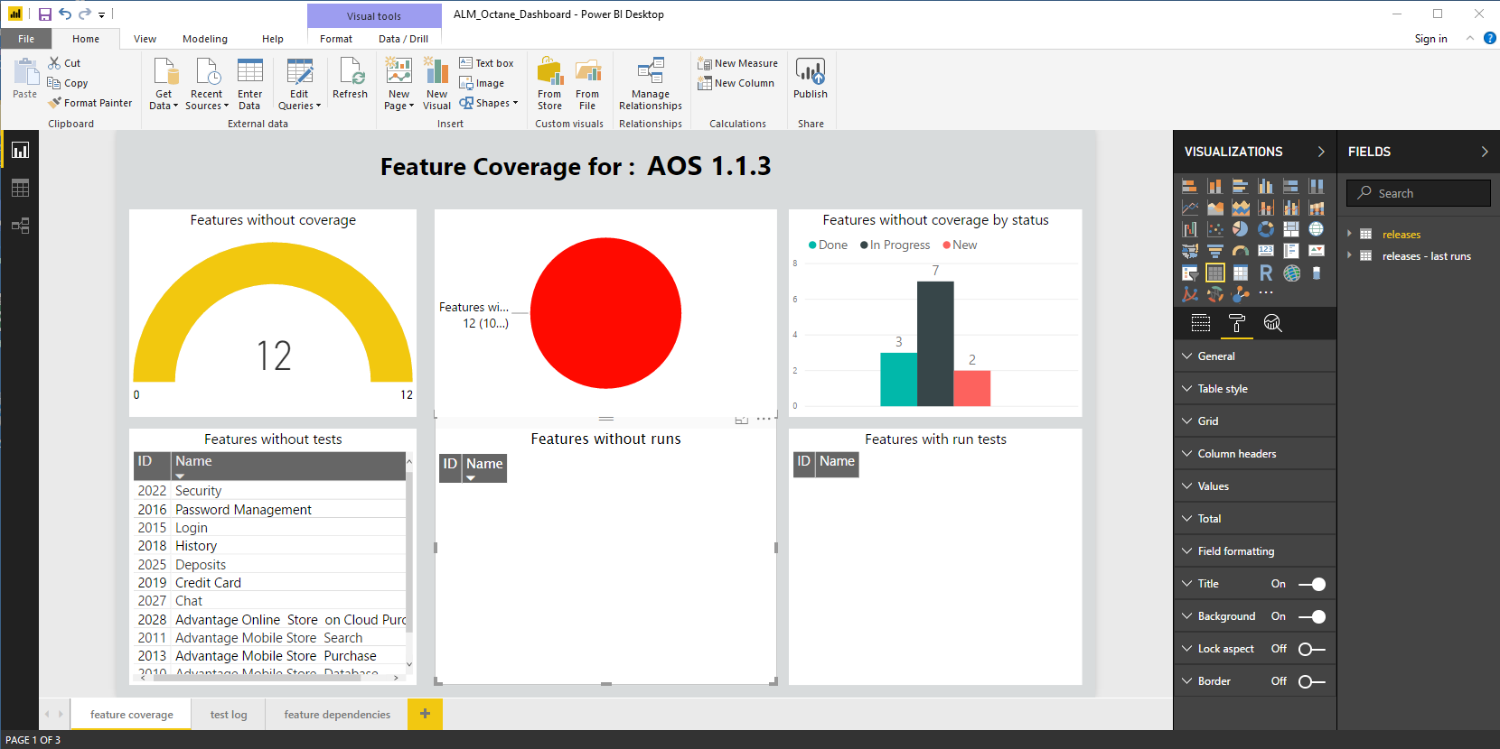

This dashboard shows features that don’t have coverage for the AOS 1.1.3 release.

1. 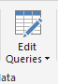Select **Edit Queries** and on the **Query Editor** window click ***release_name*** on the left.

If you see an error, click **Edit Credentials** and enter your **Basic** authentication Octane credentials.

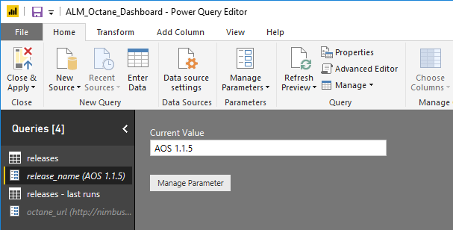

1. Change the Current Value to **AOS 1.1.5** and click **Close & Apply** on the upper left menu.
2. Your chart should change to show Feature Coverage (8) for the **AOS 1.1.5** feature.
3. Select the **test log** tab at the bottom to see the details of your **LeanFT_Gherkin** test.  
   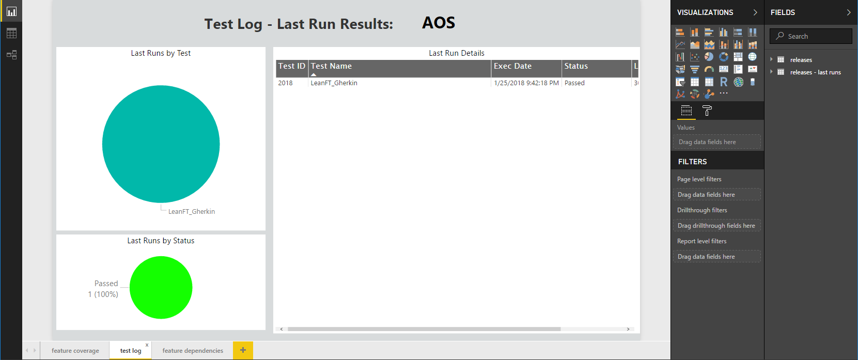

**1.1.5**

Challenge Exercise #5

Similar to Exercise 8, run a query using **Excel** and **Power Query** on the entity **gherkin_tests** and find out how many tests **alice_demo@nga** has authored. You should create a table with the following fields:

|  |  |  |  |
| --- | --- | --- | --- |
| ID | Name | Author ID | Author Name |

Alice has authored _________ tests.

Exercise 22: ALM QC Test Run Injection

Starting with ALM 15.5, you can integrate between ALM Octane and ALM QC, to automatically inject test runs from ALM QC to ALM Octane. This means you can use ALM/QC as your test execution engine in place of a CI system (e.g. Jenkins) that runs functional tests.

When a test is run in ALM/QC, a corresponding test suite and test will be automatically created in ALM Octane.

Once the test results are in ALM Octane, you can set up test assignment rules to assign retrieved test results to the relevant application modules and ALM Octane users.

You can find more information about this integration on these two ADM Help sites:

<https://admhelp.microfocus.com/octane/en/15.1.20/Online/Content/UserGuide/how-inject-alm-tests.htm>

<https://admhelp.microfocus.com/alm/en/15.5/online_help/Content/ALM_Octane_integration/overview.htm>

To enable this integration, we’ll first configure the settings and then test that it’s working.

1. We need to have the following VM’s running for this exercise:

* NimbusServer
* NimbusClient

1. From a terminal on **NimbusServer**, run the following commands or verify that these containers are already running. Allow enough time for these containers to settle down (5-8 minutes or so).

**$ nimbusapp octane:16.0.400.79 up**

**$ nimbusapp alm:16.0.1 up**

**$ nimbusapp aos:3.2 up**

## Configuring Octane for Test Injection

1. From **NimbusServer** open a **Chrome** browser and login to **ALM Octane** (<http://nimbusserver.aos.com:8085/>) with:

Name: **sa@nga**

Password: **Password1**

1. Navigate to the **Management** module and note the releases.

We need to have an identically named release in both Octane and ALM QC for the integration to work.

We’ll use the release called **AOS**.

1. We’ll also need to create an API key (credentials) to allow ALM to communicate with Octane.

In Octane, go to the settings section by clicking the gear icon and select the **Default Shared Space** on the left.

1. Choose to add an API key and set the following:

Name: **ALM**

Descriptions: **ALM API Key for test injection.**

Role: **CI/CD Integration**

In workspaces: **default_workspace**

1. Click **Add**.

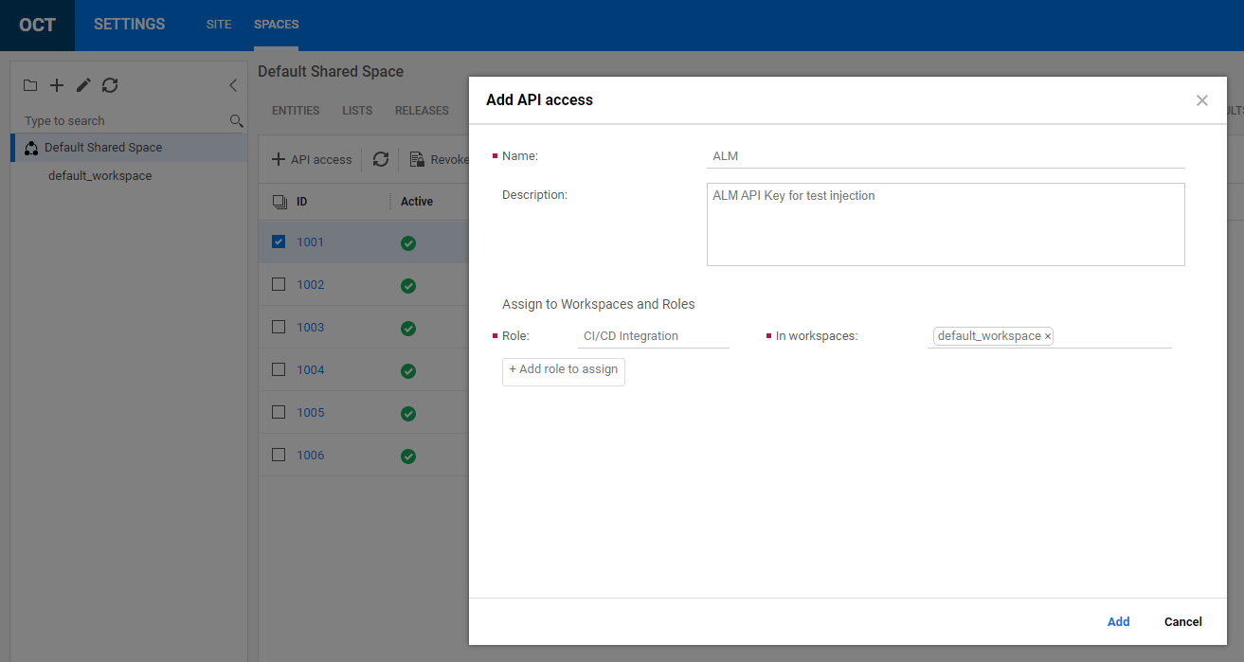

1. Copy down your **Client ID** and **Client Secret** from this window and put them into notepad or a file on NimbusServer. If you forget, you can always regenerate these keys from the option in that window.

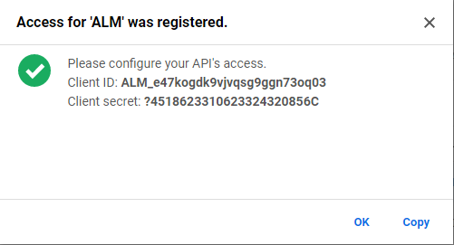

1. Click **OK** to dismiss the window.
2. Click the gear icon to return to the main application.

## Configuring the ALM Container

1. We also need to create an XML file and place it in a specific directory in the ALM container.

From a terminal on **NimbusServer**, run the following command.

**$ gedit ~/Desktop/octane-int-config.xml**

Edit the file and copy/paste the text below into it.

**NOTE:** Substitute your values from above for the **Client ID** and **Client Secret**.

Save this file as (case sensitive): **octane-int-config.xml**

**<?xml version="1.0" encoding="UTF-8" standalone="yes"?>**

**<configuration>**

**<targets>**

**<target>**

**<octane>**

**<clientId>ALM_9gxp7jzx208e0h3mv6nzvqjon</clientId>**

**<clientSecret>@36873716155178153223P</clientSecret>**

**<serverUrl>http://nimbusserver.aos.com:8085/</serverUrl>**

**<sharedSpaceId>1001</sharedSpaceId>**

**</octane>**

**<projects>**

**<project>**

**<domain>DEFAULT</domain>**

**<project>AOS</project>**

**<workspaceId>1002</workspaceId>**

**<filters>**

**<filter></filter>**

**</filters>**

**<isAutoFix>true</isAutoFix>**

**</project>**

**</projects>**

**</target>**

**</targets>**

**</configuration>**

1. This file is configured to use our unique configuration. Specifically, these items are configured:

* Client ID <created via Octane’s API access>
* Client Secret <created via Octane’s API access>
* Server URL <http://nimbusserver.aos.com:8085>
* Domain **DEFAULT** – ALM QC Domain
* Project **AOS** – Project to pull tests results from
* Workspace ID **1002** – Octane’s default workspace to populate into
* isAutoFix **true** – Required field set to true

**NOTE** – You can also use filters and other field mappings if needed.  
Check the online [ALM Help](https://admhelp.microfocus.com/alm/en/15.5-15.5.1/online_help/Content/ALM_Octane_integration/overview.htm) for those details.

1. Copy the file to the ALM container using the following command from a **NimbusServer** terminal:

**$ docker cp ~/Desktop/octane-int-config.xml alm:/var/opt/ALM/repository/sa/DomsInfo/CommonData/octane-integration**

## Configuring ALM QC for Test Injection

1. From **NimbusClient**, start **IE** and login into ALM QC **Desktop Client** (<http://nimbusserver.aos.com:8082/qcbin/>) with:

User name: **admin**

Password: **Password1**

Domain: **DEFAULT**

Project: **AOS**

1. Create a new release called **AOS** in the release module by clicking on **New Release**:

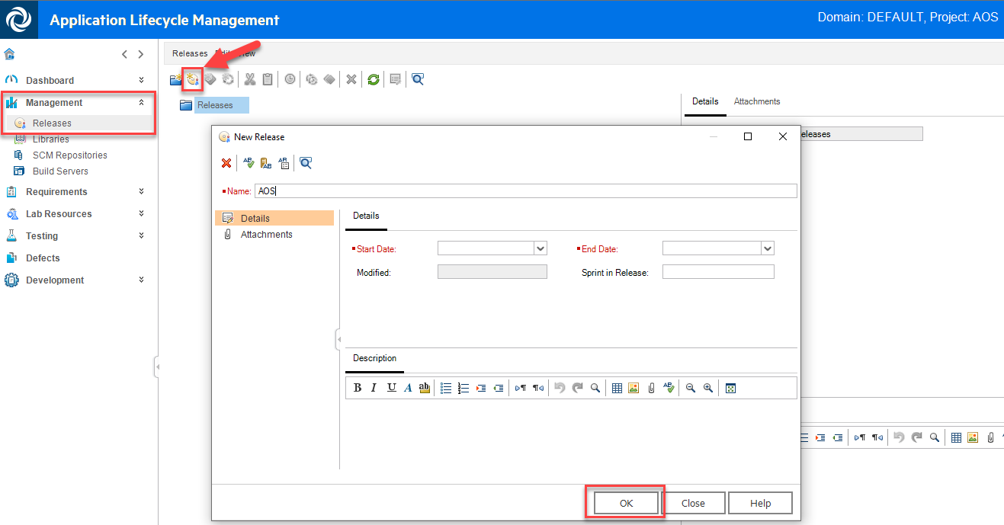

1. Set the **Start Date** to be today’s date and the **End Date** to be one month from today.
2. Click **OK** to create the new release.
3. Open a new tab in **IE** and navigate to the ALM QC **Site Administration**



1. Login to the **Site Administration** site with:

User Name: admin

Password: Password1

1. In **Site Administration**, click the **Site Configuration** tab.
2. Create a new parameter with the following values:

Parameter: **OCTANE_INTEGRATION_ENABLED**

Value: **Y**

Click **OK**.

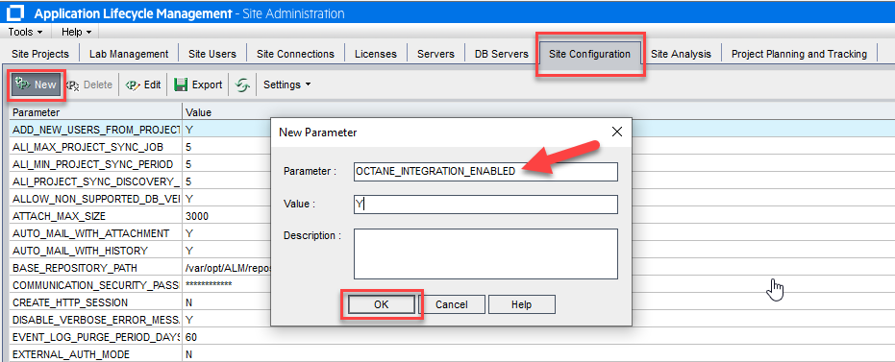

1. Create a second new parameter with the following values:

Parameter: **OCTANE_INTEGRATION_JOB_INTERVAL**

Value: **10**

Click **OK**.

These two parameters are used to turn on the QC – Octane test run injection integration and to set an interval (10 minutes) as to how often to update the data. The minimal time interval is 10 minutes which means that the data will be refreshed every 10 minutes.

1. Now that we have all the integration pieces in place, we need to test our environment to check that it is working and to see what sort of results get populated into ALM Octane.

Our first step is to create some tests and test sets in ALM QC.

1. From **NimbusClient** open the **ADM Solutions** folder on the desktop and start the

**Micro Focus Unified Functional Testing** (UFT) application.

1. Select the **Web** add-in and click **OK** in the Add-in Manager dialog.
2. From the UFT menu select **File > Open Test**   
   C:\Users\demo\Documents\Unified Functional Testing\**AOS_UFT_WEB_Regression**

We’ll use this test as a sample functional test and copy it into **ALM QC** in the **AOS** project.

1. From the **UFT** menu select **ALM > ALM Connection…**

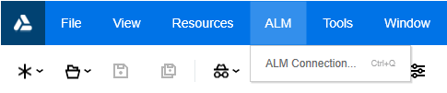

1. Enter the ALM Credentials as before (admin, Password1, DEFAULT, AOS).

Client **Connect** and then **Login** and then **Close**.

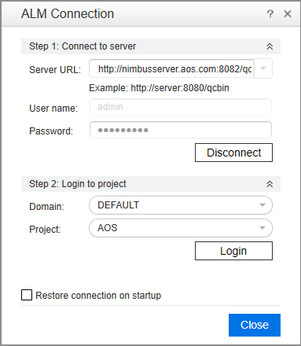

1. From the UFT menu select **File >**

**Select** the **ALM Test Plan** icon at the top left.

**Save** the new test in the folder: **Subject\CI Test Cases**

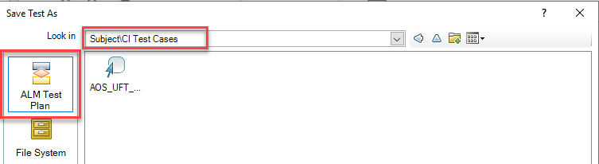

1. Click **Save** and **close** UFT One.
2. From **NimbusClient**, start **IE** and login into the ALM QC **Desktop Client.**
3. Navigate to the **Testing > Test Lab Module**
4. Select the **CI Tests** folder and create a **new Default type test set** called **OctaneTestInjection**

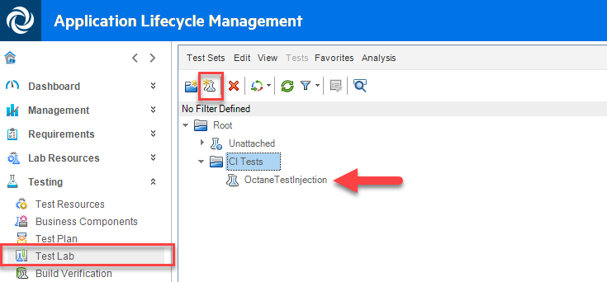

1. Choose **Select Tests** to add a new test to the test set and add the test we just created from the test plan:

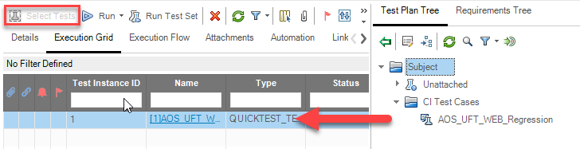

1. We now have everything we need to verify the test injection process.

Here’s what we’ve done:

* 1. Octane – Created an API Key for ALM.
  2. ALM – Created an AOS release to match the release in Octane.
  3. ALM – Created two admin parameters to turn on the test injection integration.
  4. ALM – Created the octane-int-config.xml file and put it into the ALM container.
  5. ALM – Created a new test set and UFT test in the AOS project that we can run.

NOTE: Only tests and test sets that are added AFTER the integration is configured will appear in Octane.

## Testing the Test Injection Integration

1. Now, let’s run our test set and see the results in Octane!

From the Test Plan module, select the test set and choose **Run Test Set**.

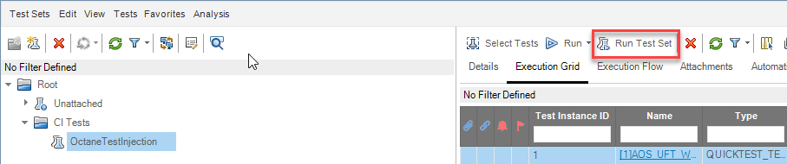

1. From the **Automatic Runner** dialog select the checkbox to **Run All Test Locally** and then click **Run All**.

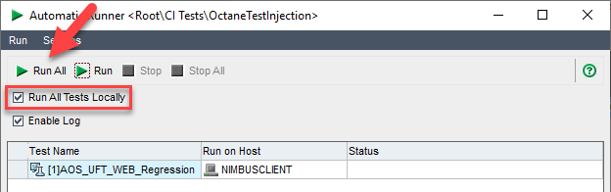

1. Wait a bit and you’ll see the **Test Run Scheduler** start and a Chrome browser will start on the AOS home page and run through a quick regression test.
2. Once the test completes, click the **X** button to close the **Automatic Runner**.
3. Open your Chrome browser and log into ALM Octane (**sa@nga**, **Password1**).
4. Navigate to the **Quality > Tests** module

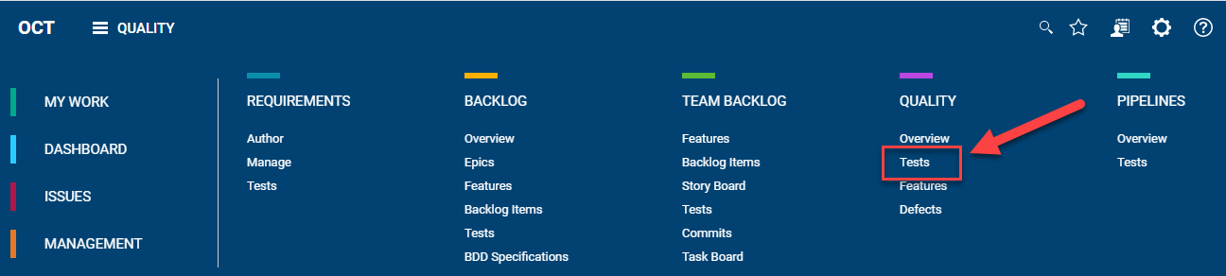

1. Create a reverse sort on **ID** (highest numbers first) and locate your **Automated Test** and **Test Suite**.

These are the new items created by ALM and whose data is imported into Octane.

**NOTE** – Since our job interval time is 10 minutes it may take that long for the data to appear.

Try refreshing the view or restarting the containers to make sure your data is updated.

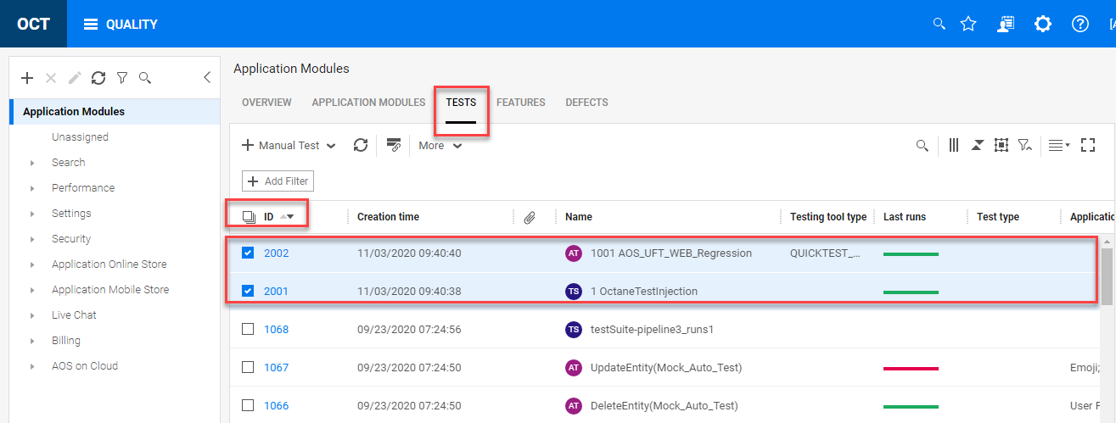

**What does this all mean?**

Once the integration is active, whenever a test is run (either manual or automated) in ALM QC the results will be populated into Octane. Any new **Test Set** will create a new **Test Suite** in Octane and any test runs will create an **Automated Test** (AT) and **Automated Run** (AR) in Octane. Manual Tests (Sprinter) will also create automated tests (AT) in Octane as well as system tests. In addition, both types of functional tests (default and functional) are supported by this integration.

The following table outlines how test sets and tests are changed in ALM Octane:

|  |  |  |  |
| --- | --- | --- | --- |
| ALM QC Name | ALM QC Type | Octane Name | Octane Type |
| MyTestSet | Test Set | 1 MyTestSet | Test Suite (TS) |
| <na> | <na> | 1 MyTestSet | Suite Run (SR) |
| MyTest | Test | 1001 MyTest | Automated Test (AT) |
| RUN_<timestamp> | Test Run | 1 MyTestSet | Automated Run (AR) |

Exercise 23: ALM / QC External Test Automation

As Agile and DevOps became popular in recent years, companies wanted to automate large portions of their testing activities and they use a wide variety of tools to achieve this goal. However, running automated tests without keeping track of the results and connecting the dots between test coverage, requirements and defects is meaningless.

In this exercise we’ll explore a technique that integrates an external tools results file into ALM / QC. It does this by way of the **Micro Focus Application Automation Tools** plugin. This is a Jenkins plugin introduced a few years ago, to enable building DevOps toolchains on Jenkins, using a wide range of automation tools from both 3rd-party vendors and Micro Focus.

The results of automated tests run through Jenkins jobs can then be sent to ALM/Quality Center or ALM Octane by the plugin, to become part of the quality metrics data.

In the current plugin you can now use Field Mapping to get test results uploaded to ALM/Quality Center. By defining flexible mapping rules in the Jenkins job configuration, the test results from any tool get linked to a test or testset automatically in ALM/Quality Center. You no longer need to manually create test cases or test sets before executing these tests – they will be created by the plugin automatically.

The specific details about using this plugin and ALM QC External Test Automation can be found here:

<https://admhelp.microfocus.com/alm/en/15.5-15.5.1/tools/jenkins/upload_external_test_result_to_ALM.htm#HowFieldMapping>

Importing External Test Results

We’ll initially look at setting a one-time external result for a test and then eventually transition that to a more dynamic solution using Jenkins, UFT Dev and Selenium. The same technique works for any automated test run by Jenkins that exports test results in XML format. With this technique, many popular tools like Selenium, Appium and Cucumber can also be integrated with ALM/Quality Center.

1. We need to have the following VM’s running for this exercise:

* NimbusServer
* NimbusClient

1. Run the following commands or verify that these containers are already running.  
   Allow enough time for these containers to settle down (5-8 minutes or so).

**$ nimbusapp devops:3.2.3 start**

**$ nimbusapp alm:16.0.1 start**

**$ nimbusapp aos:3.1 start**

**$ nimbusapp intellij:3.2.1 start**

Verify the Jenkins Plug-in

In our Nimbus environment we already have a recent copy of the **Micro Focus Application Automation Tools** plugin but it’s worth verifying the version we have and knowing where to find it.

1. Open a chrome browser on NimbusServer and navigate to the **Jenkins** browser shortcut.
2. Select **Manage Jenkins** on the left edge and then select **Manage Plug-ins**.
3. Select the **Installed** tab at the top and scroll down to the **Micro Focus Application Automation Tools** plugin. These items are organized alphabetically. Verify that the plugin version is **6.4** or greater.

Understanding External Tests in ALM

External tests in ALM QC are special kinds of tests that were created outside of ALM QC by another testing framework like Junit, NUnit or TestNG. These tests typically produce a test XML file that contains the fields and status details of the test run. The testing tool can be one of LeanFT (UFT Dev), Sahi, Selenium, SoapUI and Watir. ALM QC can directly import results from this type of XML file or have it automatically imported via a Jenkins job. We’ll eventually examine both mechanisms.

Importing a JUnit test result to ALM QC from a file

1. Go to the NimbusClient VM and start Internet Explorer and **log in** to ALM using the browser shortcut:

Username: admin

Password: Password1

1. Click **Authenticate**
2. Enter the following fields to select the AOS Project:

Domain: DEFAULT

Project: AOS

1. Click **Login**
2. Copy the following text into a text file on your desktop.

Save the file as **junitResult.xml**

<?xml version='1.0' encoding='UTF-8'?>

<result plugin="junit@1.49">

<suites>

<suite>

<file>/home/demo/Sample.SeleniumTest.xml</file>

<name>Sample.SeleniumTest</name>

<duration>19.634</duration>

<time>19.634</time>

<enclosingBlocks/>

<enclosingBlockNames/>

<cases>

<case>

<duration>19.325</duration>

<className>sample.SeleniumTest</className>

<testName>VerifyXML</testName>

<skipped>false</skipped>

<failedSince>0</failedSince>

</case>

</cases>

</suite>

</suites>

<duration>19.634</duration>

<keepLongStdio>false</keepLongStdio>

</result>

|  |
| --- |
| How did we get this file?  This file was generated by a JUnit Test via UFT Dev and Selenium. We modified a couple of values like names and such. We’ll see later that elements like <failedSince> give us a way to tell is the test passed or failed (a zero means it passed). This file gets created when Jenkins runs the JUnit job and placed in the devops container. If you want to find it, just search the devops container for “junitResult.xml” |

1. Select the **Testing > Test Lab** section on the left.
2. Open the **Subject** folder to reveal the **CI Tests** folder
3. **Right-click** on the **CI Tests** folder and select **Import External Test Results**.

If you don’t see this option, make sure you have selected **Test Lab** and not Test Plan.

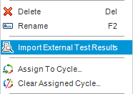

1. Set the following fields as shown below:

* Upload Results File: Path to your junitResults.xml file on your Desktop
* Test Lab: Root:/CI Tests
* Test Plan: Subject/CI Test Cases
* Testing Framework: JUnit
* Testing Tool: Selenium
* Optional Settings: <leave blank>

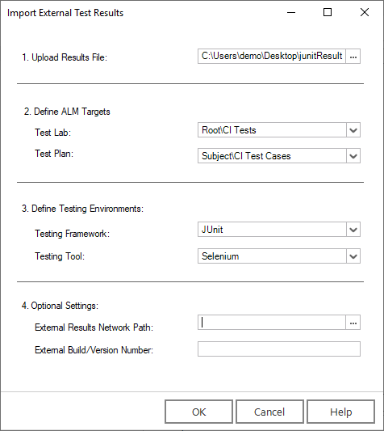

1. Click **OK** – you’ll see the system processing the file and then there will be new entries in ALM QC.

Note the three screenshots below that show the imported test in ALM QC.

NOTE: Currently the import is limited to XML 1.0 configured files. If you have an XML 1.1 file, just change the 1.1 to 1.0 and resave the file and try and reimport it again. This functionality, to import a single XML result, is not the preferred way to import external results. Instead, the import using Jenkins and the Micro Focus Application Automation Tools plugin with field mapping offers several benefits. That solution will be discussed below.

**Test Lab** – Imported test set is of type **External**:

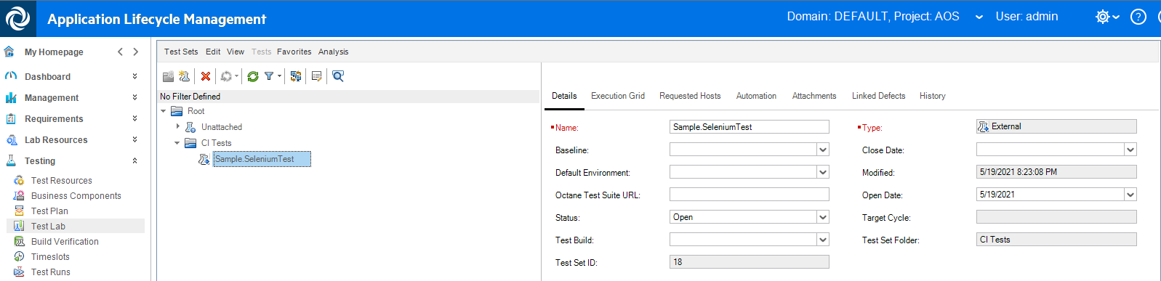

**Test Plan** – Imported test is of type **EXTERNAL-TEST**:

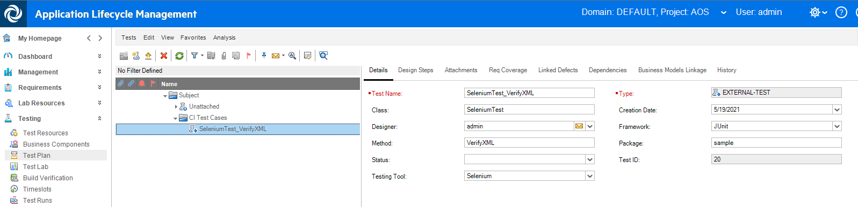

**Test Runs** – Imported test runs shows a **PASSED** status.

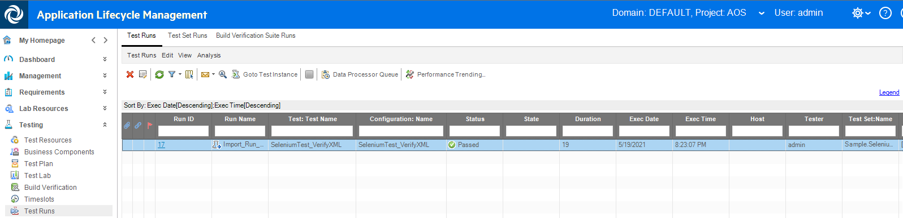

What we just did is a one-time import of a test result that was created in JUnit via Selenium.

This is fine if we only need a single result. If instead you want to get new results everytime the test is run, we’ll need a different mechanism. We’ll be covering that in the next few sections.

Create a Jenkins job to run a JUnit-UFTDev-Selenium test

In our DevOps container, in Jenkins we have a Selenium test that produces a junitResult.xml file, which is what we need. It is this file that we’ll use to continually produce results in ALM QC and to do any field mappings.   
We’ll begin by running the existing UFT Dev Selenium test and then clone a copy of it and modify its behavior.

1. Open a Chrome browser on NimbusServer and navigate to the **Jenkins** browser shortcut.
2. Select the Tests tab at the top and **click** on the **AOS Web Selenium UFT Developer Test**.

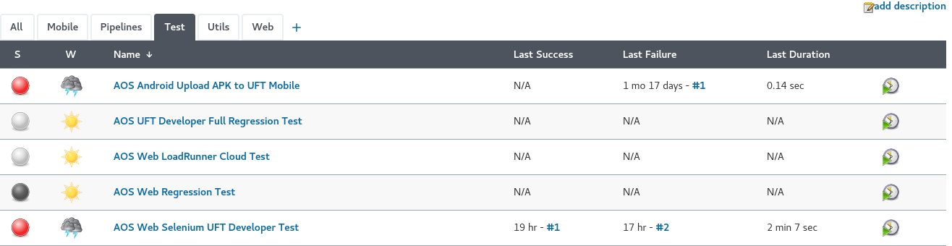

1. Choose **Build Now** on the left menu to run this test.

We want to verify that this test works properly, and we have all the correct running containers.

|  |
| --- |
| How does this work?  Jenkins is installed on our devops container and it is running the job (aka test). Our Jenkins job - AOS Web Selenium UFT Developer Test – is configured to run on NimbusServer. Jenkins uses UFT Dev and the Selenium libraries to open a Chrome browser from the IntelliJ container since that’s where UFT Dev is installed. It runs the test and then produces a result file in the devops container in /var/lib/jenkins/jobs/ in the folder that matches the name of the job. There is also a subfolder that matches the number of the job build. This result file – junitResult.xml – is the file we’ll use to get our fields and status that we’ll map to ALM QC. |

1. Verify that the test ran and produced a successful result – it should show a green ball as its status.



Importing a JUnit test result via Jenkins to ALM QC

To enable this integration, we’ll first make a copy of the Selenium job, test it and then configure then update its configuration.

1. Open the NimbusServer VM tab and open a **Chrome** browser.
2. From the Jenkins home page, select **New Item** on the left menu and label a new Jenkins job called   
   **AOSSeleniumExternalALMTest** (no spaces in the name or it will fail).
3. At the bottom, select **Copy From** and type **aos-web-selenium-uftdev-test** and then click **Save**.
4. Click **Build Now** on this job to run it. It should run successfully too.
5. Click **Configure** on the left menu and scroll all the way down to the end of the **Post Build** **Actions** section and click on the **Add post-build action** option and choose **Upload test result to ALM using field mapping**.

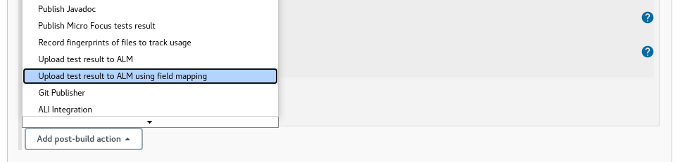

1. Set the following fields for this section:

* ALM Server ALM.NET
* ALM Credentials admin/****** (ALM .NET)
* Domain DEFAULT
* Project AOS
* Client Type <leave empty>
* Test Folder SeleniumTestFolder
* Test set Folder SeleniumTestSetFolder
* Testing result file **/junitResult.xml
* Field Mapping – Clear out the existing text and enter the following:

testset:

root: "x:/result/suites/suite"

name: "x:name"

subtype-id: "v:hp.qc.test-set.external"

test:

root: "x:cases/case"

name: "x:testName|v:_|x:testId"

subtype-id: "v:EXTERNAL-TEST"

run:

root: "x:."

duration: "x:duration"

status: "x:failedSince"

* Run status mapping – Clear out the existing text and enter the following:

status:

0: "Passed" # If status attribute is "0" in report, the run in ALM will be marked as "Passed"

1. Click **Save** to save your changes.

|  |
| --- |
| How does this work?  The three values, testset, test and run represent the three screenshots we saw earlier. Each represents an entity type in ALM QC. Specific fields like root, name and subtype-id represent fields associated with that entity. The “x:” notation says to use the XPath (XML Path Language) of an element or attribute in the XML file. The “v:” notation says to use the value that follows as a fixed string value that will be uploaded. So, “x:name” says to use the name value found in the XML file as the name in ALM QC. Similarly, “v:EXTERNAL-TEST” will set the value to be the value listed (v = value, x = XML).  NOTE: These field mapping can be dependent on each other. For instance, while you can set the test subtype to be EXTERNA-TEST you also need to set the testset subtype to be v:hp.qc.test-set.external  More details on this mapping including how to do User Defined Fields is listed in the help:  <https://admhelp.microfocus.com/alm/en/15.5-15.5.1/tools/jenkins/upload_external_test_result_to_ALM.htm> |

1. Click **Build Now** on this job to run it. It should run successfully too.

|  |
| --- |
| What Just Happened?  By running our modified test, it has triggered the new integration and exported the test results from the JUnit UFT Dev Selenium test and populated the data into ALM QC. Every time this test is run in Jenkins as a standalone test or as part of a pipeline the results will get updated in ALM QC.  *That’s perfect!* |

Challenge Exercise

One issue with the above example is that failures won’t show a failure status in ALM QC. If you note the line on “status” it only checks if the value of the “run – status” is zero. If it is, then the test will show passed. However, There isn’t an easy way to find a failed status due to how JUnit results work.

Our solution above is currently looking at the XML and finding the field “failedSince”. If the test passes, this value is zero (0). If it fails, it displays the build ID of that test and subsequent failures will continue to have that build ID integer. So, if build 1 succeeds and build 2 fails, this value is set to 2. However, if build 3 and 4 also fail, this value is still a 2 since that was when it started failing. Currently, our plugin solution can’t test for a variable value, only a static value, and we can’t check for “anything but zero.”

**The Challenge**

Fix this so that failed tests show a **Failed** status and successful tests show a **Passed** status in ALM QC.

*Solution Technique #1*Edit the selenium test in IntelliJ and catch any failure with a try-catch Java construct like below. Set an explicit “status” that you can then use instead of “failedSince” since that value is zero if passed but could be any positive integer if failed. Of course, implementing this code change for thousands of tests could be pretty time consuming so maybe this isn’t optimal.

try {

...

catch (Exception e){

Reporter.reportEvent("Replay Error","Error during replay", Status.Failed); // Report the error in UFT Dev

Assert.fail(); // Report the error in JUnit

}

*Solution Technique #2*

Keep the existing “failedSince” field to check for success with a zero value. Create a new user defined field in ALM customization to capture the “FailedSince” value and set that value using a UDF specification in this integration. In ALM customization workflow, parse the value of that field to see if it is zero or not. If it is not zero, set the status of the Run to be “Failed”.

**Clever!  
  
You have learned how to import external test results into ALM QC!**

Exercise 24: Implementing the Definition of Done

Understanding when user stories and related element are “done” is an important concept in an agile methodology. This is often referred to as “The Definition of Done.” This isn’t as simple as it sounds.

When all of a user story’s children tasks are completed then the user story should be marked done as well.  
We’d like this to happen automatically without someone having to manually mark the user story as done. The same concept rolls up to features and epics as well.

We might also consider what happens when entities change out of done or completed phases and what effect that should have on their parents.

We’ll implement a subset of this solution using Octane’s Business Rules but it’s also possible to implement this using Octane’s REST API – which might offer a more complete solution. This link shows the REST-based solution: <https://admhelp.microfocus.com/octane/en/15.1.20/Online/Content/API/Scenario-TasksMarkDone.htm>

To enable this integration, we’ll first configure the settings and then test that it’s working.

1. We need to have the following VM’s running for this exercise:

* NimbusServer

1. From a terminal on **NimbusServer**, run the following commands or verify that these containers are already running. Allow enough time for these containers to settle down (5-8 minutes or so).

**$ nimbusapp octane:16.0.400.79 up**

## Mark Features Done if Stories are Completed

1. The following diagram shows the parental relationships between epics, features, user stories, quality stories, defects and tasks. If all the children tasks of a user story have a phase marked as completed then we want a rule that will set the user story’s phase to be done. This allows applies up the hierarchy chain.

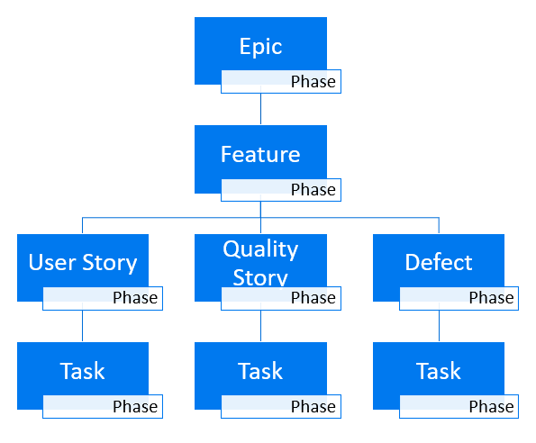

## Creating a Sample Hierarchy in Octane

1. We’ll start by creating a simple hierarchy in Octane with an epic, two features and three user stories per feature. By using this simple structure, we can easily test that our rules are working.

NOTE: Currently, the rules mechanism in ALM Octane does not have the ability to roll up changes on Defects or Quality Stories, only User Stories. For this reason, a complete solution would require the use of the REST API. This exercise offers a way to explore this “Definition of Done” concept and the various scenarios that it must solve.

1. **Open** your browser and **Login** to ALM Octane: <http://nimbusserver.aos.com:8085/ui>

* Username: sa@nga
* Password: Password1

1. Navigate to the Octane **Backlog** module and select **Epics**

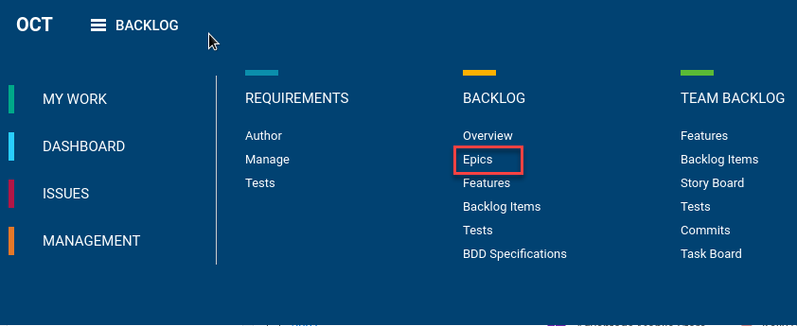

1. 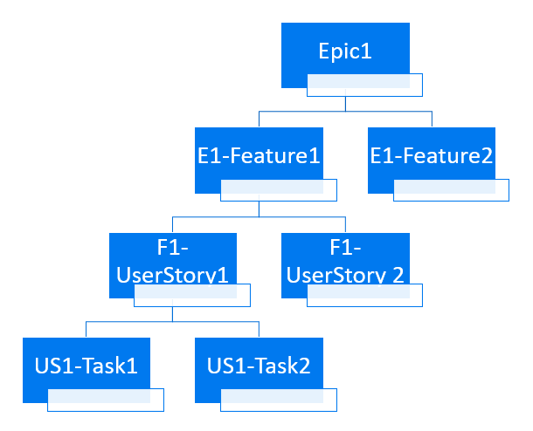Create the following structure in Octane so we can test our upcoming rule changes. This structure makes it easy to see that our rule changes will have made an impact on how Octane works.
2. Our initial goal is make sure that if both tasks (**US1-Task1** and **US1-Task2**) are marked “Completed” then we want the parent **F1-UserStory1** to be marked “Done.”  
     
   **NOTE**: Different entities have different end states. The following table summarizes this:

|  |  |
| --- | --- |
| Entity | End State |
| Epic | **Done** |
| Feature | **Done** |
| User Story | **Done** |
| Task | **Completed** |

It’s also important to understand how these entity states transition since Octane won’t allow a rule-based transition to a new state unless that direct transition is allowed by the workflow. For example, if our user story is in the **New** or **In Progress** state and we attempt to move it to **Done** it won’t work. Octane enforces these transitions before attempting to run its rules.

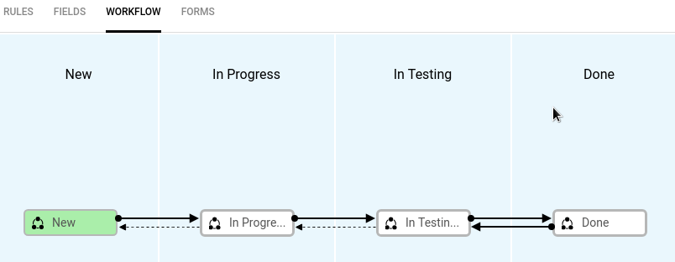

1. Open a second tab in your browser and log into Octane and navigate to the **Settings > Spaces** administration module.

## Creating a Business Rule in Octane

1. Select the **default_workspace** and **User Story** under the **Entities** tab and choose to create a new **Business Rule** by clicking the plus ( **+** ) sign.

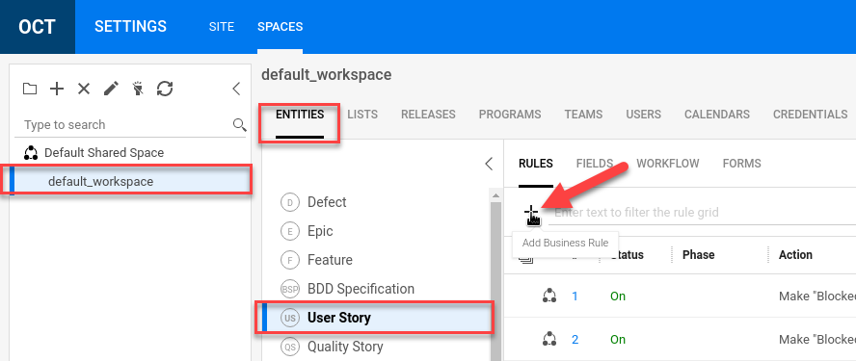

**NOTE**: We could have configured this new rule for the **Default Shared Space** but we’ll stick to just creating it for the **default_workspace**.

1. Set the values for the **ACTION** tab as shown. Do not click OK yet.

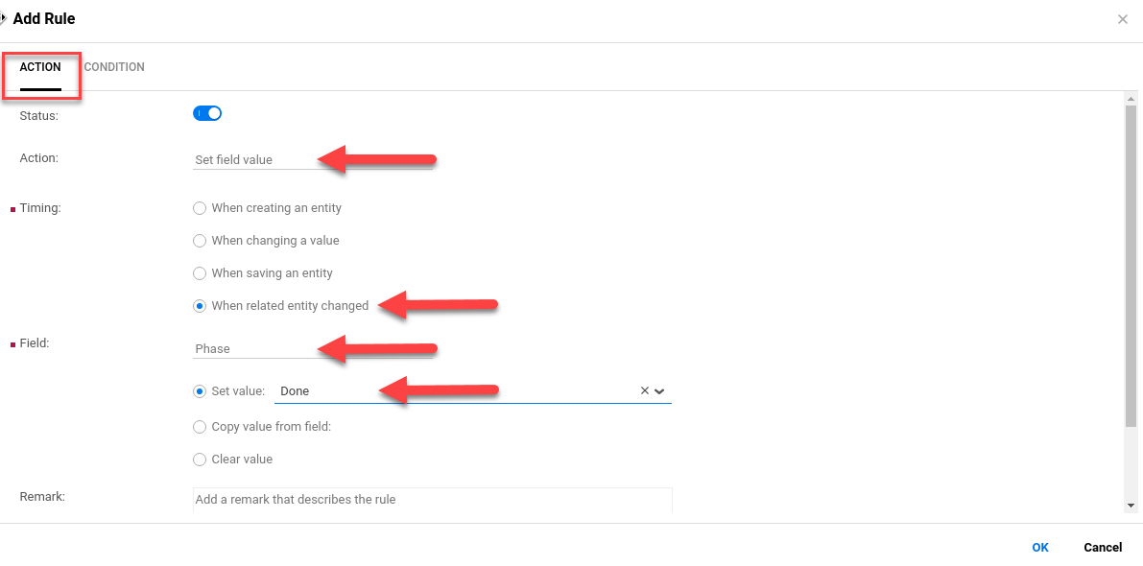

Action: Set Field Value

Timing: When related entity changes

Field: Phase

Set Value: Done

1. Select the **Condition** tab and set the values as shown.

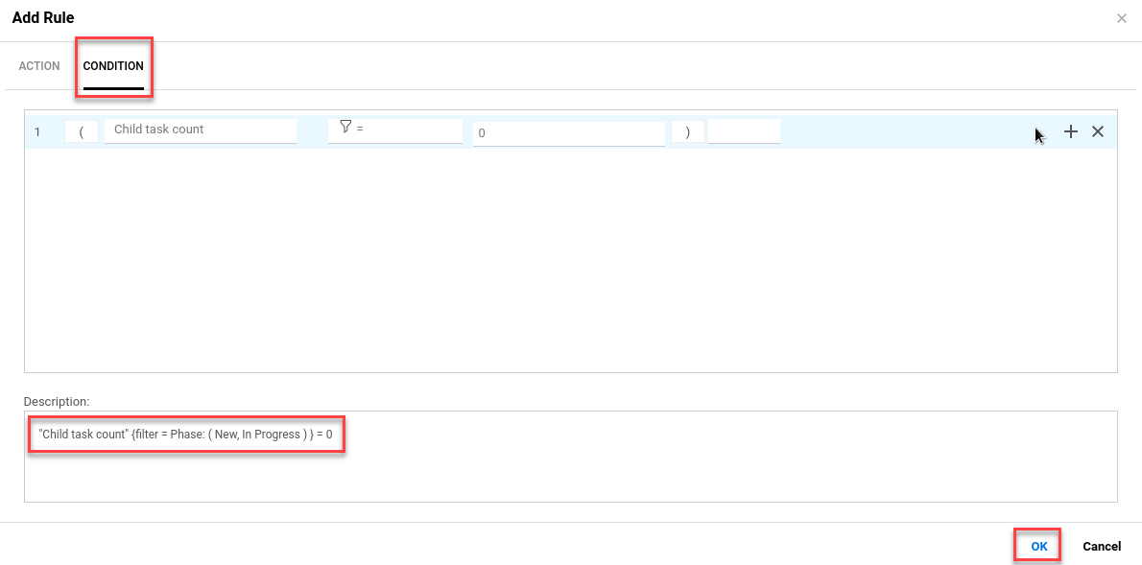

Field 1: Child task count

Field 2: **Filter =** and then **Add Filter** and choose **Phase** and select **In Progress** and **New**

Field 3: 0

1. Setting the Filter (Field 2) can be a little tricky. Make sure to scroll down until you see **Filter** and then select = and then **Add Filter** on **Phase** and choose the values **New** and **In Progress**.

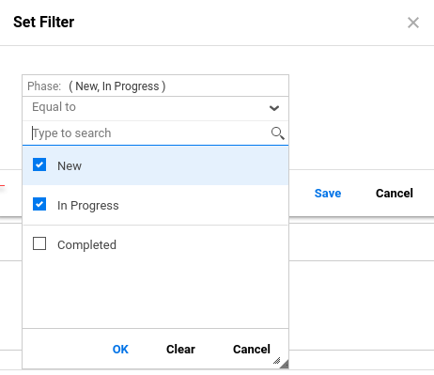

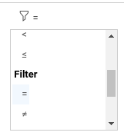

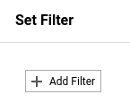

1. If you’ve done this correctly, your **Description** should read:

"Child task count" {filter = Phase: ( In Progress, New ) } = 0

1. Click **OK**

**What does all this do?**

What we’ve done is create a rule that checks the count of a User Story’s child tasks whose phases are either In Progress or Done. If the number of those children is zero (which means those tasks are in the Completed state), then the rule is triggered (the action) which sets the User Story’s Phase is set to **Done**.

1. Click **Save** to save your changes.

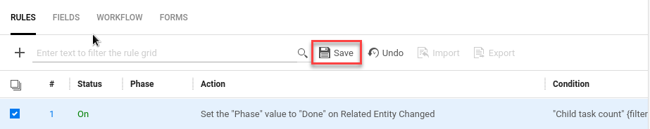

## Testing our Business Rule

1. Now that we’ve created this rule we want to test it out and make sure it’s working.

Select your other browser tab (logged into Octane) and add the **Phase** column to both the User Story and Feature grid views. This will make viewing the automatic changes a lot easier.

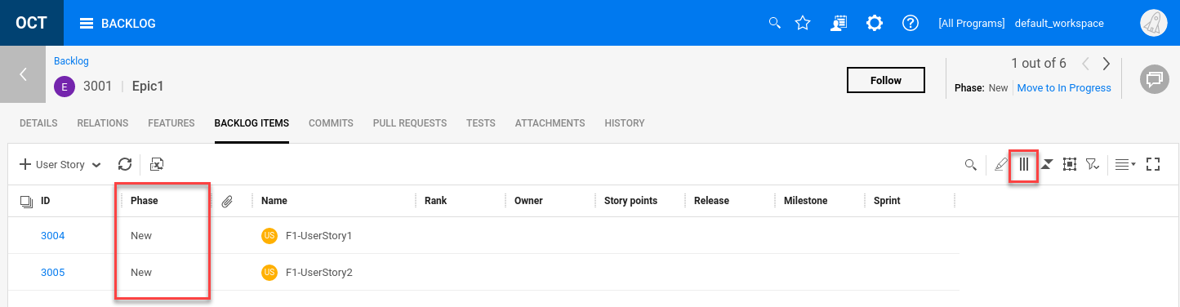

1. **Drag and move** the two tasks under **F1-UserStory1** to be completed as shown.

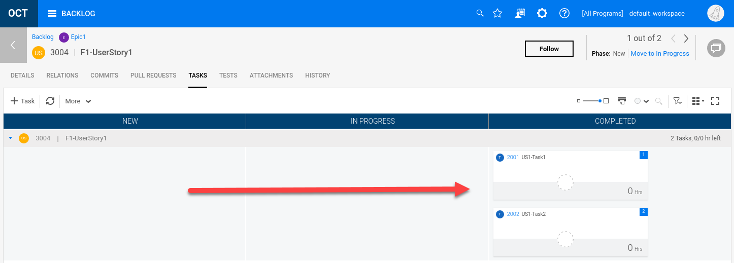

1. Go back and look at the **parent** User Story and note that the state did not change from **New**.

This is because Octane won’t allow a transition from **New** directly to **Done**.

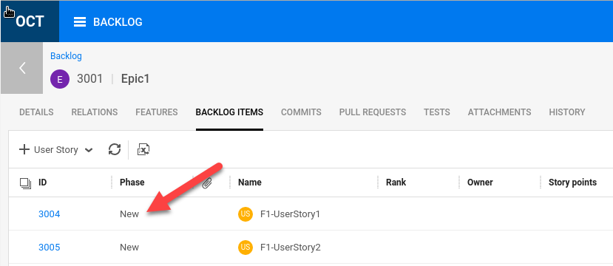

1. Now, edit the **Phase** field for the **F1-UserStory1** and change it from **New** to **In Progress**.

Then, change it from **In Progress** to **In Testing**. It needs to be in this state for our rule to trigger.

1. We still need one thing to happen before the user story phase is changed to Done.

We need some change to happen that resaves one of the tasks.

Drag and drop **US1-Task1** from **Completed** to **In Progress** and then back to **Completed**.

That change is enough to trigger our rule and change the phase of the user story to **Done**.

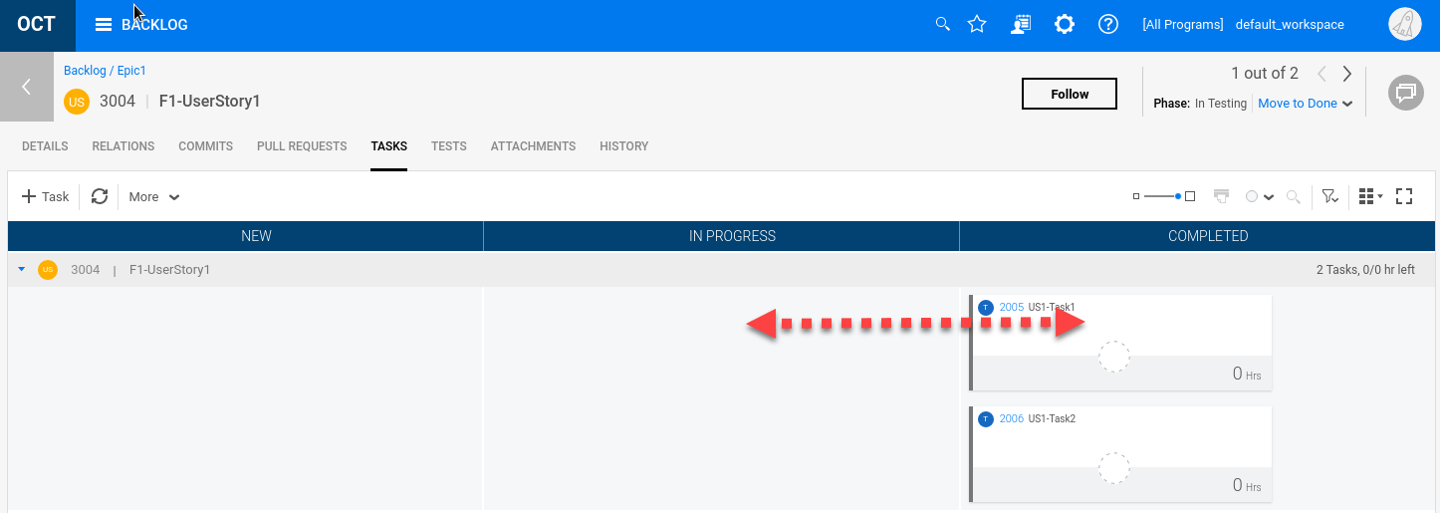

1. Click the back button in Octane and look at the phase again. You may need to refresh the view.

It should show the value Done for the phase.

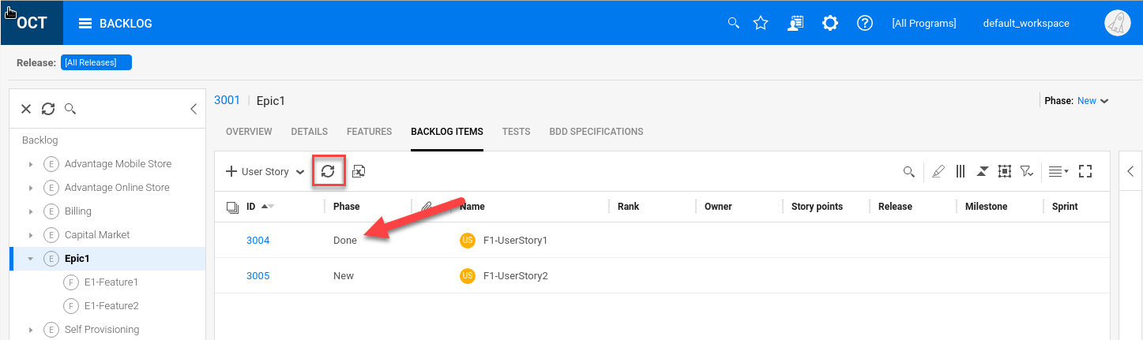

1. **Congratulations!** You now have an automatic rule that will set a user story’s phase to Done if its children’s tasks are all Completed (and the user story is in the In Testing phase).

Experiment with changing these states and become confident with how the rule performs.

## Extending the Definition of Done

Feel free to extend this to **Features** and change its status to **Done** if all its children user stories are **Done**.

**HINT**: Use the following description in the rule to guide which entities to use. They aren’t the same!

"Children count" {filter = Metaphase: (In Progress; In Testing; New) } = 0

Test your results with the hierarchy that you made.

**Hint**: If you want to see if a rule is triggering, create another rule with the same conditions and have the rule just create a comment. Then you can see (or not see) if the rule is actually getting triggered.

**EXTRA CHALLENGE**

In addition to having a rule for Features and User Stories, create rules to transition backwards – when a task comes out of the **Completed** phase to **In Progress**, change the parent user story phase to **In Testing**. Create a similar backward rule for features too – good luck!

**NOTE**: Currently you can’t extend this technique to **Epics** since there’s no timing option for “When related entity changes.” Epics also don’t have a child-count field to track as well.

You also can’t extend this to defects or quality stories but perhaps that will change in a future version.

Exercise 25: Introduction to PulseUno

Configuring PulseUno

PulseUno is a configuration management tool that uses Git as its CM system and allows you to easily integrate other DevOps tools and processes. It also can enforce that specific approval processes are followed, providing extensive tracking and audit logs. PulseUno provides an added layer of devops management to continuous integration.

PulseUno really has two major devops functions:

* Works as a graphical Git repository and enhanced Git security client.
* Works as a graphical CI system, like Jenkins, to execute “chains” of operations.

1. Start the **NimbusClient** and **NimbusServer** VMs (edit NimbusClient hosts with NimbusServer’s ens33).
2. **Start** or verify that the following Docker containers are running on NimbusServer for this exercise:

**$ nimbusapp pulseuno:22.1-3.2 start**

**$ nimbusapp aos:3.2 start**

**$ nimbusapp devops:3.2.3 start**

**$ nimbusapp intellij:3.2.1 start**

**$ nimbusapp octane:16.0.400.79 start**

1. **Log in** to PulseUno (http://nimbusserver.aos.com:8092/pulse) from NimbusServer (demo, +P@ssword1).
2. Select the **Administration** icon from the top menu bar.

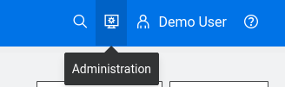

1. From the **Administration** view select **Agents** on the left edge or select the **AGENTS** section on the right.

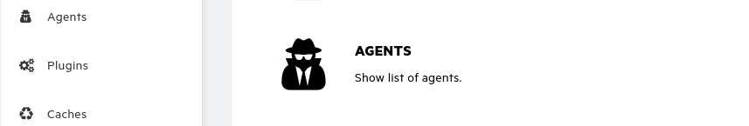

Agents are running processes that can connect to other remote machines to run processes.

By default, our PulseUno container creates a local agent in the container. When PulseUno first starts up, we need to approve and connect this agent. We’ll create a second agent on NimbusClient later.

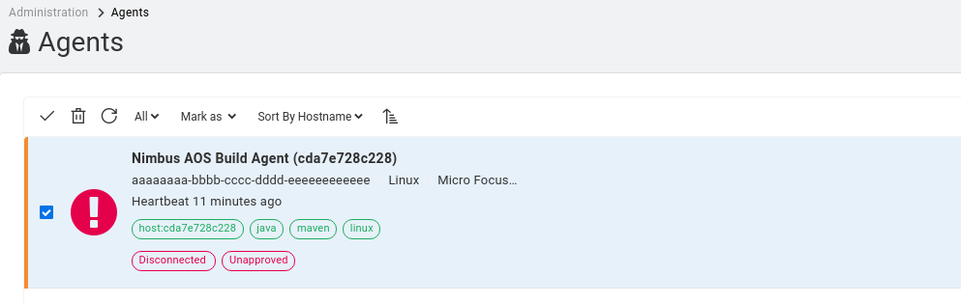

1. **Select** the **Nimbus AOS Build Agent** and select **Mark As > Approved** and enter a reason.
2. **Select** the agent checkbox and refresh the page until the agent shows green and is connected.

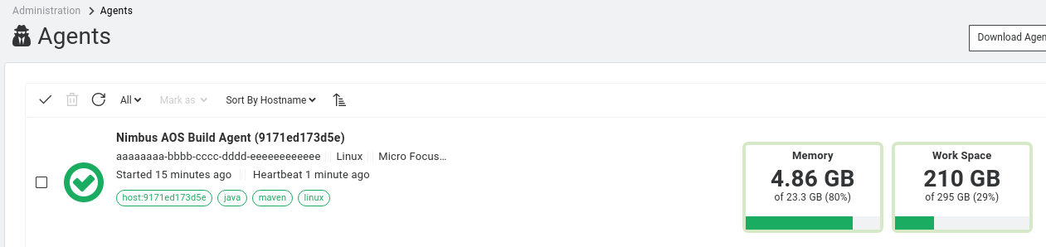

1. Select the **Nimbus AOS Build Agent** name link and the **CAPABILITIES** tab and **EDIT** to add a **maven** capability, hit **RETURN** and then click **SAVE**. This will identify the agent as one having maven build capabilities – which we need for our AOS-source.   
     
   **NOTE**: You need to hit **RETURN** or **comma** (**,**) after typing **maven** to get the capability tag to **SAVE.**

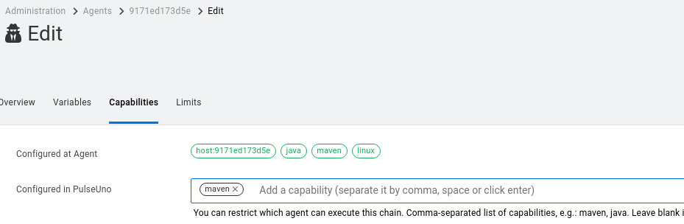

1. **Click** on the **Spaces** tab at the top and notice the **AOS** space. This space contains dozens of imported git repositories that mimic those in the **devops** container. These can be used in a changeset of activities.  
   To examine this collection, click on the **AOS** text. This will navigate you to the **Details** section inside the space.

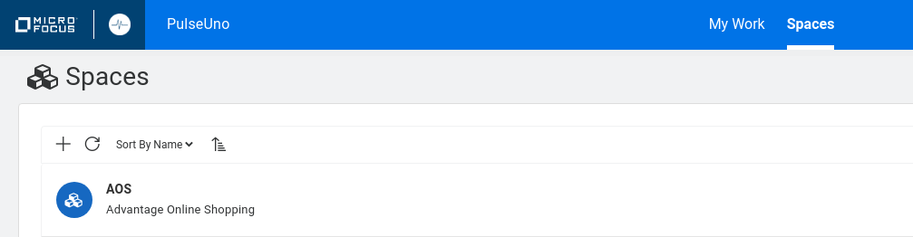

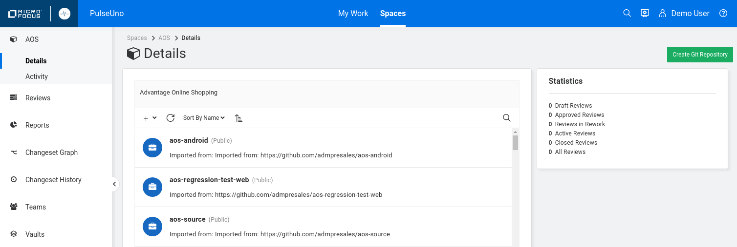

1. Go back to the **Spaces** tab (use the breadcrumb display at the top) and click the **+** to **create a new space**.

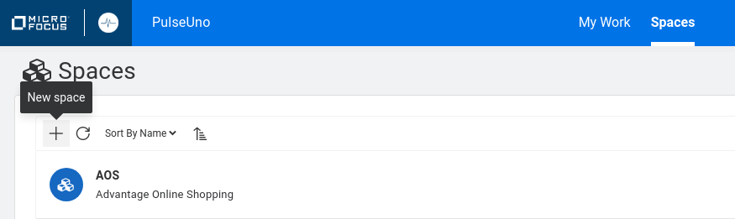

1. **Name** the new space **Space-1** and click **SAVE**.

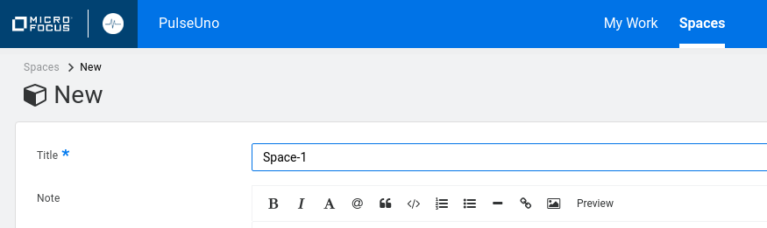

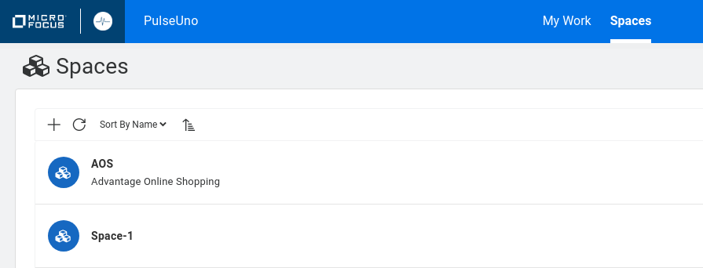

Select the new space and notice at the top left that there are breadcrumbs for your path.

These breadcrumbs are very useful when navigating around the PulseUno interface.   
**Spaces > Space-1 > Details**

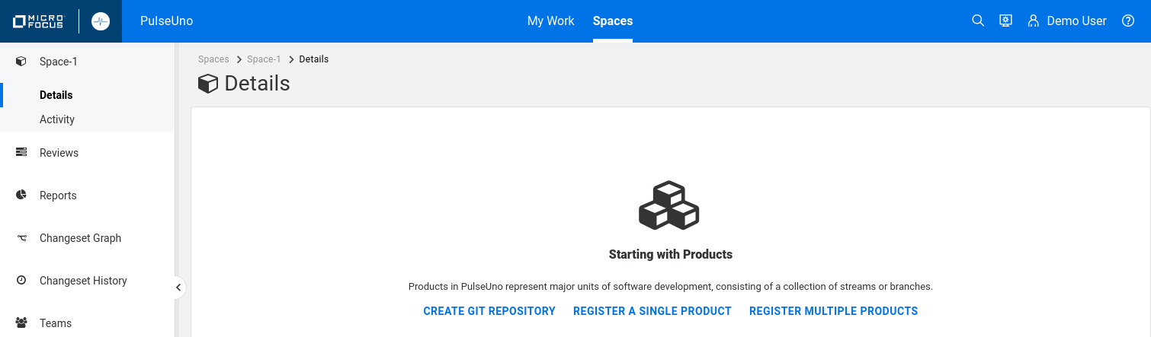

1. **Click** **CREATE GIT REPOSITORY** and name the repo **GitRepo-1** and click **SAVE**.

This will create a new, empty git repository that is managed by PulseUno.

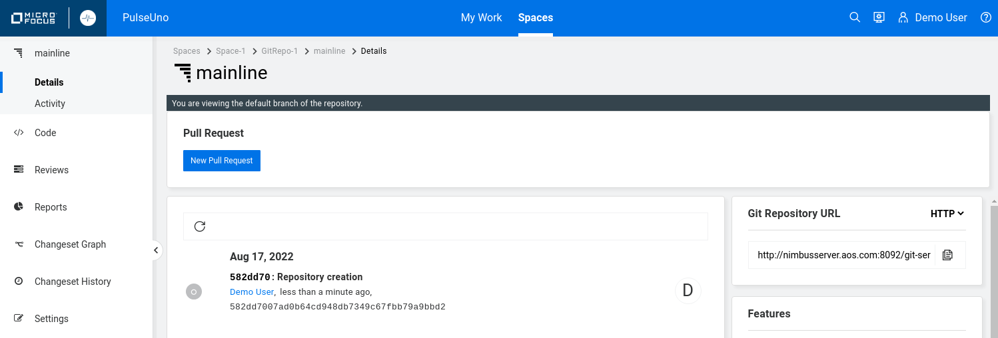

1. On the far right of your screen is the URL for your git repo and a copy button. **Click** the copy button and then open a terminal window and type “git clone ” and then **paste** in the URL link.  
     
   It should look like this:

**[demo@nimbusserver ~]$ git clone http://nimbusserver.aos.com:8092/git-server/repo/space-1/gitrepo-1**

You’ll need to enter the PulseUno username and password, when prompted, to perform the clone.

* demo
* +P@ssword1

This will clone a copy of your repository which should just contain a **readme.md** file.

We won’t use this repo for anything else but this shows how you can clone a repo from PulseUno.

1. **Click** the **GitRepo-1** on the breadcrumbs at the top to navigate back to the repository view.  
   **Spaces > Space-1 > GitRepo-1 > mainline > Details**

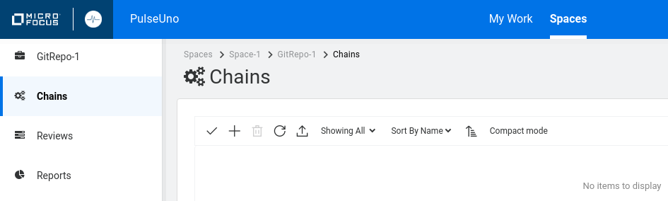

1. Click on the **Chains** option on the left edge to continue with the next section.

Creating and Running Chains

1. On the left edge, select the **Chains** option.

Chains are a series of actions that can be performed on demand or get triggered by an event. This is similar to Jenkins jobs, builds and pipelines. We’re going to start by creating a chain that runs a Jenkins job from our devops container. So we’re using one CI tool (PulseUno) to call another (Jenkins).

1. Click the **+** to create a new chain and select the **STEPS** tab and name it **Chain-1**. Do not click SAVE yet.

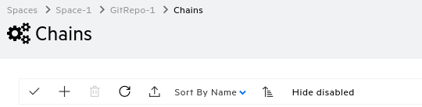

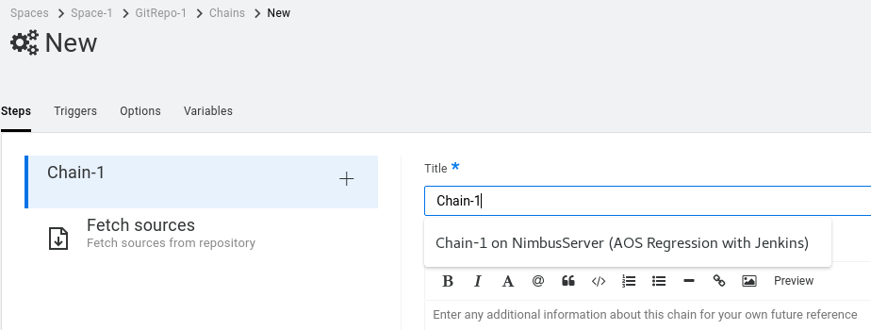

Notice the tabs at the top. For this chain you can define STEPS, TRIGGERS, OPTIONS and VARIABLES.

Initially, all chains have a **Fetch sources** step. Subsequent steps will be placed below that.

1. **Click** the **+** to add a new step.  
   The table below shows some of the different CI step types that you can add.  
   Micro Focus products are shown in **blue**.

NOTE: if you need to run steps on different machines (like UFT One on a Windows machine and Jenkins on a Linux machine) you will need to create separate chains for each and connect them in a parent chain that runs the other chains. Each chain can only run on a single agent / OS architecture.

|  |  |  |  |
| --- | --- | --- | --- |
| **Ant** | **Email Notification** | **JUnit Parser** | **Run a Docker Container** |
| **Build a Docker Image** | **Fetch from Dimensions CM** | **Maven** | **Run another chain** |
| **Capture to Dimensions CM** | **Fetch from Git** | **Micro Focus LoadRunner** | **Run script in Docker Container** |
| **CheckStyle** | **Fetch from StarTeam** | **Micro Focus UFT One** | **Script** |
| **CM Build** | **Fortify SCA** | **Microsoft Teams Notification** | **SonarQube** |
| **DA Deployment** | **Jenkins** | **NUnit Parser** | **TestNG Parser** |

Here are some of the **TEST** options available – feel free to browse around all the tabs to see them.

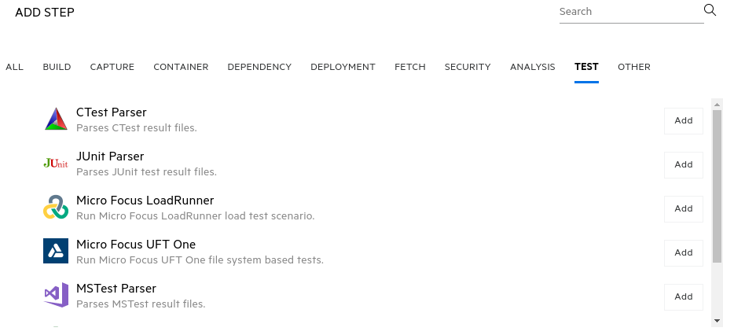

1. **Select** the **Jenkins** option and click **ADD** (later, you can also drag-and-drop to change the order).
2. **Select** the **Jenkins** option on the left and fill out the fields as shown below and click **SAVE** and **CLOSE**.

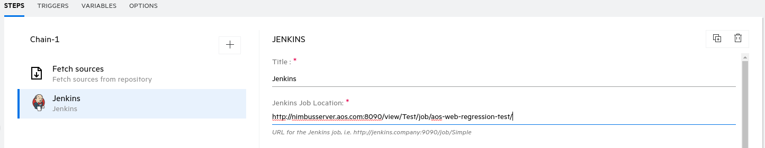

|  |  |
| --- | --- |
| Field | Value |
| Title | Jenkins |
| Jenkins Job Location | http://nimbusserver.aos.com:8090/view/Test/job/aos-web-regression-test/ |

1. **Click** the **Chain-1** link if you aren’t already displaying that page.

Before running the chain, verify that your aos, devops and intellij containers are running and healthy.

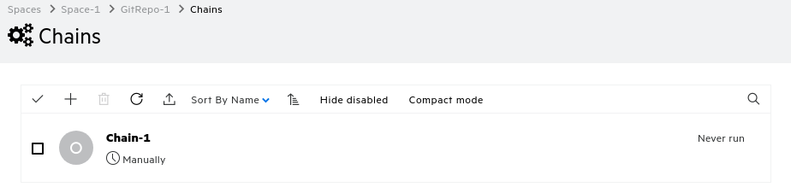

1. **Select** **RUN ON LATEST CHANGESET** to start running this chain.

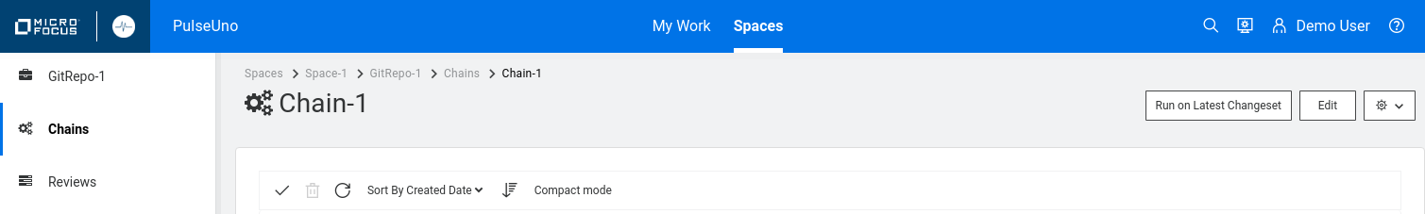

1. In the Run Chain “Chain-1” window, add the capability “**maven,**”. Make sure to add the comma or hit RETURN so your screen shows as below.

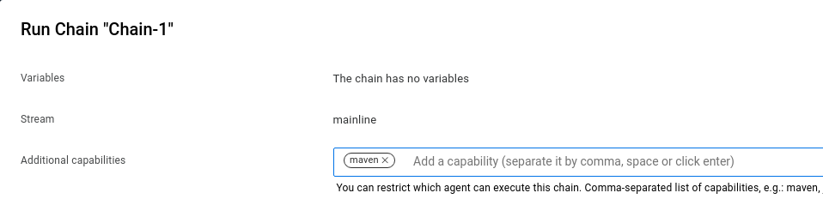



1. **Select** **RUN CHAIN** and it will display the following and start the **AOS Web Regression Test**.

NOTE: On this page there’s no need to select a changeset if you are just running the latest changeset.

1. As the Jenkins job runs, click the **Changeset** text link to see the individual step results.  
   The **Chain run Info** section contains global information on the chain itself and the **Fetch from Git** section pulls the job from PulseUno’s git repository.  
     
   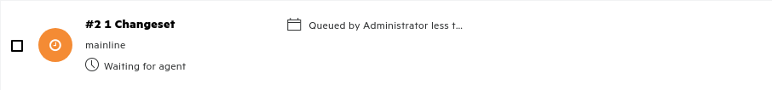  
   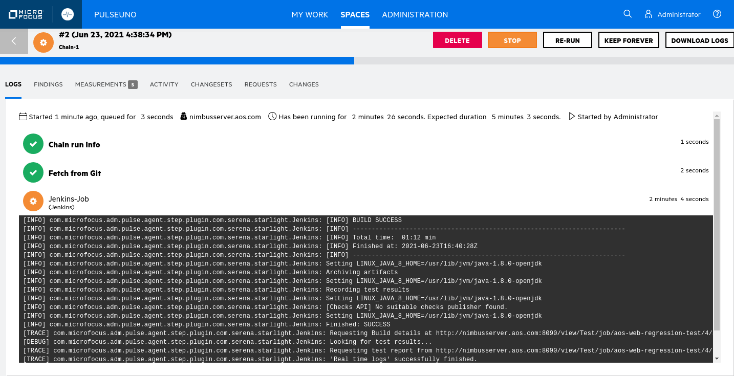
2. After the Changeset finishes **click** the link again to see the details.

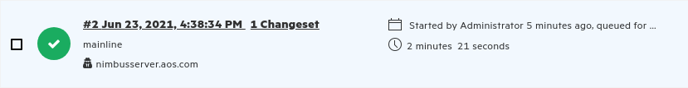

1. **Click** the **TESTS** tab to see the individual results of the **JUnit** test annotations in this Jenkins job.

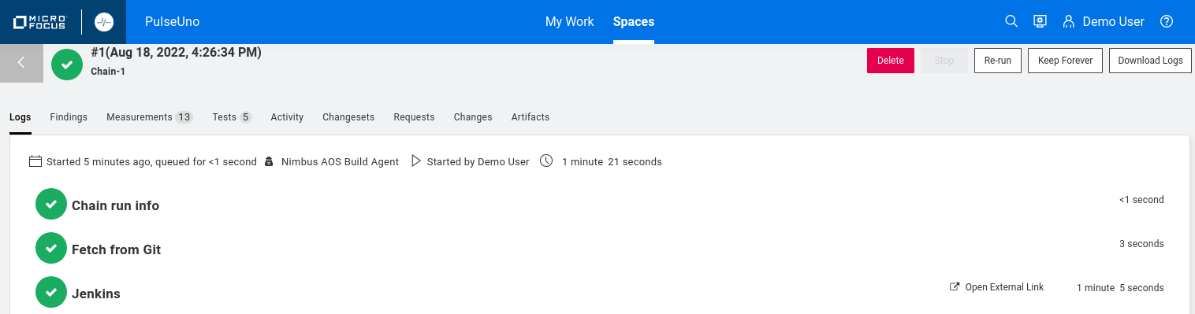

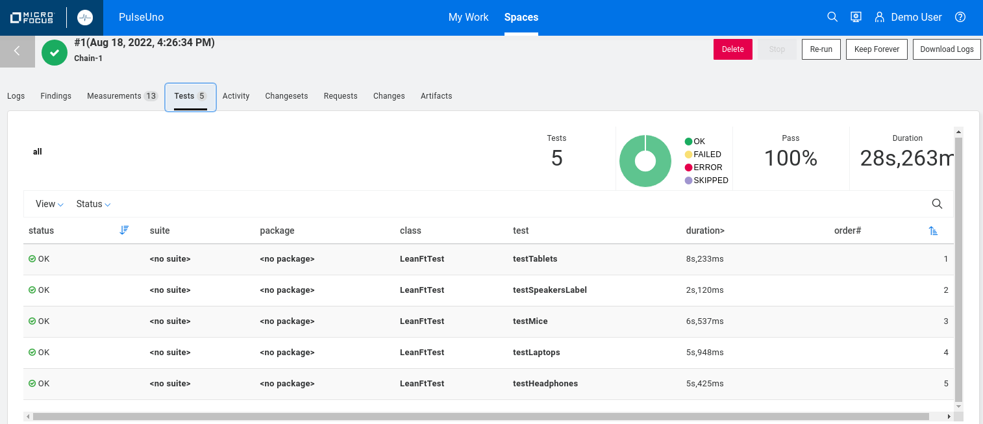

**What did we just do?**

In this first exercise we used PulseUno’s ability to act as a CI server (similar to Jenkins) to run a chain (i.e. Jenkins job) on the PulseUno agent that comes pre-installed in the PulseUno container. That job calls our Jenkins CI server (the devops container) to run the UFT Dev - AOS regression test.

Executing UFT One tests from PulseUno

Next, we’ll create a chain that runs a simple UFT One test on NimbusClient. To run PulseUno chains on a specific machine (like Windows with UFT One installed) we’ll need to specify the agent on that machine.

* 1. Since we need to run UFT Tests and they can only run on a Windows machine, we’ll need to configure a new agent to run on our NimbusClient VM.

From the NimbusClient VM, open a browser to PulseUno via the shortcuts and login in with:

* Username demo
* Password +P@ssword1  
  1. Select the **Administration** site and select the **Agents** section.

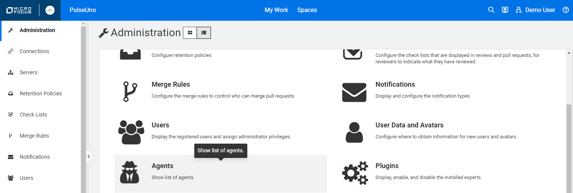

* 1. Select the **Download Agent Install** button. This will download an agent Zip archive to your Downloads folder.



* 1. Create a new folder on your desktop called **PulseUno Agent** and extract the contents there.

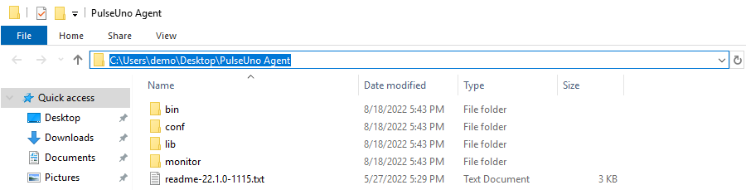

* 1. Edit the **conf\config.properties** file to change the ***pulse.base.url*** as shown below and **save** your change.

*pulse.base.url*=**http://nimbusserver.aos.com:8092/pulse**

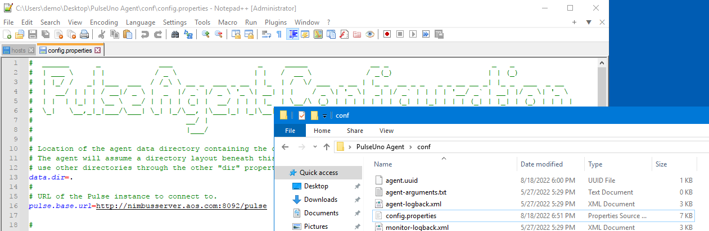

* 1. On NimbusClient, open a CMD windows and **cd** to the **C:\Users\demo\Desktop\PulseUno Agent\bin** folder and type **agent.cmd** to start the PulseUno agent on NimbusClient.

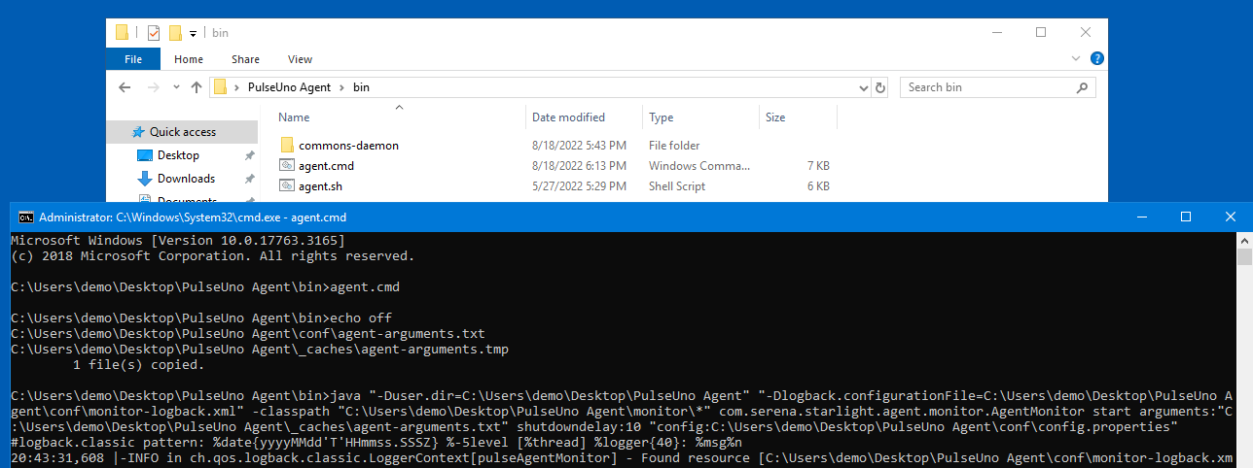

1. Minimize this CMD window but keep it running. This command runs the agent that communicates to PulseUno and can run actions on NimbusClient. The Zip file that we downloaded contains agent functionality and scripts for both Linux and Windows.

**NOTE**: If you want the agent to start automatically whenever you boot this VM, then stop the **agent.cmd** command with **CTRL+C** and then type **agent.cmd install**. This will install a service called   
**Micro Focus Pulse Agent**. Then open the Services ( icon) and set the service to **Log On** as   
**Local System account**. Then, **Start** the service. You can then close **Services** and any **Explorer** windows.

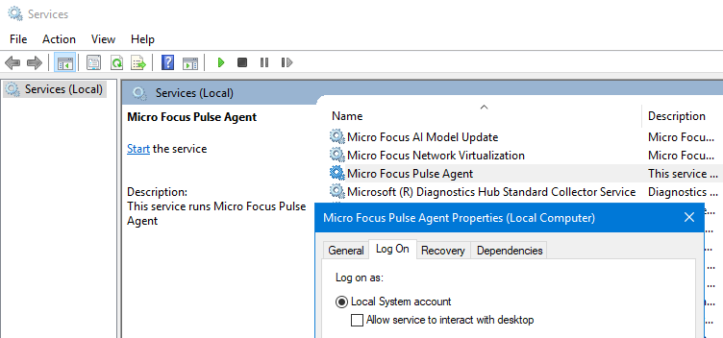

1. From PulseUno, select the **ADMINISTRATION** icon at the top and select **AGENTS**. You should now see the **nimbusclient** agent running but it is not approved. Select that agent and **Mark as** **Approved**. It can take a minute or two to show the agent approved and green so wait a bit and click the refresh option.

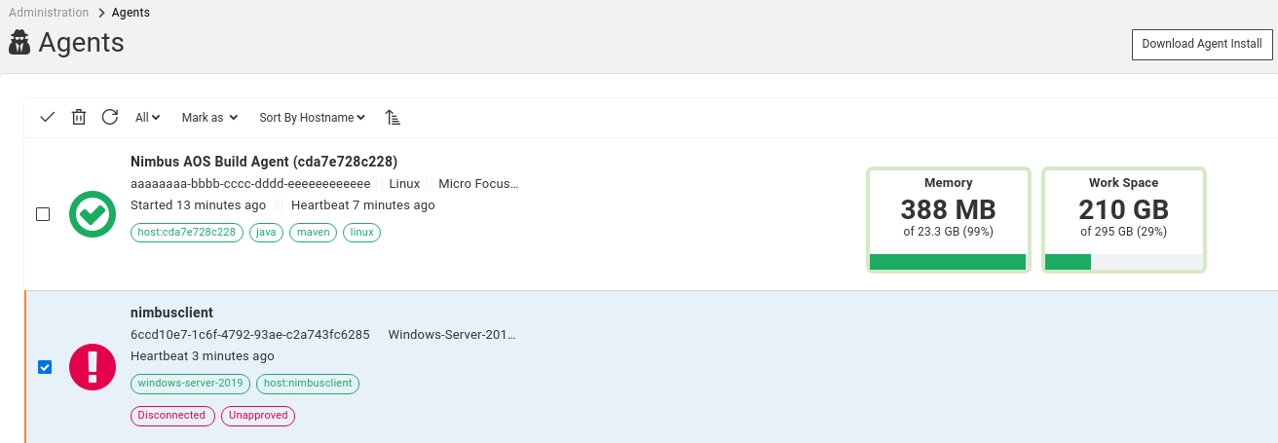

1. Select the **nimbusclient** name link and **EDIT** it to add a **uft-one** capability. Remember to hit either **ENTER** or **comma** (**,**) before hitting **SAVE**. This identifies that agent as having UFT One capabilities which also means it is a Windows machine. When we run chains that require UFT One, we can specify that we want to run on a machine with this capability (**uft-one**), instead of NimbusServer, which is Linux).

NOTE – Chains can typically only run on one agent at a time BUT you can define a special step  
(**Run another chain**) that calls a different chain which runs on a different agent/machine.

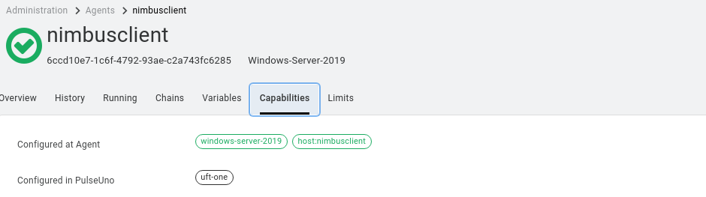

1. From NimbusClient, open a CMD window and run the following command to clone a **UFT One** test from the devops container onto NimbusClient to be your test. Make sure it’s located at **C:\Users\demo**

**C:\Users\demo> git clone http://nimbusserver.aos.com:8092/git-server/repo/aos/uft-one-aos-web-regression**

1. Close the **CMD** window and from PulseUno, create a new Chain on **GitRepo1** named:   
   **Chain-2 on NimbusClient (uft-one-aos-web-regressions-test)**
2. Select the **+** to add a step and add the **Micro Focus UFT One** step.

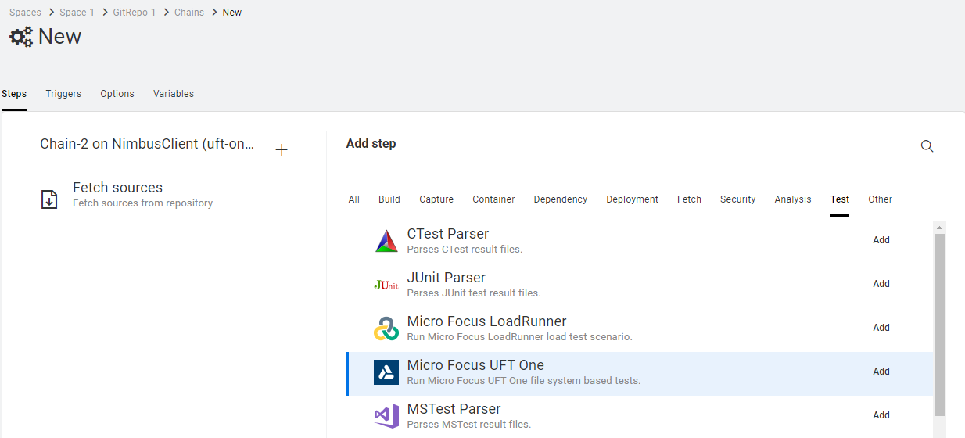

1. Select the **OPTIONS** tab and set the **Required capabilities** to **uft-one.**

Also uncheck the **Stop Chain on first step failure**. This allows all steps to run even if they fail.

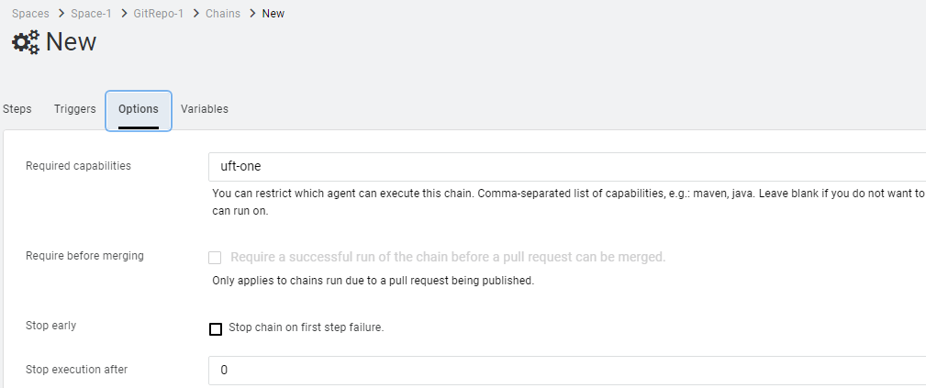

1. Select the **STEPS** tab and add steps to create the following structure and click **Save**:

**Fetch sources**:

Use all defaults

**Micro Focus UFT One**:

Tests: **C:\Users\demo\uft-one-aos-web-regression\AOS_UFT_WEB_Regression**

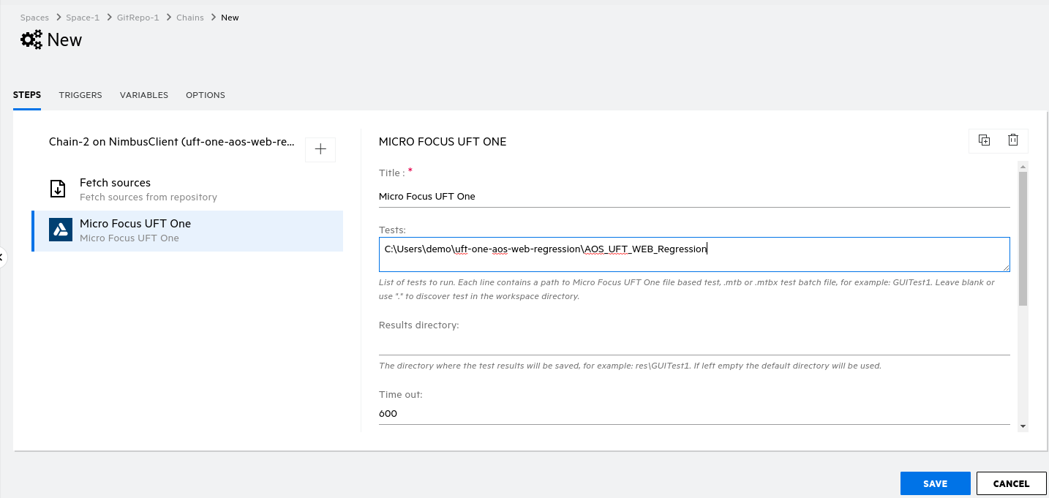

1. Using the breadcrumb trail go to **Spaces > Space-1 > GitRepo-1 > Chains** and select this chain and click **RUN ON LATEST CHANGESET** and then **RUN CHAIN** to run this chain to verify that it runs and passes properly. If you have any issues, verify the following:

* NimbusClient VM is running.
* The **nimbusclient** agent is up and running and has the right capability (uft-one).
* The **OPTIONS** tab for the chain has **uft-one** as a Required capability.
* You don’t have IntelliJ or UFT Dev running on NimbusClient.
* The AOS container is up and running.
* The test exists at **C:\Users\demo\uft-one-aos-web-regression\AOS_UFT_WEB_Regression**

1. While the chain is running, click on the **#1 1 Changeset** link to see the log of activity.

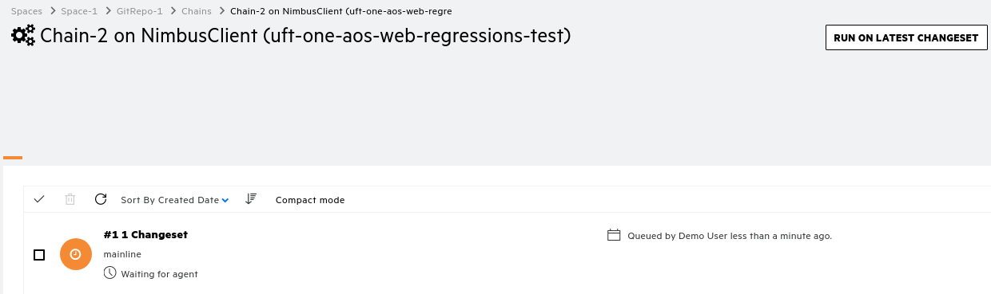

1. When the chain finishes, you can view the steps that completed.

To see the logs of any individual step, click the link for that step.

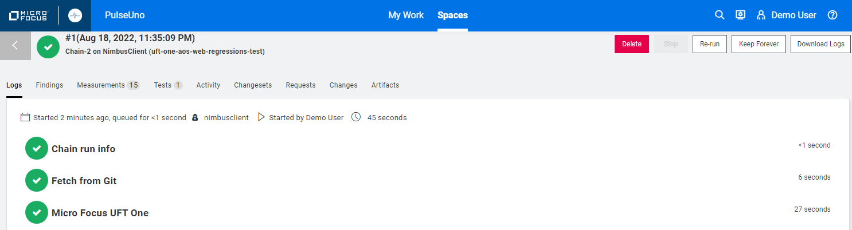

1. As an optional challenge, create a third chain (Chain-3) that calls chains 1 and 2 - search for  
   **Run another chain** and add it twice – once to run Chain 1 and once to run Chain 2.

Configuring PulseUno with Octane / ValueEdge

As part of a typical scenario showing PulseUno and ValueEdge we want to have source code managed in PulseUno. A code change triggers a PulseUno chain to run which recompiles AOS, deploys it and runs code quality and functional tests.

This exercise will follow the business process outlined below:

1. Show PulseUno source code repository for AOS – explain PulseUno’s advanced repository capabilities.
2. Configure Octane/ValueEdge and PulseUno integration so both are kept in sync.
3. Import a PulseUno chain based on the AOS source repo.
4. Add an Octane/ValueEdge pipeline that is tied to PulseUno chain.
5. Execute the AOS Chain to show build, deploy, test steps.
6. Change the AOS source code to modify Speakers to Audio.
7. Trigger the AOS Chain to build, deploy and test the new AOS.
8. Show PulseUno results and changes in Octane/ValueEdge.

For PulseUno and Octane/ValueEdge to talk to each other we need to set up that connection.  
You’ll either use your **local Octane container** on NimbusServer or the **SaaS-based ValueEdge instance**.

**If using your local Octane container:**

1. Log in to your local Octane instance and go to **Settings > Spaces** and select **A Default Shared Workspace** (top level on the left menu) and create a new **API ACCESS** key called **pulseuno** with role **CI/CD integration** in the **default_workspace**.
2. **Save** the **Client ID** and **Client Secret** values.
3. Note your URL from your local Octane (Shared Space is **RED**, Workspace is **BLUE**)  
   http://nimbusserver.aos.com:8085/ui/?p=**1001**/**1002**
4. Log into PulseUno and go to **ADMINISTRATION** > **CONNECTIONS**

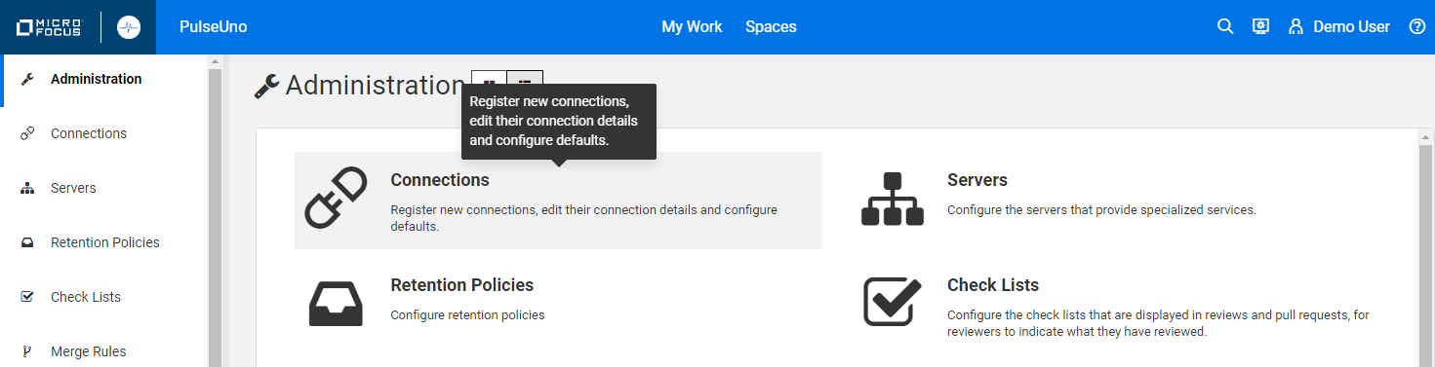

1. Click the **+** to add a new connection and set the values as shown below and click **SAVE**.

|  |  |
| --- | --- |
| **Title** | OctaneLocal |
| **Web URL** | http://nimbusserver.aos.com:8085 |
| **API Token (Client ID)** | < from step 2 above > |
| **Secret (Client Secret)** | < from step 2 above > |
| **Shared Space** | **1001** |
| **Pulse Instance ID** | Use default value (checked) |

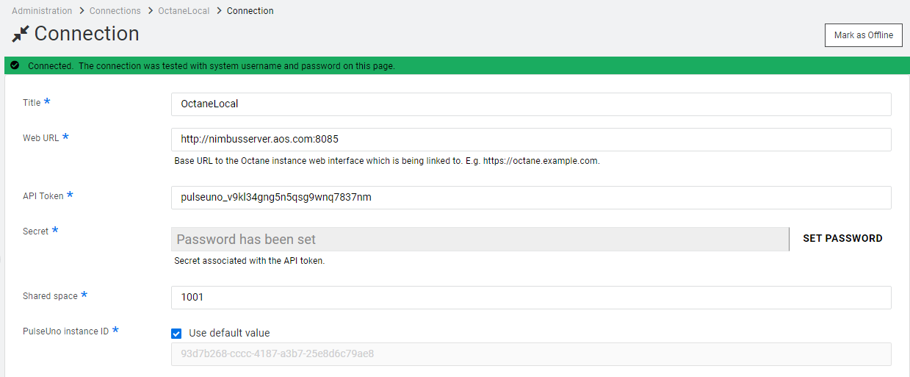

1. Click the **OctaneLocal** link again and verify that your connection shows green.  
   
2. Navigate to **SPACES > Space-1 > GitRepo-1** and select **Settings > Integrations** on the left and under the **OCTANE** section enter **OctaneLocal** and **1002** and click **SAVE.**  
   **NOTE –** **DO NOT** use the REQUESTS section above the OCTANE section. That has a different purpose.

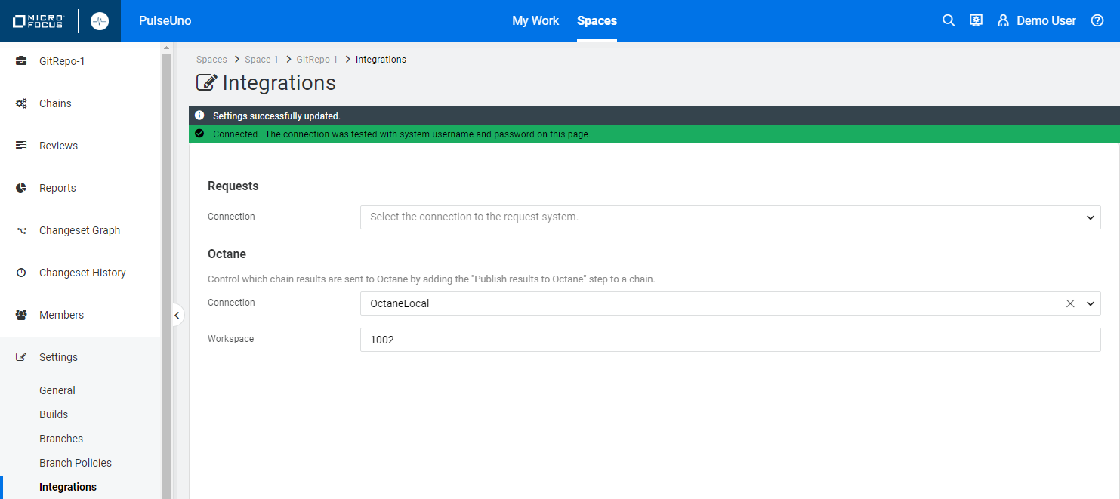

1. Go back to Octane and select **Settings > Spaces** and under the **DEVOPS** tab create a new  
   CI Server called **PulseUno CI**. Use the pulldown for CI Server to select the PulseUno URL and click **Add**.

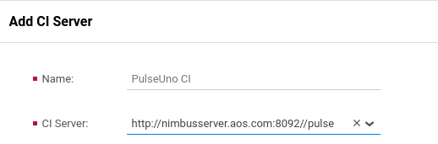

You’ve now connected a local Octane to PulseUno so it can serve as a CI server similar to Jenkins.

**If using the SaaS-based ValueEdge instance:**

1. Verify that you received a communication with your ValueEdge **Client ID** and **Client Secret**.
2. Note your unique URL from ValueEdge (Shared Space is **RED**, Workspace is **BLUE**)  
   https://almoctane-eur.saas.microfocus.com/ui/?p=**<your SS>**/**<your WS>**
3. Log into PulseUno and go to **ADMINISTRATION** > **CONNECTIONS**



1. Click the **+** to add a new connection and set the values as shown below and click **SAVE**.

|  |  |
| --- | --- |
| **Title** | ValueEdge |
| **Web URL** | https://almoctane-eur.saas.microfocus.com/ |
| **API Token (Client ID)** | < from step 2 above > |
| **Secret (Client Secret)** | < from step 2 above > |
| **Shared Space** | **< your SS >** |
| **Pulse Instance ID** | Generate a UUID via **https://www.uuidgenerator.net/** |

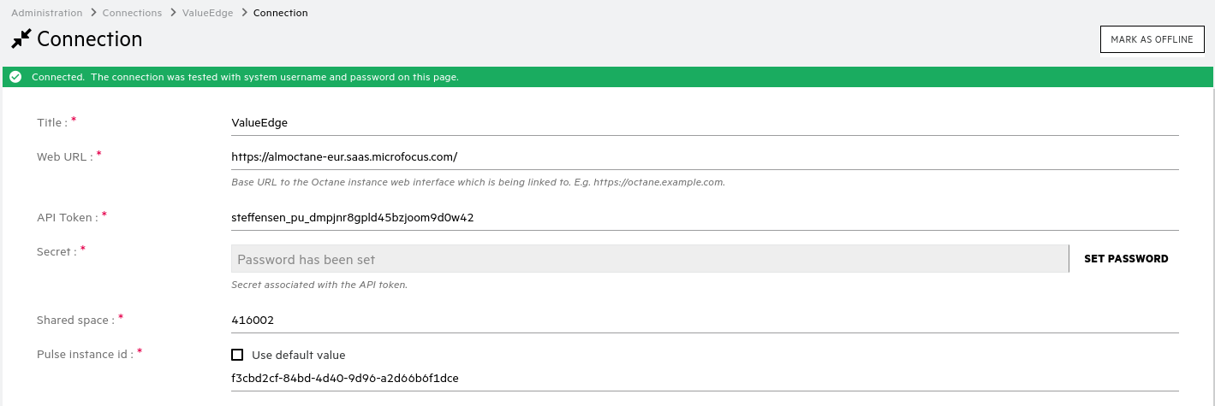

https://almoctane-eur.saas.microfocus.com/

ValueEdge

< your SS >

1. Click the **ValueEdge** link and verify that your connection shows green.  
   
2. **Uncheck** the **Use default value** checkbox and generate a UUID from this site using:  
   <https://www.uuidgenerator.net/>

A unique UUID will appear when you go there – just copy it and place that value in the   
**Pulse Instance ID** field.

1. Navigate to **SPACES > Space-1 > GitRepo-1** and select **Settings > Integrations** on the left and under the **OCTANE** section enter **ValueEdge** and **< your WS >** and click **SAVE.**

NOTE – **DO NOT** use the REQUESTS section above the OCTANE section. That has a different purpose.



ValueEdge

< your WS >

Go back to Octane and select **Settings > Spaces** and under the **DEVOPS** tab create a new  
CI Server called **PulseUno CI**. Use the pulldown for CI Server to select the PulseUno URL and click **Add**.



You’ve now connected a SaaS ValueEdge to PulseUno so it can serve as a CI server similar to Jenkins.

https://almoctane-eur.saas.microfocus.com/

Creating a Chain on the AOS-source Repository

Next, we’ll examine the AOS Source code repository in PulseUno and import a chain definition that builds the AOS code, deploys it as a new container and then runs functional tests on the new AOS container.

1. Log into PulseUno (demo, Password1) and select **SPACES**.
2. There are several repositories pre-populated in our PulseUno container under the space called AOS.

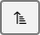These are copies of the same repositories we have in the devops container under git control.  
  
Select the **AOS** space and verify that they are sorted alphabetically. You should see this icon.

1. Select the **aos-source** link.

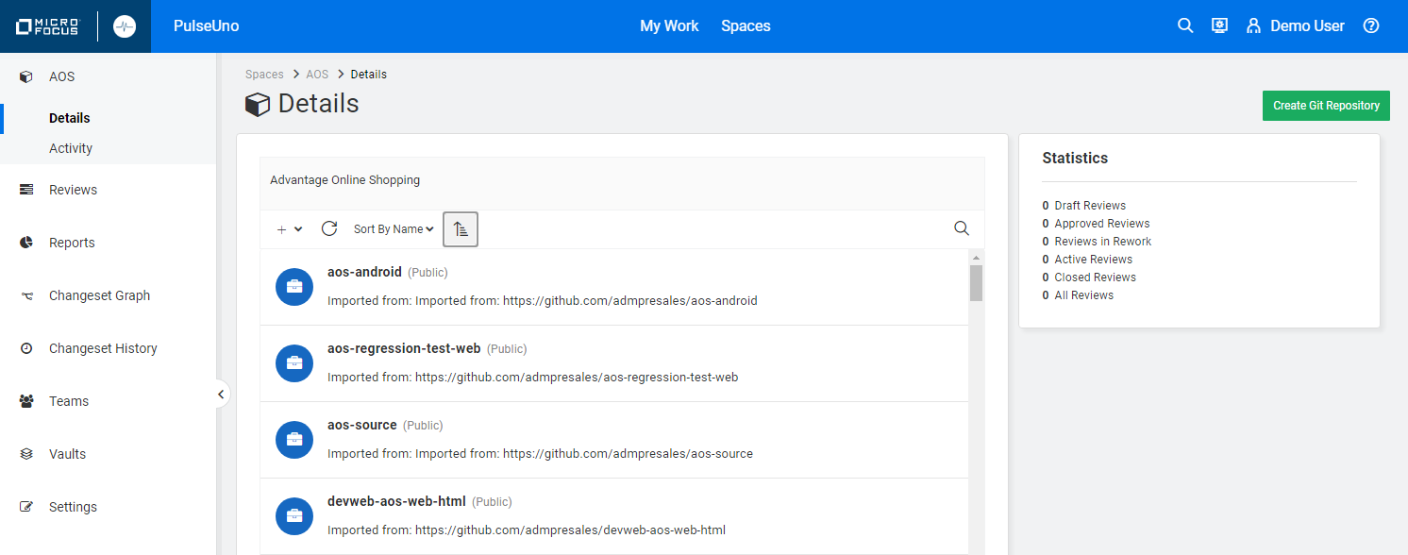

This view shows the **aos-source** code branch and many other build versions.

Whenever we view, edit or build this code we need work on version **3.2** which is the default branch.

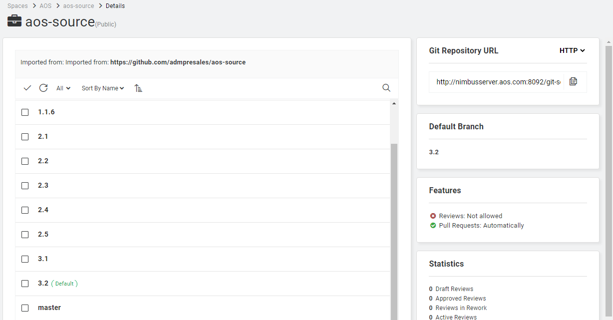

1. Select the **3.2** link and then select **</> Code** on the left-hand menu.  
   This shows the code tree for the **3.2** version of AOS.
2. Navigate to: **root / src / main / webapp / app / controllers / categoriesCtrl.js**

Examine **line 27** as this is where we’ll eventually change the code to display **Audio** instead of **Speakers**.

When we make our change, we’ll use the **IntelliJ** IDE to edit this code and commit/push it back to the PulseUno git repository.

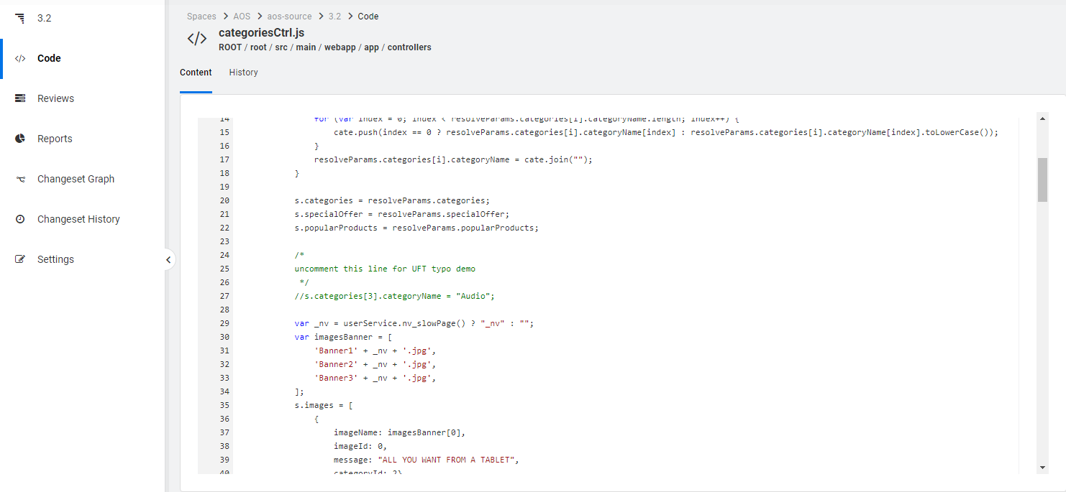

PulseUno tracks all the changes made to our code base and allows easy access to view those changes.

When changes are made you can use PulseUno’s viewer to see when, where and who made changes.

1. Go back to **SPACES > AOS > aos-source** and select **Settings > Integrations** on the left-hand menu.
2. Select the **OCTANE** section and verify that you have configured your connection as described in the sections above (**local Octane container** **or** **SaaS-based ValueEdge instance**).



1. Go back to **Spaces > AOS > aos-source** and select **CHAINS** on the left-hand menu.  
   TIP: You can use the breadcrumbs at the top to easily navigate in PulseUno.

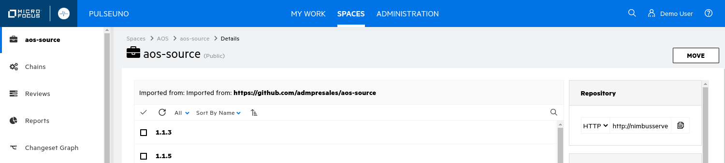

1. From the terminal on **NimbusServer** run the following commands to download two chain definitions.

These are pre-built chains that mimic jobs in Jenkins to build, deploy and test the AOS website.

**$ cd ~/Downloads**

**$ git clone https://github.com/msteffensen19/AOS-Web-Root-Module-Pipeline-Chain.git**

**$ git clone https://github.com/msteffensen19/uft-one-aos-web-regression-chain.git**

1. Choose the **Import Chain** icon to import a new chain.

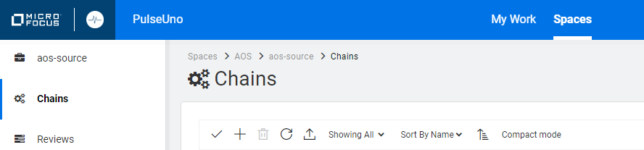

1. Select the file from the **~/Downloads/ AOS-Web-Root-Module-Pipeline-Chain** folder and click **Open**.

Repeat this process to import the **~/Downloads/uft-one-aos-web-regression-chain** folder as well.  
You can use the breadcrumbs to navigate back to the **Chains** section again to do this import.

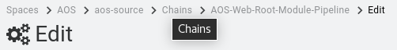

1. We still need to connect the **Run another chain** step with the imported **AOS-Web-Root-Module-Pipeline** chain. Select that chain and choose to **EDIT** it and set the chain to **uft-one-aos-web-regression.**

Click **SAVE** and **CLOSE**.

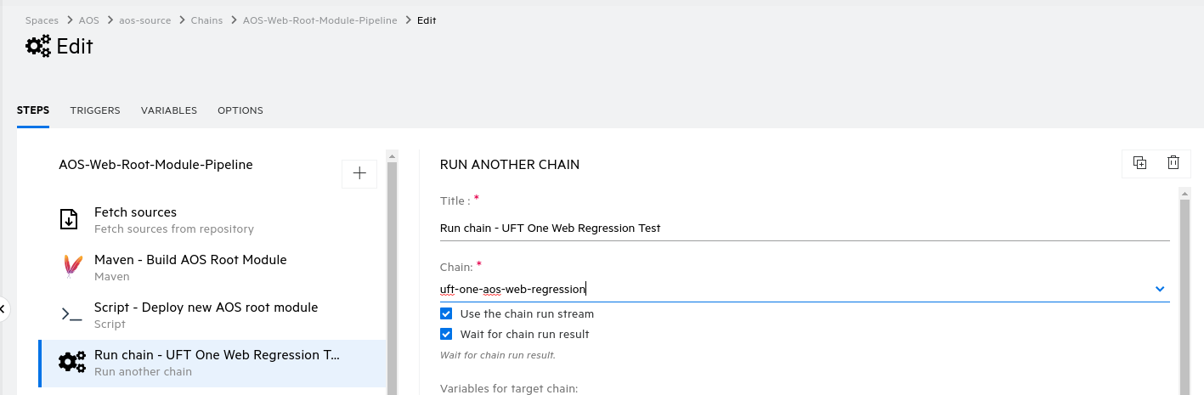

1. When you eventually run these chains they will show a color (**red** or **green**) displaying their latest status. The following image shows their status before a run on the chains (grey).

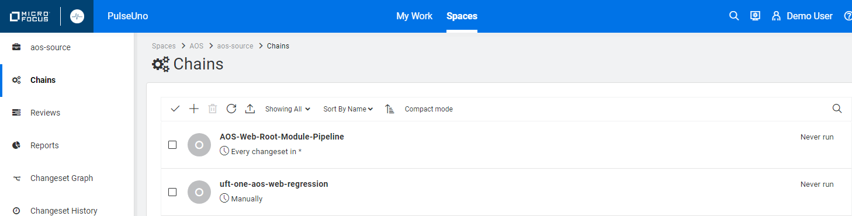

**What are we doing?**

In this section we’re importing a couple of existing chains so we don’t have to create them from scratch. These two chains run the build, deploy, test process that we outlined before. The AOS-Web-Root-Module-Pipeline chain is very similar to the same named pipeline we often use in Jenkins.

The second imported chain is actually called from the first chain and runs a UFT One test on NimbusClient. Since PulseUno typically runs on a single agent/server we build and deploy AOS on NimbusServer but then we need to run a UFT One functional test to verify AOS on NimbusClient. Fortunately, PulseUno has a step that can “run another chain” and that step can be on another agent/server.

While we had built a similar UFT One chain in a different repository in the first section, this version of PulseUno can’t use a chain stored in a different repository so we have to get a local copy in this repo. That may change with a future release.

PulseUno can also run jobs from Jenkins and we do that in this solution too. That gives us lots of flexibility when it come to what we can achieve with PulseUno’s CI capabilities.

1. Select the AOS-Web-Root-Module-Pipeline link and select **EDIT**



1. The screenshot below shows the individual steps that this chain will run.

Click **CLOSE** when you are done looking at the chain details.

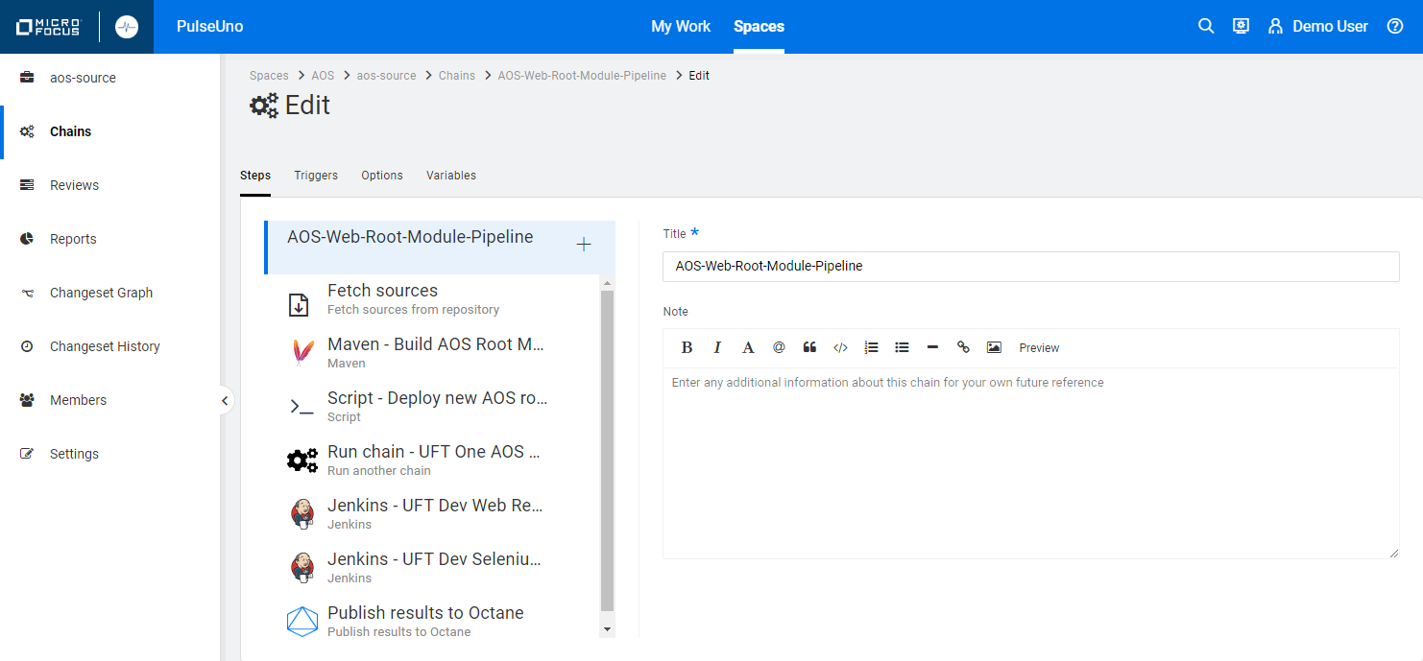

1. These are the PulseUno steps we’ll run to fetch, build, deploy and test our AOS website:

|  |  |
| --- | --- |
| **Step Name** | **Function** |
| Fetch sources | Copy the AOS Source git repo to a local PulseUno workspace |
| Maven – Build AOS Root Module | Use Maven commands to compile/build the AOS source |
| Scripts – Deploy new AOS root module | Run several script commands to deploy a new Tomcat container |
| Run chain – UFT One Web Regression Test | Run a UFT One Regressions test chain on NimbusClient |
| Jenkins – UFT Dev Web Regressions Test | Run a UFT Dev Web Regression Test job on Jenkins |
| Jenkins – UFT Dev Web Selenium Test | Run a UFT Dev Selenium Test job on Jenkins |
| Publish results to Octane | Publish all the chain results to Octane |

Connecting the Pipeline to Octane / ValueEdge

Next, we’ll make sure that our pipeline results get into Octane, just like Jenkins pipelines.

* 1. Log into ALM Octane (sa@nga, Password1) and navigate to the **Pipelines** module.

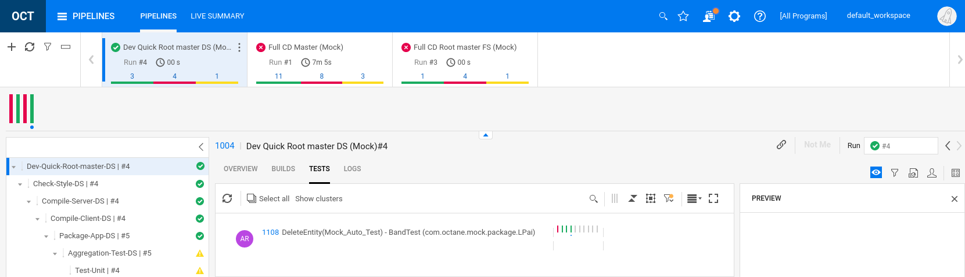

* 1. Create a new pipeline by clicking the **+** symbol and fill out the form and click **Save**.

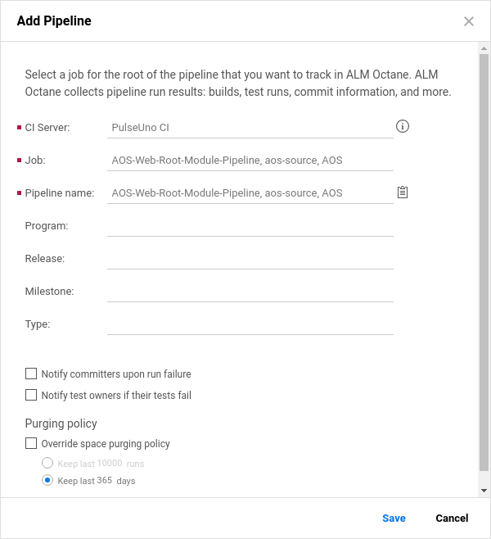

CI Server PulseUno CI

Job AOS-Web-Root-Module-Pipeline

Pipeline Name AOS-Web-Root-Module-Pipeline

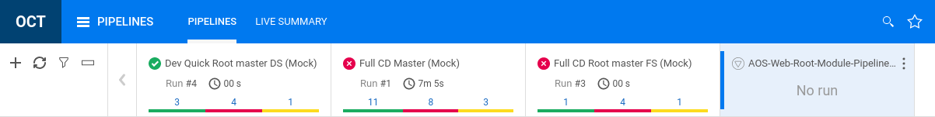

Now we have our PulseUno pipeline (chain) connected to Octane so our results will show there.

Running the AOS-Web-Root-Module-Pipeline Chain

Now that we have our imported chains, and they’re connected to Octane, we can run a changeset.

1. Verify that you have started the **NimbusClient-2022-R3** and **NimbusServer-2021-R3** VMs.
2. Verify that the following Docker containers are running on NimbusServer for this exercise:

**$ nimbusapp pulseuno:22.1-3.2 start**

**$ nimbusapp aos:3.2 start**

**$ nimbusapp devops:3.2.3 start**

**$ nimbusapp intellij:3.2.1 start**

**$ nimbusapp octane:16.0.400.79 start**

1. Verify that your **Nimbus AOS Build Agent** and **nimbusclient** agents are running and showing green.

Also, make sure that they have **maven** and **uft-one** capabilities listed, respectively.

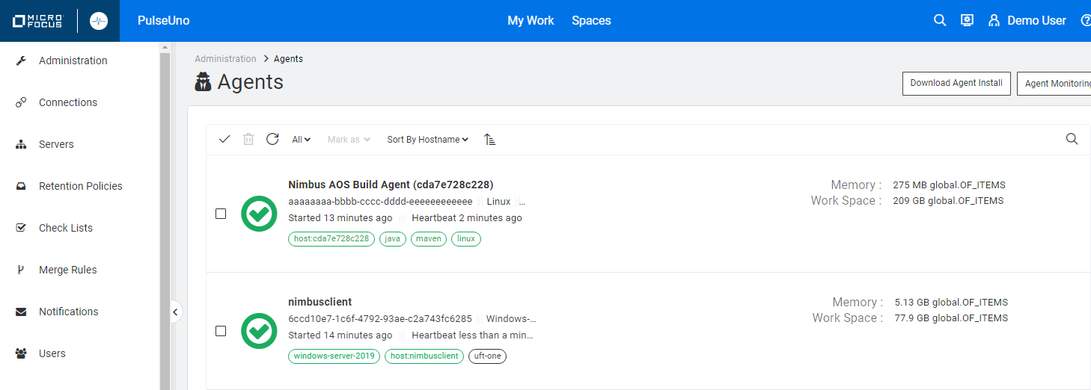

1. Select **Spaces > AOS > aos-source > Chains** and select the **AOS-Web-Root-Module-Pipeline** link.



1. Select **RUN ON LATEST CHANGESET**



1. Select the stream **3.2** and click on **RUN CHAIN**.

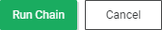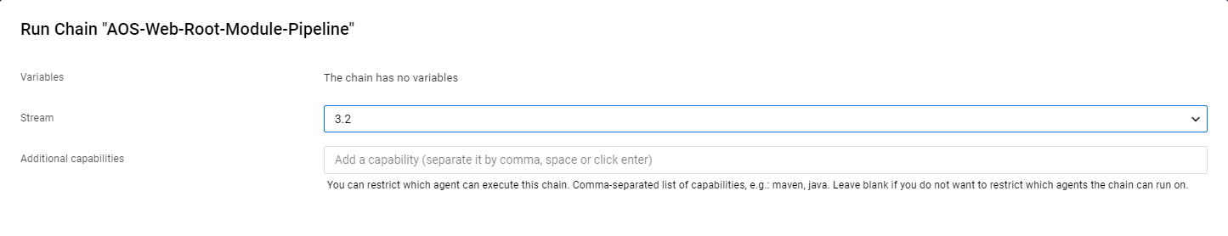

1. Click on the **#1 1 Changeset** link and watch the steps as they are executed.

NOTE – The first run of a changeset build can take several minutes as all the resources are downloaded.

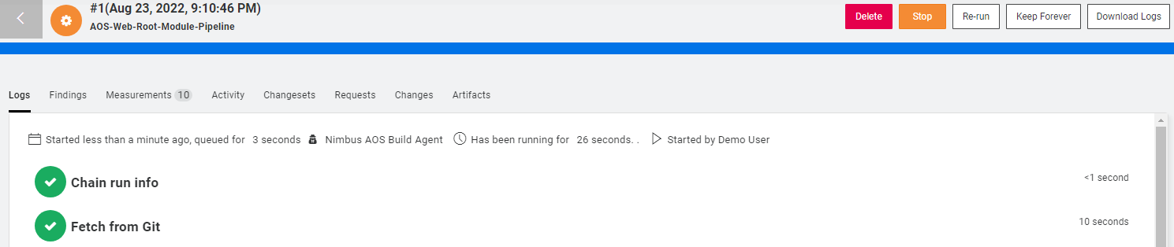

1. Once the chain finishes, switch back to ALM Octane to view the pipeline run results.

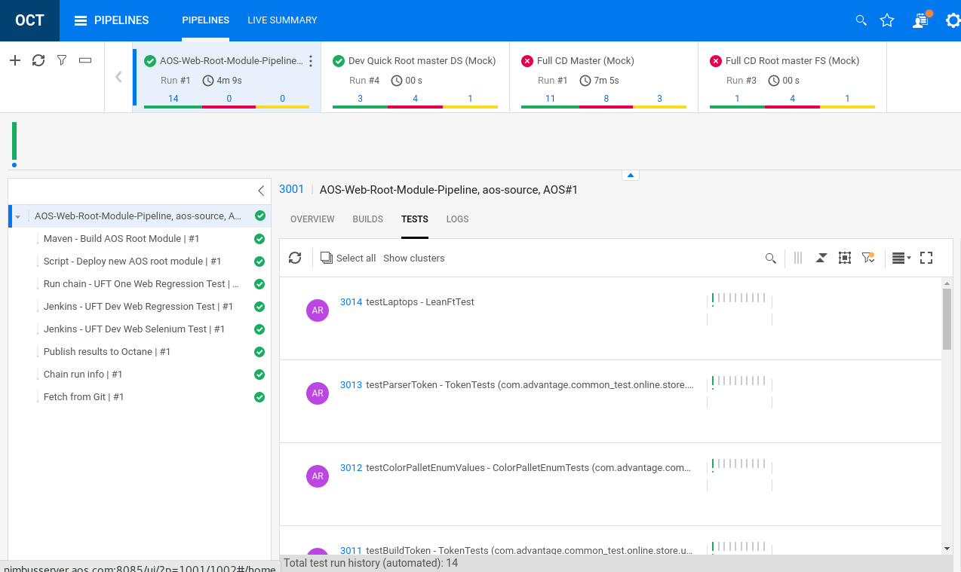

Changing the AOS-source code and Rebuilding

Now, we’ve seen how PulseUno can run chains and build/deploy/test software. Next, we’ll start working as a developer and changing our code to reflect a request from marketing. That code change will have a ripple effect when the code is committed and pushed to our PulseUno repository. As a result, the build will start automatically along with the deploy and testing steps.

1. From NimbusServer, open Chrome and log into PulseUno and navigate to **Spaces > AOS > aos-source**

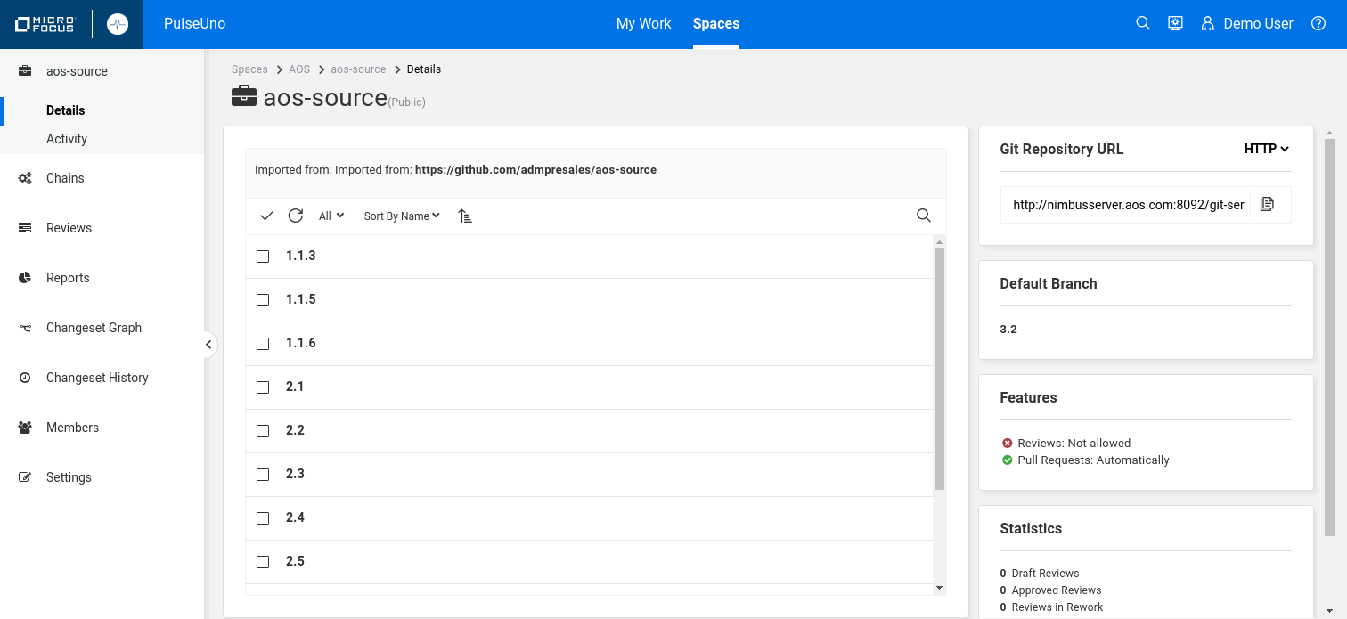

1. Select the **Copy URL** icon under Git Repository URL at the right. This will contain the PulseUno git repository URL that we’ll check out our code from. The code will go into the **pulseuno** container.  
   The URL should look like this:

**http://nimbusserver.aos.com:8092/git-server/repo/aos/aos-source**

1. Bring up the **IntelliJ** interface on NimbusServer and choose **Get from VCS** and paste in the URL.

You must use CTRL+V to paste in the URL.

1. Click **Clone** and if any popups appear select **Trust Project**.  
   Wait for all the indexing and downloading to finish – this can take several minutes.
2. Open the Project tree on the left to:

**root > src > main > web > app > controllers** and select **CategoriesCTRL.js**

Notice line 27 which we discussed before.

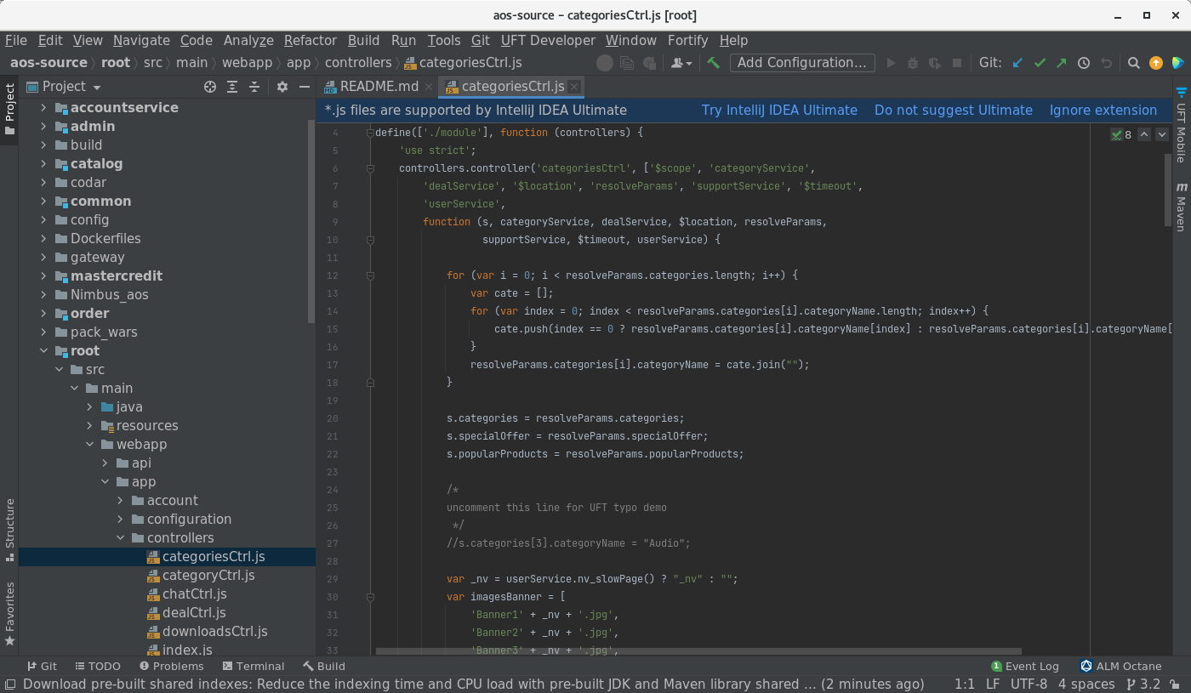

1. Edit line 27 to remove the two leading slashes so it looks like:

s.categories[3].categoryName = "Audio";

Uncommenting that line will cause the AOS application to relabel the Speakers category to Audio.

1. From the menus at the top select **Git > Commit…**

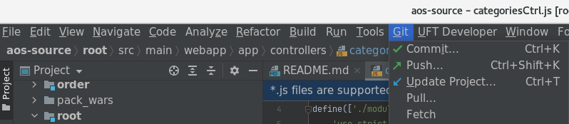

1. Add a **Commit Message** like **Changed Speakers to Audio** and select **Commit**.

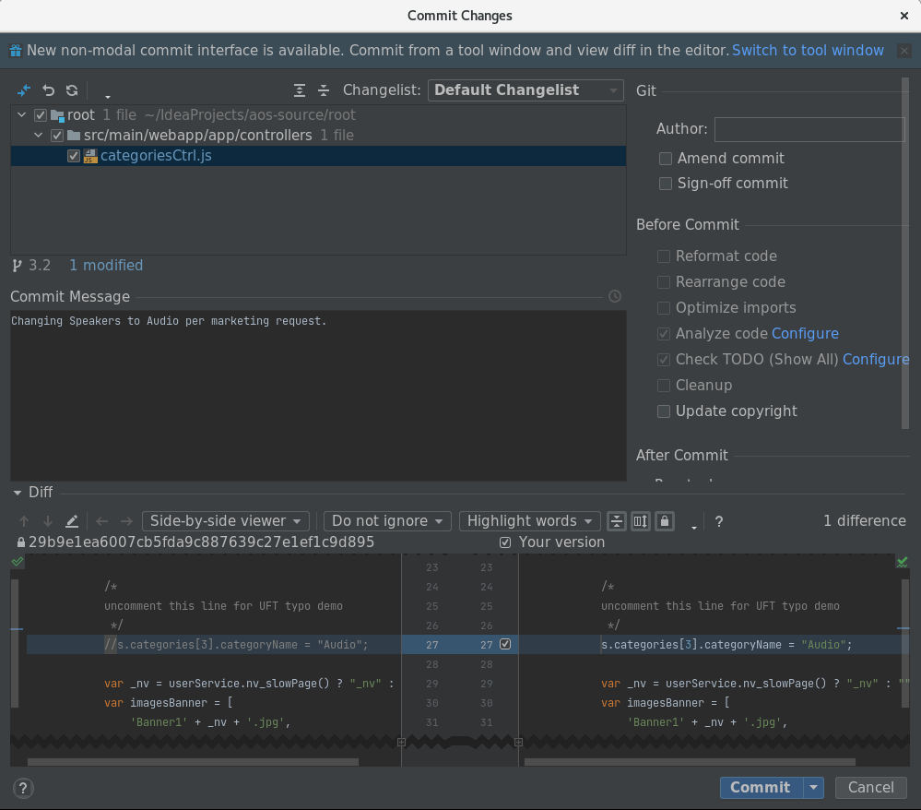

1. If prompted for Name and Email enter **demo**, **admin@default.com** and click **Set and Commit.**

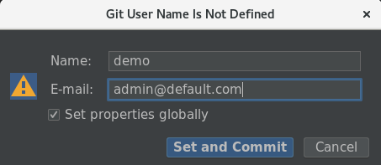

1. From the **Push Commits to aos-source** window select **Push**.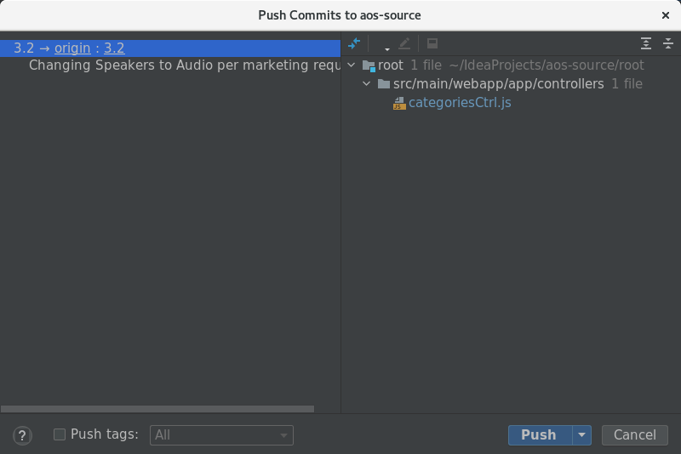
2. Enter the credentials for this account (**demo**, **+P@ssword1**) and click **Log In**.

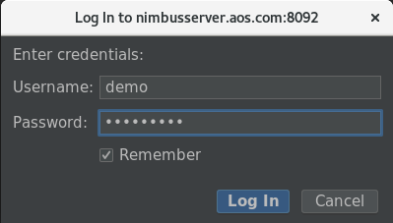

1. Once this happens, PulseUno will come alive and start running the **AOS-Web-Root-Module-Pipeline**.  
   Minimize this window and bring up the **PulseUno Changeset** screen.

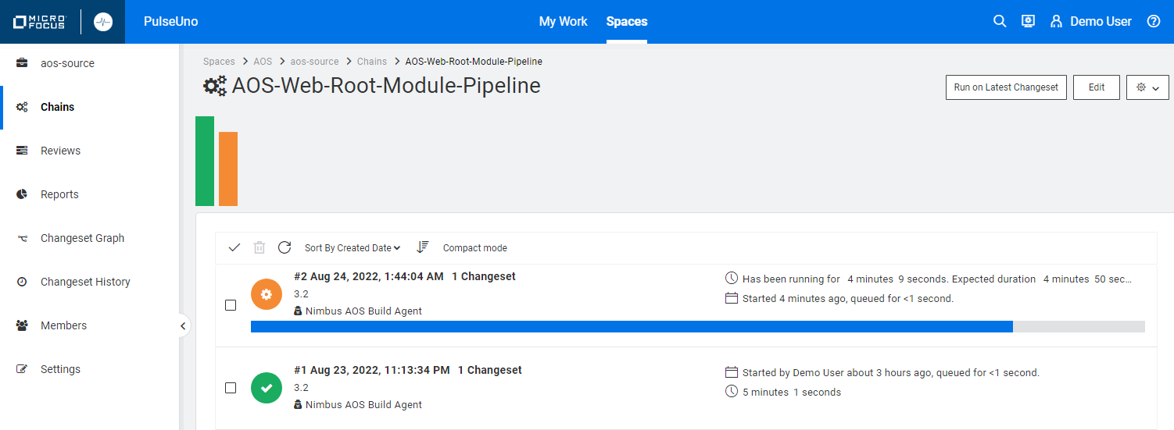

1. Select the Changeset text link and watch the steps as they complete.

Two tests fail since they try to click the Speakers category and that was changed to Audio.

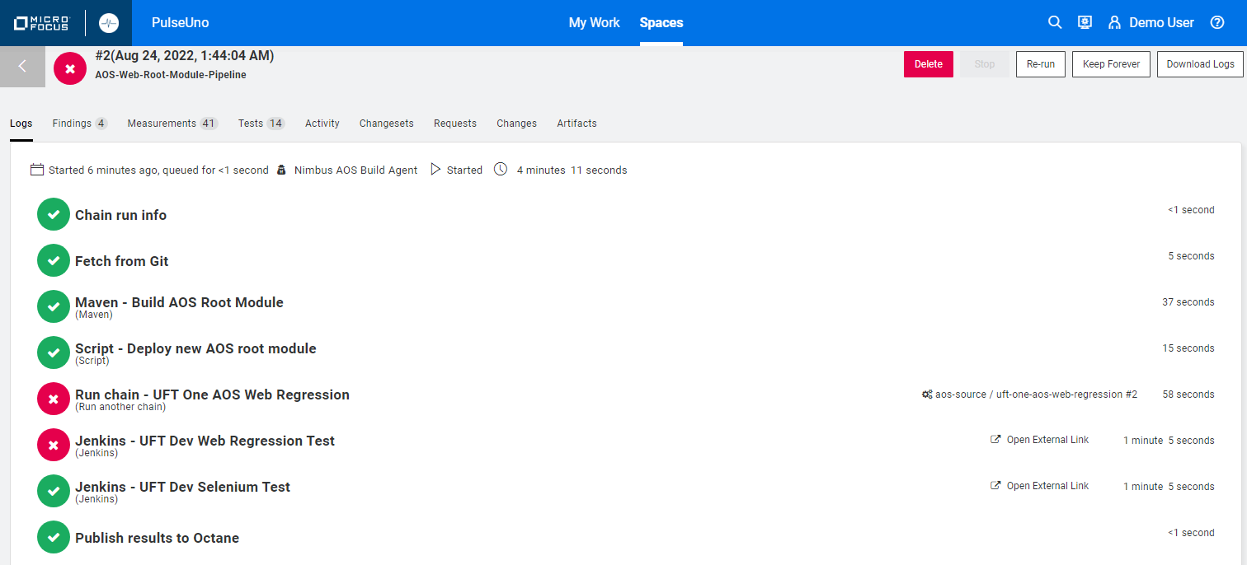

1. Navigate back to ALM Octane and examine the results that have shown in the pipeline there.

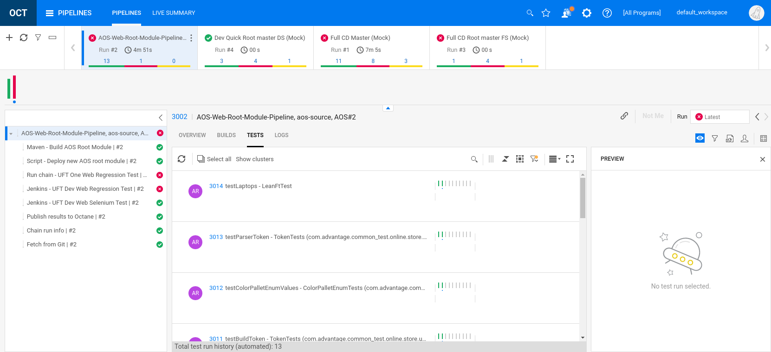

1. Click the failure link to see why the JUnit tests failed.

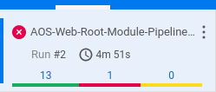

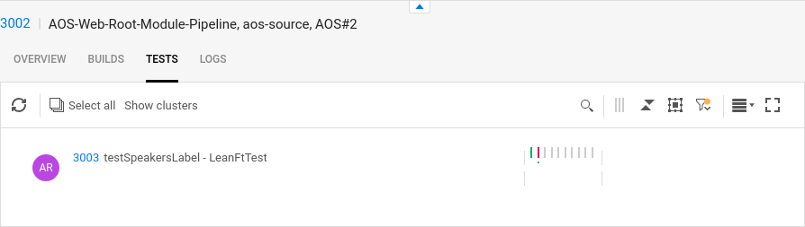

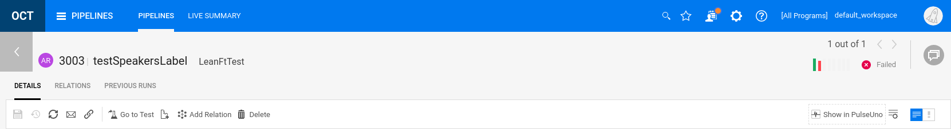

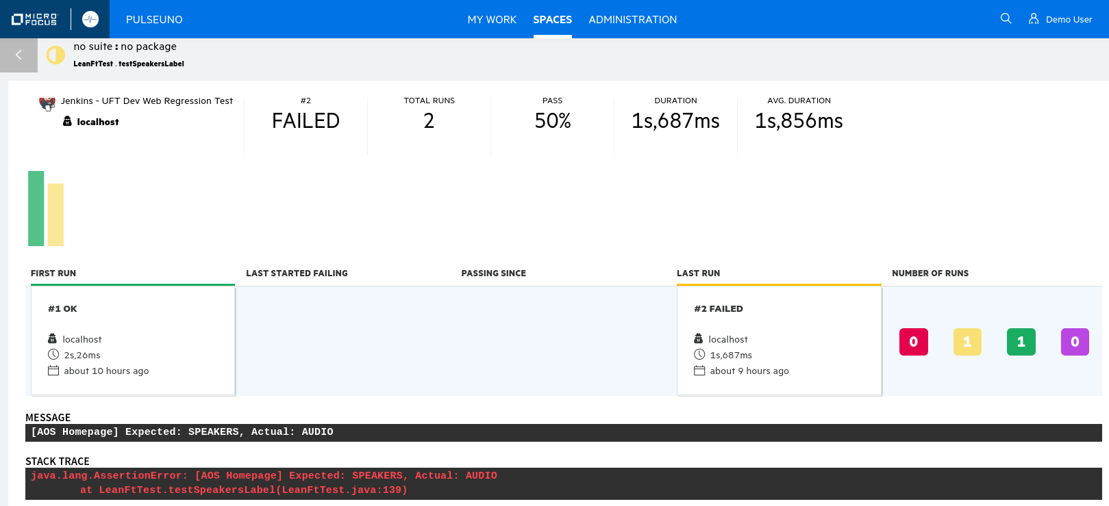

Your image may differ

**STACK TRACE:** java.lang.AssertionError: [AOS Homepage] Expected: SPEAKERS, Actual: AUDIO

at LeanFtTest.testSpeakersLabel(LeanFtTest.java:139)

Examining PulseUno’s Code Tracking

PulseUno tracks not just the code changes but the test results, the people who made the changes and the different runs of your changesets.

1. Log into PulseUno and go to **Spaces > AOS > aos-source Changeset Graph**

Click the red **X** to show the link below.

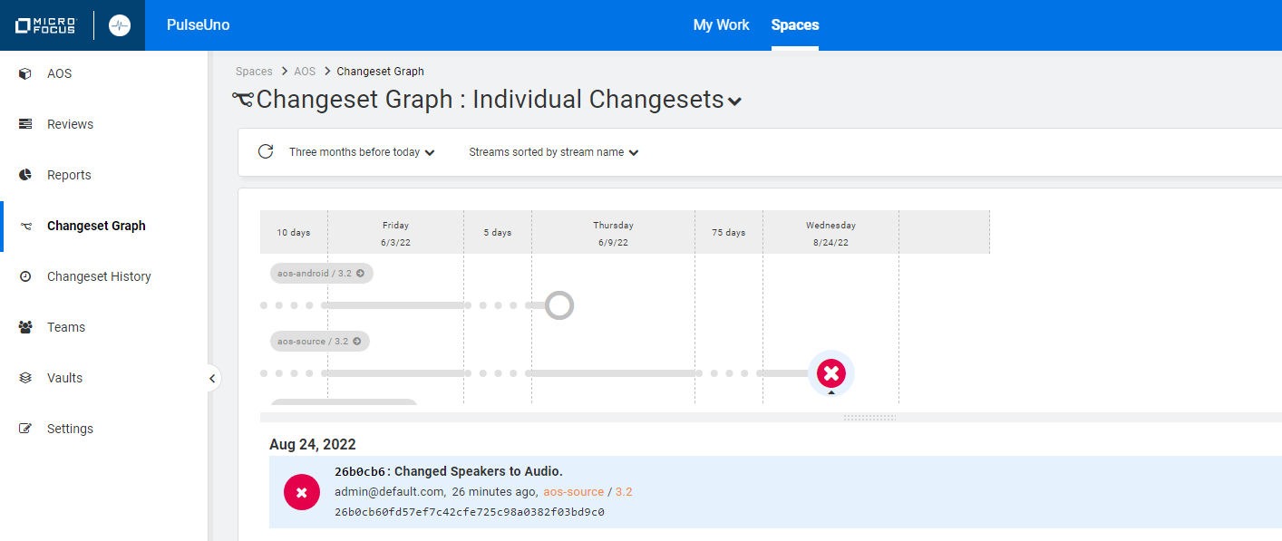

1. Click the **Changed Speakers to Audio** link.
2. Scroll down on the **CONVERSATION** tab to see more details.

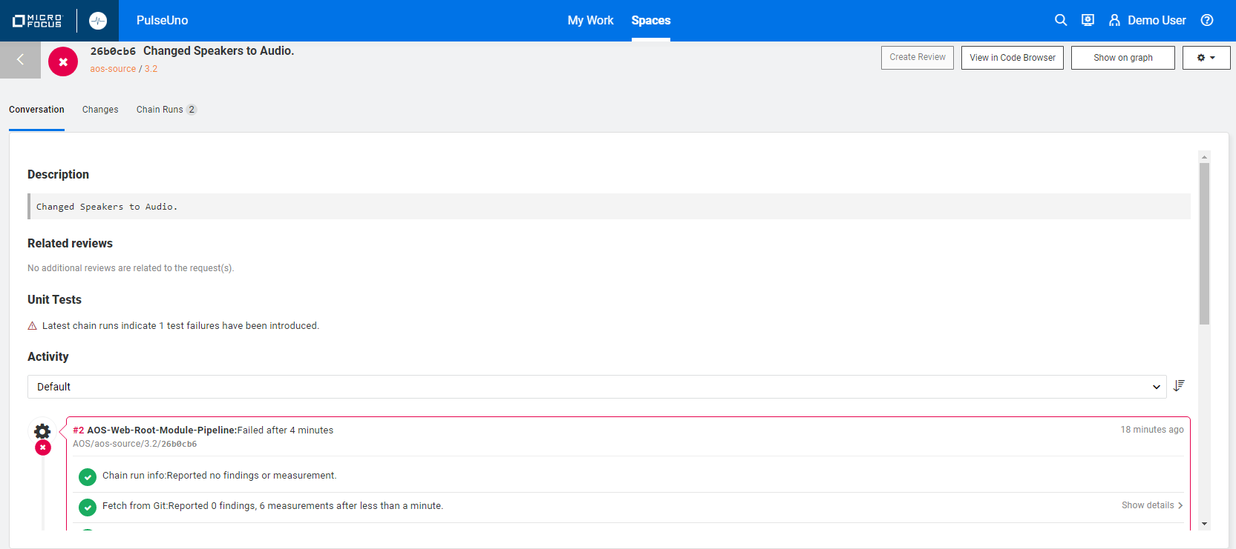

1. Click on the **CHANGES** tab to see the code change.

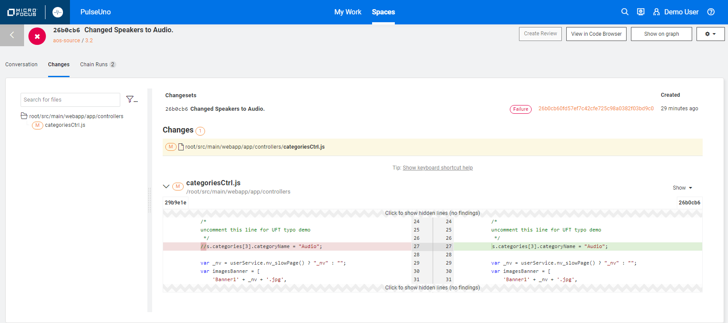

1. Click on the **CHAIN RUNS** tab to see those step details.

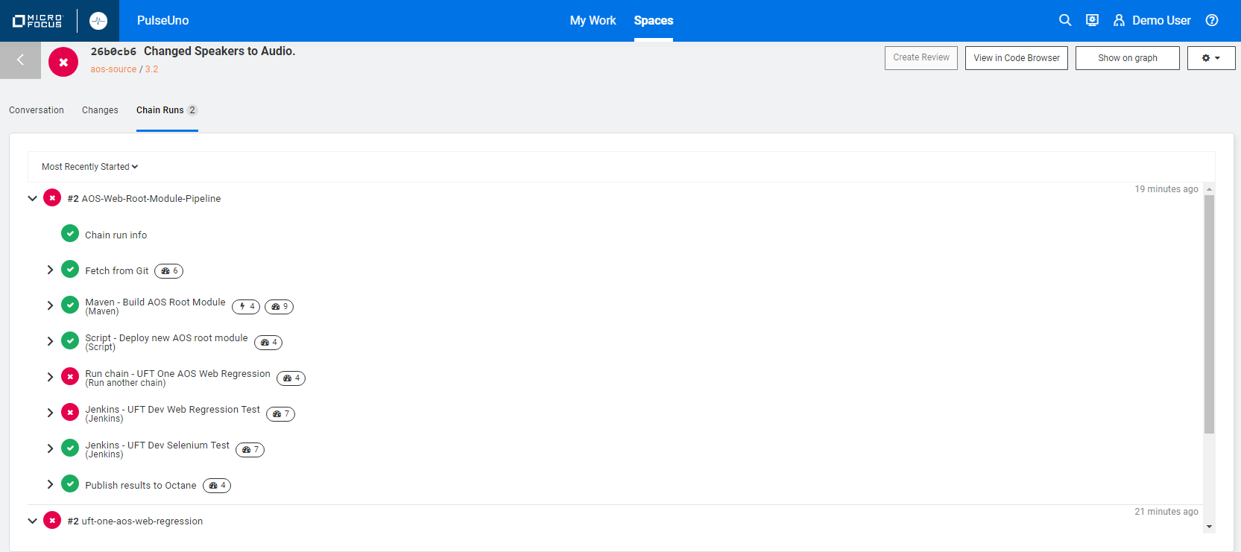

**Wow!  
  
You’ve learned all about PulseUno and how it works with Octane/ValueEdge!**

Running Release Process Auto-Actions using PulseUno

PulseUno can also be used to run Octane/ValueEdge auto-action processes from the Release Management module. This exercise shows you how to configure and run an Auto-Action process using PulseUno.

1. Log into Octane/ValueEdge and go to RELEASE MANAGEMENT > PROCESSES
2. Select the **2001** link for **Advantage Mobile Store**
3. Expand **Stage 1 > Group 1** and select **Action 1**  
   This will place our auto-action at the beginning of a process that we can start.
4. Under the **+ Stage** option select **Auto Action**

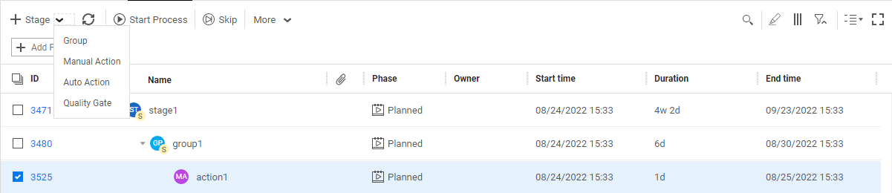

1. Add an **Auto Action** and set the following fields and click **Add**:

**Name**: PulseUno-AutoAction

**Parent**: group1

**Action Type**: PulseUno Run job

**CI Server**: PulseUno CI

**CI Job:** AOS-Web-Root-Module-Pipeline, aos-source, AOS

**Execution Parameter -**

**Stream/Branch Name**: 3.2

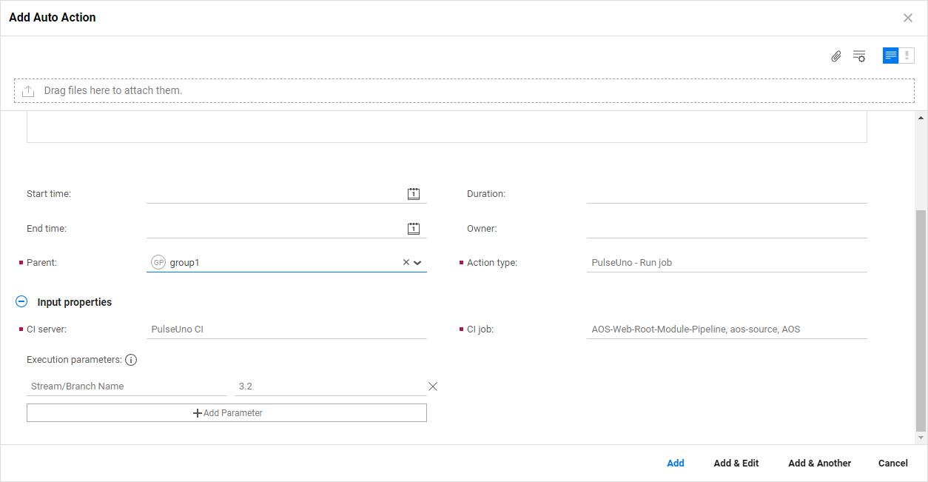

1. To test this, verify that your **PulseUno-AutoAction** is under the Stage1 > Group1 process and set each process above it to **Complete**. That will trigger the **PulseUno-AutoAction** process using PulseUno as the execution engine.

As the PulseUno job runs you’ll see the browsers start on NimbusClient and NimbusServer as they run through the AOS tests.

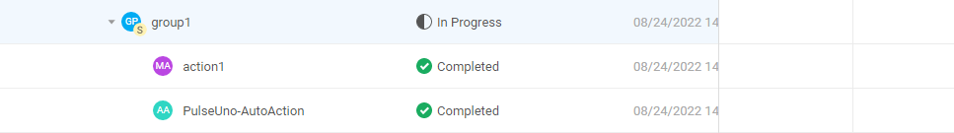

Exercise 26: Configuring ValueEdge with Data

Configuring ValueEdge to Track Waste

ValueEdge is a fully Integrated end-to-end Value Stream Management (VSM) platform. It is a software development cloud-based platform to visualize and manage the flow of value that incorporate ALM Octane on the Micro Focus SaaS platform.

In this section we’ll describe how to configure the data in your SaaS instance to show waste and waste categories and how to identify rework and waiting time.

**IMPORTANT NOTE**: These changes to enable the Waste and Waste Category may have already been performed on your ValueEdge SaaS instance. It’s possible to do this at the Shared Space level as well as on an individual workspace level. You can check if this was done by checking the Rules and Workflow at the Shared Space level to see if Waste category **Actions** exist. If they do not, then you can proceed with these instructions.

1. Login to your ValueEdge SaaS instance (managed by the SaaS and ADM Technical Enablement teams).
2. Verify that you have populated data into your workspace using the data generator.
3. Select the gear icon > **Settings** and select your workspace name on the left edge.  
     
   ValueEdge ships with 5 default Waste Categories. We’ll be configuring **Rework** and **Waiting time.**

* Partially done work
* **Rework**
* Overprocessing
* **Waiting time**
* None

1. Under Entities, select **Epics** and verify that Waste and Waste category are shared space fields.
2. Under Entities, select **Features** and verify that Waste and Waste category are shared space fields.

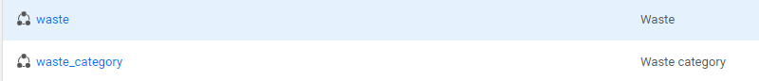

NOTE: Waste Lists are ONLY editable at the Shared Space Level – this has already been done for you.  
User Story waste and Defect waste will follow in a later release.

1. Add a new business rule to both the **Epic** and **Feature** entities.

Click **+** to add a new Rule:

**EPIC and FEATURE** – Waiting Time:

On the **Action** tab, set the fields with the following values:

* Action: Select **Set field value**.
* Timing: Select **When saving an entity**  
  The waste category is not available for other timing options.
* Field to change: Select **Waste category**
* Change > Set value: Select **Waiting time**

On the **CONDITION** tab, specify **Phase > equal > Ready for QA**.

When this business rule is triggered and an item's phase changes to **Waiting for QA**, then   
**Waste** tracking starts.

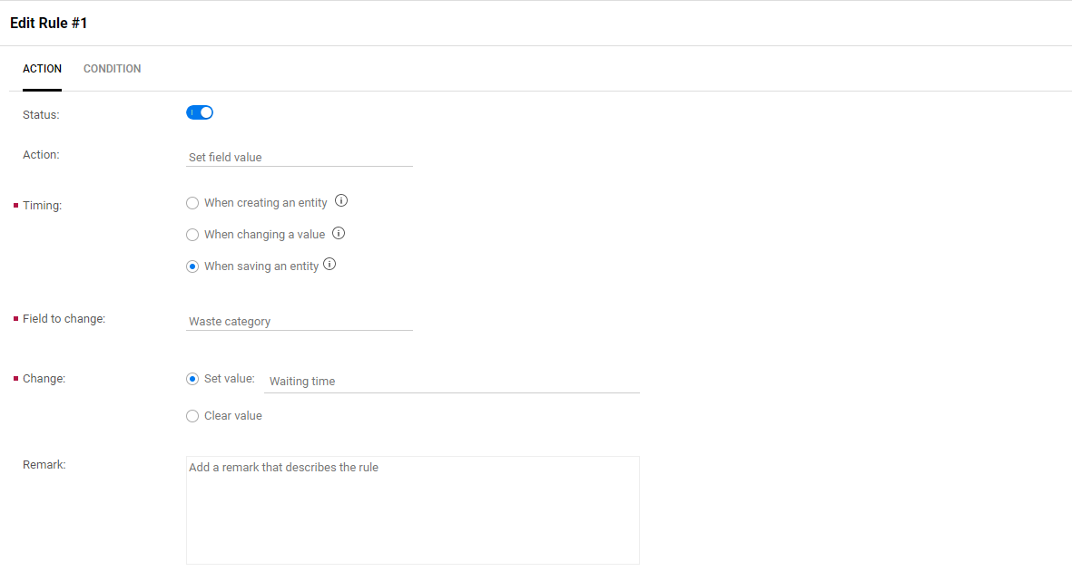

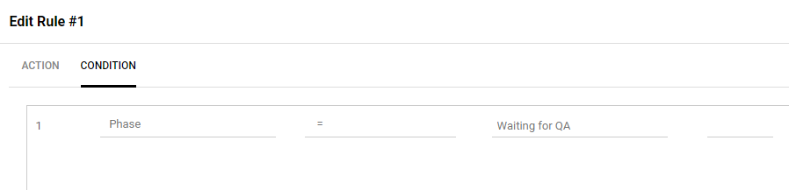

1. Click **+** to add a second rule to both the **Epic** and **Feature** entities:

**EPIC** and **FEATURE**: Rework

On the **Action** tab, set the fields with the following values:

* Action: Select **Set field value**.
* Timing: Select **When saving an entity**  
  The waste category is not available for other timing options.
* Field to change: Select **Waste category**
* Change > Set value: Select **Rework**.

On the **CONDITION** tab, set the following condition:

**Repeating phase > equal > Yes > AND > Phase > equal > In Progress**

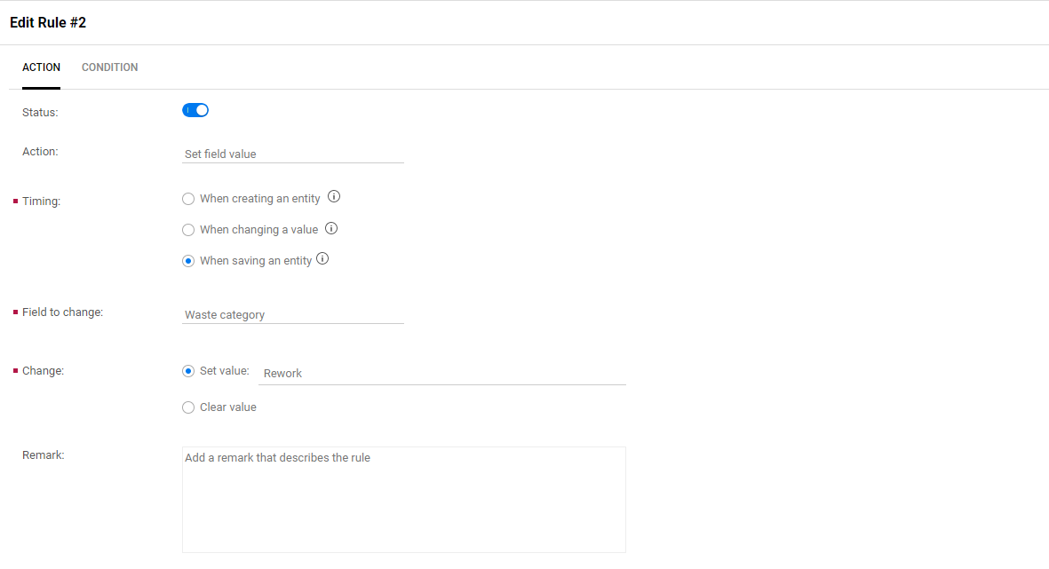

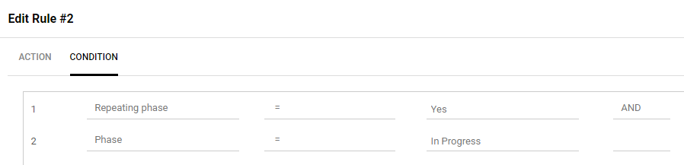

When this business rule is triggered, the re-entering of the **In Progress** phase will trigger the **Rework** waste category.

1. Exit the administrator **Settings** section by clicking the gear icon.
2. Create some data by moving several Epics and Features from one phase to another.

Populating Waste Data in ValueEdge

1. To create **Waiting time** waste category data:

* Locate and move a Feature’s phase from **In Progress** to **Waiting for Test**
* Locate and move an Epic’s phase from **In Progress** to **Waiting for Test**

1. To create **Rework** waste category data:

* Locate and move a Feature’s phase from **In Testing** back to **In Progress**
* Locate and move an Epic’s phase from **In Testing** back to **In Progress**

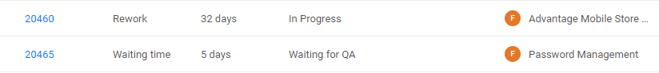

Configuring Waste Widgets

After you’ve configured the waste categories and created some data you can then add some special ValueEdge widgets to your dashboard.

1. Log into ValueEdge and select the Dashboard module.
2. Click the plus ( + ) to create a new widget and choose the **Value Stream Management** tab on the left.

There are two, predefined Value Stream Management widgets you can use:

* **Flow efficiency trend – waste over time**  
  This is a trend widget that helps you understand your workflow efficiency trend, based on waste time for features or epics in a specific scope.
* **Waste time grouped by category over time**

This widget is a summary widget that helps you track waste time for features and epics in a specific scope.

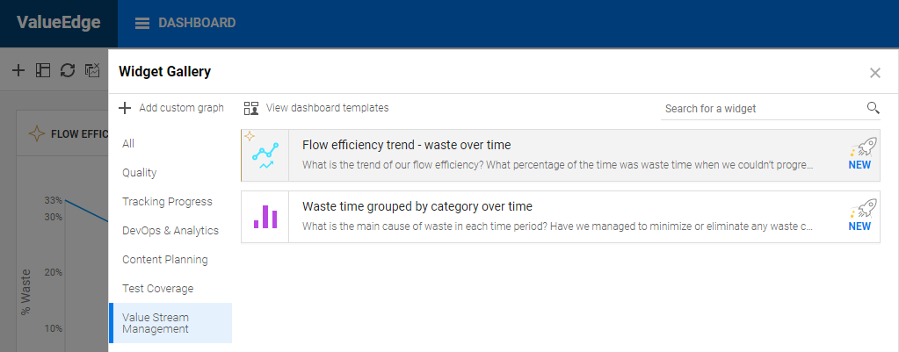

1. Add both graphs to your dashboard.

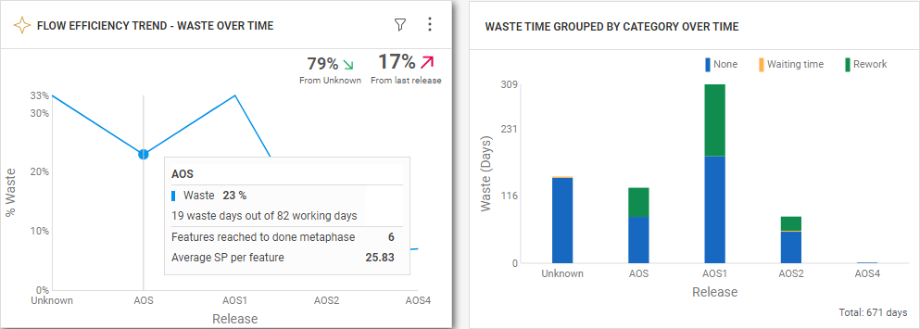

Exercise 27: Exporting and Importing Workspaces

Starting with Octane 15.1.90, Octane can both export and import workspaces and their associated elastic search data. This offers several advantages allowing customers to share or replicate projects with other organizations, and also backing up existing workspace states.

**NOTE**: Exported projects can only be imported into the exact same Octane and elastic search versions.

1. If Octane isn’t running, start it from the **terminal** on **NimbusServer** by typing:

**$ nimbusapp octane:16.0.400.79**  **start**

1. Open your browser and **Login** to **ALM Octane**: <http://nimbusserver.aos.com:8085/ui>
   * Username: [**sa@nga**](mailto:userx@octane.com)
   * Password: **Password1**
2. Select the **default_workspace** under **A Default Shared Workspace** project.

## Exporting an Octane Space

When exporting spaces in Octane it’s important to note that you can only export shared or isolated spaces and not the individual workspaces inside those spaces.

**NOTE**: Exported projects can only be imported into the exact same Octane and elastic search versions.

1. Select the **Backlog** module and the **BACKLOG ITEMS** tab and **create** a new user story called **My User Story**.  
   We’re doing this to show that our new data will also appear in the exported space.

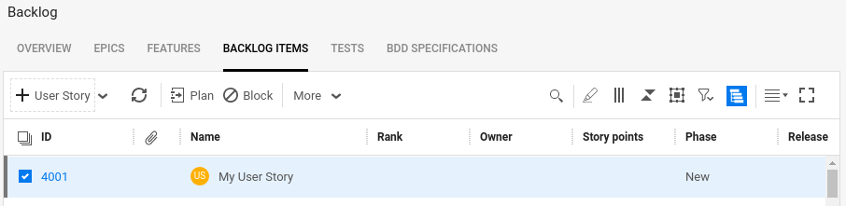

1. Select **Coming Soon!** under the **Advantage Banking** project.  
   We’re doing this so we aren’t logged into the default_workspace when we export it.
2. Open a Terminal on NimbusServer and run the following five commands:

**$ docker exec -it octane /bin/bash**

**# echo "path.repo: [\"/opt/octanerepo/storage/site\"]" >> /etc/elasticsearch/elasticsearch.yml**

**# mkdir /opt/octanerepo/storage/site/elastic-repo**

**# chmod 777 /opt/octanerepo/storage/site/elastic-repo**

**# chown -R octane /opt/octanerepo/storage/site/elastic-repo**

**# chgrp -R octane /opt/octanerepo/storage/site/elastic-repo**

**# exit**

1. This appends the configuration details for the export/import functionality to elastic search.

Now restart the octane container with this command:

**$ nimbusapp octane restart**

1. After Octane has fully restarted (wait until the status is healthy), we need to register a new Elastic repository using a REST call to the Elastic server from inside the Docker container with:

**$ docker exec -it octane /bin/bash**

**# curl -X PUT localhost:9200/_snapshot/octane_migrate -H "Content-Type: application/json" -d '{"type": "fs", "settings": { "location": "/opt/octanerepo/storage/site/elastic-repo"}}'**

**# exit**

1. Open a browser to Octane and login to Octane with:
   * Username: [**sa@nga**](mailto:userx@octane.com)
   * Password: **Password1**
2. Navigate to the **Settings > Site** section in Octane.

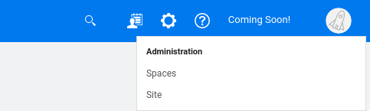

1. Select the **PARAMETERS** tab and scroll down to **MIGRATION_ELASTIC_REPOSITORY**.
2. Set the Value to be **octane_migrate** and click **Save**.

This parameter must be set to export the elastic search information.

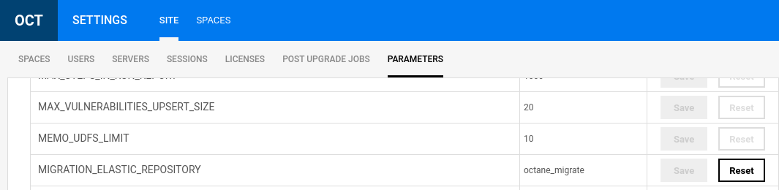

1. Under the **SITE** setting select **SPACES** and then select **A Default Shared Workspace**.

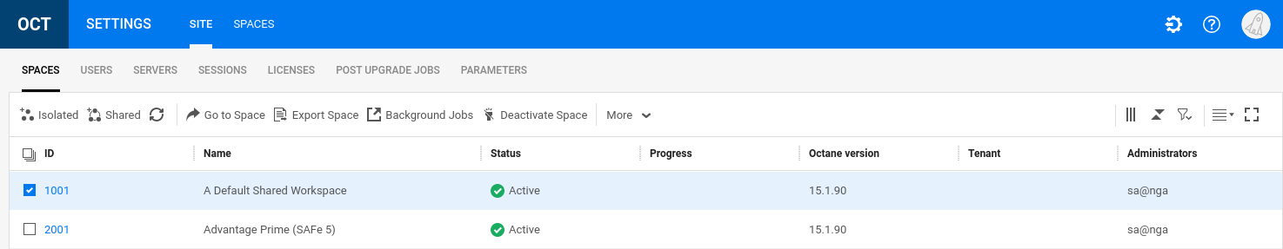

1. Select **Deactivate Space**. This will remove any logged in users and prevent any new data coming in.

While not absolutely necessary when exporting a space, this is a best practice.

1. Select **Export Space** from the same menu.  
   Verify that **DB**, **Storage**, **Elastic** and **Audit** are all selected and click **Export**.

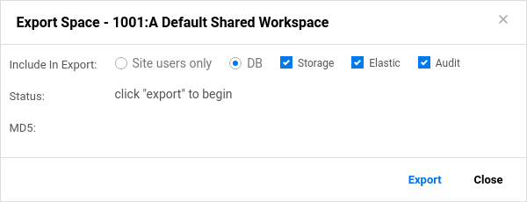

1. Click **Download** to download the resulting .osa file.

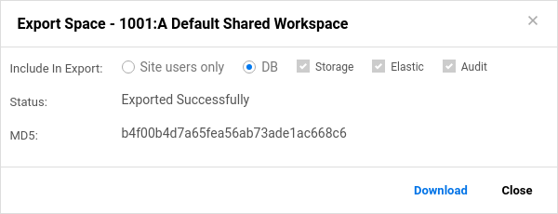

1. **Great!** Now we have a copy of the Octane space that includes the Elastic Search details.

Next we’ll import that copy into a new space on the same server that we’ll create.

Importing an Octane Space

1. Deselect the space “**A Default Shared Workspace**” so no spaces are selected.
2. From the **More** menu select **Import Space**.

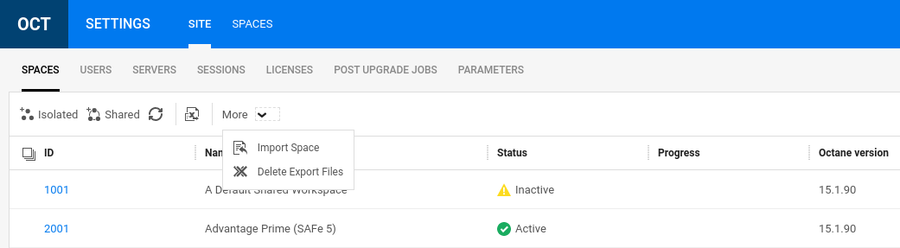

|  |
| --- |
| OPTIONAL - NOTE: If importing to a *different* Octane instance, you have to copy the Elastic Search snapshots folder that was used when you did the export. This means you have to copy this directory from the source system to the target. Below are the commands for the source machine.  $ docker exec -it octane /bin/bash  # cd /opt/octanerepo/storage/site  # tar cvf elastic-repo.tar.gz elastic-repo  # exit  $ docker cp octane:/opt/octanerepo/storage/site/elastic-repo.tar.gz ~/Downloads  You’ll need to copy both the .osa file and the elastic-repo.tar,gz file to the other server.  We’ll assume they are copied to that same ~/Downloads directory. Below are the commands for the commands for the target machine.  $ docker cp ~/Downloads/elastic-repo.tar.gz octane:/opt/octanerepo/storage/site/  $ docker exec -it octane /bin/bash  # cd /opt/octanerepo/storage/site  # rm -rf elastic-repo  # tar xvf elastic-repo.tar.gz  # chmod -R 777 elastic-repo  # chgrp -R octane elastic-repo  # chown -R octane elastic-repo  # curl -X DELETE localhost:9200/_snapshot/octane_migrate  # curl -X PUT localhost:9200/_snapshot/octane_migrate -H "Content-Type: application/json" -d '{"type": "fs", "settings": { "location": "/opt/octanerepo/storage/site/elastic-repo"}}'  # exit  $ nimbusapp octane restart |

1. Select the **File Name** to import and name the new space “**My Default Space**” and click **Import**

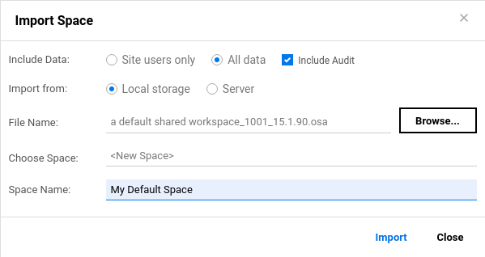

1. Exit out of the **Settings** section and set your new project to **My Default Space > default_workspace**.

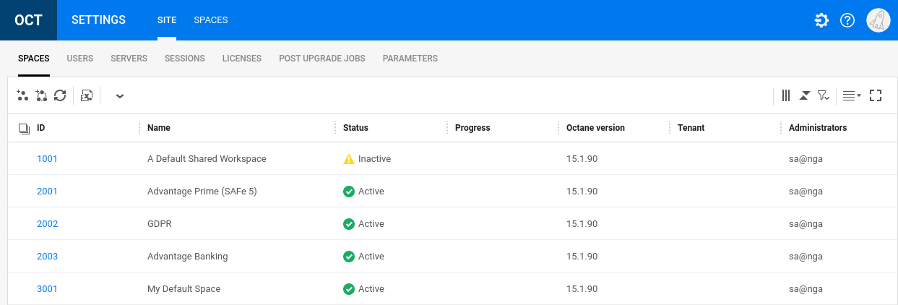

1. Verify that your created data exists and elastic search works by searching for **My User Story**.

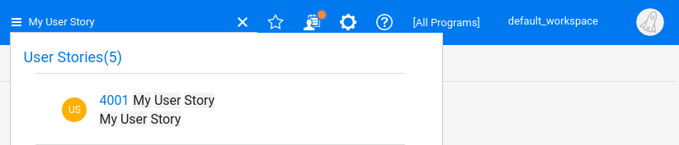

1. Once you’ve found the user story you created, you’re done.

**That was awesome work – nice job!**

Exercise 28: Utilizing Model Based Testing (MBT)

Model based testing (MBT) is a new capability implemented in ALM Octane and ValueEdge that imports UFT actions and test parameters to create reusable test components. These components are assembled into flows and test paths from which tests are generated.

Since there can be dozens or hundreds of paths through an application, different strategies can be selected to reduce the testing effort. Each strategy generates a set of tests that will exercise that strategy.

The MBT capability is available as a SaaS plus local implementation. ALM Octane or ValueEdge is deployed via Micro Focus SaaS and they are connected to CI and UFT One systems locally hosted by the customer. MBT tests are stored in a Git repository which is connected to the SaaS instance and a CI system like Jenkins. Once this is configured, the tests are maintained in Git and changes are discovered by the Micro Focus Application Automation Tools plug-in.

## Configuring the SaaS instance of MBT

1. Start the **NimbusServer** and **NimbusClient** VMs.
2. To get started with MBT you’ll need a SaaS instance of ALM Octane or ValueEdge to be provisioned. Fortunately, one was provisioned by the presales with the following URL:

<https://mbt.almoctane.com>

1. You’ll also need your login credentials for this site which you should have received via email from your presales practice manager. Those credentials will look something like:
   * Username = [your_email@microfocus.com](mailto:your_email@microfocus.com)
   * Password = Password1
2. You should also have received your client ID and Client secret via an email.

Those credentials will look something like:

* Client ID: **<yourname>_mbt_35m79m21825gwfr7zm5rwkqzx**
* Client secret: **%212422519738229152240M**

## Cloning the Flight-MBT git repository

We will use a pre-build MBT set of units for this exercise that are stored in GitHub.

* 1. Open a browser on Nimbus Client and login to your GitHub account and make **Master** your default Repo

(**Settings > Repositories**)

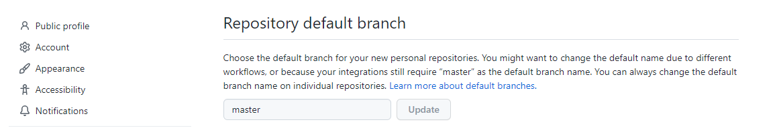

* 1. Create a **New** git repo in your GitHub account using your browser and call it **Flight-MBT**.

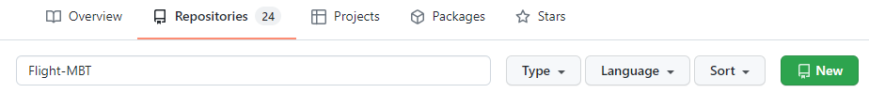

* 1. Clone the repo to NimbusClient by opening a CMD window (or Git Bash) and type the following:

**cd C:\**

**git clone https://github.com/msteffensen19/Flight-MBT.git**

**cd Flight-MBT**

**git push --force https://github.com/<your git account>/Flight-MBT.git**

* 1. This will push the pre-built Flight-MBT repo to your recently-created github repo.

This folder contains a UFT test with several **Flight GUI** actions.

## Configuring Jenkins and DevOps

Jenkins is the CI system we’ll use for MBT and that resides in the DevOps container on Nimbus Server.

1. From Nimbus Server, start the DevOps container with:

**$ nimbusapp devops:3.2.3 start**

1. To begin, make sure your environment is clean and free from any previous integration details.  
   See the section **Resetting the MBT Environment** for more details.
2. Verify that your Jenkins instance has the 7.3-beta or later Micro Focus Application Automation Tools plugin installed by opening Jenkins and navigating to Manage Jenkins > Manage Plugins.



1. Go to Manage Jenkins > Configure System and configure these three fields:

Location: MBT URL from your login

Client ID: Client ID from presales practice manager

Clint Secret: Client secret from presales practice manager

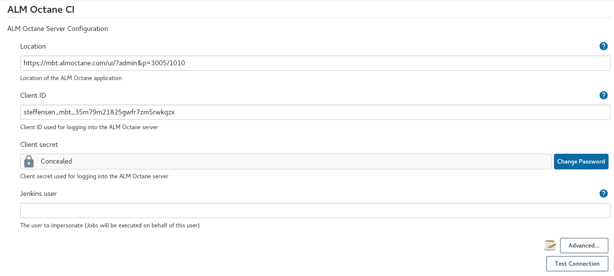

1. Click Advanced and edit Instance id to add some unique text (like your name) into the string and then click **Test Connection** and **SAVE**. This makes your local instance unique so MBT can recognize it.

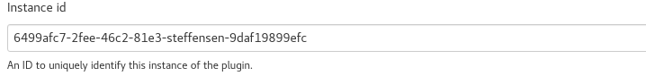

1. Restart the Devops container with:

**nimbusapp devops restart**

## Configuring Octane

Next, we’ll configure Octane to support our MBT environment.

1. On Nimbus Server, open a browser tab and connect to your Octane MBT instance and make sure you’re connected to your unique workspace and then Login (sa@nga, Password1).
2. In Octane, go To **Settings > Spaces > DEVOPS** tab and create a new CI Server and select the Jenkins URL from the pulldown.

Name: mbt-ci-server

CI Server: <http://nimbusserver.aos.com:8090>

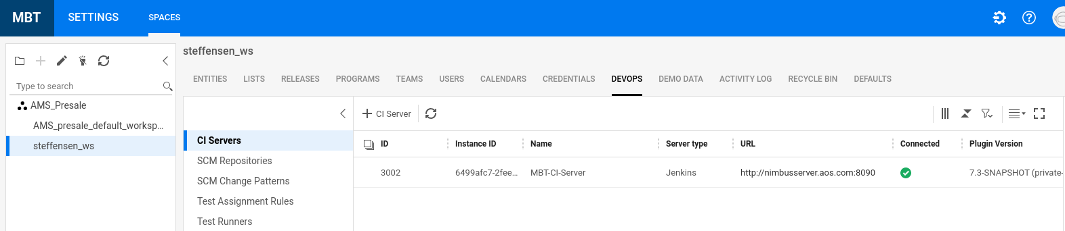

1. From the same interface select **Test Runners** and add a new test runner.

Name: mbt-runner

Framework: MBT

CI Server: mbt-ci-server

Repository: https://github.com//<your git account>/Flight-MBT.git

Click **Test Connection** to verify that everything is correct and then click **SAVE**.

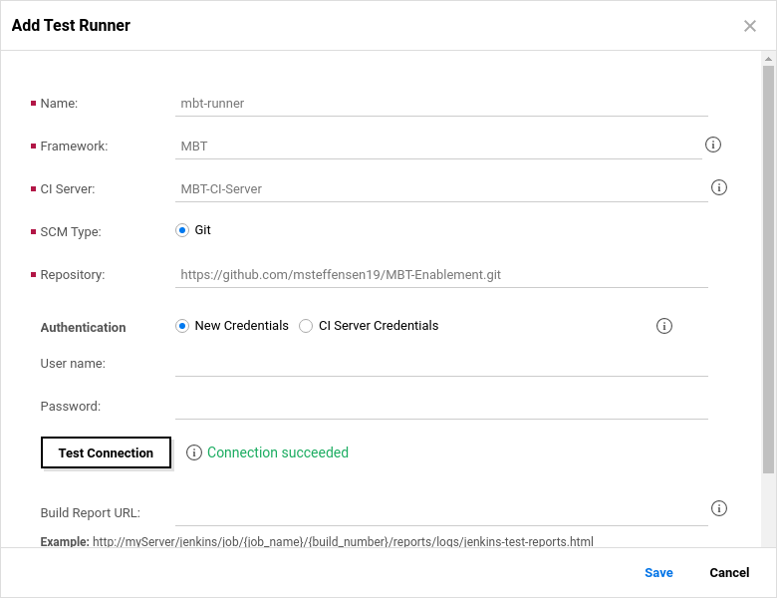

Once you click **SAVE**, this will spawn the Auto-Discovery job In Jenkins which creates a Jenkins job and creates the Units in MBT which are your building blocks for creating modular tests.

1. Select the **RELEASES** tab and create at least one release.  
   It’s a required entity for MBT so we need to have one defined.

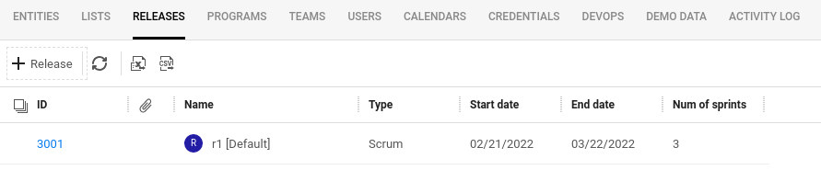

1. Verify that your git folder appears under the **Auto Discovered** folder in MBT.

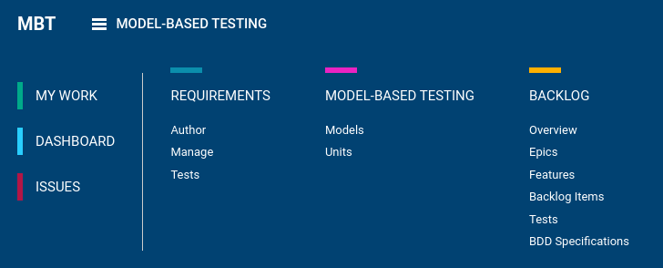

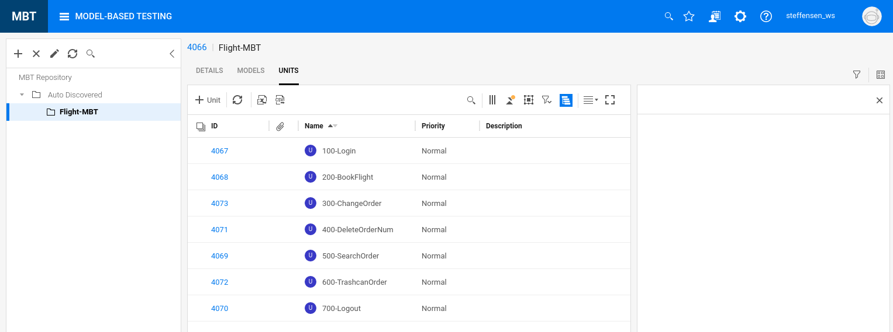

## Creating and Running an MBT Model

1. Create an empty MBT Model called Model-1 and select Add & Edit.

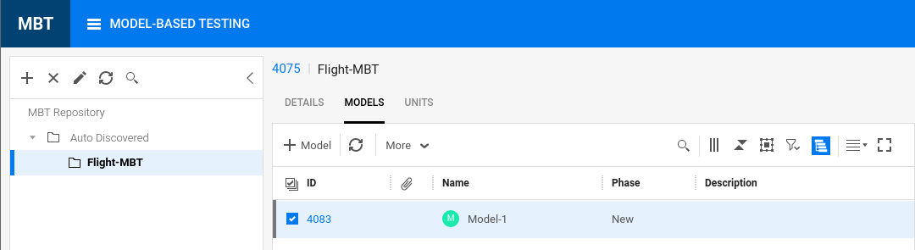

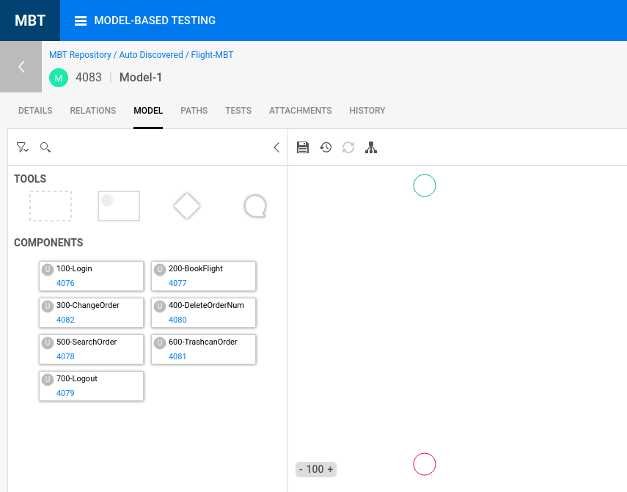

1. Create the following model structure (currently there’s no export/import of models).

* To connect lines, move close to an object border until you see and then drag to the other border.
* Use the **DEL** key to delete an item.
* Change the zoom level to help position units.
* Connect the units roughly and fix it the layout later with auto arrange.
* Click to **Save** the model

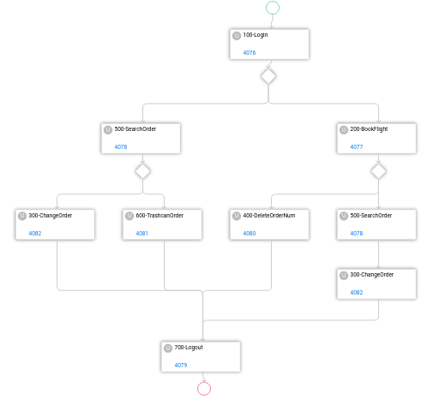

1. Select the **PATHS** tab and then select all the paths and click **Generate Test**.

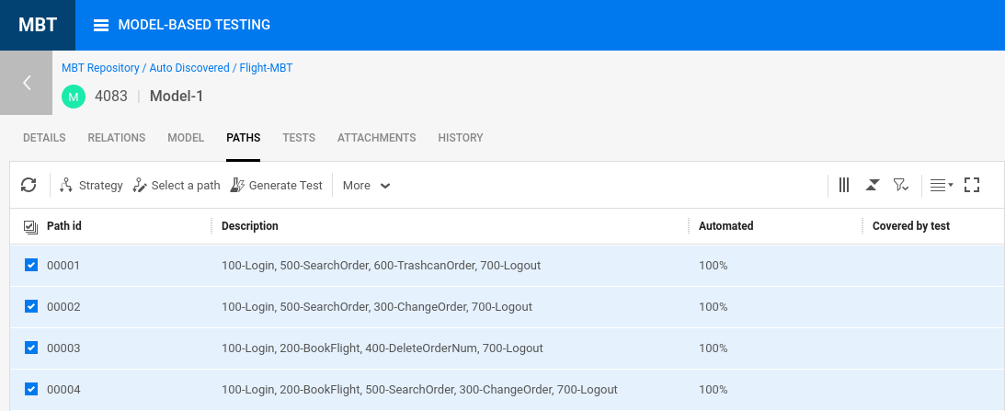

1. Select the **TESTS** tab for **100-200-400-700** and **Link** the output params to the input params.

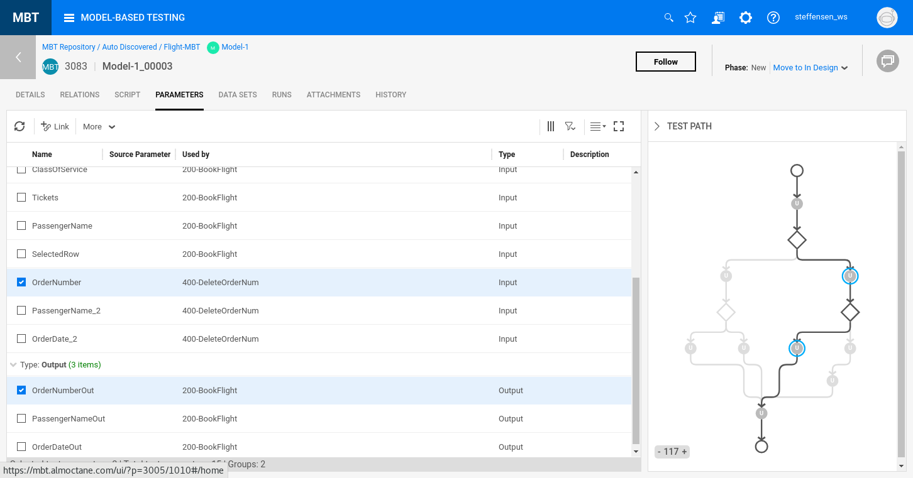

1. Repeat the linking process for test **100-200-500-300-700**.
2. Select the numeric link test for path **100-500-600-700** and add a second data line with **Mike Focus** as **PassengerName** and click **Save.** (the 2nd iteration will fail since that passenger name doesn’t exist).

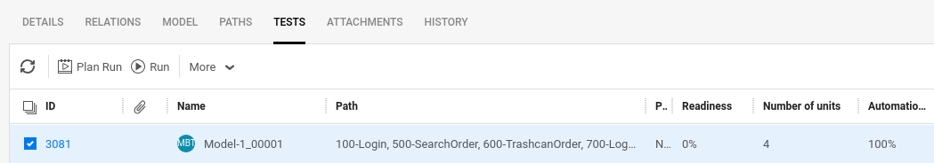

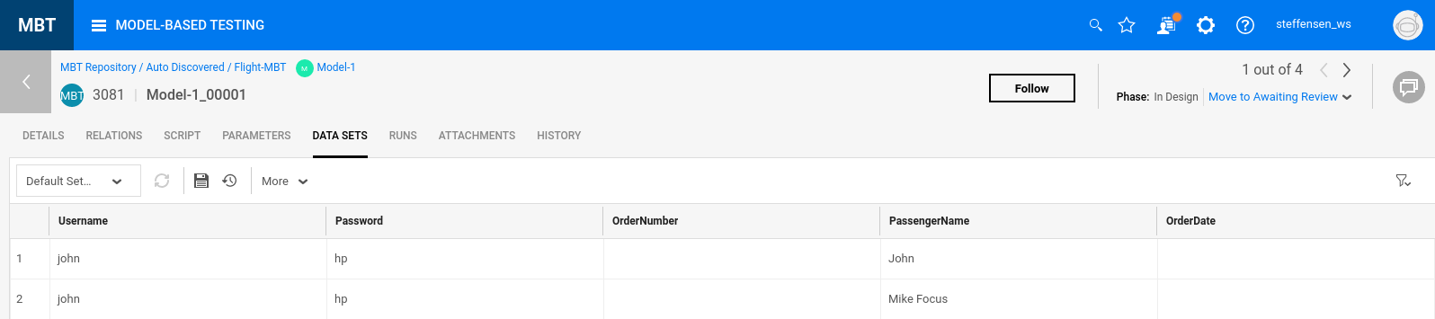

1. Create a **Test Suite** and add the MBT Test.

* Select **Model-1** and the **TESTS** tab.
* Select all the paths.
* Right click to **Create Test Suite**.
* Label it as **MyTestSuite** and select **Add & Edit**.

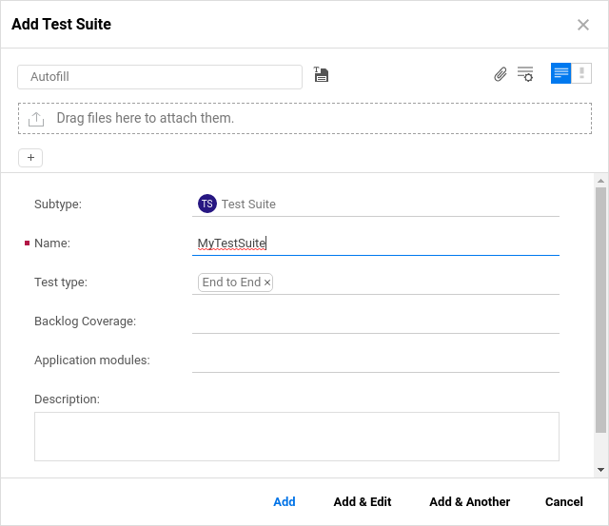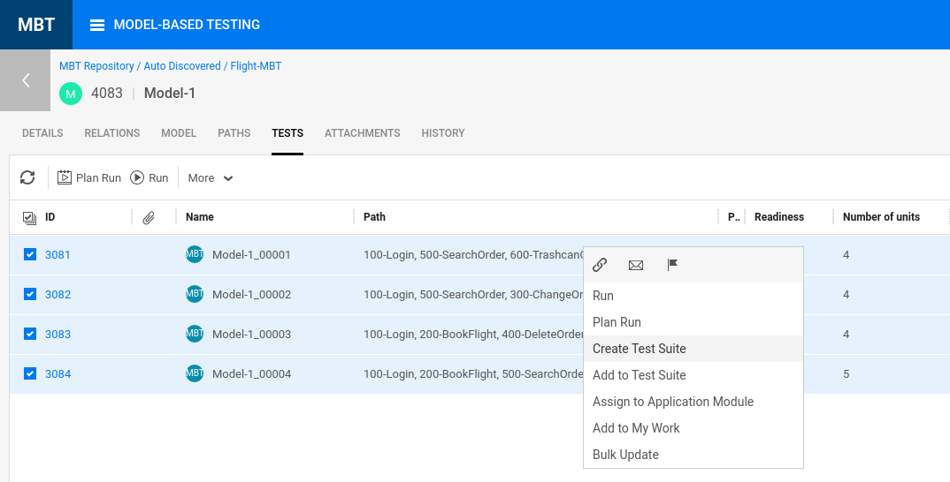

1. Add the columns **Test runner** and **Run mode** via **|||**
   * Right click and choose **Bulk Update**
   * Set to **mbt-runner** and **Automatically**
   * 
2. Click **Run Suite** and **Let’s Run**

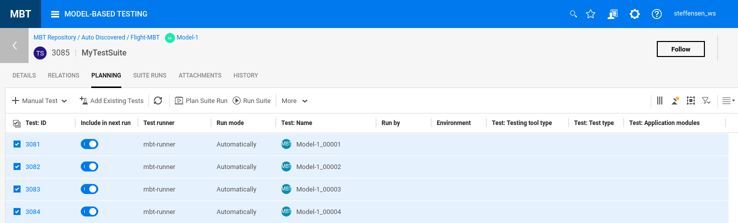

1. Check the reports – one test should fail since Mike Focus does not have an existing reservation.

To make all the tests pass, remove the second data line for Mike Focus and run the test again.

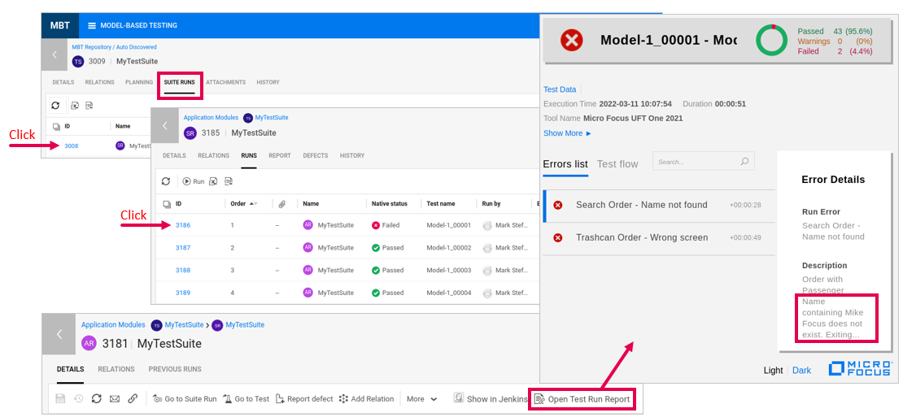

1. Change the phase to **Ready** for some units to show **% Readiness**. The blue color indicates it is **Ready**.

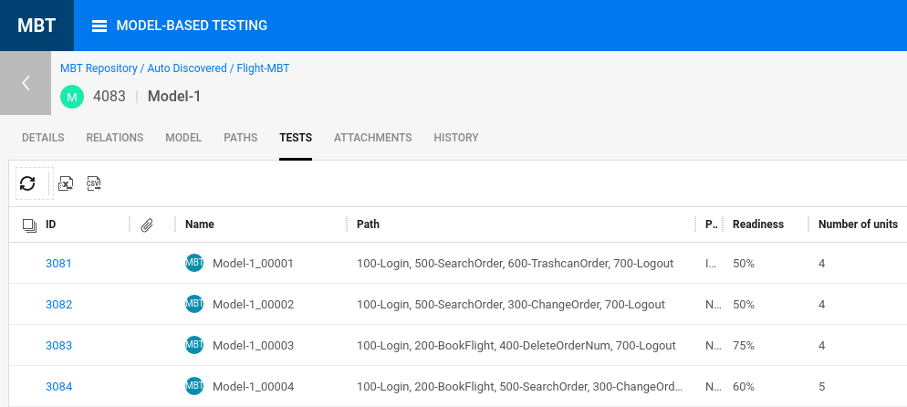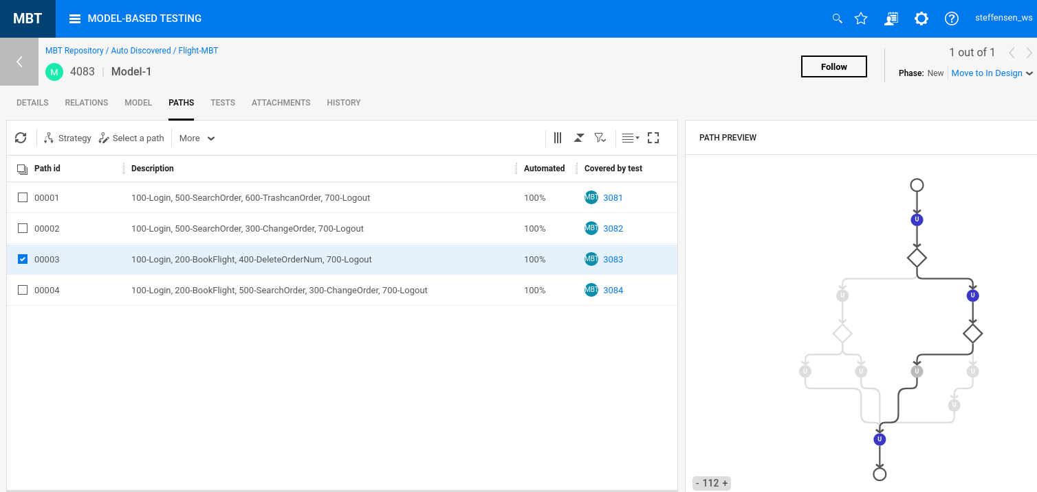

## Creating and Running an AI Codeless Model

1. TBD.

## Caveats for MBT

* + MBT currently doesn’t support Octane Pipelines.
  + Need to find ways to convert existing customer’s tests to MBT.
  + Data table parameters need to be transitioned to Test Parameters.
  + More Test Data Management needed (UFT Data Generator will help).
  + Should support Function libraries and Recovery Scenarios OOTB.
  + Actions, Libraries and Recovery Scenarios all need relative paths.
  + Navigating from MBT Models through to Test Results is awkward.
  + If errors with “Action not found” appear, stop the UFT Helper service.
  + Requirement for Git “Master” will be fixed soon to allow “Main” too.
  + Changes to UFT tests pushed to Git will reflect in next suite run but default test parameters don’t update.

## Resetting the MBT Environment

To clear out your MBT environment and reset your data, do it in the following order:

1. From MBT Octane/ValueEdge - from Quality > Tests, Delete all Test Suites and MBT Tests
2. From MBT > Models
   1. Delete all your Models
   2. Delete all your Units
   3. Delete Units folder
3. From MBT Octane/ValueEdge Settings
   1. Delete all MBT Test Runners
   2. Delete the devops CI Server - mbt-ci-server
4. From Jenkins
   1. Delete any MBT-Test-Runner jobs (they may have disappeared already)

You’ll eventually create the DEVOPS CI Server (mbt-ci-server) and Test Runner (mbt-runner) but follow the order and steps outlined in the main section above.

Appendix

|  |  |
| --- | --- |
| Latest Container / Application Versions | |
| Octane | 16.0.400.79 |
| ValueEdge | 16.1.18.60 |
| DevOps | 3.2.4 |
| IntelliJ | 3.2.1 |
| AOS | 3.2 |
| MFConnect | 4.4.2 |
| SonarQube | 7.7 |
| SCA | 21.2.1 |
| SSC | 21.2.1 |
| Audit Workbench | 21.2.1 |
| ALM | 16.0.1 |
| WebInspect | 21.2.1 |
| PulseUno | 22.1-3.2 |
| Autopass | 12.3.0_d |

Select entire document contents and then type CTRL+A + F9 to update all versions.

Then save this document, close it and open it and all the versions *should* be fixed and updated.